Design Document Zhang Junyi 119010431

Code flow:

To make a snake game. I set snake as a list. Each “square” including “head” is a list with 2 items – x and y. then the square will be added to the snake list. When snake move forward, the new “head” will copy the last item in the list, then added into list, the first item in list will be popped out.

Before each move, the function will check whether player wins, fails, whether the snake is out of range and whether the snake meets the food. If snake meets the food, a counter will be activated to count how many squares need to add. In each add activity, the snake won’t conduct “pop” action in order to lengthen the body.

To test the game status, functions will test if the coordinate of head and food/monster are identical. If true, it will conduct proper processes. If a food is consumed by snake, it will move to (1000,1000), and if all food are in (1000,1000), you will win.

The snake, food and monster are actually all list with (x,y) coordinates group, the program track their movement by tracking list.

For the moving direction, the turtle uses onkey to get keyboard input, and the input will be transfer to x=_ and y=_. Then when snake moves, it position will previous position plus the heading parameters. The monster will move along the same direction as snake but with a random speed, and it will always stays in game area.

This code also provide “press R to restart”

Functions:

generatefood(): this function is used to generate food and their position. It use random number for coordinates and loop to make sure food won’t come out at the same position. The global “food” will be used in main function.

showfood(): this function usese turtle to show food on screen. Turtle will go to proper coordinate and “write” the correct number and return to previous position.

square(x,y,size,color): this function I to draw square, turtle will go to position(x,y), and draw the square as the size of (size) and color in (color).

Initialize(): this function is for initialization, it will generate the snake and monster, and generate, show food. Set the proper screen refresh and set the key input. Finally it will call snakemove function by onclick

Changedirection(): this function will turn user input into heading parameter.

Monstermove(): this function is used for let monster to move

UI(): this function write “body contact and time” on the head of the screen.

Contact(): this function is used to count the contact times of snake and monster

Failcheck(): by detecting the coordinate of snake’s head and monster and bound, this function will return False if meet condition.

Winchect(): this function will test if all food are at (1000,1000). If so , it will show win.

Foodcheck(): this function test the coordinate of head and food.

Pausecheck(): this function check if user is pausing

Snakemove(): this function works as main function, if copy the head, checking every circumstances, move the snake and draw it. At last it use ontimer to recall itself.

Sample output:

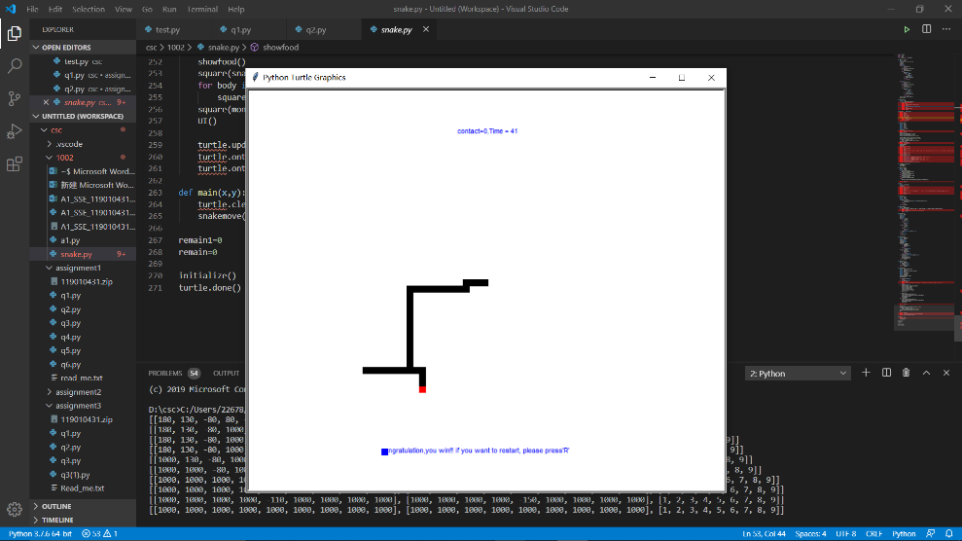1: win

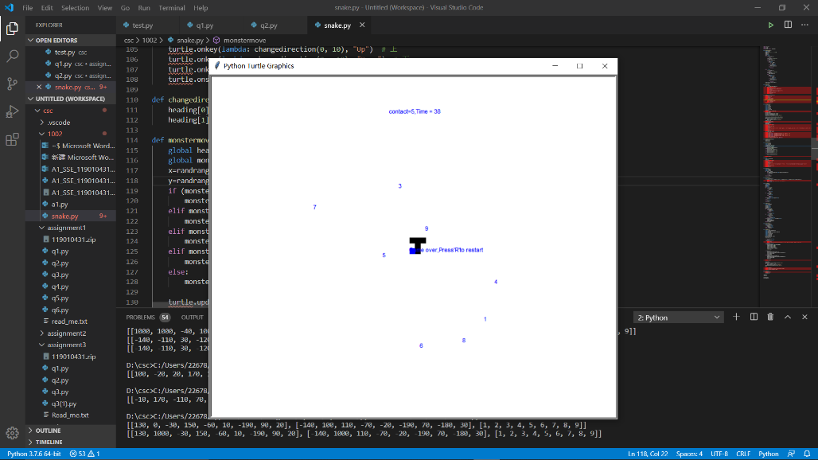2. Game over:

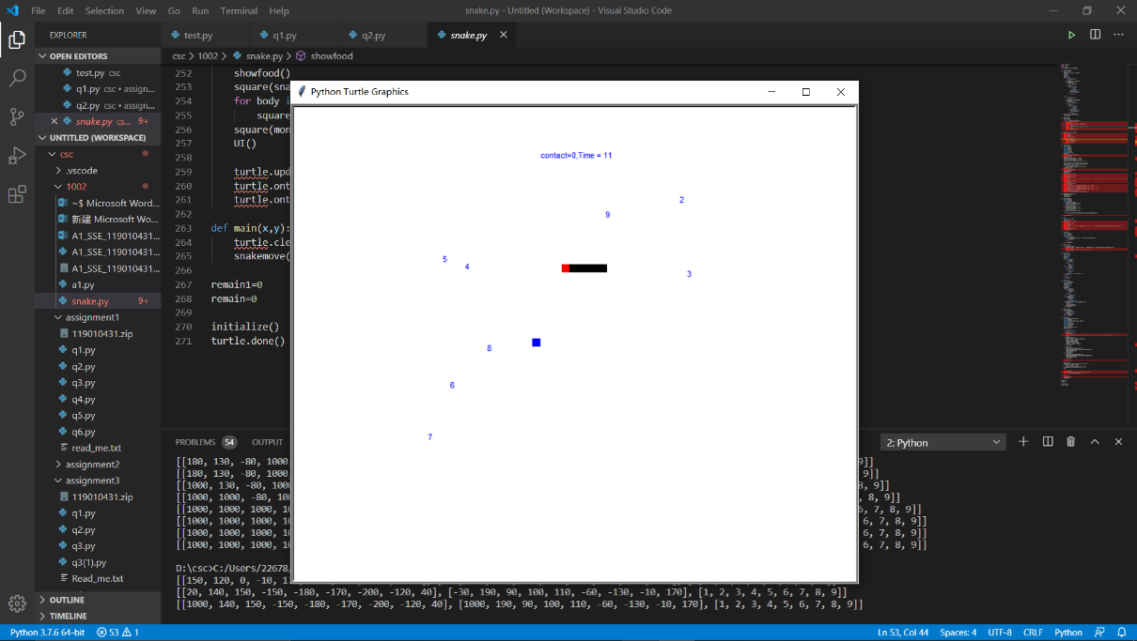3. 1 food consumed:

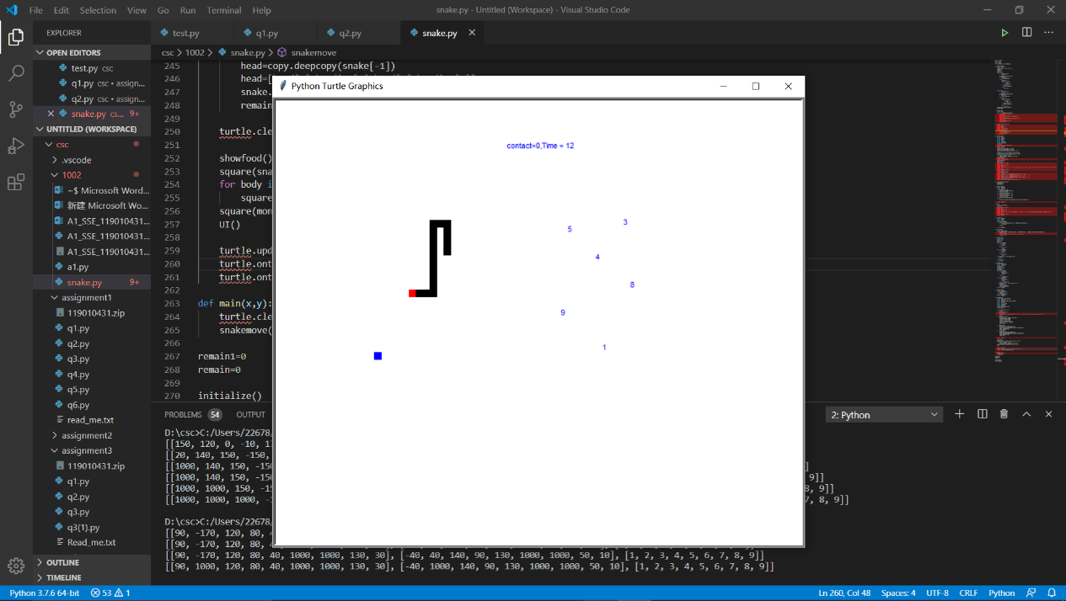4. 3 food consuimed