Report of CSC1001 Team Project
Group Members:
Zhang Junyi (119010431)
Liu Lanxi (190010191)
Chen Mengjie (119010020)

Description of data and questions we are interested in
In this project, we are required to do machine learning base on the 1119 cases in the train file. Base on the learning, our program is expected to predict whether the quality of samples in the test file is above 6. We used classification tree to do the prediction.
There are two key problems about building up our tree. First, we need to find out the order of classifying the data in each column during the decision. Second, we need to find out the way to define each node and sub-node. In each step of classification, the data in a specific column is divided into two groups by a boundary. Our aim is to make the grouped samples respectively correspond to one of the results (whether its quality mark is larger or lower than 6). We used Gini coefficient to calculate the impurity entropy after each split. The number split by which the entropy impurity is the smallest will be defined as the node. After the first round of classification, we will do a second-round base on the first round, using the same method. The procedure above will be repeatedly conducted until the tree is established.

Review of some approaches
Finding the node: The number split by which the Gini coefficient is the smallest is the node. We need to find out this number. In our previous program, we randomly picked a number within the interval formed by the maximum and the minimum of the numbers in the column, and named it test. The system will calculate the Gini coefficient if the data is split by test. Then, the test will move at a small step within its neighborhood. In the meantime, the system will calculate a new Gini and compare it with the previous one. Only if the new Gini is smaller than the last one will it be recorded. If there occurs a number such that all number within its neighborhood cause a larger Gini than the number, the number will be eventually defined as the node of the corresponding parameter. However, this method may probably find out the local minimum rather than the global minimum.
We finally use traversal to find the node. At first, the minimum of the data will be taken as the node. Then the node will be added a fixed value like 0.1 or 1. After each move, the new Gini will be calculated. The system will record the Gini values and find out the smallest one. The point with the smallest Gini will be defined as the node.
Build up the tree. In our previous program, we defined some functions performing judgement in different branches. The main function directly called these functions and do comparison to find out the accuracy. In consideration of the accuracy and readability, we chose the if-else loop to execute the judge. The tree built by if-else logic is easy to edit. Also, the result can be quickly calculated.

Principle and logic of the approach
Data of training sample is storage in a file name train.csv. One line has the eleven parameters of one sample. The reader reads all the lines. The lines will be storage in a big list alldata. The alldata consists of many sub-lists, each of which consists the eleven parameters in one single line. A sub-list represents one sample.
First, we split all samples in alldata into two groups. We seperatecly use one of the parameters excluding the quality score as the basis to split the samples and calculated the Gini respectively. By comparing between the ten results, we picked up the parameter corresponds to the smallest Gini.
Then we checked the number of samples with quality above or below 6 in both groups. We found out that when the volatile acidity is higher than 0.85, the qualities are almost all lower than or equal to 6. Thus, the wine with volatile acidity above 0.85 can be predicted as bad wine (quality <= 6). However, when the volatile acidity is lower than 0.85, we cannot accurately predict the quality. We did a double classification for the wine with violate acidity lower than 0.85. Using the same method, we found out all sub-nodes. The flow chart is shown as follows.
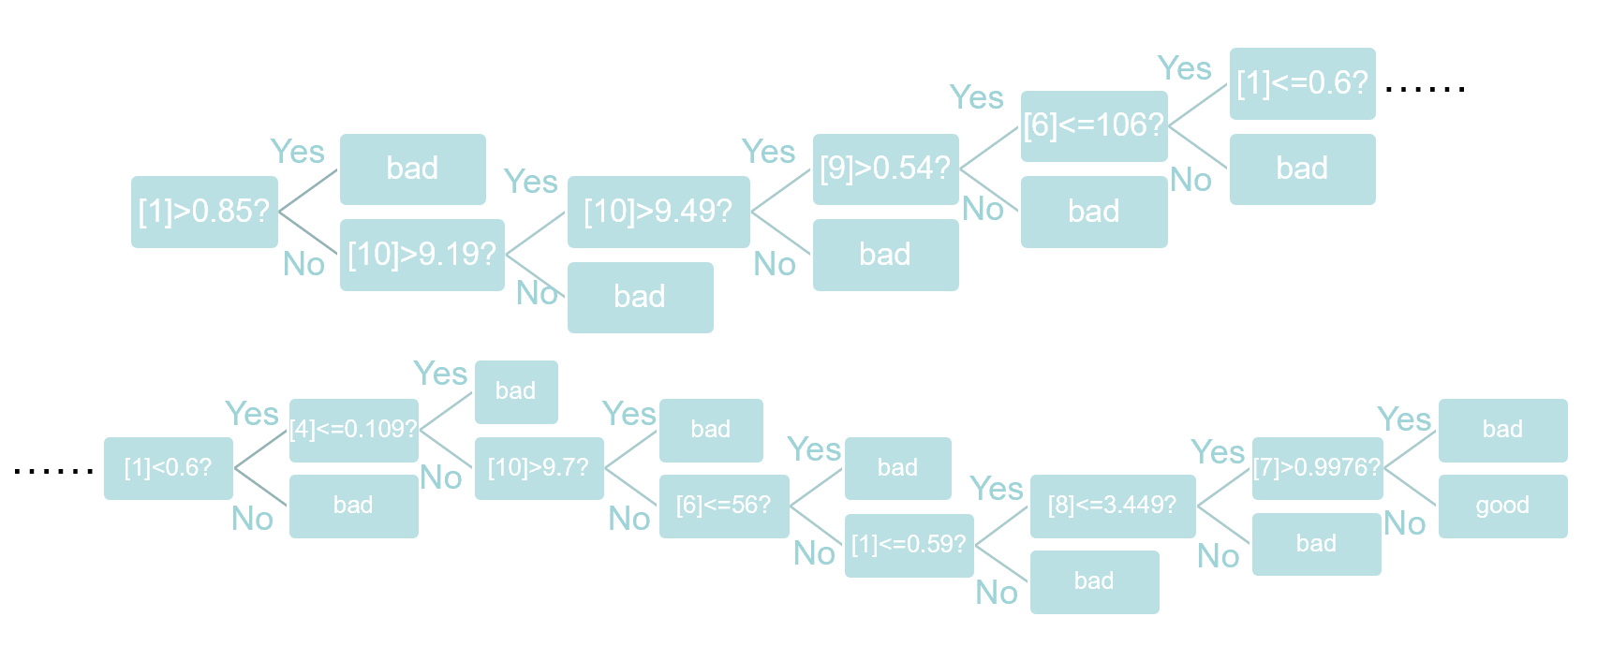
After the establishment of the tree, the program will do the judgement for all samples in the test file. When the judgement is finished, there will be an algorithm to calculate the accuracy of the prediction. First, the sub-lists will be edited. If the wine is predicted to be good wine, the list representing the wine will be appended a number 5. Else, it will be appended 7. After editing all sub-lists, the system will check whether the prediction is correct by traversal. If the 11th element of the list is below 6 when the last element is 5, or the 11th element is above 6 when the last element is 7, then the prediction is correct. Otherwise it is incorrect. There will be variables countRight and countFalse counting the total right and wrong predictions. Finally, the accuracy is calculated by the following formula.
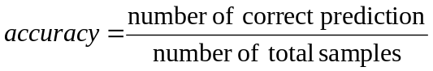
Conclusion
The accuracy of our prediction is 0.8291666666666667.

Workload Assignment
Zhang Junyi: Develop the way to define each node. Build the decision tree base on the entropy and Gini value. Adjust the parameters. Do the optimization of the whole program to improve the accuracy.
Chen Mengjie: Developed several methods to improve the efficiency of sorting the data. Offer original data to help the group define the nodes. Debug the final program. Write the report document.
Liu Lanxi: Try different accesses to build up the tree. Offer suggestions to optimize the program. Help adjusting the parameter. Write the final simulate program.

