Output from the StackTesterDriver in PP15.1 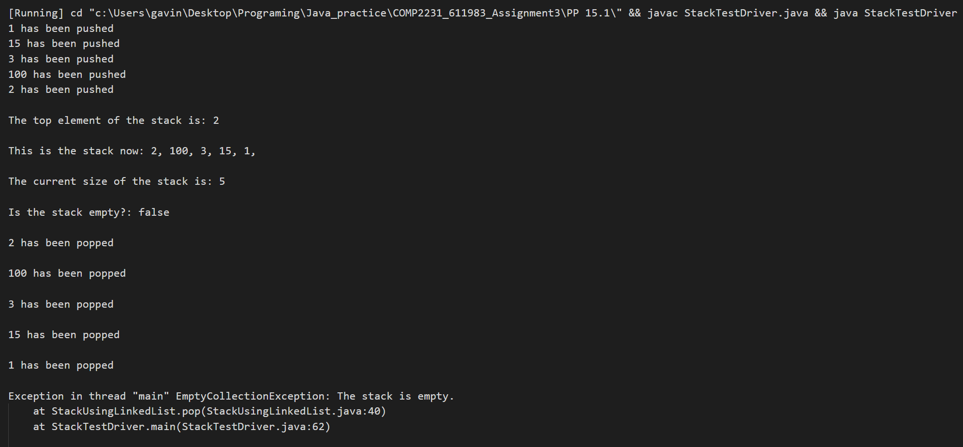

Output from the StackTesterDriver in PP15.2

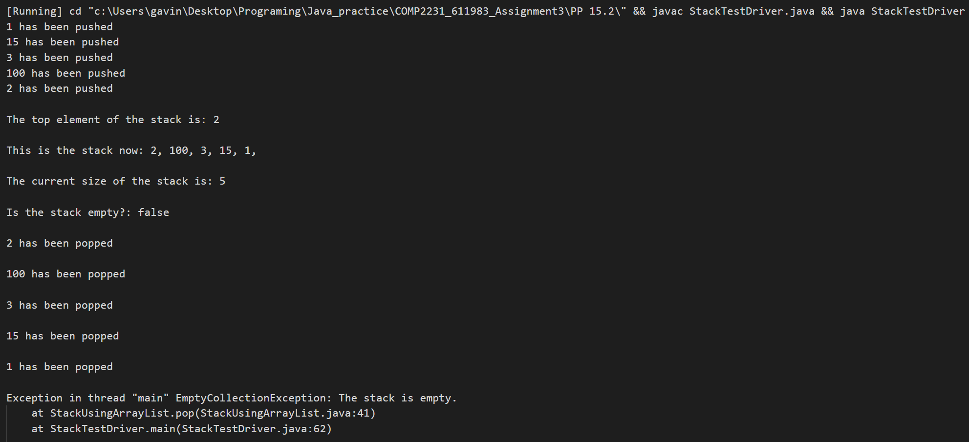

Output from the QueueTesterDriver in PP15.3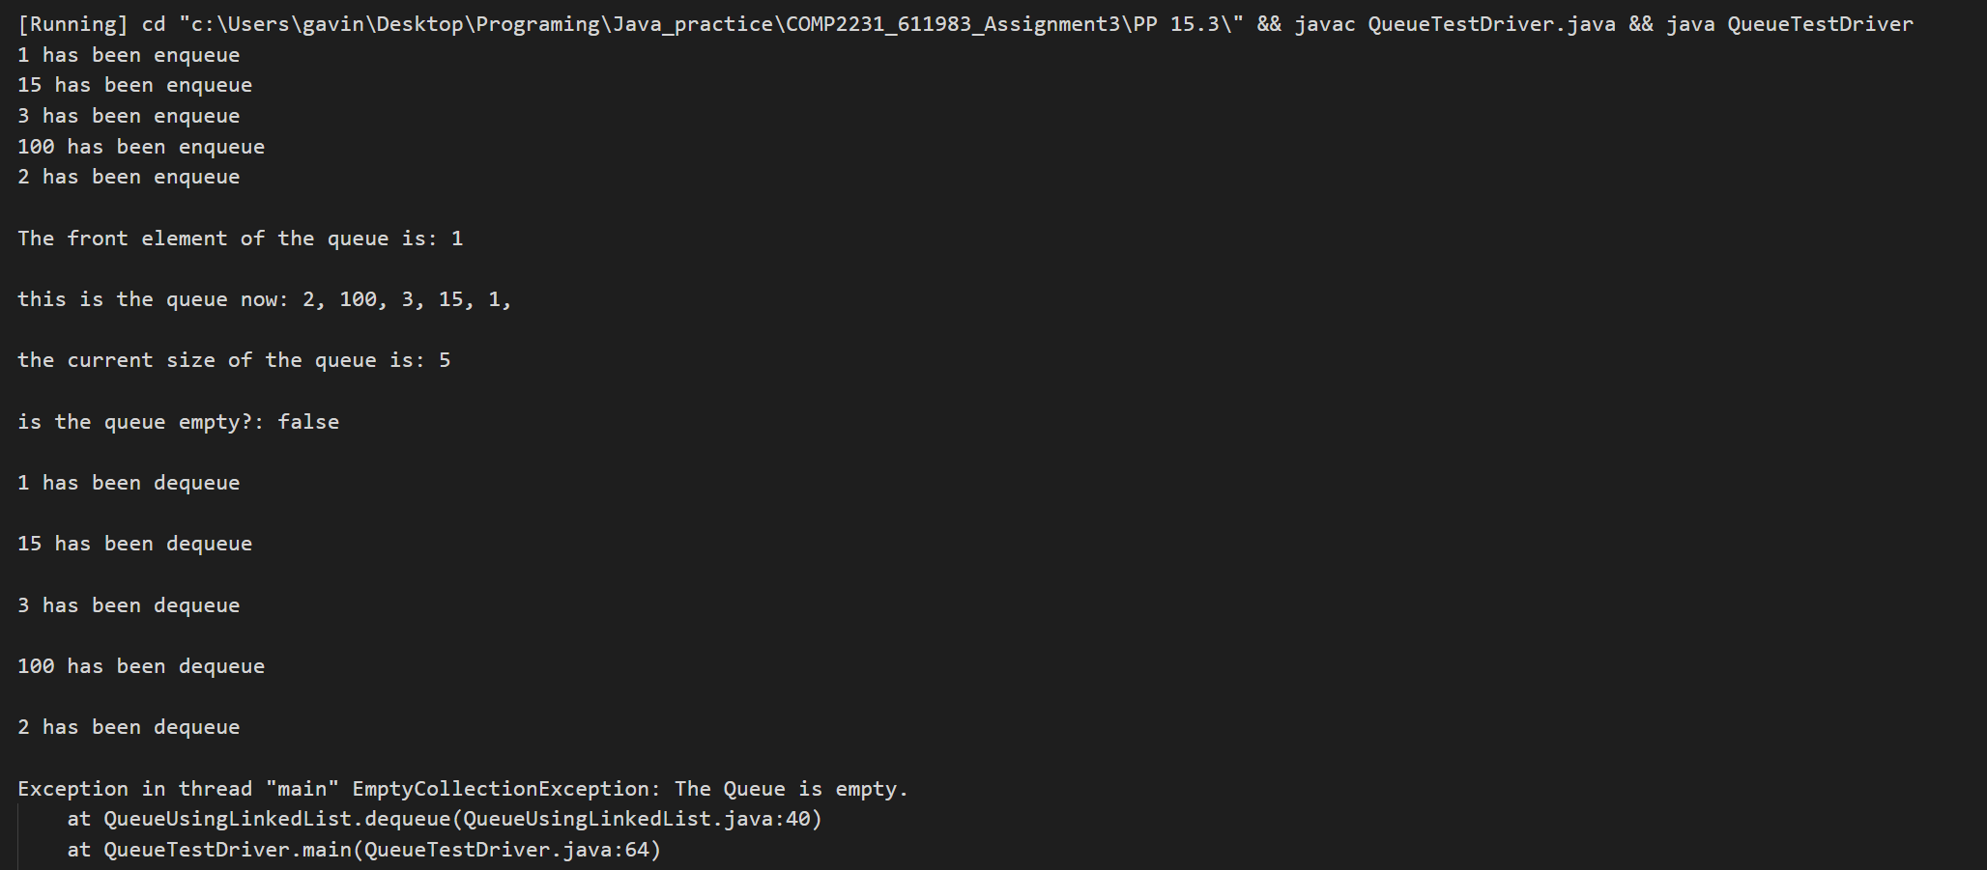

Output from the QueueTesterDriver in PP15.4