Here is a test showing that BackPainAnalyzer functions as intended

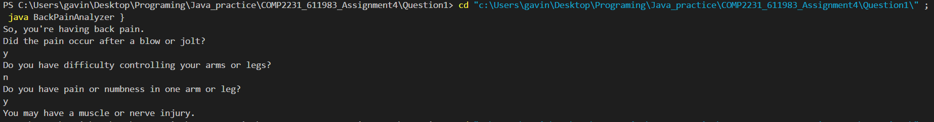

Here is another test showing that BackPainAnalyzer functions as intended

