This is a diagram the outlines the flow of the decision tree WhatPrice.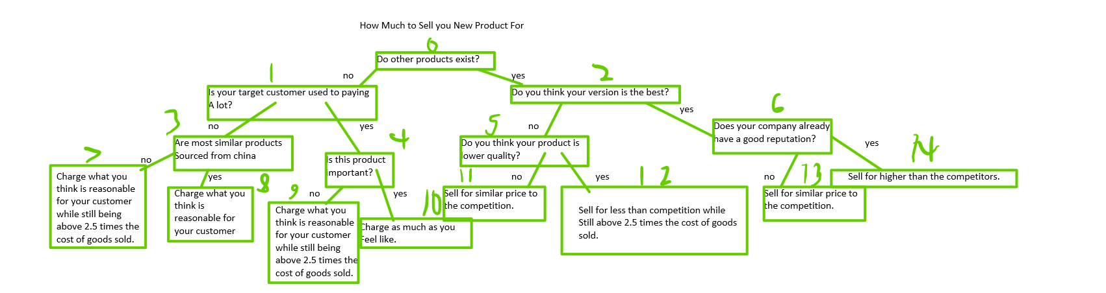

Here is a test showing that WhatPrice functions as intended

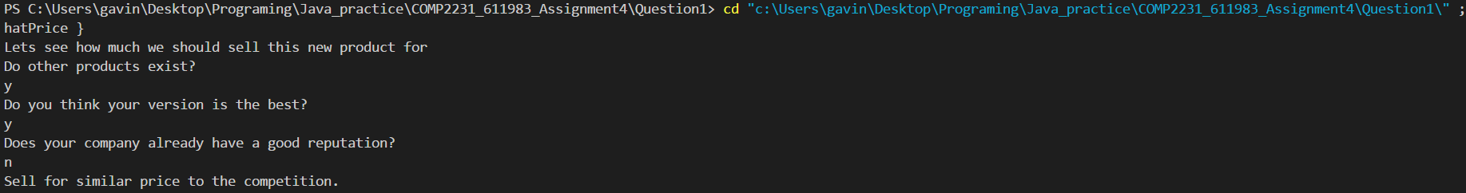

Here is another test showing that WhatPrice functions as intended

