**Fort Lewis Collage PCR Thermocycler**

James Feguson, Jesse Duran, Wesley Killinen, Jason Wagner, Caroline Kulesza, Christie Chatterley, Yiyan Li

**Abstract:**

The goal of this study was to identify critical design parameters and develop a thermocycler system that performs polymerase chain reaction (PCR). We used four 77.1 W peltier modules to adjust the temperature of the sample and a silicon heating pad to prevent sample evaporation. The system is managed by a programable logic controller (PLC) tethered to a PC. Our thermocycler correctly amplified intended genes, but also generated some unwanted byproducts. Heating and cooling speeds averaged 1.11 ± 0.33°C/s and consumed an average of 55.97 ± 0.39 W, both of which could be improved upon by increasing the number of pieltier modules and improving the selection of the system’s Proportional Integral Derivative (PID) constants.

**1. INTRODUCTION**

Polymerase chain reaction (PCR) is a vital microbiology technique in which a DNA sequence is amplified by being copied millions of times [1]. PCR has broad applications in bacteria testing, including source-tracking and identification of pathogenic strains in surface waters or blood streams [2]. By detecting the presence of specific bacteria, treatment can be swifter and more effective.

PCR is achieved using a thermocycler which heats and cools water (or blood) samples mixed with reagents for a number of cycles. A thermocycler consists of two main components: a heating block to control the temperature of the samples and a heated lid to prevent condensation on the top of the vials. Many commercial thermocyclers are available on the market; however, they are expensive, immobile, or power hungry [3].

We aimed to design hardware for a thermocycler system and identify critical design parameters. We intend that this thermocycler could be used with PCR tubes or microfluidic chambers which would allow for a flow through device. We also intend that this system will eventually be field deployable.

**2. MATERIALS AND METHODS**

**2.1 Hardware**

The following figures detail the hardware setup for this thermocycler. Fig. 1 shows images of the thermocycler. Fig. 2 shows how components are connected.

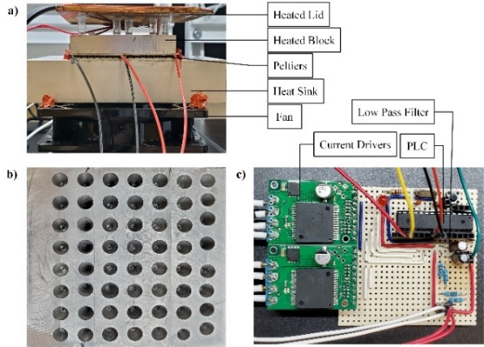

Fig.1 (a) Thermocycler setup. (b) Heating block wells. (c) Current drivers, programmable logic controller (PLC), and low pass filters mounted to a circuit board.

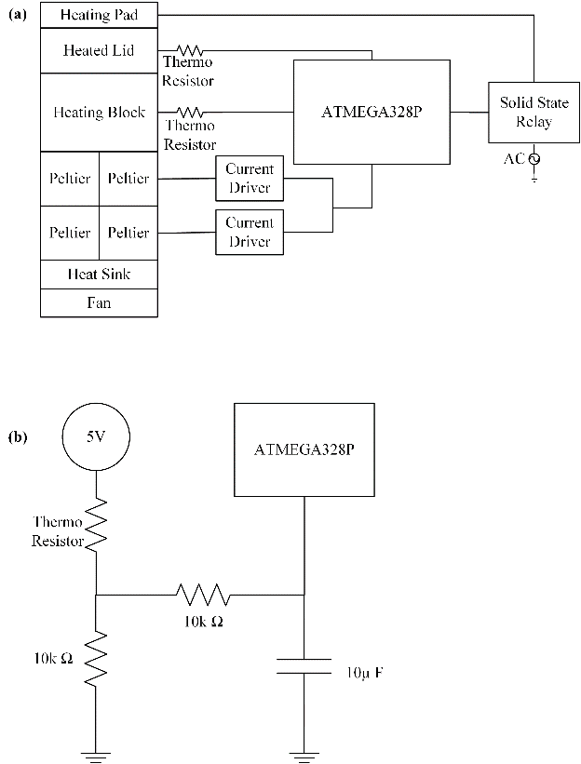

Fig.2 (a) Thermocycler hardware connection schematic. (b) Low pass filter used by the thermoresistors to stabilize analog signals.

An ATMEGA328P programmable logic controller (PLC) regulates the moment to moment temperature via four 12711-9L31-09CQ peltier modules and an AOLE ASH-25DA solid state relay (SSR) connected to a Zerostart 3400063 250 W silicone heating pad.

The heating block is constructed from 6061 aluminum with 56 wells (diameter/depth?) drilled for housing samples. Four peltiers are mounted in parallel, both electrically and physically, between the heating block and an extruded aluminum heatsink. The heatsink is cooled by a 120 mm 12 V fan. Two VNH5019 current drivers regulate voltage across each peltier module. Depending on the polarity, the peltiers will either pump heat into or out of the block. The peltiers are powered using a 15 V 600 W power supply.

The heating lid is composed of two components, the silicone heating pad and a copper plate. Copper was chosen for the plate due to its conductive properties. The silicone pad is plugged into a 120 Vrms wall socket and connected to an SSR which turns on the pad if the plate is less than 90°C. Temperatures where measured via thermoresistors on the bottom of the copper plate and inside a small hole in the heating block.

**2.2 Software**

The software consists of a Python GUI and an Arduino sketch. The GUI handles user interface and manages the cycle procedure (Figure 3a). Cycle steps are added to a cycle queue based on user defined parameters. Once the cycling process has begun cycle steps are de-queued and the cycle temperature at the front of the queue sent via USB to a PLC running the Arduino sketch.

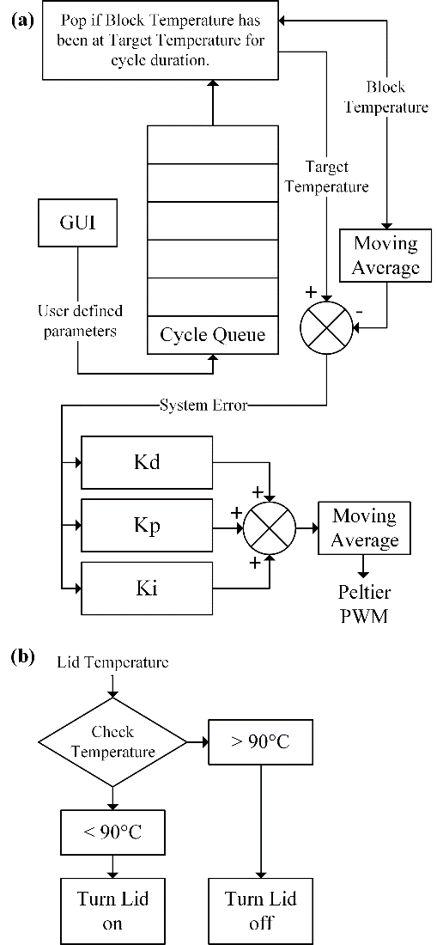



Fig. 3 Software overview. (a) Peltier control system, (b) Heated lid control system

The Arduino sketch uses an altered version of Proportional Integral Derivative (PID) control where multiple sets of PID constants are used to manage temperature. This was done to account for non-linearities in the heating and cooling process. PID constants were chosen with the following goals in mind: the system should be fast to improve total process time and be able to maintain accurate temperatures, so PCR reactions happen efficiently. It should also not oscillate so power consumption is reduced and unnecessary waste heat is not generated, which would further hurt the ability of the system to cool. The constants used are described in Table 1.

Table 1 Gains for PID system

|  |  |  |  |
| --- | --- | --- | --- |
| Target Step | Kp | Ki | Kd |
| 94°C → 60.5°C | 19 | 0.2 | 10000000 |
| 60.5°C → 72°C | 9 | 0.17 | 10000000 |
| 72°C → 94°C | 9 | 0.4 | 10000000 |

After PID calculation, this signal is converted into pulse width modulation (PWM) and direction signals for the two VNH5019 chips.

Signal noise became a problem after increasing the derivative gain. In order to stop oscillation, the derivative gain needed to be very high which also caused some stability issues due to noise also being amplified. To reduce noise, low pass filters were applied to thermoresistor signals and moving averages were applied to the block temperature and peltier PWM.

**2.3 PCR Experiment**

Colony PCR was performed on *E. coli* K12 using primer pairs to amplify the ybbW or uidA gene. The ybbW primer sequences were designed using MacVector software v17.0.10. The ybbW primer sequences are as follows: ybbWforward, 5’-TCAGCGCCTTTTTCATTGCC-3’ and ybbWre­verse, 5’-CCGCGTAACATTGCAAACCA-3’. The uidA primer sequences were derived from a published study [2] and were as follows: uidAforward, 5’-CGGAAGCAACGCGTAAACTC-3’ and uidAre­verse, 5’-TGAGCGTCGCAGAACATTACA-3’.

All PCR reactions used OneTaq 2X Master Mix (NEB) and primers at 0.25uM. Cycling conditions were 95°C for 5min, followed by 35 cycles of 95°C for 1min, 60.5°C for 1min, 72°C for 1min. Products were stored at 4°C until analysis by 1% TBE agarose gel electrophoresis.

This experiment will be performed by our thermocycler to test if it works and a Bio-Rad T100 Thermal Cycler for use as a control.

**3.RESULTS**

**3.1 PCR Reaction Results**

As shown in Fig. 4, PCR products were successfully and correctly amplified from the ybbW and uidA genes of *E. coli* K12 in both thermocyclers. In both thermocyclers, amplification of ybbW yielded a specific product of 177bp and amplification of uidA yielded a specific product of 70 bp.



Fig. 4 Agarose gel electrophoresis analysis of ybbW and uidA PCR products generated in a Bio-Rad T100 thermocyler (left panel) and our system (right panel). PCR reactions containing template are noted (+), no template controls are noted (-). Bright band in 100bp ladder is 500bp long.

**3.2 Cycling Performance**

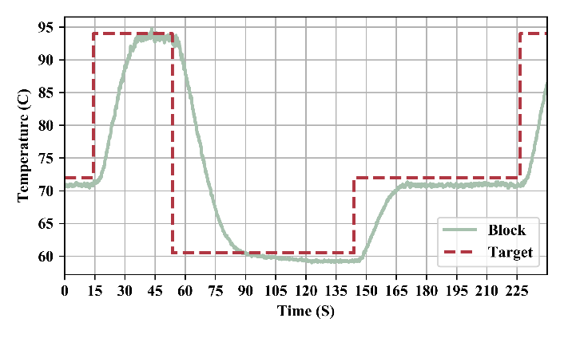

Fig. 5 A typical thermal cycle with target and measured heating block temperature for the experimental conditions described in section 2.3.

The average time this system took to arrive within 2°C of target temperature are presented in Figure 1. As there was no ramp for the start of the first cycle or for the end of the last cycle, only the middle 33 cycles were included in the average.

|  |  |
| --- | --- |
| Target Step | Ramp Duration CI 95 |
| 94°C → 60.5°C | 29.94 ± 0.19 s |
| 60.5°C → 72°C | 23.33 ± 0.22 s |
| 72°C → 94°C | 20.44 ± 0.16 s |

Table 2 average system temperature ramp times.

**3.3 Heated Lid**

The time it took to get the lid to target temperature was 69 seconds compared to 2min 17s for the Bio-Rad T100 thermocycler. The lid continued to heat after the SSR was switched off due to the residual heat in the silicon pad. After 300 seconds, the oscillation in temperature settled within 10°C above the target temperature (Figure 6).

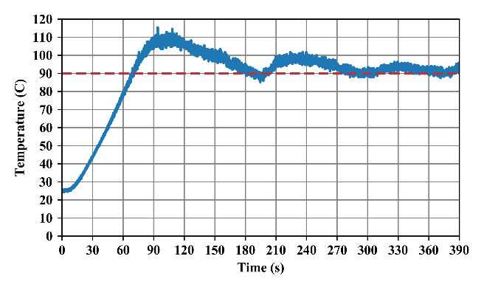

Fig. 6 Heated lid temperature warming from room temperature to target temperature of 90°C

**3.4 Peltier Power Consumption**

As shown in Fig. 7, when increasing the number of pieties physically in parallel and decreasing the applied voltage across them, both reduced power consumption and improved thermal performance resulting in improved efficacy.

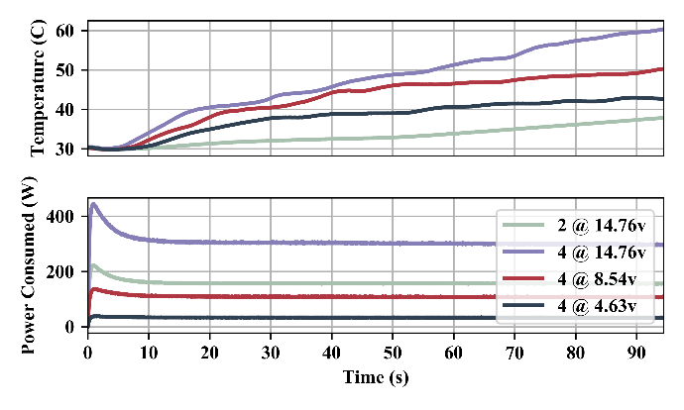

Fig. 7 Hot side temperature and maximum power consumption of various peltier configurations heating 16oz of tap water.

During cycle routine described in section 2.3, this system consumed an average of 55.97 ± 0.39 W CI 95 with peak consumption reaching 458.55 W.

**4. DISCUSSION**

**4.1 PCR Reaction Results**

Our PCR system correctly amplified *E. coli* K12 genes. There was however some non-specific binding of primers, which is likely due to temperature inaccuracies in both unknown measurement error and system steady state error which was about 1°C.

**4.2 Cycling Performance**

Our system had an average ramp rate of 1.11 ± 0.33°C/s. Compared to a Bio-Rad T100 Thermal Cycler which has an average ramp rate of 2.5°C/s [4]. Our system took a little more than twice as long to perform the same temperature ramp.

During system testing we noted that cooling performance would significantly slow over time for cycle procedures that ran at higher frequencies. It is believed that this was caused by the heatsink not being fast enough at dissipating heat. As such a we should switch to a heatsink that is faster at dissipating heat

**4.3 Further Design**

Overshoot of the heated lid temperature could be improved by adding PID control to reach the target temperature without overshoot. PWM may be used to simulate an analog signal going to the SSR. The PID system for the peltiers could also be better tuned to achieve faster speed and reduce steady state error as well as generalized to work with other cycle parameters. A redesigned heating block could be more space efficient allowing for less mass to be heated unnecessarily.

The system could also be improved by increasing the number of peltiers to achieve greater thermal performance and power efficiency.

**5. REFERENCES**

[1] L. Garibyan and N. Avashia, “Research Techniques Made Simple: Polymerase Chain Reaction (PCR)”, Journal of Investigative Dermatology, Vol. 133, no. 3, pp. 1-4, 2013.

[2] D. I. Walker, J. Mcquillan, M. Taiwo, R. Parks, C. A. Stenton, H. Morgan, M. C. Mowlem, and D. N. Lees, “A highly specific Escherichia coli qPCR and its comparison with existing methods for environmental waters,” Water Research, vol. 126, pp. 101–110, 2017. Available: <http://doi.org/10.1016/j.watres.2017.08.032>

[3] P. Belgrades, W. Benett, D. Hadley, J. Richards, P. Stratton, R. Meriella, and F. Mlanovich,”PCR Detection of Bacteria in Seven Minutes”, Science, vol.284, no. 5413, pp 449-450, 1999.

[4] “T100™ Thermal Cycler.” [Online]. Available: https://www.bio-rad.com/en-us/product/t100-thermal-cycler?ID=LGTWGIE8Z. [Accessed: 21-Jan-2020].