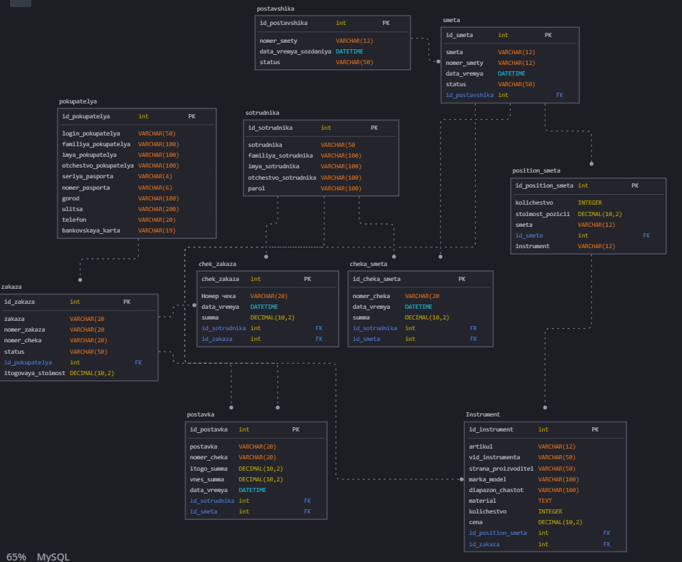
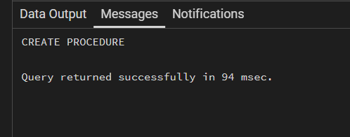
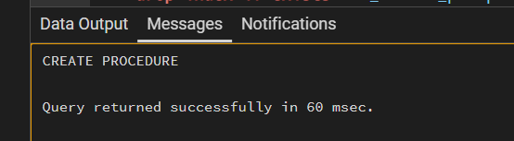

Физическое название | Тип данных | Обязательный |  | Ограничения | Скрипт
ИНСТРУМЕНТ
Id_instrument | int | да | Сурргоатный ключ |  | create table if not exists Instrument (id_instrument int not null constraint PK_instrument primary key, artikul varchar(12) not null, vid_instrumenta varchar(50) not null, strana_proizvoditel varchar(50), marka_model varchar(100), diapazon_chastot varchar(100), material text, kolichestvo integer not null, cena decimal(10,2) not null, id_position_smeta int constraint FK_instrument_position references position_smeta(id_position_smeta), id_zakaza int constraint FK_instrument_zakaz references zakaza(id_zakaza));
artikul | VARCHAR(12) | Да |  | PRIMARY KEY, UNIQUE, PATTERN 'МТ№[0-9]{10}'
vid_instrumenta | VARCHAR(50) | Да |  | Уникальное
strana_proizvoditel | VARCHAR(50) | Да |  | Уникальное
marka_model | VARCHAR(100) | Да |  | Уникальное
diapazon_chastot | VARCHAR(100) | Да |  | Уникаольное
material | TEXT | Да |  | Уникаольное
kolichestvo | INTEGER | Да |  | CHECK (kolichestvo >= 0)
cena | DECIMAL(10,2) | Да
СОТРУДНИК
Id_sotrudnika | int | да |  | Суррогатный ключ | create table if not exists sotrudnika (id_sotrudnika int not null constraint PK_sotrudnika primary key, sotrudnika varchar(50) not null, familiya_sotrudnika varchar(100) not null, imya_sotrudnika varchar(100) not null, otchestvo_sotrudnika varchar(100), parol varchar(100) not null);
login_sotrudnika | VARCHAR(50) | Да |  | PRIMARY KEY, UNIQUE, LENGTH >= 8
familiya_sotrudnika | VARCHAR(100) | Да |  | Уникальное
imya_sotrudnika | VARCHAR(100) | Да |  | Уникальное
otchestvo_sotrudnika | VARCHAR(100) | Да |  | DEFAULT '-', CHECK (otchestvo_sotrudnika != '')
parol | VARCHAR(100) | Да |  | LENGTH >= 8, PATTERN: минимум 1 заглавная, 1 строчная латинская буква, 1 цифра, 1 спецсимвол
ПОСТАВЩИК
id_postavshika | int | да |  | Сурргоатный ключ | create table if not exists postavshika (id_postavshika int not null constraint PK_postavshika primary key, nomer_smetry varchar(12) not null, data_vremya_sozdaniya datetime not null, status varchar(50) not null);
nomer_smety | VARCHAR(12) | Да |  | PRIMARY KEY, UNIQUE, PATTERN 'СМ№[0-9]{9}'
okpo_postavshika | VARCHAR(10) | Да |  | FOREIGN KEY
status | VARCHAR(50) | Да |  | CHECK (status IN ('Закрыт', 'В рассмотрении', 'Оплачен'))
data_vremya_sozdaniya | DATETIME | Да |  | Не ноль
ПОКУПАТЕЛЬ
Id_pokupatelya | int | да |  | Суррготаный ключ | create table if not exists pokupatelya (id_pokupatelya int not null constraint PK_pokupatelya primary key, login_pokupatelya varchar(50) not null, familiya_pokupatelya varchar(100) not null, imya_pokupatelya varchar(100) not null, otchestvo_pokupatelya varchar(100), seriya_pasporta varchar(4), nomer_pasporta varchar(6), gorod varchar(100), ulitsa varchar(200), telefon varchar(20), bankovskaya_karta varchar(19)); | 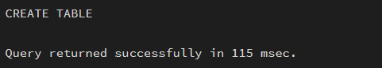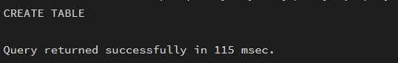
login_pokupatelya | VARCHAR(50) | Да |  | PRIMARY KEY, UNIQUE, LENGTH >= 8
familiya_pokupatelya | VARCHAR(100) | Да |  | Уникальное
imya_pokupatelya | VARCHAR(100) | Да |  | УНикальное
otchestvo_pokupatelya | VARCHAR(100) | Да |  | DEFAULT '-', CHECK (otchestvo_pokupatelya != '')
seriya_pasporta | VARCHAR(4) | Да |  | PATTERN '[0-9]{4}'
nomer_pasporta | VARCHAR(6) | Да |  | PATTERN '[0-9]{6}'
gorod | VARCHAR(100) | Да |  | Уникальное
ulitsa | VARCHAR(200) | Да |  | Уникальное
telefon | VARCHAR(20) | Да |  | PATTERN телефонного номера
bankovskaya_karta | VARCHAR(19) | Да |  | PATTERN номера карты
СМЕТА
Id_smeta | int | да |  | Суррогатный ключ | create table if not exists smeta (id_smeta int not null constraint PK_smeta primary key, smeta varchar(12) not null, nomer_smetry varchar(12) not null, data_vremya datetime not null, status varchar(50) not null, id_postavshika int not null constraint FK_smeta_postavshika references postavshika(id_postavshika));
nomer_smety | VARCHAR(12) | Да |  | PRIMARY KEY, UNIQUE, PATTERN 'СМ№[0-9]{9}'
okpo_postavshika | VARCHAR(10) | Да |  | FOREIGN KEY (ссылка на ПОСТАВЩИК)
data_vremya_sozdania | DATETIME | Да |  | Не ноль
status | VARCHAR(50) | Да |  | CHECK (status IN ('Закрыт', 'В рассмотрении', 'Оплачен'))
ПОЗИЦИЯ_СМЕТЫ
Id_position_smeta | int | да |  | Суррогатный ключ | create table if not exists position_smeta (id_position_smeta int not null constraint PK_position_smeta primary key, kolichestvo integer not null, stoimost_pozitsii decimal(10,2) not null, smeta varchar(12) not null, id_smeta int not null constraint FK_position_smeta_smeta references smeta(id_smeta), instrument varchar(12) not null);
nomer_smety | VARCHAR(12) | Да |  | FOREIGN KEY (ссылка на СМЕТА)
kolichestvo | INTEGER | Да |  | kolichestvo > 0
stoimost_pozicii | DECIMAL(10,2) | Да |  | stoimost_pozicii >= 0
instrument | VARCHAR(12) | Да |  | FOREIGN KEY
ЧЕК_СМЕТЫ
id_cheka_smeta | int | да |  | суррогатный | create table if not exists cheka_smeta (id_cheka_smeta int not null constraint PK_cheka_smeta primary key, nomer_cheka varchar(20) not null, data_vremya datetime not null, summa decimal(10,2) not null, id_sotrudnika int not null constraint FK_cheka_smeta_sotrudnik references sotrudnika(id_sotrudnika), id_smeta int not null constraint FK_cheka_smeta_smeta references smeta(id_smeta));
nomer_cheka | VARCHAR(20) | Да |  | PRIMARY KEY, UNIQUE, PATTERN 'КЧ/[0-9]{2}/[0-9]{11}'
nomer_smety | VARCHAR(12) | Да |  | FOREIGN KEY UNIQUE
summa | DECIMAL(10,2) | Да |  | summa >= 0
login_sotrudnika | VARCHAR(50) | Да |  | FOREIGN KEY
data_vremya_sozdaniya | DATETIME | Да |  | Не ноль
ЗАКАЗ
Id_zakaza | int | да |  | Суррогатный ключ | create table if not exists zakaza (id_zakaza int not null constraint PK_zakaza primary key, zakaza varchar(20) not null, nomer_zakaza varchar(20) not null, nomer_cheka varchar(20), status varchar(50), id_pokupatelya int not null constraint FK_zakaza_pokupatelya references pokupatelya(id_pokupatelya), itogovaya_stoimost decimal(10,2));
nomer_zakaza | VARCHAR(20) | Да |  | PRIMARY KEY, UNIQUE, PATTERN
login_pokupatelya | VARCHAR(50) | Да |  | FOREIGN KEY
data_vremya | DATETIME | Да |  | Не ноль
itogovaya_stoimost | DECIMAL(10,2) | Да |  | (itogovaya_stoimost >= 0
Чек_ЗАКАЗА
Id_check_zakaza | int | да |  | Суррргатный | create table if not exists chek_zakaza (id_chek_zakaza int not null constraint PK_chek_zakaza primary key, nomer_cheka varchar(20) not null, data_vremya datetime not null, summa decimal(10,2) not null, id_sotrudnika int not null constraint FK_chek_zakaza_sotrudnik references sotrudnika(id_sotrudnika), id_zakaza int not null constraint FK_chek_zakaza_zakaz references zakaza(id_zakaza));
nomer_zakaza | VARCHAR(20) | Да |  | FOREIGN KEY
nomer_cheka | VARCHAR(20) | Да |  | PRIMARY KEY, UNIQUE, PATTERN
data_vremya | DATETIME | Да |  | Не ноль
login_sotrudnika | VARCHAR(50) | Да |  | FOREIGN KEY
summa | DECIMAL(10,2) | Да |  | summa >= 0

Физическое название | Тип данных | Обязательный |  | Ограничения
ИНСТРУМЕНТ
Id_instrument | int | да | Сурргоатный ключ |  | create index if not exists idx_instrument_id on Instrument(id_instrument);
artikul | VARCHAR(12) | Да |  | PRIMARY KEY, UNIQUE, PATTERN 'МТ№[0-9]{10}' | create index if not exists idx_instrument_artikul on Instrument(artikul);
vid_instrumenta | VARCHAR(50) | Да |  | Уникальное | create index if not exists idx_instrument_artikul on Instrument(artikul);
strana_proizvoditel | VARCHAR(50) | Да |  | Уникальное
marka_model | VARCHAR(100) | Да |  | Уникальное
diapazon_chastot | VARCHAR(100) | Да |  | Уникаольное
material | TEXT | Да |  | Уникаольное
kolichestvo | INTEGER | Да |  | CHECK (kolichestvo >= 0)
cena | DECIMAL(10,2) | Да
СОТРУДНИК
Id_sotrudnika | int | да |  | Суррогатный ключ | create index if not exists idx_sotrudnika_id on sotrudnika(id_sotrudnika);
login_sotrudnika | VARCHAR(50) | Да |  | PRIMARY KEY, UNIQUE, LENGTH >= 8 | create index if not exists idx_sotrudnika_fio on sotrudnika(familiya_sotrudnika, imya_sotrudnika, otchestvo_sotrudnika);
familiya_sotrudnika | VARCHAR(100) | Да |  | Уникальное
imya_sotrudnika | VARCHAR(100) | Да |  | Уникальное
otchestvo_sotrudnika | VARCHAR(100) | Да |  | DEFAULT '-', CHECK (otchestvo_sotrudnika != '')
parol | VARCHAR(100) | Да |  | LENGTH >= 8, PATTERN: минимум 1 заглавная, 1 строчная латинская буква, 1 цифра, 1 спецсимвол
ПОСТАВЩИК
id_postavshika | int | да |  | Сурргоатный ключ | create index if not exists idx_postavshika_id on postavshika(id_postavshika);
nomer_smety | VARCHAR(12) | Да |  | PRIMARY KEY, UNIQUE, PATTERN 'СМ№[0-9]{9}' | create index if not exists idx_postavshika_nomer on postavshika(nomer_smetry);
okpo_postavshika | VARCHAR(10) | Да |  | FOREIGN KEY
status | VARCHAR(50) | Да |  | CHECK (status IN ('Закрыт', 'В рассмотрении', 'Оплачен'))
data_vremya_sozdaniya | DATETIME | Да |  | Не ноль
ПОКУПАТЕЛЬ
Id_pokupatelya | int | да |  | Суррготаный ключ | create index if not exists idx_pokupatelya_id on pokupatelya(id_pokupatelya);
login_pokupatelya | VARCHAR(50) | Да |  | PRIMARY KEY, UNIQUE, LENGTH >= 8 | create index if not exists idx_pokupatelya_login on pokupatelya(login_pokupatelya);
familiya_pokupatelya | VARCHAR(100) | Да |  | Уникальное | create index if not exists idx_pokupatelya_fio on pokupatelya(familiya_pokupatelya, imya_pokupatelya, otchestvo_pokupatelya);
imya_pokupatelya | VARCHAR(100) | Да |  | УНикальное
otchestvo_pokupatelya | VARCHAR(100) | Да |  | DEFAULT '-', CHECK (otchestvo_pokupatelya != '')
seriya_pasporta | VARCHAR(4) | Да |  | PATTERN '[0-9]{4}'
nomer_pasporta | VARCHAR(6) | Да |  | PATTERN '[0-9]{6}'
gorod | VARCHAR(100) | Да |  | Уникальное
ulitsa | VARCHAR(200) | Да |  | Уникальное
telefon | VARCHAR(20) | Да |  | PATTERN телефонного номера
bankovskaya_karta | VARCHAR(19) | Да |  | PATTERN номера карты
СМЕТА
Id_smeta | int | да |  | Суррогатный ключ | create index if not exists idx_zakaza_nomer on zakaza(nomer_zakaza);
nomer_smety | VARCHAR(12) | Да |  | PRIMARY KEY, UNIQUE, PATTERN 'СМ№[0-9]{9}' | create index if not exists idx_smeta_nomer on smeta(nomer_smetry);
okpo_postavshika | VARCHAR(10) | Да |  | FOREIGN KEY (ссылка на ПОСТАВЩИК)
data_vremya_sozdania | DATETIME | Да |  | Не ноль
status | VARCHAR(50) | Да |  | CHECK (status IN ('Закрыт', 'В рассмотрении', 'Оплачен'))
ПОЗИЦИЯ_СМЕТЫ
Id_position_smeta | int | да |  | Суррогатный ключ | create index if not exists idx_position_smeta_id on position_smeta(id_position_smeta);
nomer_smety | VARCHAR(12) | Да |  | FOREIGN KEY (ссылка на СМЕТА)
kolichestvo | INTEGER | Да |  | kolichestvo > 0
stoimost_pozicii | DECIMAL(10,2) | Да |  | stoimost_pozicii >= 0
instrument | VARCHAR(12) | Да |  | FOREIGN KEY
ЧЕК_СМЕТЫ
id_cheka_smeta | int | да |  | суррогатный | create index if not exists idx_cheka_smeta_id on cheka_smeta(id_cheka_smeta);
nomer_cheka | VARCHAR(20) | Да |  | PRIMARY KEY, UNIQUE, PATTERN 'КЧ/[0-9]{2}/[0-9]{11}' | create index if not exists idx_cheka_smeta_nomer on cheka_smeta(nomer_cheka);
nomer_smety | VARCHAR(12) | Да |  | FOREIGN KEY UNIQUE
summa | DECIMAL(10,2) | Да |  | summa >= 0
login_sotrudnika | VARCHAR(50) | Да |  | FOREIGN KEY
data_vremya_sozdaniya | DATETIME | Да |  | Не ноль
ЗАКАЗ
Id_zakaza | int | да |  | Суррогатный ключ | create index if not exists idx_zakaza_id on zakaza(id_zakaza)
nomer_zakaza | VARCHAR(20) | Да |  | PRIMARY KEY, UNIQUE, PATTERN | create index if not exists idx_zakaza_nomer on zakaza(nomer_zakaza);
login_pokupatelya | VARCHAR(50) | Да |  | FOREIGN KEY
data_vremya | DATETIME | Да |  | Не ноль
itogovaya_stoimost | DECIMAL(10,2) | Да |  | (itogovaya_stoimost >= 0
Чек_ЗАКАЗА
Id_check_zakaza | int | да |  | Суррргатный | create index if not exists idx_chek_zakaza_id on chek_zakaza(id_chek_zakaza);
nomer_zakaza | VARCHAR(20) | Да |  | FOREIGN KEY
nomer_cheka | VARCHAR(20) | Да |  | PRIMARY KEY, UNIQUE, PATTERN | create index if not exists idx_chek_zakaza_nomer on chek_zakaza(nomer_cheka);
data_vremya | DATETIME | Да |  | Не ноль
login_sotrudnika | VARCHAR(50) | Да |  | FOREIGN KEY
summa | DECIMAL(10,2) | Да |  | summa >= 0

Роли |  | Менеджер | Кассир | Склад раб | Администратор
Название обьекта | Функции
pokupatelya | Выборка | X | X | X | X
 | Добавление | X |  |  | X
 | Изменение | X |  |  | X
 | Удаление |  |  |  | X
sotrudnika | Выборка |  |  |  | X
 | Добавление |  | X |  | X
 | Изменение | X |  |  | X
 | Удаление |  |  |  | X
postavshika | Выборка | X |  |  | X
 | Добавление | X |  |  | X
 | Изменение | X |  |  | X
 | Удаление | X |  |  | X
zakaza | Выборка | X | X | X | X
 | Добавление | X | X |  | X
 | Изменение | X |  |  | X
 | Удаление |  |  |  | X
 |  |  |  |  | X
smeta | Выборка | X |  |  | X
 | Добавление | X |  |  | X
 | Изменение | X |  |  | X
 | Удаление |  |  |  | X
position_smeta | Выборка | X |  | X | X
 | Добавление | X |  |  | X
 | Изменение | X |  |  | X
 | Удаление |  |  |  | X
chek_zakaza | Выборка | X | X |  | X
 | Добавление |  | X |  | X
 | Изменение |  |  |  | X
 | Удаление |  |  |  | X
cheka_smeta | Выборка | X |  |  | X
 | Добавление | X |  |  | X
 | Изменение |  |  |  | X
 | Удаление |  |  |  | X
postavka | Выборка | X |  | X | X
 | Добавление | X |  | X | X
 | Изменение | X |  |  | X
 | Удаление |  |  |  | X
Instrument | Выборка | X |  | X | X
 | Добавление | X |  | X | X
 | Изменение | X |  | X | X
 | Удаление |  |  |  | X

Название роли | Название обьекта | Функции | скрипт
rl_manager_zakupok | pokupatelya | Select, Insert, Update | grant select, insert, update on pokupatelya to rl_manager_zakupok;
 | postavshika | Select, Insert, Update | grant select, insert, update on postavshika to rl_manager_zakupok
 | zakaza | Select, Insert, Update | grant select, insert, update on zakaza to rl_manager_zakupok;
 | smeta | Select, Insert, Update | grant select, insert, update on zakaza to rl_manager_zakupok;
 | position_smeta | Select, Insert, Update | grant select, insert, update on position_smeta to rl_manager_zakupok;
 | cheka_smeta | Select, Insert | grant select, insert on cheka_smeta to rl_manager_zakupok;
 | postavka | Select, Insert, Update | grant select, insert, update on postavka to rl_manager_zakupok;
 | Instrument | Select, Insert, Update | grant select, insert, update on Instrument to rl_manager_zakupok;
rl_kassir | pokupatelya | Select | grant select on pokupatelya to rl_kassir;
 | zakaza | Select, Insert | grant select, insert on zakaza to rl_kassir;
 | chek_zakaza | Select, Insert | grant select, insert on chek_zakaza to rl_kassir;
rl_skladskoy | zakaza | Select | grant select on zakaza to rl_skladskoy;
 | position_smeta | Select | grant select on position_smeta to rl_skladskoy;
 | postavka | Select, Insert | grant select, insert on postavka to rl_skladskoy;
 | Instrument | Select, Insert, Update | grant select, insert, update on Instrument to rl_skladskoy;
rl_administrator | pokupatelya | ALL | grant all privileges on pokupatelya to rl_administrator;
 | sotrudnika | ALL | grant all privileges on sotrudnika to rl_administrator;
 | postavshika | ALL | grant all privileges on postavshika to rl_administrator;
 | zakaza | ALL | grant all privileges on zakaza to rl_administrator;
 | smeta | ALL | grant all privileges on smeta to rl_administrator;
 | position_smeta | ALL | grant all privileges on position_smeta to rl_administrator;
 | chek_zakaza | ALL | grant all privileges on chek_zakaza to rl_administrator;
 | cheka_smeta | ALL | grant all privileges on cheka_smeta to rl_administrator;
 | postavka | ALL | grant all privileges on postavka to rl_administrator;
 | Instrument | ALL | grant all privileges on Instrument to rl_administrator;

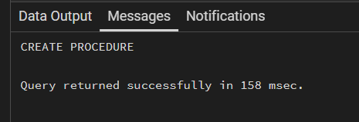

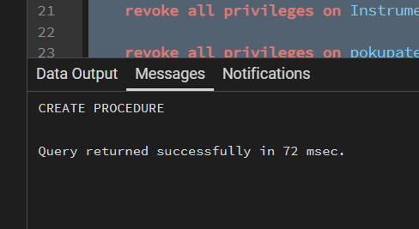

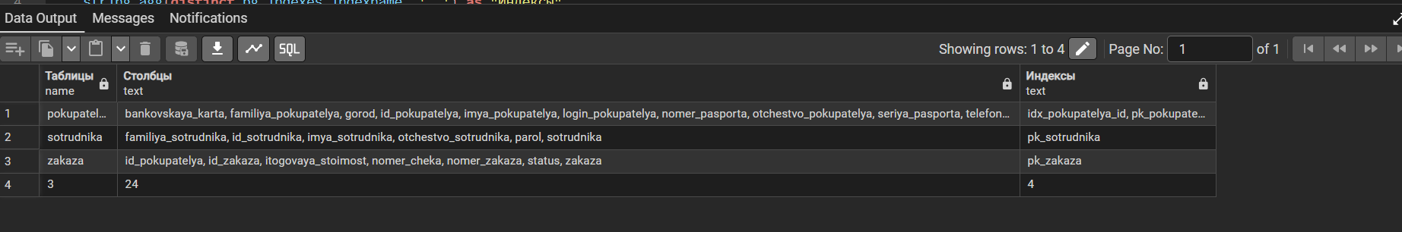

select
information_schema.tables.table_name as "Таблицы",
string_agg(distinct information_schema.columns.column_name, ', ') as "Столбцы",
string_agg(distinct pg_indexes.indexname, ', ') as "Индексы"
from information_schema.tables
inner join information_schema.columns
on information_schema.columns.table_name = information_schema.tables.table_name
left join pg_indexes
on information_schema.tables.table_name = pg_indexes.tablename
where
information_schema.tables.table_schema = 'public'
and table_type = 'BASE TABLE'
group by information_schema.tables.table_name
union all
select
(select count(*)::text from information_schema.tables where table_schema = 'public' and table_type = 'BASE TABLE'),
(select count(information_schema.columns.column_name)::text
from information_schema.tables
inner join information_schema.columns on information_schema.columns.table_name = information_schema.tables.table_name
where information_schema.tables.table_schema = 'public'),
(select count(pg_indexes.indexname)::text
from information_schema.tables
inner join pg_indexes on information_schema.tables.table_name = pg_indexes.tablename
where information_schema.tables.table_schema = 'public');
Параметры | PostgreSQL
Номер версии | 1.0.0.1
Что сделано | - • Созданы 10 таблиц: pokupatelya, sotrudnika, postavshika, zakaza, smeta, position_smeta, chek_zakaza, cheka_smeta, postavka, Instrument  • Созданы 47 столбцов и 12 межтабличных связей (внешних ключей)  • Созданы 23 индекса (включая первичные ключи)  • Произведено распределение доступа 4 ролям: rl_manager_zakupok, rl_kassir, rl_skladskoy, rl_administrator  • Созданы процедуры Structure_Create() и Structure_Re_Create() для быстрого создания и перезаписи структуры  • Создан Backup файл

