Agile-Devops Lab

Cyclesheet – 1

Use appropriate Git Commands to Execute the following case studies in VS Code

Case Study 1:
New Project Version Control Setup Scenario:

You are assigned to develop a Library Management System. Before coding, your team decides to enable version control.

Tasks:
- Create a project folder and open it in VS Code

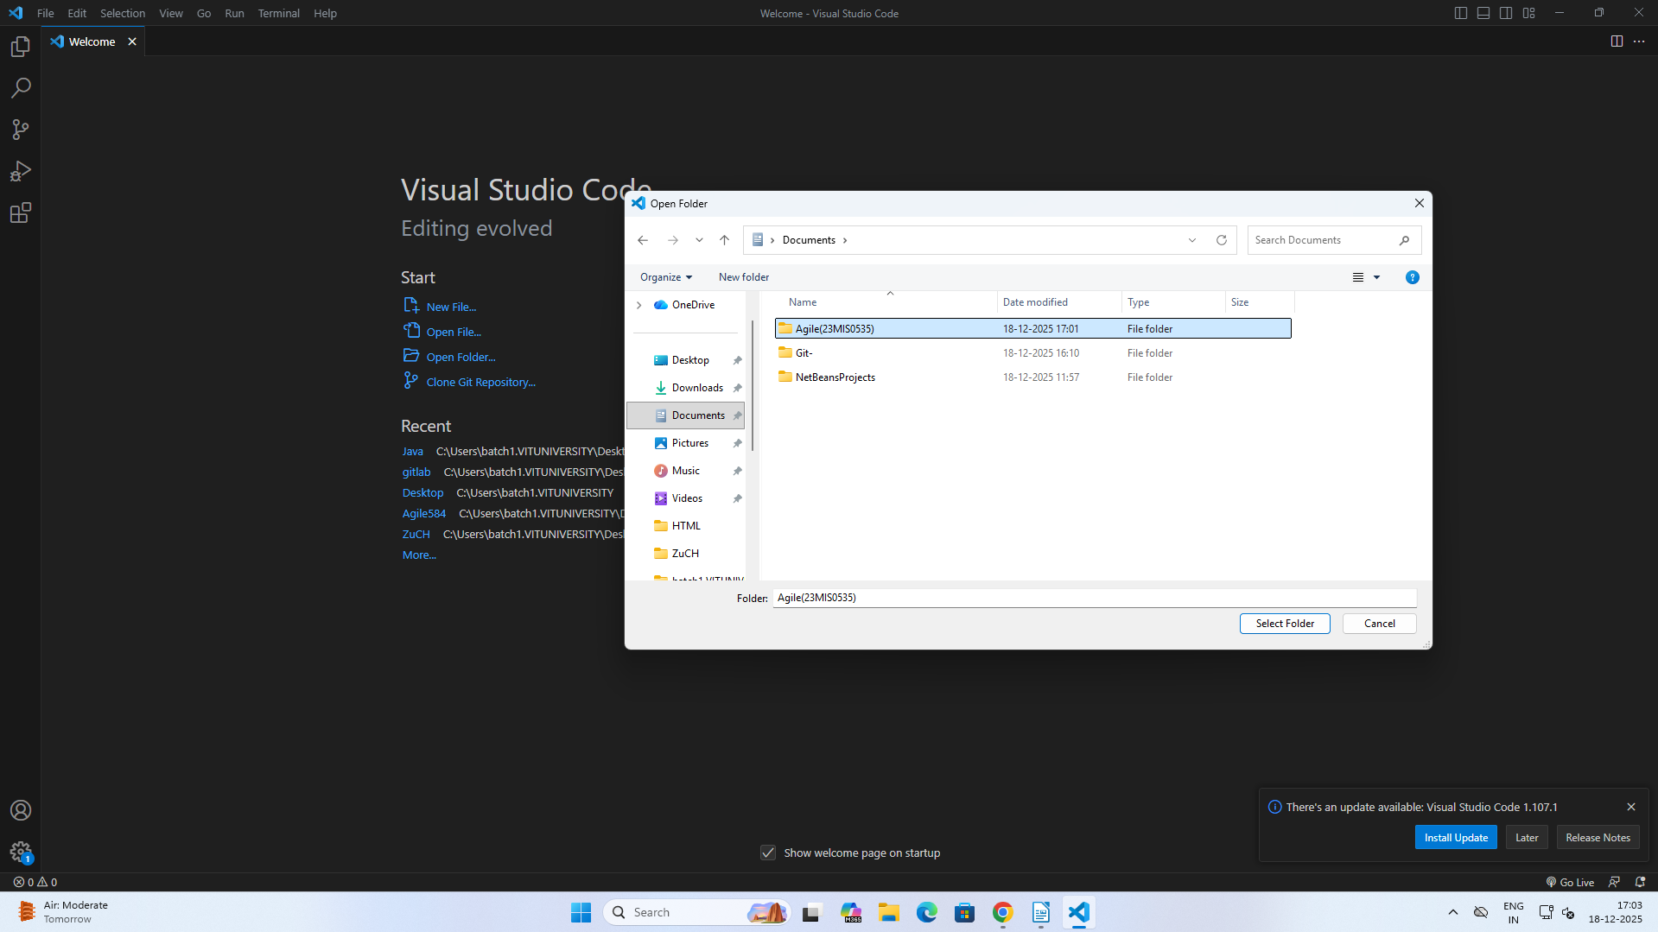

- Initialize a Git repository
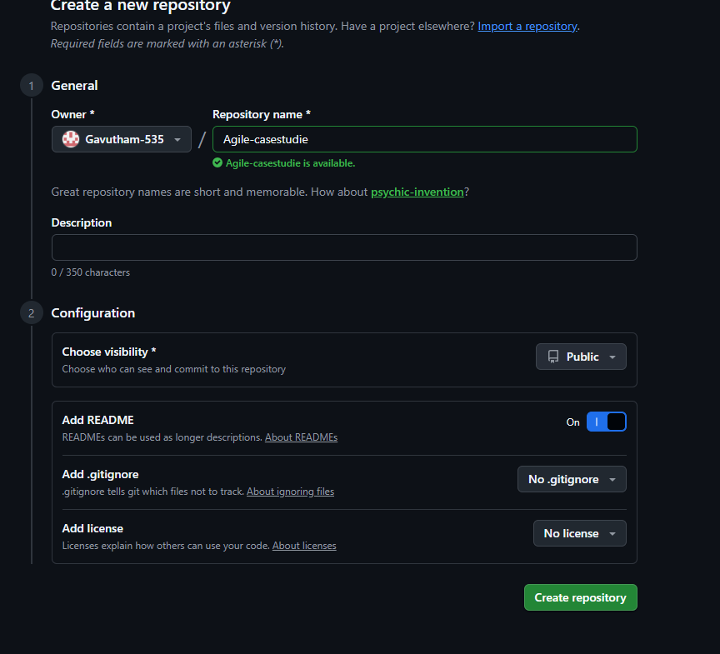
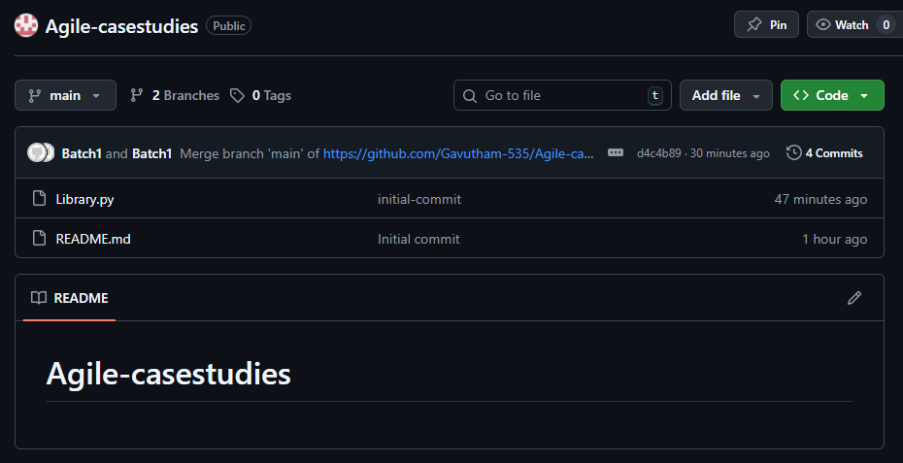

- Create a Python file and track it using Git

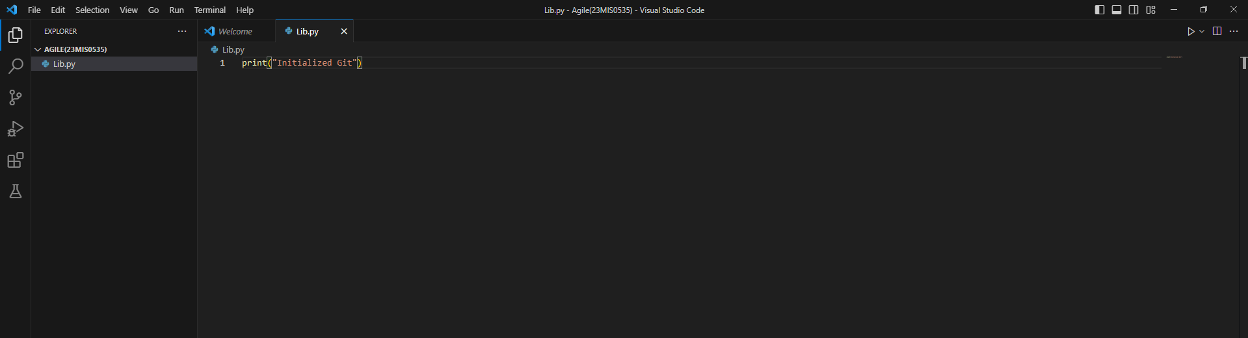
- Commit the initial version

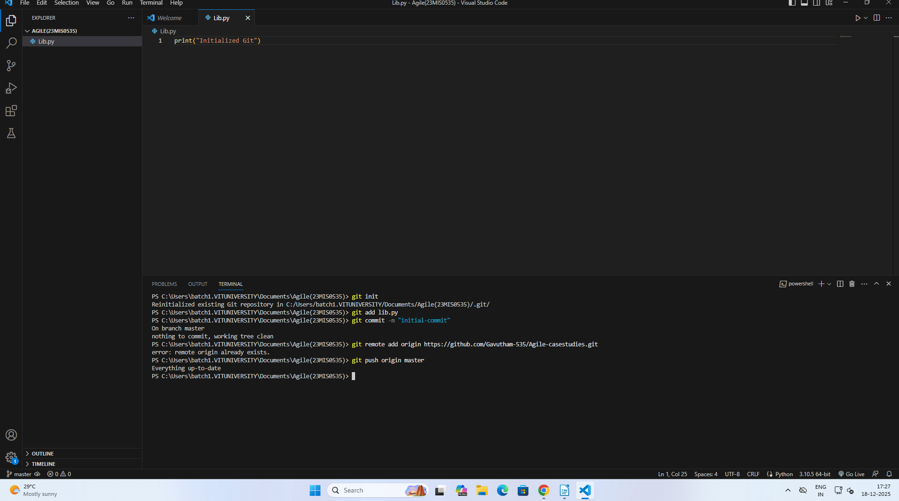

Python file added successfully!
