Smart Attendance System Diagrams

1. System Architecture (Block Diagram)
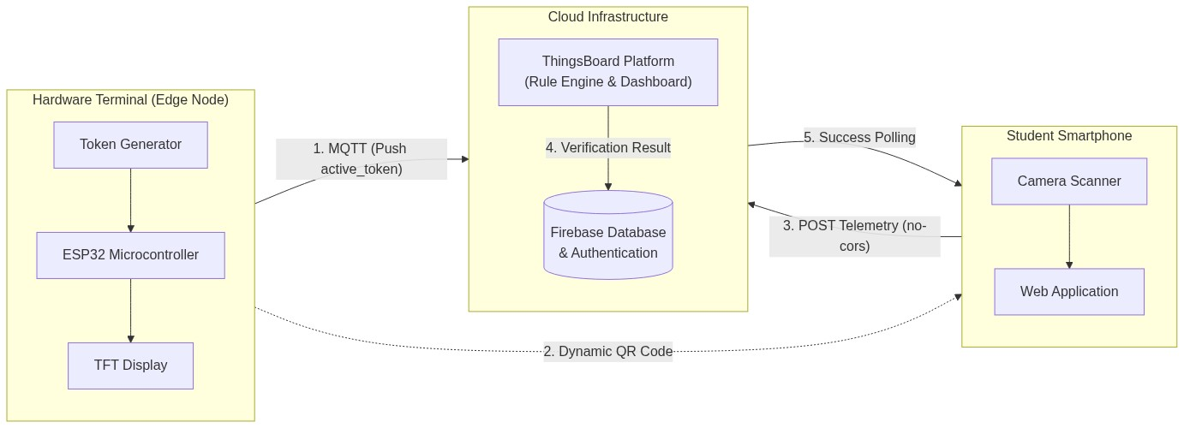

2. Hardware Logic (ESP32 Flowchart)
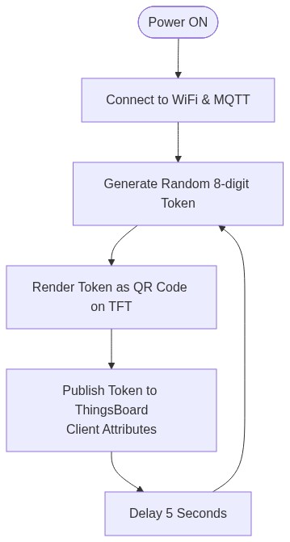

3. Student Check-in Logic (System Flowchart)
