**Course Submission Cover Sheet  
Module:** CC6012 Data and Web Application **Deadline:** 3PM, xx of March 2024  
**Module Leader:** Dr Sandra Fernando

**Student ID:**

Acknowledgement

Table of Contents

System Requirements 4

Database Generation 4

Implementation of the Web-based Database Application 4

Testing 4

Further discussion 4

Table of Figure

Figure 1 : Login UI 66

Figure 2 : User Menu UI 67

Figure 3 : Apply Leave UI 68

Figure 4 : Leave History 72

Figure 5 : Leave Cancellation 73

Figure 6 : Leave Status 76

Figure 7 : Admin Menu UI 77

Figure 8 : Register Employee UI 79

Figure 9 : Leave Management 83

Figure 10 : Leave Approval 87

Figure 11 : Define Roaster UI 90

Figure 12 : Leave Report 93

# System Requirements

1. Home Page

**Feature**: Display company information and provide sign-in links for the admin.

**Details**: Static content with company information (e.g., mission, vision, services).

Sign-in links for admin access.

1. Admin Functionality

**Feature**: Admin can sign in.

**Details**: Admin authentication (username and password).

**Feature**: Admin can add/delete books/CDs details.

**Details**:

Form to enter book/CD details (title, author, subject, ISBN, publication year, type, etc.).

Delete functionality for removing book/CD entries.

**Feature**: Admin can edit/update books/CDs details.

**Details**: Editable form to update existing book/CD details.

**Feature**: Admin can issue a book and update returns.

**Details**: Issue book form (book ID, student ID, issue date, return date).

Update return status and date.

**Feature**: Admin can view all books and CDs.

**Details**: List view of all books and CDs with search, filter, and sort options.

1. Guest Functionality

**Feature**: Guests can search for books.

**Details**: Search bar with options to filter by title, author, subject, etc.

**Feature**: Guests can reserve books.

**Details**:

Reservation form (guest details, book ID).

Confirmation message on successful reservation.

**Feature**: Guests can leave a message.

**Details**:

Contact form (name, email, message).

Submit button to send the message to the admin.

1. Database Requirements

**Entities**:

Admin: Username, Password.

Book: BookID, BookReferenceNumber, Title, Author, Category, ISBN, Publication, PublicationYear, Edition, AvailabilityCopy, NoOfCopy

CD: CdID, CdTitle, Author, Category, Publication, PrintedYear

Issue: IssueID, BookID, StudentID, IssueDate, ReturnDate.

Student: StudentID, FirstName, LastName, ID, Email, Address, Telephone, RegisteredDate, TerminatedDate.

# Database Generation

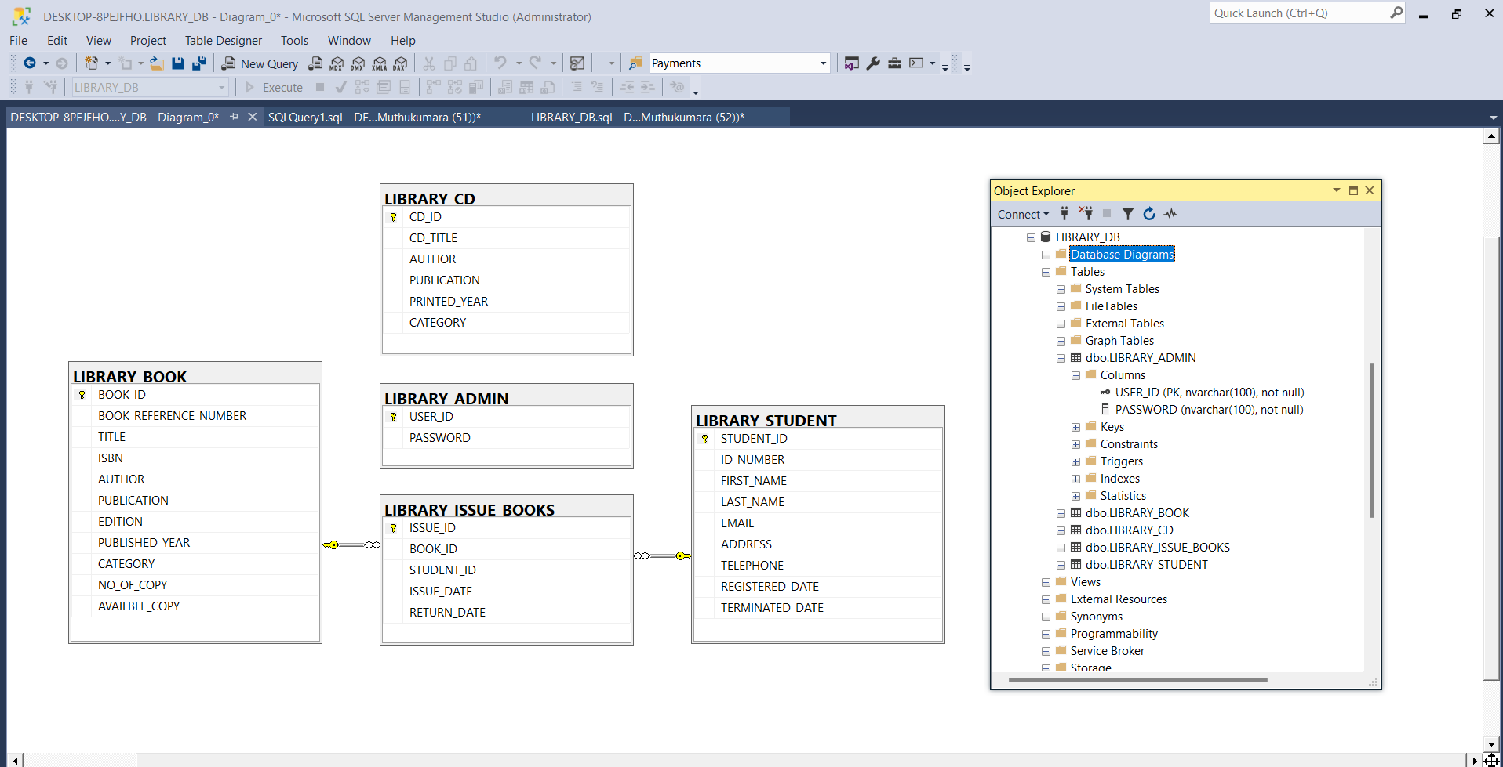

# Implementation of the Web-based Database Application

# Testing

# Further discussion