Timber Beam Analysis Report

# Beam Geometry

Span: 3.75 m

Support conditions (N0, N1): xyz,xyz (Interpreted as: Pinned (fixed translation xyz, free rotation), Pinned (fixed translation xyz, free rotation))

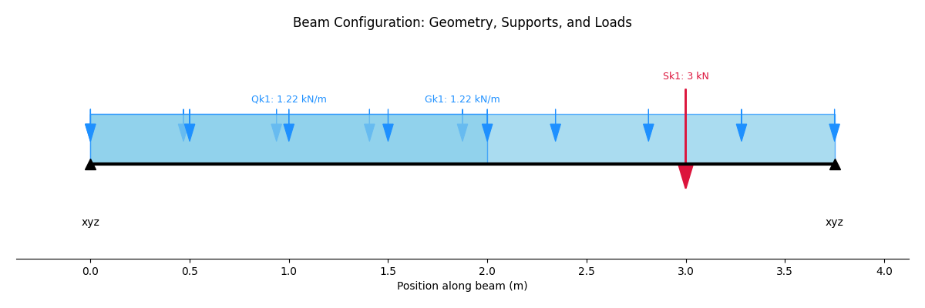

# Section Detail

Timber Grade: C24

Number of Sections: 2

Breadth (b): 50 mm (Total: 100 mm)

Depth (h): 200 mm

# Member Details

Service Class: SC1

Length of Bearing: 100 mm

# Applied Loadings

Uniformly Distributed Loads (UDLs):

|  |  |  |  |  |
| --- | --- | --- | --- | --- |
| Load Name | Load Type | Magnitude (kN/m) | Start (m) | End (m) |
| Gk1 | permanent | 1.22 | 0 | 3.75 |
| Qk1 | live | 1.22 | 0 | 2 |

Point Loads:

|  |  |  |  |
| --- | --- | --- | --- |
| Load Name | Load Type | Magnitude (kN) | Position (m) |
| Sk1 | snow | 3 | 3 |

# Load Combinations

## ULS Load Combinations

|  |  |  |  |  |
| --- | --- | --- | --- | --- |
| Combination | Permanent factor | Live factor | Snow factor | Wind factor |
| ULS1 | 1.35 | 1.5 | 0.75 | 0.75 |
| ULS2 | 1.35 | 1.05 | 1.5 | 0.75 |

## SLS Load Combinations

|  |  |  |  |  |
| --- | --- | --- | --- | --- |
| Combination | Permanent factor | Live factor | Snow factor | Wind factor |
| SLS1 | 1 | 1 | 0.5 | 0.5 |
| SLS2 | 1 | 0.7 | 1 | 0.5 |

# Analysis Results

## Maximum Bending Moment (ULS Envelope)

Maximum Positive Bending Moment ( sagging): 0.00 kN-m

Maximum Negative Bending Moment (hogging): -5.88 kN-m

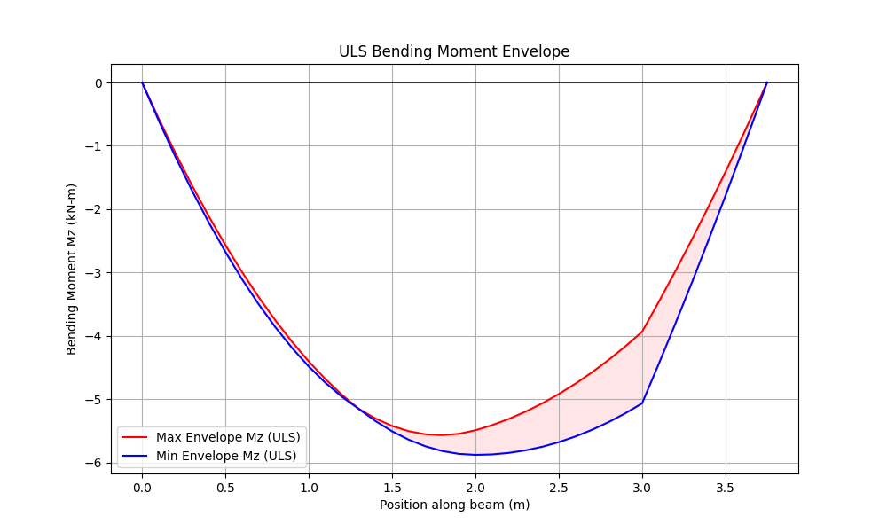

## Maximum Shear Force (ULS Envelope)

Maximum Positive Shear Force: 6.22 kN

Maximum Negative Shear Force: -7.37 kN

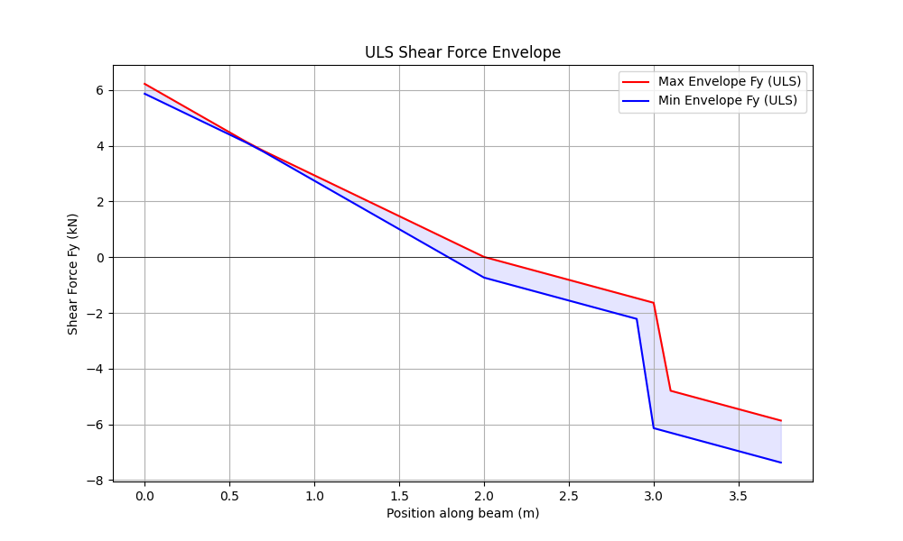

## Maximum Deflection (SLS Envelope)

Maximum Downward Deflection: -8.50 mm

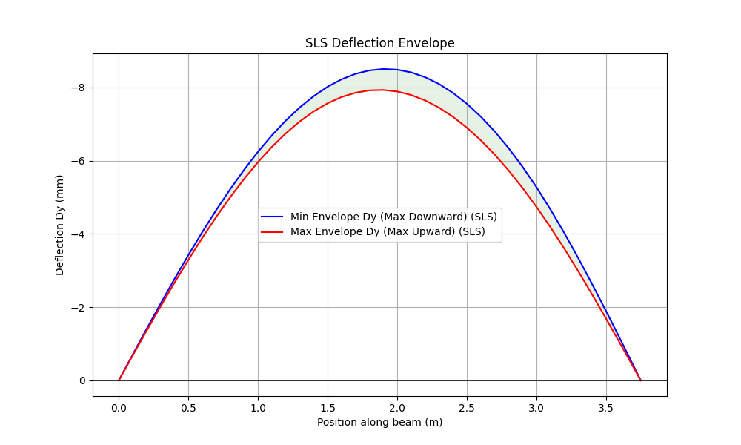

## Unfactored Support Reactions (Vertical)

|  |  |  |
| --- | --- | --- |
| Load Case | Support N0 Reaction (kN) | Support N1 Reaction (kN) |
| Gk1 | 2.29 | 2.29 |
| Qk1 | 1.79 | 0.65 |
| Sk1 | 0.60 | 2.40 |