Timber Beam Analysis Report

# Beam Geometry

Span: 4.0 m

Support conditions (N0, N1): x,y (Interpreted as: Custom (x), Roller (fixed translation y, free translation xz, free rotation))

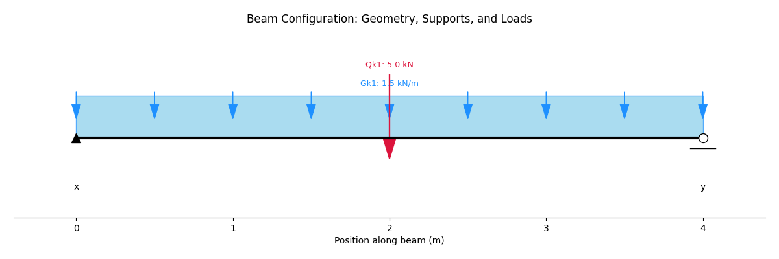

# Section Detail

Timber Grade: C24

Number of Sections: 1

Breadth (b): 75 mm (Total: 75 mm)

Depth (h): 225 mm

# Member Details

Service Class: SC1

Length of Bearing: 100 mm

# Applied Loadings

Uniformly Distributed Loads (UDLs):

|  |  |  |  |  |
| --- | --- | --- | --- | --- |
| Load Name | Load Type | Magnitude (kN/m) | Start (m) | End (m) |
| Gk1 | permanent | 1.5 | 0 | 4.0 |

Point Loads:

|  |  |  |  |
| --- | --- | --- | --- |
| Load Name | Load Type | Magnitude (kN) | Position (m) |
| Qk1 | live | 5.0 | 2.0 |

# Load Combinations

## ULS Load Combinations

|  |  |  |  |  |
| --- | --- | --- | --- | --- |
| Combination | Permanent factor | Live factor | Snow factor | Wind factor |
| ULS1 | 1.35 | 1.5 | 0 | 0 |

## SLS Load Combinations

|  |  |  |  |  |
| --- | --- | --- | --- | --- |
| Combination | Permanent factor | Live factor | Snow factor | Wind factor |
| SLS1 | 1 | 1 | 0 | 0 |

# Analysis Results

## Maximum Bending Moment (ULS Envelope)

Maximum Positive Bending Moment ( sagging): 1.46 kN-m

Maximum Negative Bending Moment (hogging): -0.83 kN-m

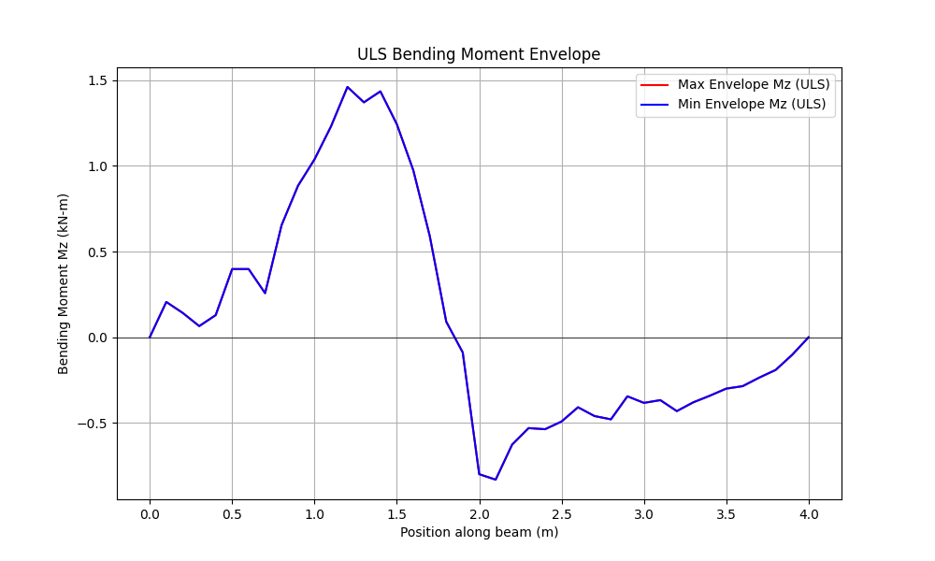

## Maximum Shear Force (ULS Envelope)

Maximum Positive Shear Force: 6.25 kN

Maximum Negative Shear Force: -3.17 kN

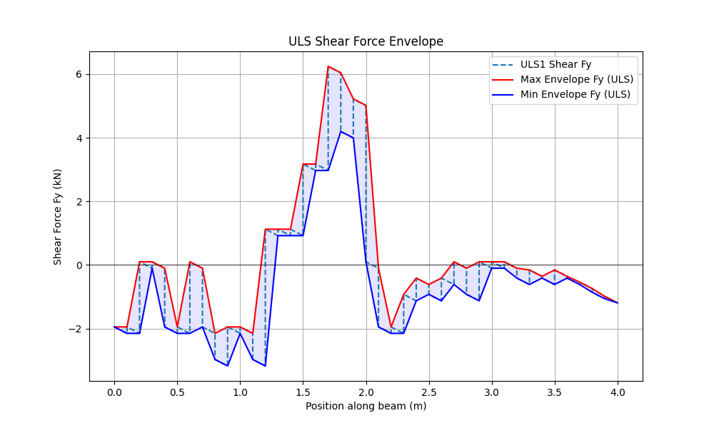

## Maximum Deflection (SLS Envelope)

Maximum Downward Deflection: -849021317819.79 mm

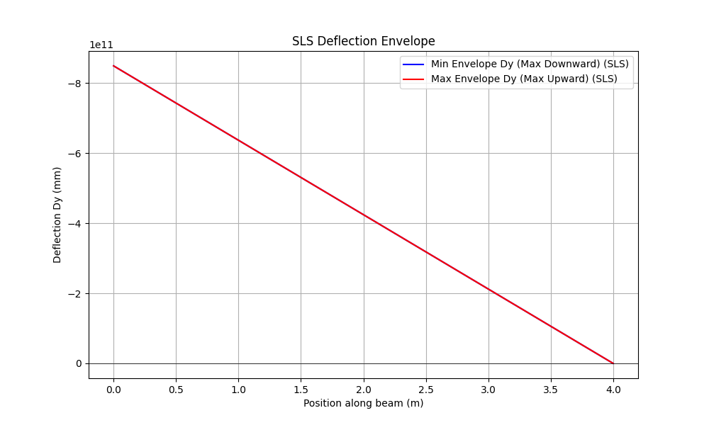

## Unfactored Support Reactions (Vertical)

|  |  |  |
| --- | --- | --- |
| Load Case | Support N0 Reaction (kN) | Support N1 Reaction (kN) |
| permanent_Gk1 | 0.00 | 0.00 |
| live_Qk1 | 0.00 | 0.00 |