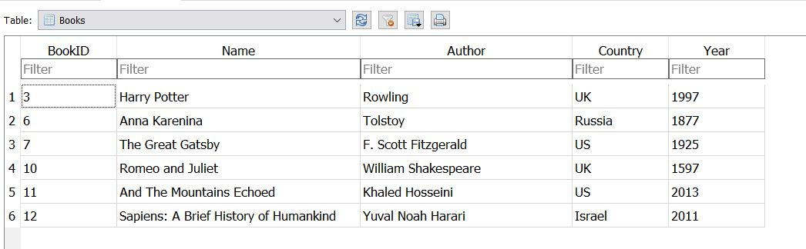

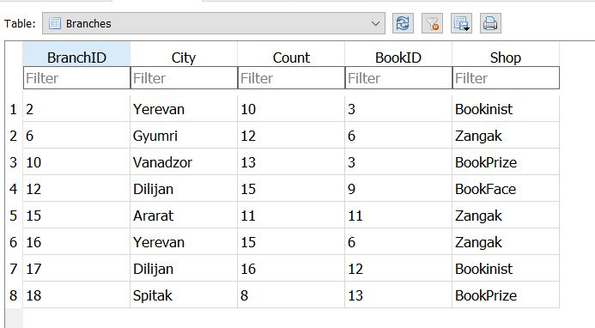

Add Data to Created Tables

1. *Return the names and cities of all the books from Zangak store*

**SELECT** Books.Name, Branches.City

**FROM** Books

**INNER JOIN** Branches

**ON** Books.BookID= Branches.BookID

**WHERE** Branches.shop=‘Zangak’;

1. *Return all books name and authors those count between 11 and 15*

**SELECT** Books.Name, Books.Authors

**FROM** Books

**INNER JOIN** Branches

**ON** Books.BookID= Branches.BookID

**WHERE** Branches.Count **BETWEEN** 11 **AND** 15;

1. *Return books names and counts, those are not exists in Yerevan*

**SELECT** Books.Name, Branches.Count

**FROM** Books

**INNER JOIN** Branches

**ON** Books.BookID= Branches.BookID

**WHERE** Branches.City **NOT LIKE** ‘Yerevan’;

1. *Using subquery select the city of the “And the mountains Echoed Book”*

**SELECT** Branches.City

**FROM** Branches

**WHERE** Branches. BookID=( **SELECT** Books.BookID

**FROM** Books

**WHERE** Books.Name=‘And the mountains Echoed Book’);