MDM2 – Case Study: Intelligent Systems in Production
One‑Page Proposal

Team | Sensor–Text Fusion team (supervisor: Hamidreza Heidari)
Members | Vadlakonda Dhruva Teja; Gayantha Rukshan Kuruppuarachchi; Sudarsi Amansnohith
Project Title | Sensor–Text Fusion for Predictive Maintenance
GitHub Repository URL | https://github.com/amansnohith909/sensor-text-fusion-predictive-maintenance
Contact Email | aman.sudarsi@stud.th.deg.de
Industrial Application (target domain/use‑case) | Predictive maintenance of production machinery: early failure warning for manufacturing equipment to cut unplanned downtime
Keywords (3–6) | predictive maintenance; sensor–text fusion; NLP; Big Data (PySpark); XGBoost; Streamlit
Submission Date (YYYY‑MM‑DD) | 2026-10-20
Gant Chart | 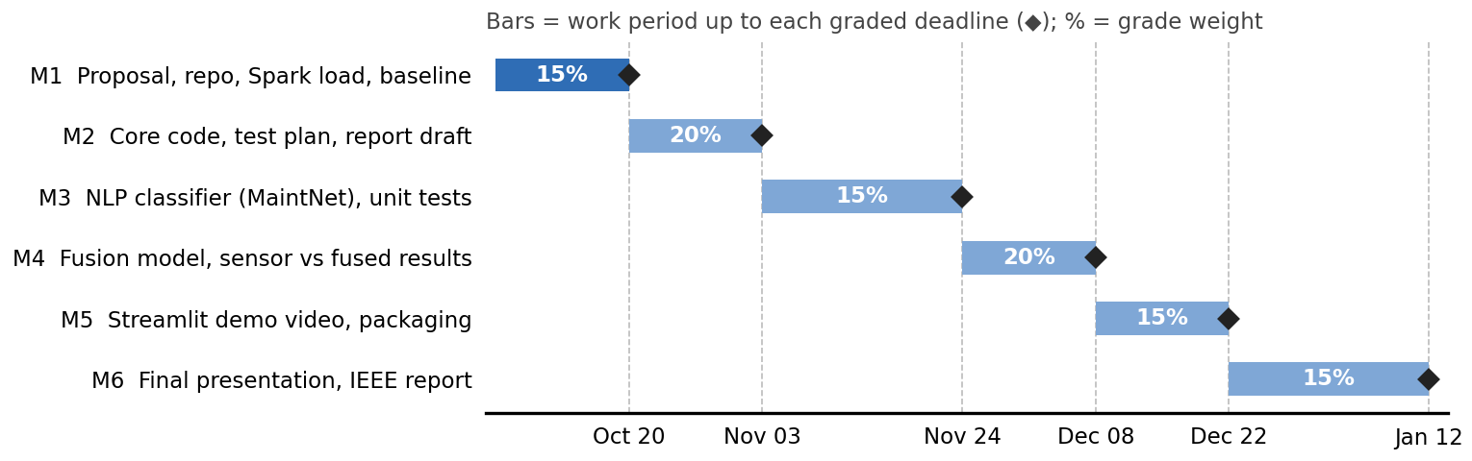

1) Problem Statement & Measurable Outcomes (3–4 sentences) | Unplanned machine failures cause costly downtime in production, yet most predictive maintenance systems use sensor telemetry only and ignore the technicians’ written maintenance logs, which hold early warnings such as “unusual noise” or “bearing worn”. We fuse both sources in a PySpark pipeline to predict failure within the next 24 hours and test whether fusion beats a sensor-only baseline.  KPIs: (1) recall on failures (primary); (2) precision / false-alarm rate; (3) F1 per component, plus NLP classifier accuracy and F1 on MaintNet fault categories; (4) estimated downtime avoided = failures caught × average repair time.
2) Motivation & Industrial Relevance (2–3 sentences) | Maintenance planners and production managers benefit from earlier warnings and fewer false alarms, which means less downtime, better quality and safer work (the module goals). The logs are already written by technicians, so the added value needs no new sensors or hardware, and the scalable Big Data pipeline can handle growing telemetry volumes.
3) Related Work Snapshot (2–3 key references) | Sensor Review 2024 and PHM Society papers: early fusion of sensor and text data beat traditional methods by 2.6–16.9%, and sensor + NLP outperformed sensor-only models.  Akhbardeh et al., MaintNet (COLING 2020; AACL 2020): maintenance logs use messy logbook language, so standard NLP fails and adapted methods are needed. Krupitzer et al. (survey): Big Data is a core element of predictive maintenance.  Gap: no public dataset holds sensor data and text logs for the same machines; we build a documented semi-synthetic pairing and measure the benefit of fusion against a sensor-only baseline.
4) Method & Feasibility (≤6 sentences) | Data: Microsoft Azure Predictive Maintenance (Kaggle; 100 machines, hourly telemetry, errors, maintenance and failures) and MaintNet aircraft logs (6,169 free-text entries). (1) PySpark builds rolling 3 h / 24 h statistics and event counts. (2) Logs are cleaned, lemmatized and vectorized (TF-IDF), then classified into fault types (mechanical, electrical, hydraulic); MaintNet-style logs are generated and classified for Azure events. (3) Sensor and text features are joined on machine ID and time, and XGBoost predicts failure within 24 h on sensors only and on fused features. (4) Time-based train/test split; recall, precision, F1 and downtime avoided are compared. Artifacts: GitHub repo, Streamlit demo, IEEE report.
5) Milestones & Timeline (short table/list) | M1 · Oct 20 (15%): proposal, tech stack, MVP repo, Spark data load, baseline  M2 · Nov 3 (20%): core code, baseline, test plan, literature map, report draft  M3 · Nov 24 (15%): NLP classifier on MaintNet, issues board, unit tests  M4 · Dec 8 (20%): fusion model working, first sensor-only vs fused results  M5 · Dec 22 (15%): Streamlit demo video, run instructions, packaging  M6 · Jan 12 (15%): final presentation, IEEE report (15–20 pages)
6) Risks & Ethics (1–2 sentences) | Azure sensor data is simulated and the Azure text logs are semi-synthetic, so results are a proof of concept and this is disclosed openly; the NLP model is trained on real MaintNet text, and class imbalance (rare failures) is handled with class weights/resampling and recall reporting. Only public Kaggle datasets are used (no personal data, sources cited), and leakage and bias are checked via the time-based split and the aviation-to-factory fault-type mapping.

Phase 1 rubric (15%): Team & GitHub (2%), On‑time (2%), Topic & Proposal (5%) — Industrial Application, Problem+Outcomes, Feasibility+Timeline; Presentation (6%).

