https://www.youtube.com/watch?v=OPxeCiy0RdY&feature=youtu.be&list=PLGLfVvz_LVvSpxyVx5XcprEgvhJ1BzruD

Angular Js is based on the following model view controller

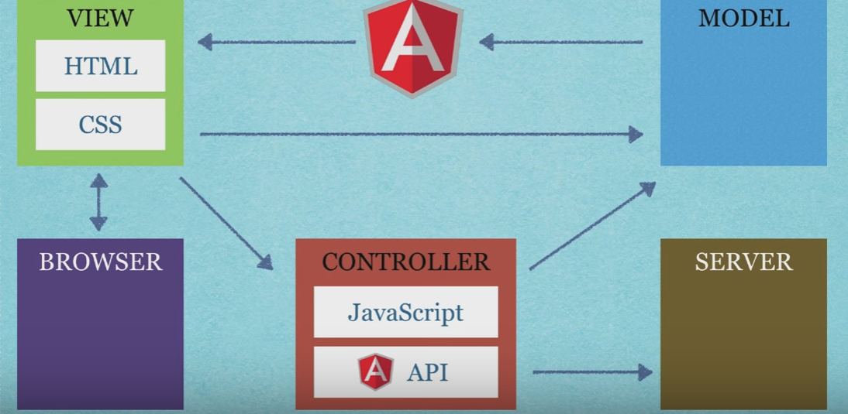

**MODULES:** These are used to represent the components used in the application & it is a container for the different parts of an application.

**DIRECTIVES:** They are used to extend the html tags.it binds data to the html elements .

**SCOPES:**  they are javascript objects that are used to represent data . [Scope](https://docs.angularjs.org/api/ng/type/$rootScope.Scope) is an object that refers to the application model. It is an execution context for [expressions](https://docs.angularjs.org/guide/expression). Scopes are arranged in hierarchical structure which mimic the DOM structure of the application.

**EXPRESSIONS:** They are directly linked to the scope(data) that help us in changing the view dynamically. Angular expressions are JavaScript-like code snippets that are mainly placed in interpolation bindings.

**SERVICES:** these are services.

**angular.module():**  It is used to create a component .it is a collection of services, directives, controllers, filters, and configuration information. (<https://docs.angularjs.org/api/ng/function/angular.module>) .

**ng-app :** It is used to auto-bootstrap an AngularJS Application . Bootstrapping means initializing Angular JS (<https://docs.angularjs.org/api/ng/directive/ngApp> ) .There are two ways to do it first is **auto-bootstrapping using ng-app** second is by  **manual bootstrapping (**[**http://stackoverflow.com/questions/21058213/what-is-meant-by-bootstrapping-in-angular-js**](http://stackoverflow.com/questions/21058213/what-is-meant-by-bootstrapping-in-angular-js) **).**  Bootstrapping can be done only once at the root element <html> or <body>.

**ng-init :** it is a directive that initializes application data by assigning different values to variables.

**ng-controller:** The ngController directive attaches a controller class to the view.  A Controller is defined by a JavaScript **constructor function** that is used to augment the [Angular Scope](https://docs.angularjs.org/guide/scope).

**ng-model :** The ngModel directive binds an input,select, textarea (or custom form control) to a property on the scope using [NgModelController](https://docs.angularjs.org/api/ng/type/ngModel.NgModelController), which is created and exposed by this directive.

**ng-click:** The ngClick directive allows you to specify custom behavior when an element is clicked.

**ng-bind:** The ngBind attribute tells Angular to replace the text content of the specified HTML element with the value of a given expression, and to update the text content when the value of that expression changes.

**ng-repeat:**  it is used to cycle through a list of informations in ng-init or otherwise inside the js.

**ng-cloak:** The ngCloak directive is used to prevent the Angular html template from being briefly displayed by the browser in its raw (uncompiled) form while your application is loading. Use this directive to avoid the undesirable flicker effect caused by the html template display.

**ng-if:** The ngIf directive removes or recreates a portion of the DOM tree based on an {expression}.

**ng-include:** it is used to include html fragments from other html files

**ng-switch:**  it is used to insert html elements based upon switch case events.