Sri Lanka Institute of Information Technology 

New York Stock Exchange Data Warehouse

DWBI-assignment-II

IT16014350

Gayashan Kariyawasam | SLIIT | 2018-05-18

# Abstract

Purpose of this document is to demonstrate the Report Building process of the Data warehouse. First this will give a brief introduction and explanation of scope of the project. Then an explanation about Cube. Followed by Explanation of Reports.

## KeyWords

* Fundamentals - financial information and management commentary, as reported in quarterly or annual statements
* Security - a tradable financial asset
* ticker symbol - stock symbol is an abbreviation used to uniquely identify publicly traded shares of a particular stock.
* GICS- Global Industry Classification Standard
* This Document is Created According to IEEE Standards.

# Introduction

The New York Stock Exchange is the world’s largest and one of the oldest stock exchange. It’s a market place where stocks of multibillion companies are traded every day. It’s average daily trading value was approximately US$169 billion in 2013[1].

Stock prices changes over time depending on many factors. It could be changes in government policies, political instability or high demand for some product. Certain individuals like Stock traders make some profit by foreseeing these changes. If these individuals see an upward trend they buy at current price level and sell it in future for a profit. Similarly, if they see a downward trend they could sell their stocks before they lose any money.

All these stock market related trading happens based trader’s individual experience on the market trends. But experience based decision might lead to bad outcomes [2]. So, we should be careful make our decisions based on data, After a proper analysis.

This is where this Data warehouse comes to play. It helps to store, organize historical stock market Data and finally make our analysis. A Stock market has a large volume of transactional data. So, it is important to have a OLAP data warehouse. Otherwise OLTP data base would take higher query time.

Extraction process for this Data warehouse design has been created to manage multiple source files. Client could add any new stock data about a new company just by downloading the CSV file from Yahoo Finance and adding it to the Data/stock folder. And this is designed to optimize client queries in many different scenarios.

# Cube Creation Process

First new Data source is configured to connect to the data warehouse. Then Data source view is created. In this view several named calculations are added to make it easier to identify hierarchies & other data properly.

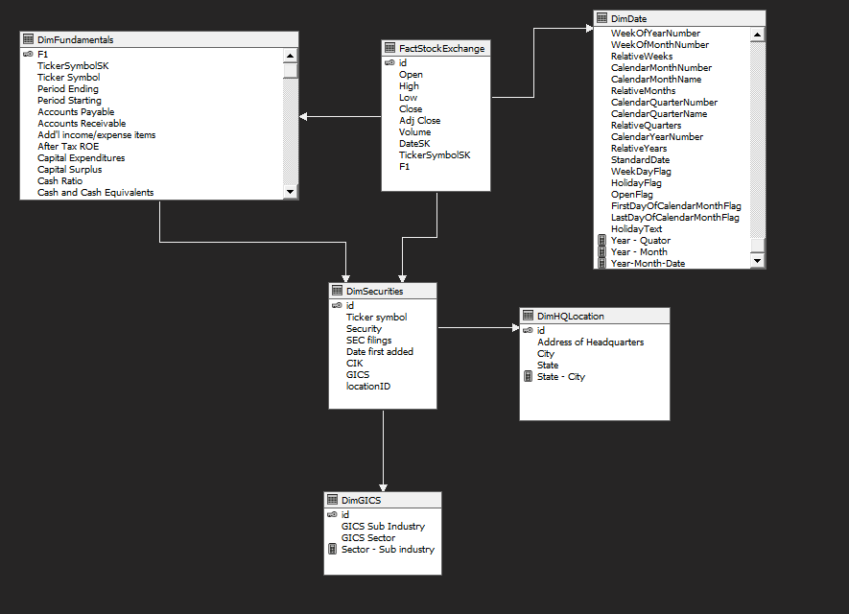

### Named Calculations

* Year-Quarter
* Year-Month
* Year-Month-Date
* State-City
* Sector-Sub industry

## Dimensions

3 dimension are created for our requirements. Namely, Security, Date & Fundamentals.

### Security

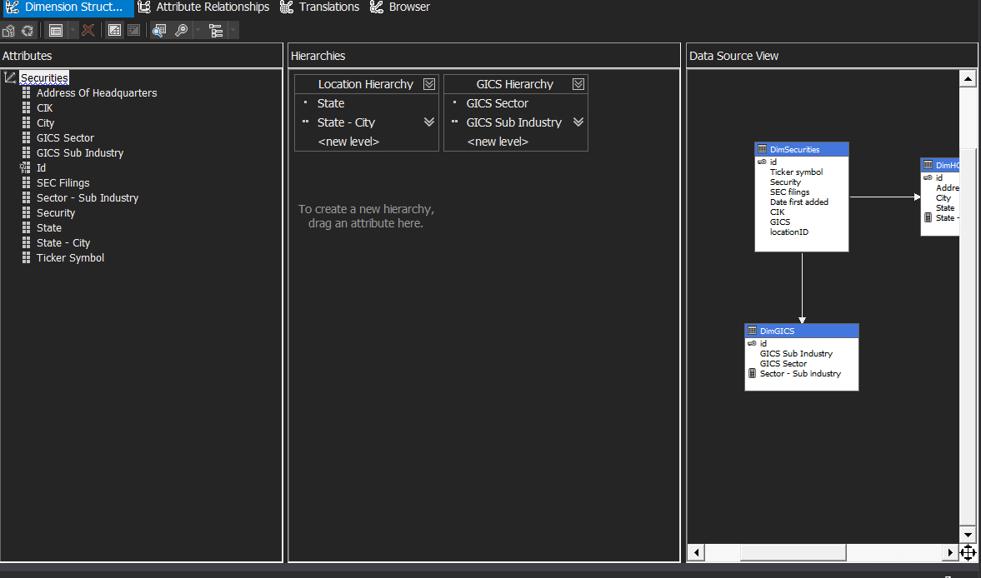

Since our DW Schema is Snow Flake. Attributes from the snow other dimensions are also added to the securities dimension.

For this Dimension 2 Hierarchies are created.

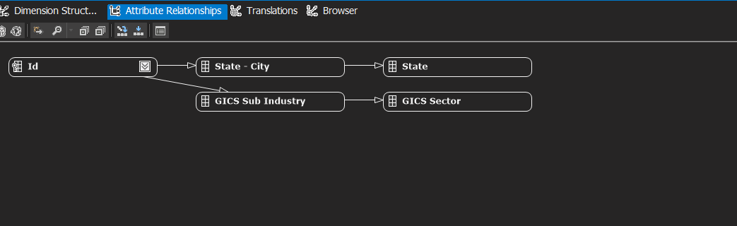

### Date

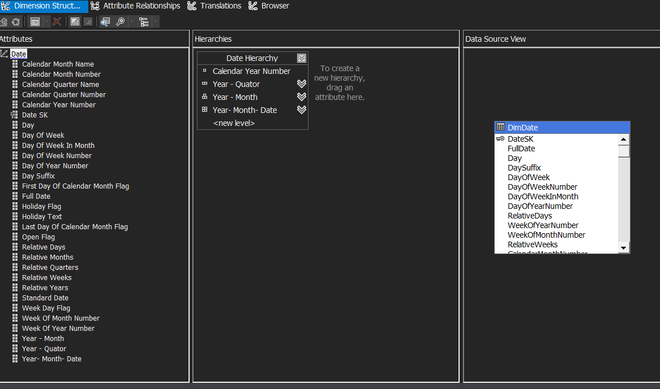

For the date dimension one Hierarchy is created.

### Fundamentals

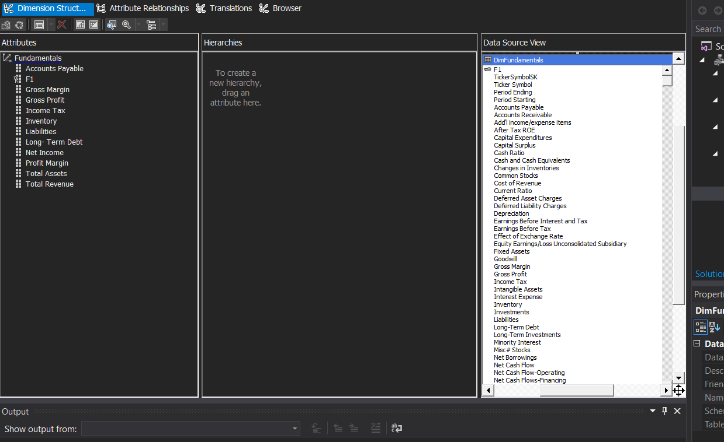

Many attributes are excluded from the view for this dimension.

Stock Ex Cube

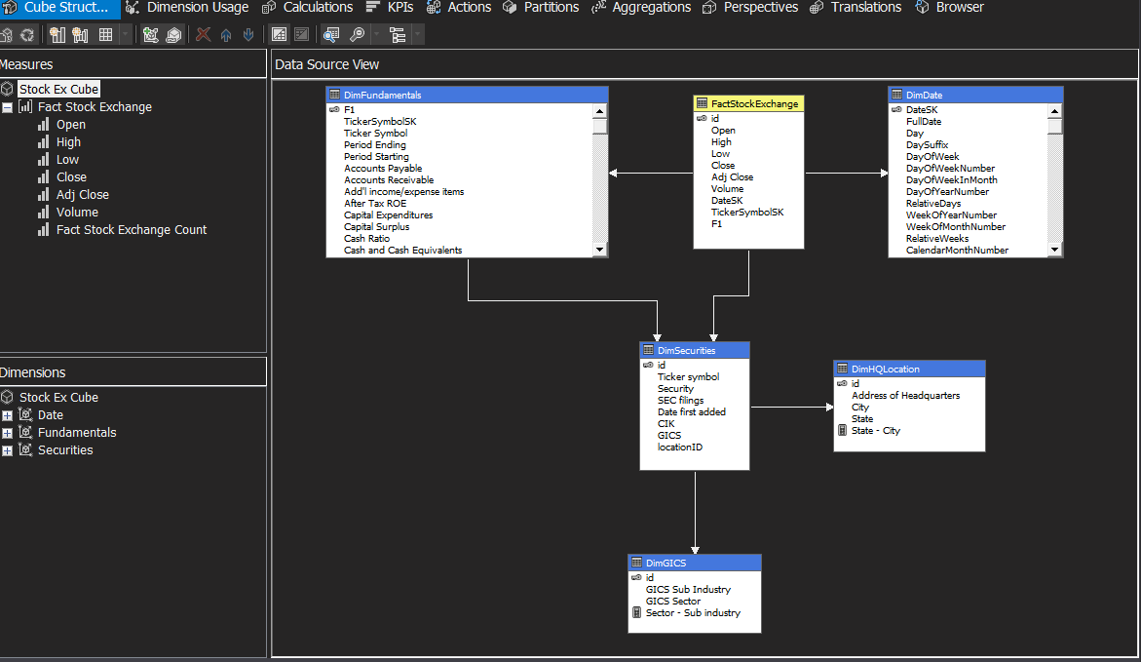

Cube is created after the dimension. This cube has 6 measures.

* Open
* High
* Low
* Close
* Adj. Close
* Volume

### Named Calculation

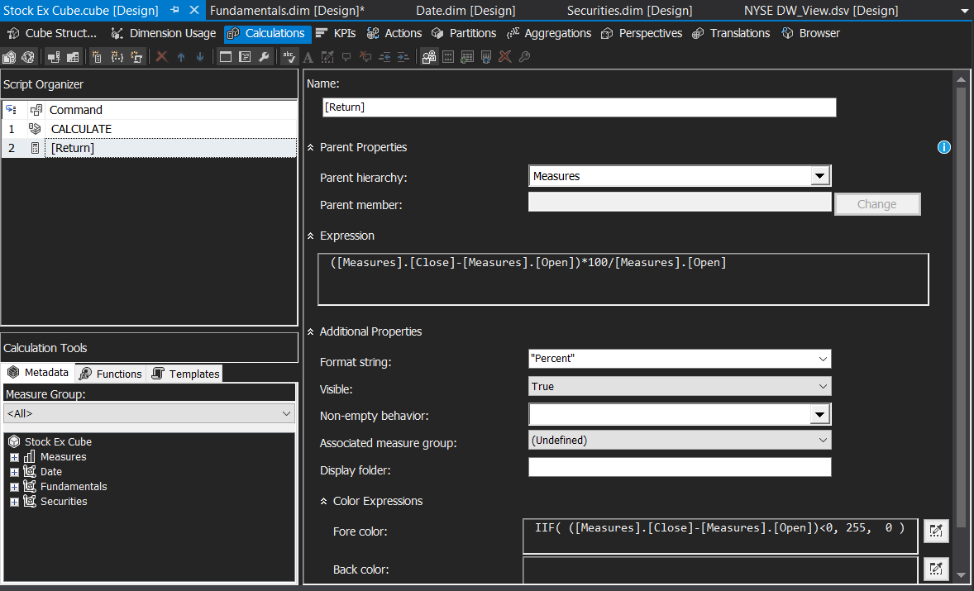

Named Calculation is added to the cube for identify if the stock price is risen or dropped. This is formatted as a percentage value. And Color Expression is added to identify this value is below 0 or not.

### KPI

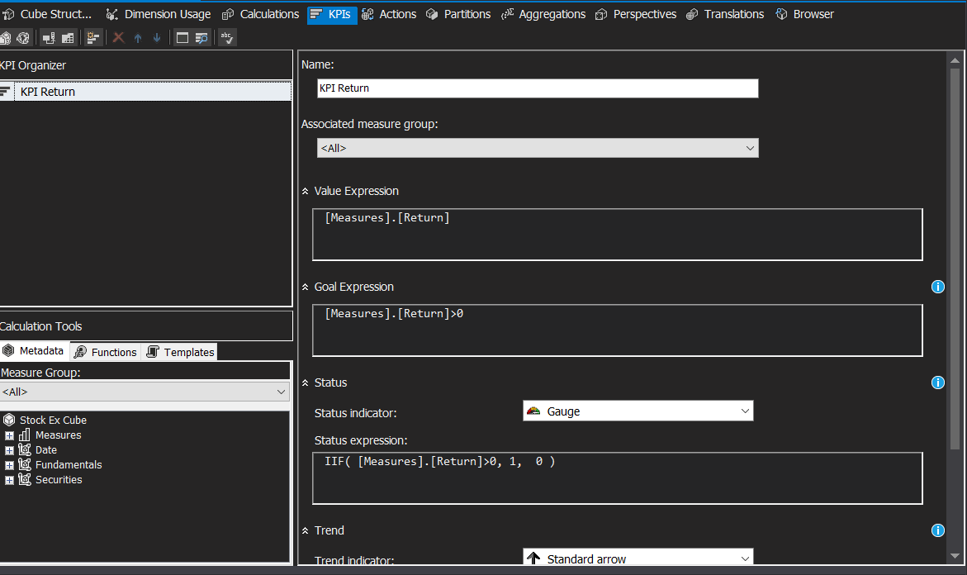

KPI is added to identify stock price growth and drop.

# Reports

### Excel report

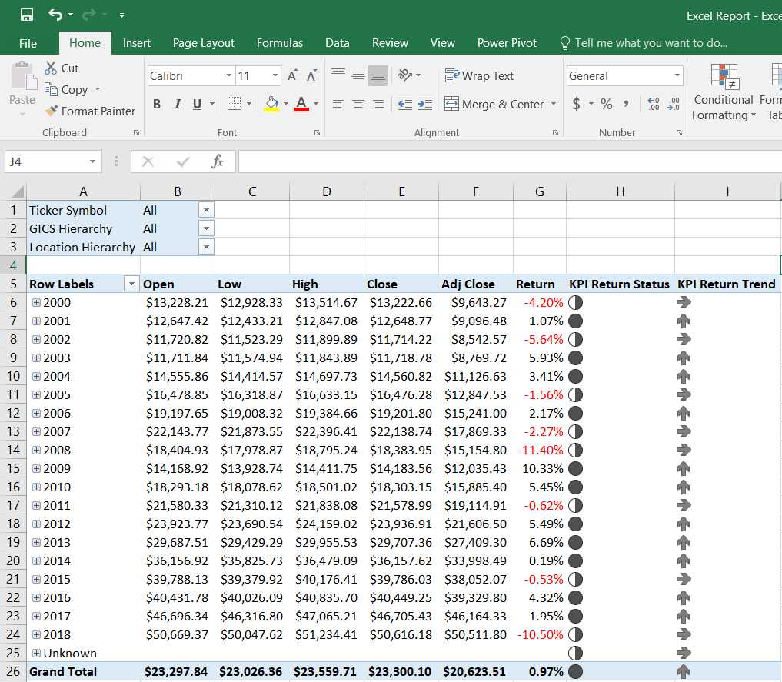

We can use Excel Report for slice-dice and drill down-roll up Operations. KPI is also visible in this report

# Report 1

Power BI is used for the report creation. Before view these reports install custom visual inside custom visual folder.

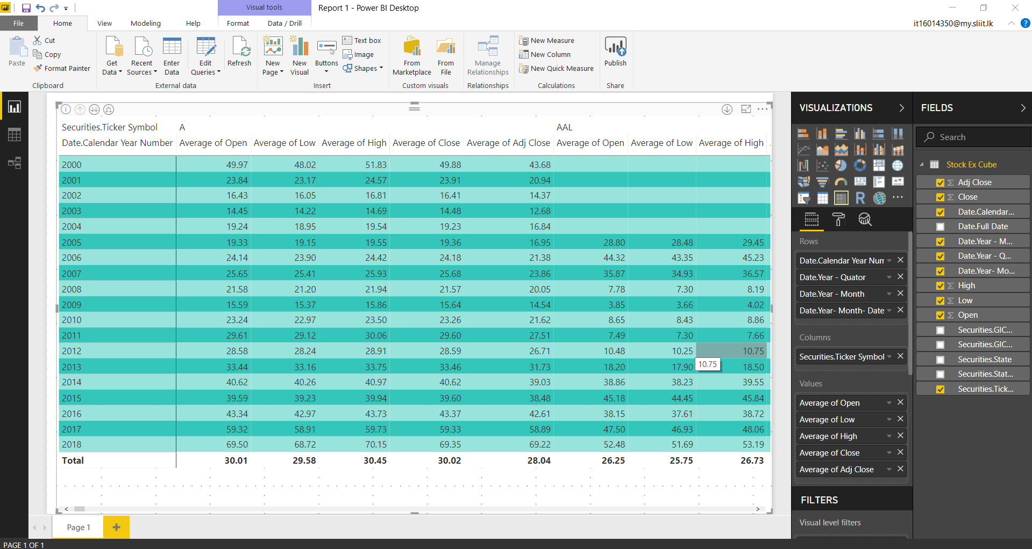

# Report 2

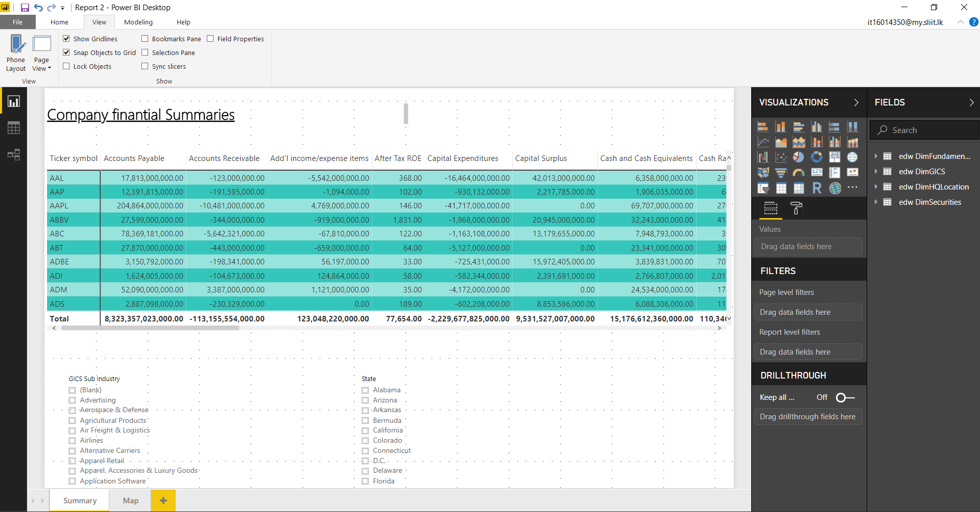

Use 2 slicers in this report for slice & dice operations.

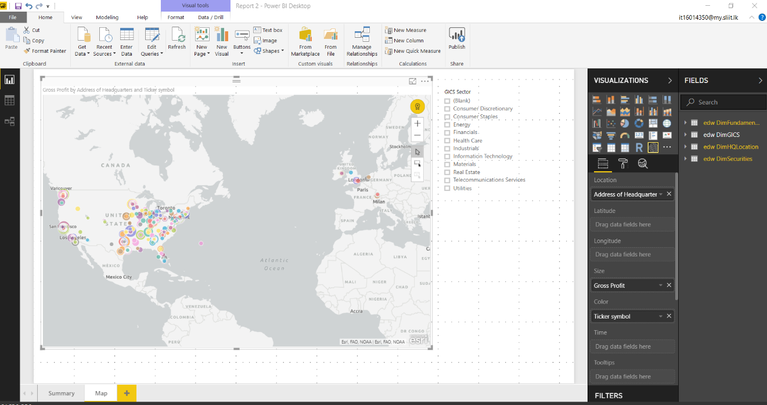

All the companies are mapped in this document.

# Report 3

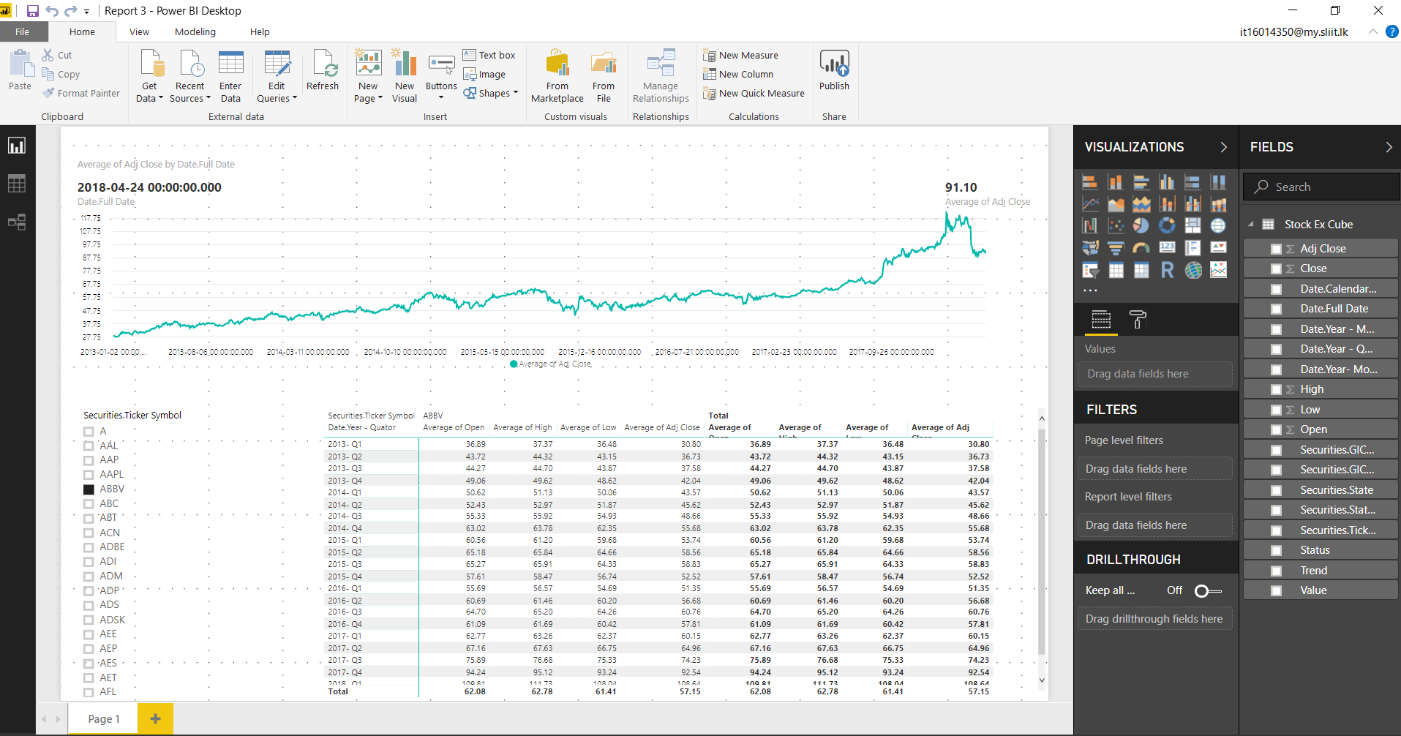

Select the table and use the drill down icon do drill down by time.

# Report 4

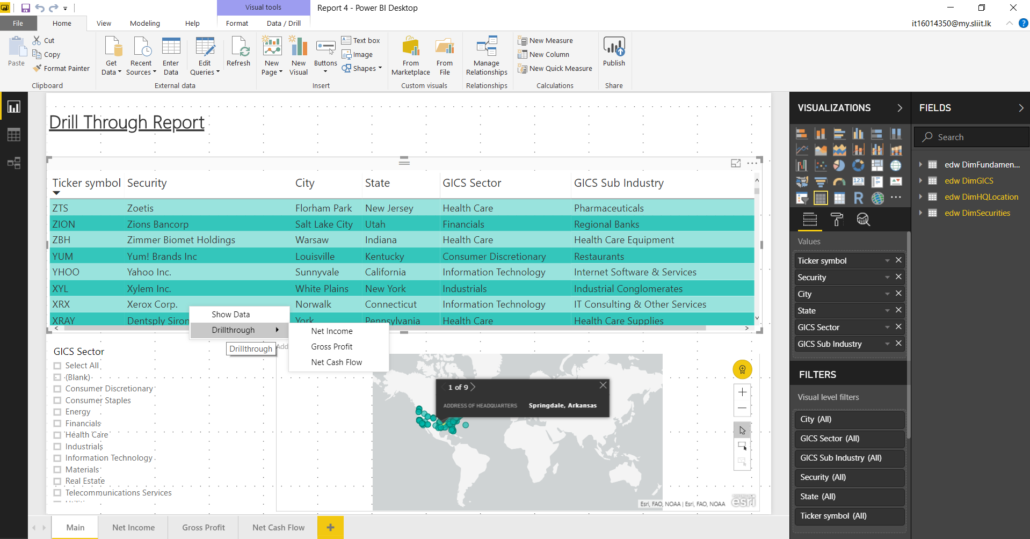

For Drill through operations right click on any row and select drill through then select any given selection.

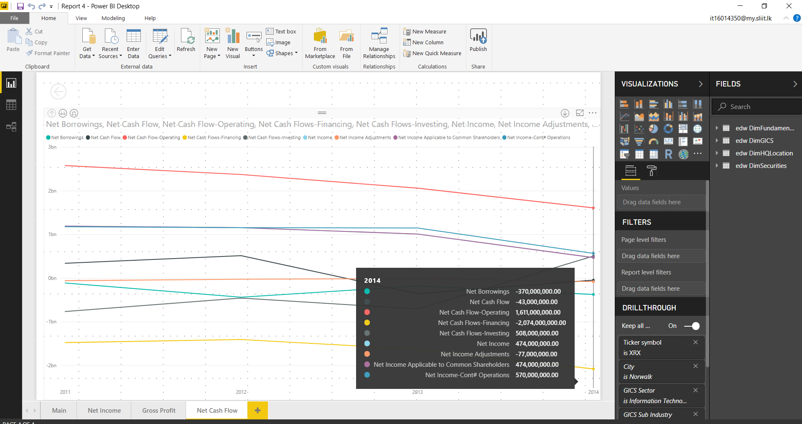

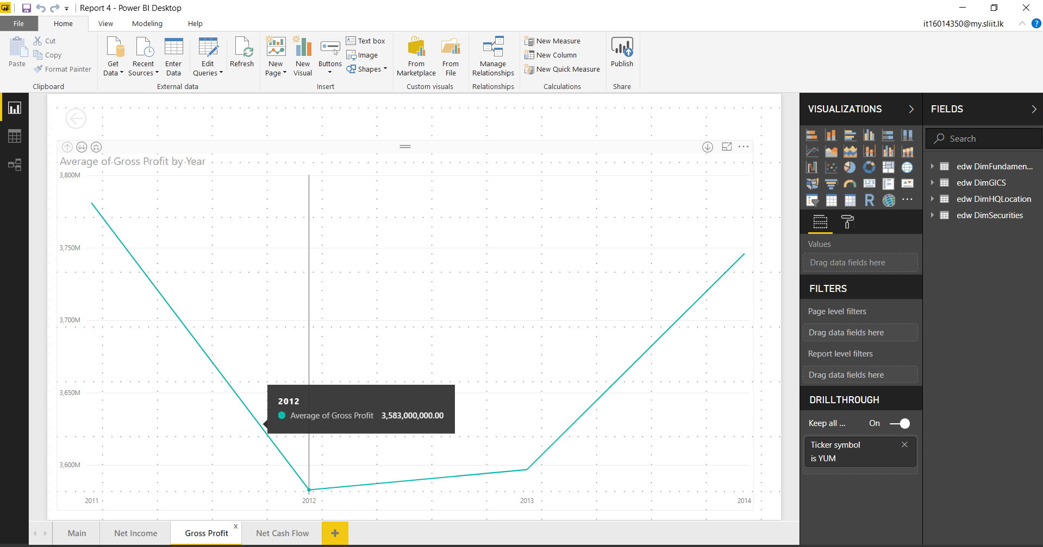

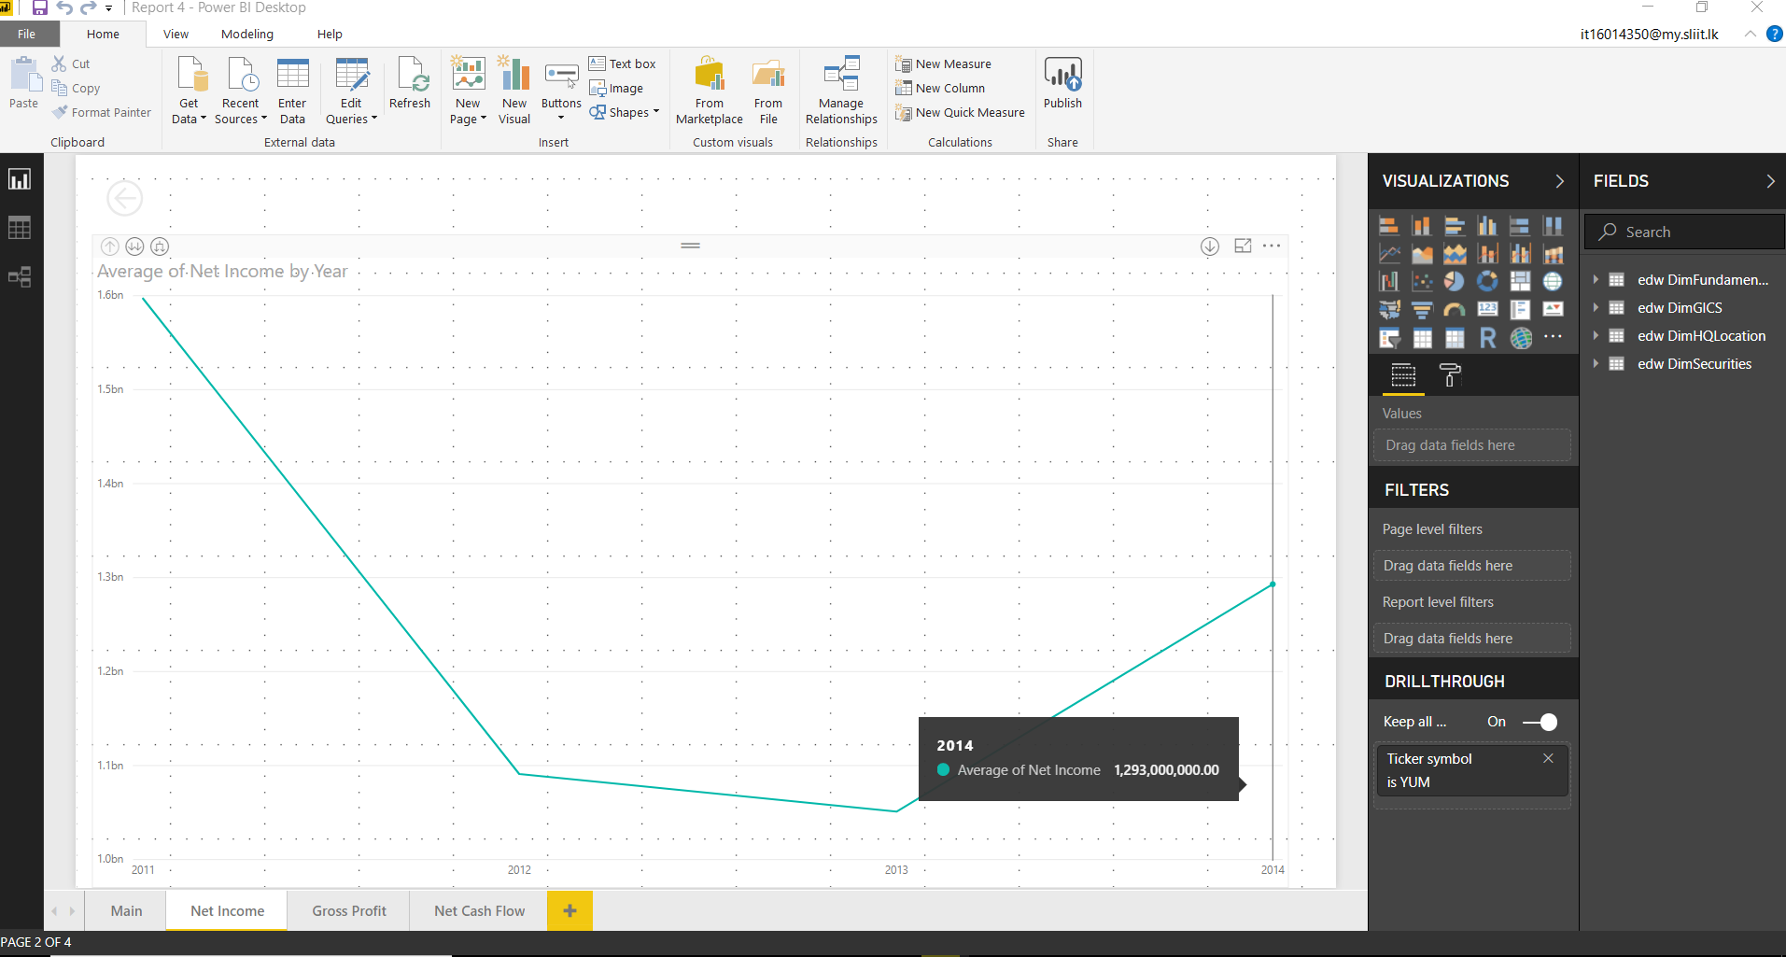

# References

[1] – "NYSE Group Shares Outstanding and Market Capitalization of Companies Listed, 2016" [Online]

Available - <http://www.nyxdata.com/nysedata/asp/factbook/viewer_edition.asp?mode=tables&key=333&category=5> [Accessed: May. 02, 2018]

[2] – "In A Data Era, How Does Your Gut Fit In To Decision Making?" [Online]

Available - <https://datahero.com/blog/2014/11/11/data-era-gut-fit-decision-making> [Accessed: May. 02, 2018]