**Stakeholders of the system**

* Researchers
* Buyers
* Fund bodies
* System admin

**Identified web services**

* Researcher – adding, viewing, editing, and removing projects to and from the system and managing researcher profile.
* Buyer – adding, viewing, editing, and removing items to and from cart and managing Buyer profile.
* Funders sponsoring projects and managing sponsors profiles.
* System admin – managing users and add funders of the system.

**Use case diagram of the overall system**

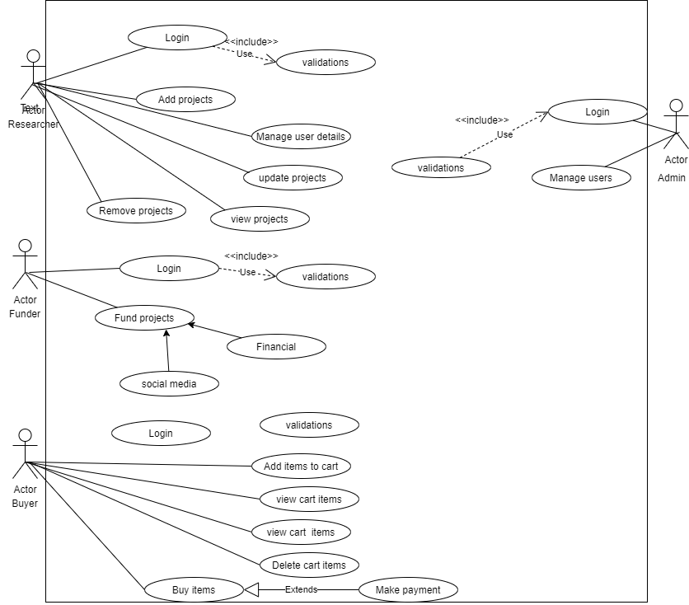

**ER diagram for the overall system**

