Librisync
Abstract:
LibriSync is an online Library Management System that automates library operations by replacing manual methods with a modern digital solution using HTML, CSS, Java, and MySQL. It provides dedicated modules for Administrators and Users to efficiently manage books, members, transactions, and fine calculations with accuracy and security. By integrating these technologies, LibriSync reduces paperwork, minimizes errors, and delivers a seamless and efficient library experience.

Team Name: Quantum Coders.

Team Members: Amaravathi, Priyadharshini, Gayathri, Nithya Shree.

Technologies Used: Html, CSS, MySQL, Java, Git, GitHub.

Project Wireframe

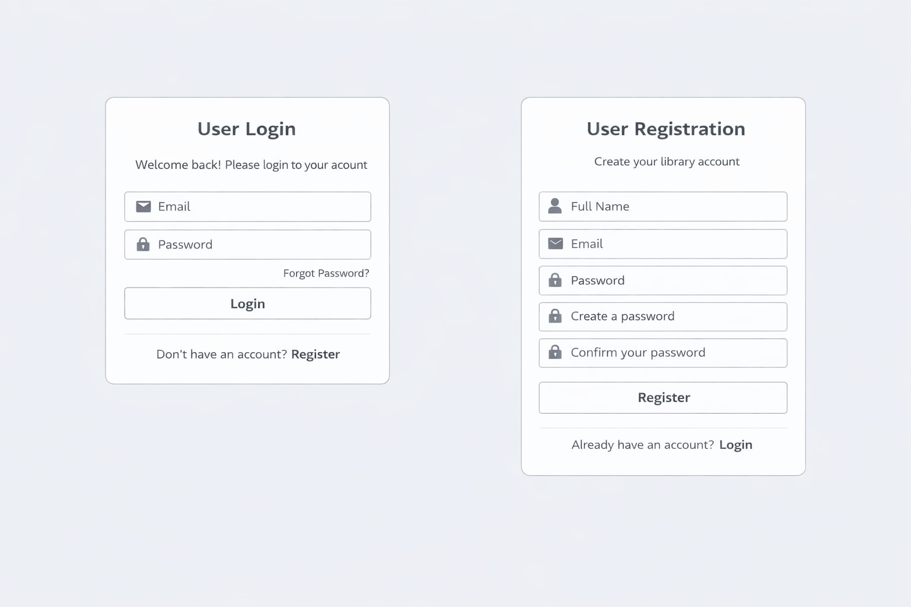

Module 1: User Login page



Module 2 : User Register page



Module 3 : User Dashboard

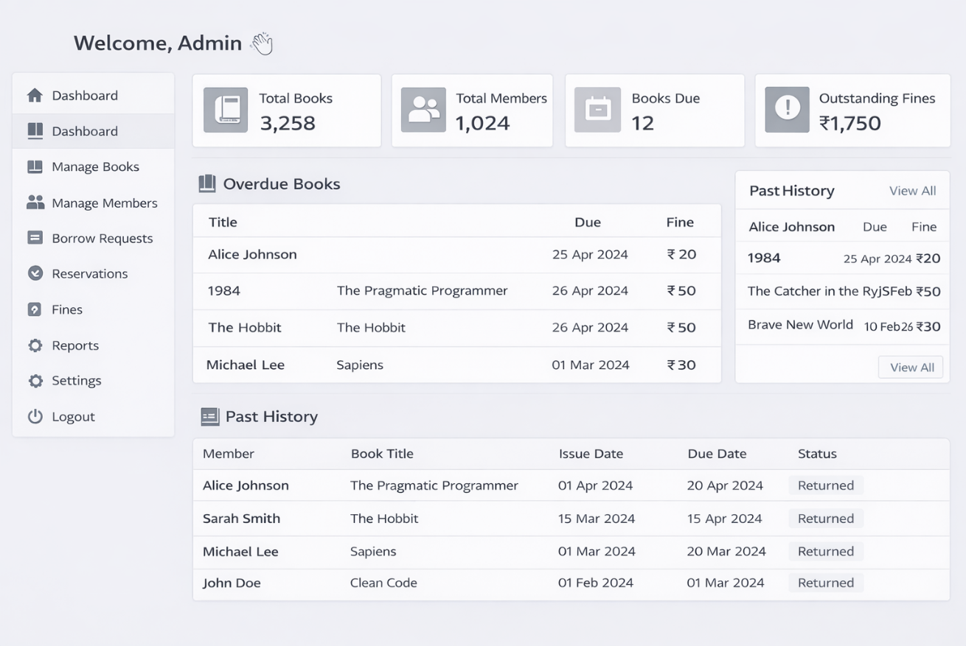

Module 4 : Admin Dashboard



Module 5 : Manage Issues



Module 6 : Manage Books
Description
LibriSync is a web-based Library Management System designed to automate and simplify day-to-day library operations for both administrators and users. The system enables administrators to manage books, members, issue and return transactions, and fine calculations, while users can easily search, borrow, and return books through a clean and intuitive interface. Built with HTML, CSS, JavaScript, Java, and MySQL, LibriSync delivers a secure, accurate, and efficient digital library experience that eliminates manual paperwork and reduces operational errors.

