Salesforce Developer Bridge Program
Day 2 – Apex Collections, Governor Limits, Bulkification, Asynchronous Apex & LWC Communication
Name: Gayathri Ettela
Date: July 29, 2026

Day 2 Objectives
The objectives of Day 2 were:
- Understand Apex Collections (List, Set, Map)
- Learn Governor Limits in Salesforce
- Understand Bulkification techniques
- Create and test a bad trigger and fix it
- Learn Asynchronous Apex using @future methods
- Understand LWC Component Communication
- Improve trigger design and interview readiness

Quick Recap from Day 1
Topics completed on Day 1:
- Salesforce Data Modeling
- Lookup Relationships
- Schema Builder
- SOQL Queries
- Apex Basics
- First Trigger
- Trigger Handler Class
Key learnings:
- Trigger logic should be written in a Handler Class.
- Trigger.new contains records currently being processed.
- Handler classes improve code maintenance and readability.

Block 1 – Apex Collections
What is a List?
A List is an ordered collection of elements.
Features:
- Allows duplicate values
- Maintains insertion order
- Indexed collection
Example:
List<String> cities = new List<String>{
'Hyderabad',
'Bangalore',
'Chennai',
'Mumbai',
'Delhi'
};

for(String city : cities){
System.debug(city.toUpperCase());
}
Expected Output
HYDERABAD
BANGALORE
CHENNAI
MUMBAI
DELHI

What is a Set?
A Set stores unique values only.
Features:
- No duplicate values
- Faster searching
- Commonly used to collect record IDs
Example:
Set<Id> patientIds = new Set<Id>();

for(Patient__c p :
[SELECT Id FROM Patient__c]){
patientIds.add(p.Id);
}

System.debug('Set Size: ' + patientIds.size());
Expected Result
The Set size equals the number of unique Patient records.

What is a Map?
A Map stores key-value pairs.
Features:
- Fast record lookup
- Frequently used in bulkified triggers
Example:
Map<Id, Patient__c> patientMap =
new Map<Id, Patient__c>(
[SELECT Id, Name
FROM Patient__c]
);

Id sampleId =
patientMap.keySet().iterator().next();

System.debug(
patientMap.get(sampleId).Name
);
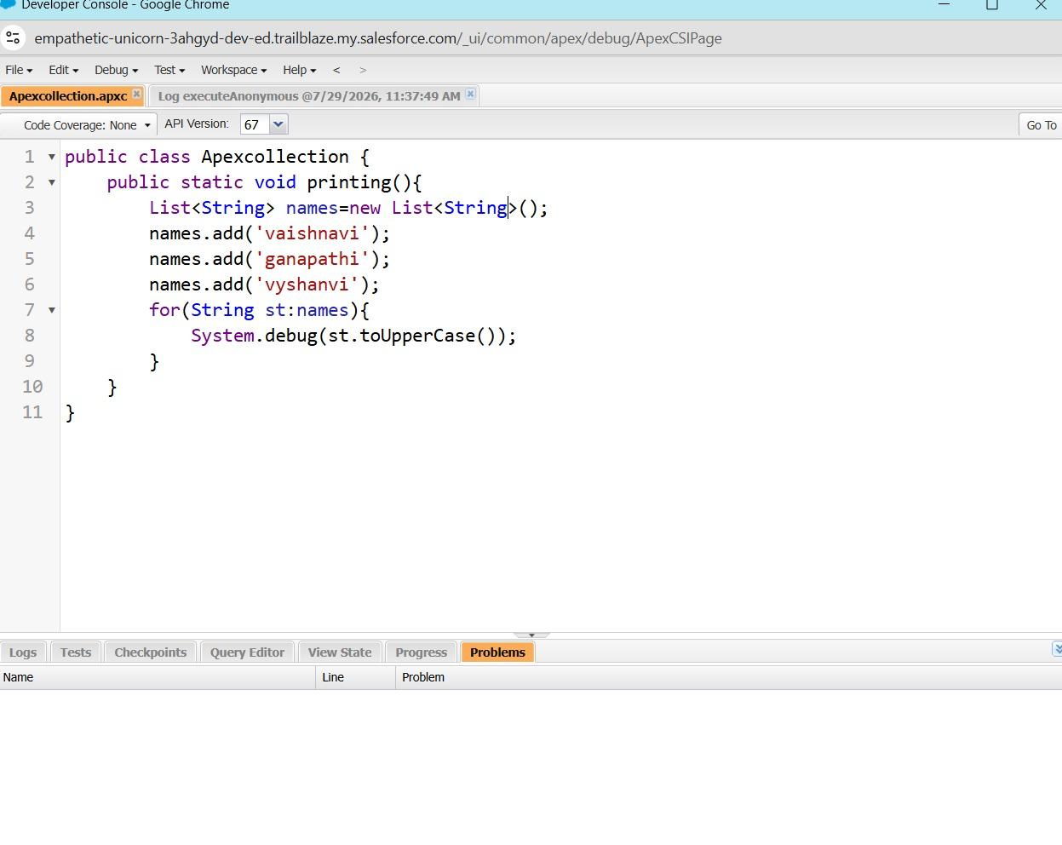
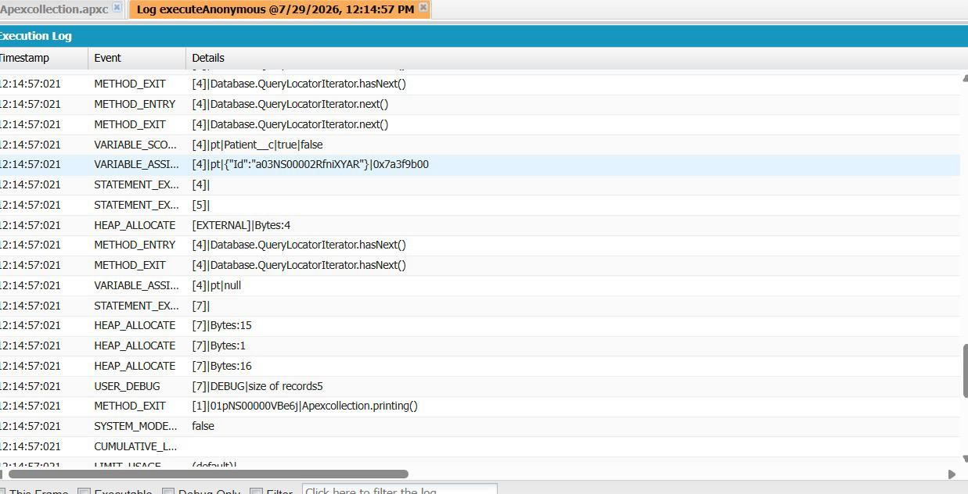

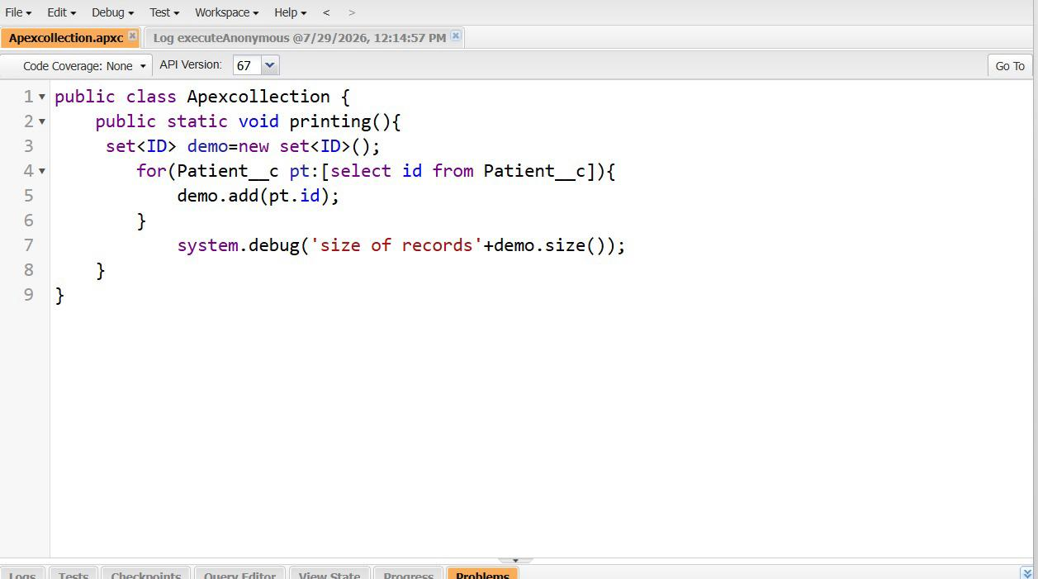
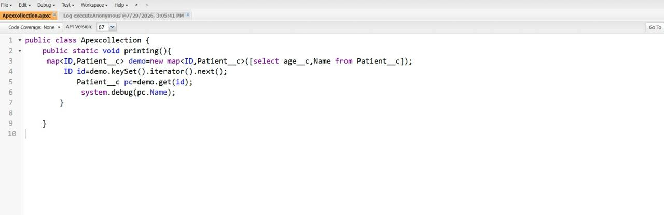

Block 2 – Governor Limits and Bulkification
What are Governor Limits?
Salesforce is a multi-tenant platform.
Governor Limits ensure that one organization does not consume excessive resources and impact others.
Common limits:
- Maximum 100 SOQL Queries
- Maximum 150 DML Statements
- CPU Time Limits
- Heap Size Limits

Bad Trigger Example
The following trigger contains SOQL inside a loop.
trigger BadApplicationTrigger
on Application__c(before insert){

for(Application__c app : Trigger.new){

Student__c student =
[SELECT Id, CGPA__c
FROM Student__c
WHERE Id = :app.Student__c];

}
}
Problem
For 200 records:
- One query executes for each record
- Governor limit exceeded
Typical Error:
System.LimitException:
Too many SOQL queries: 101

Bulkified Version
Set<Id> studentIds = new Set<Id>();

for(Application__c app : Trigger.new){
studentIds.add(app.Student__c);
}

Map<Id, Student__c> studentMap =
new Map<Id, Student__c>(
[SELECT Id, CGPA__c
FROM Student__c
WHERE Id IN :studentIds]
);
Improvements
- SOQL outside loops
- Supports bulk inserts
- Better performance
- Follows Salesforce best practices

What is Bulkification?
Bulkification means writing code that can process many records in a single transaction efficiently.
Best Practices:
- Never write SOQL inside loops
- Never write DML inside loops
- Use Lists, Sets, and Maps
- Query records in bulk
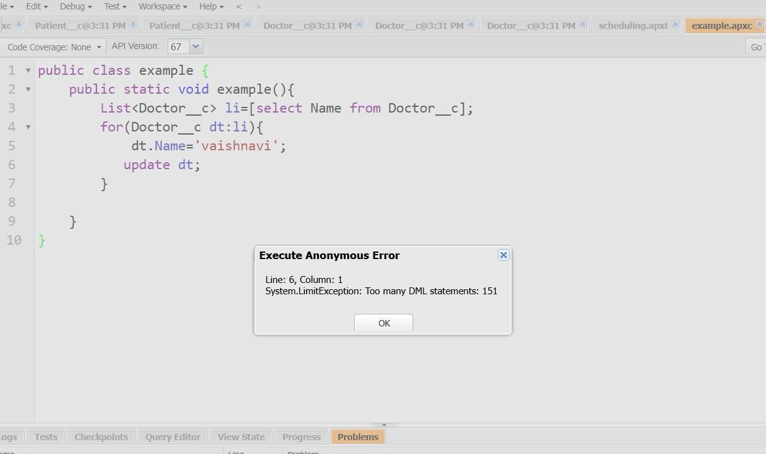
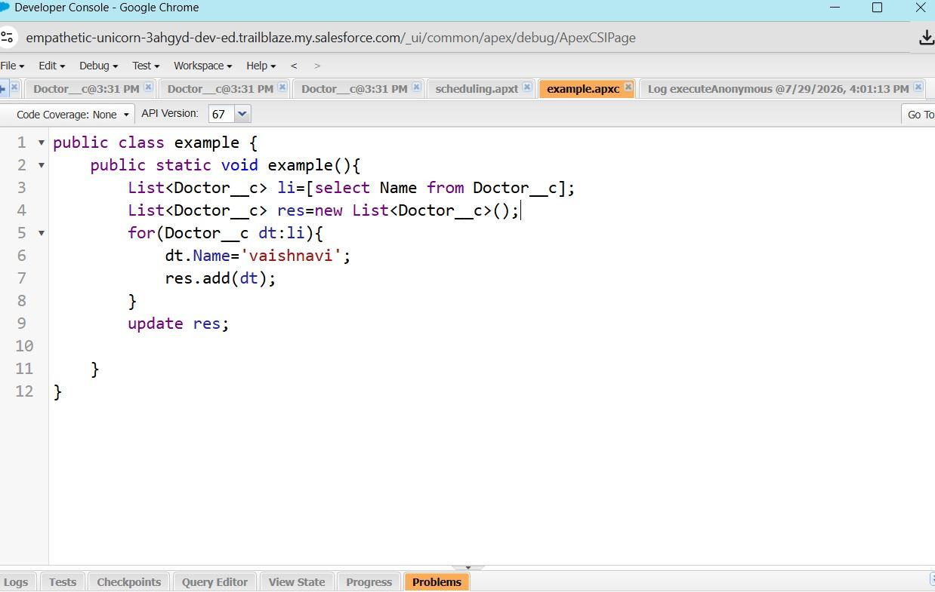
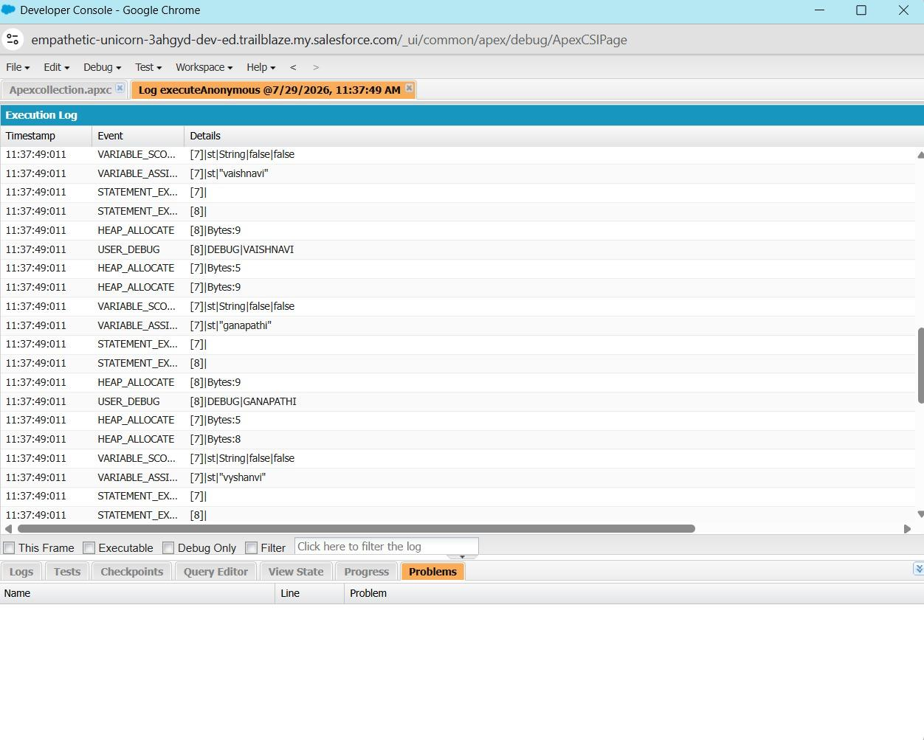

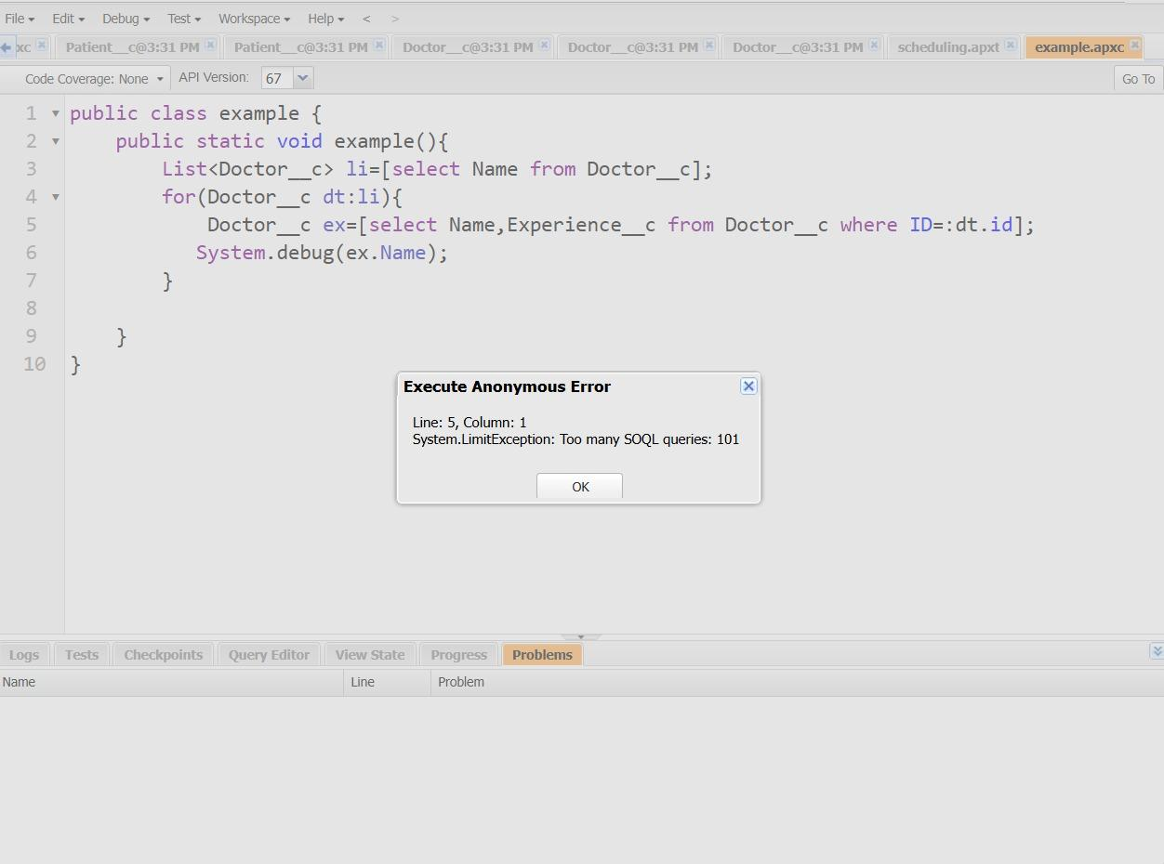
Block 3 – Asynchronous Apex
What is Asynchronous Apex?
Asynchronous Apex executes in the background.
Benefits:
- Faster user experience
- Handles long-running operations
- Reduces transaction load

Future Method Example
public class FuturePatientUpdater {

@future
public static void updatePatient(Id patientId){

Patient__c patient =
[SELECT Id, Status__c
FROM Patient__c
WHERE Id = :patientId];

patient.Status__c = 'Updated';

update patient;
}
}
Execute Anonymous:
FuturePatientUpdater.updatePatient(
'PATIENT_RECORD_ID'
);

Future Method vs Queueable Apex
Future Method | Queueable Apex
Simple implementation | More flexible
Primitive parameters only | Supports complex objects
Cannot chain jobs | Supports chaining
Older approach | Recommended approach

Why Use Batch Apex?
Batch Apex is used when:
- Processing thousands of records
- Large data cleanup
- Scheduled maintenance jobs
- Data migration activities

Block 4 – Lightning Web Components (LWC)
Parent to Child Communication
The parent component passes data to the child using a public property.
Child Component:
import { LightningElement, api }
from 'lwc';

export default class ChildComponent
extends LightningElement {

@api recordId;
}
Usage in Parent:
<c-child-component
record-id={recordId}>
</c-child-component>

Child to Parent Communication
Child Component:
handleClick(){

const event =
new CustomEvent('notify');

this.dispatchEvent(event);
}
Parent Component:
<c-child-component
onnotify={handleNotify}>
</c-child-component>
Parent JavaScript:
handleNotify(){

this.message =
'Event Received';
}
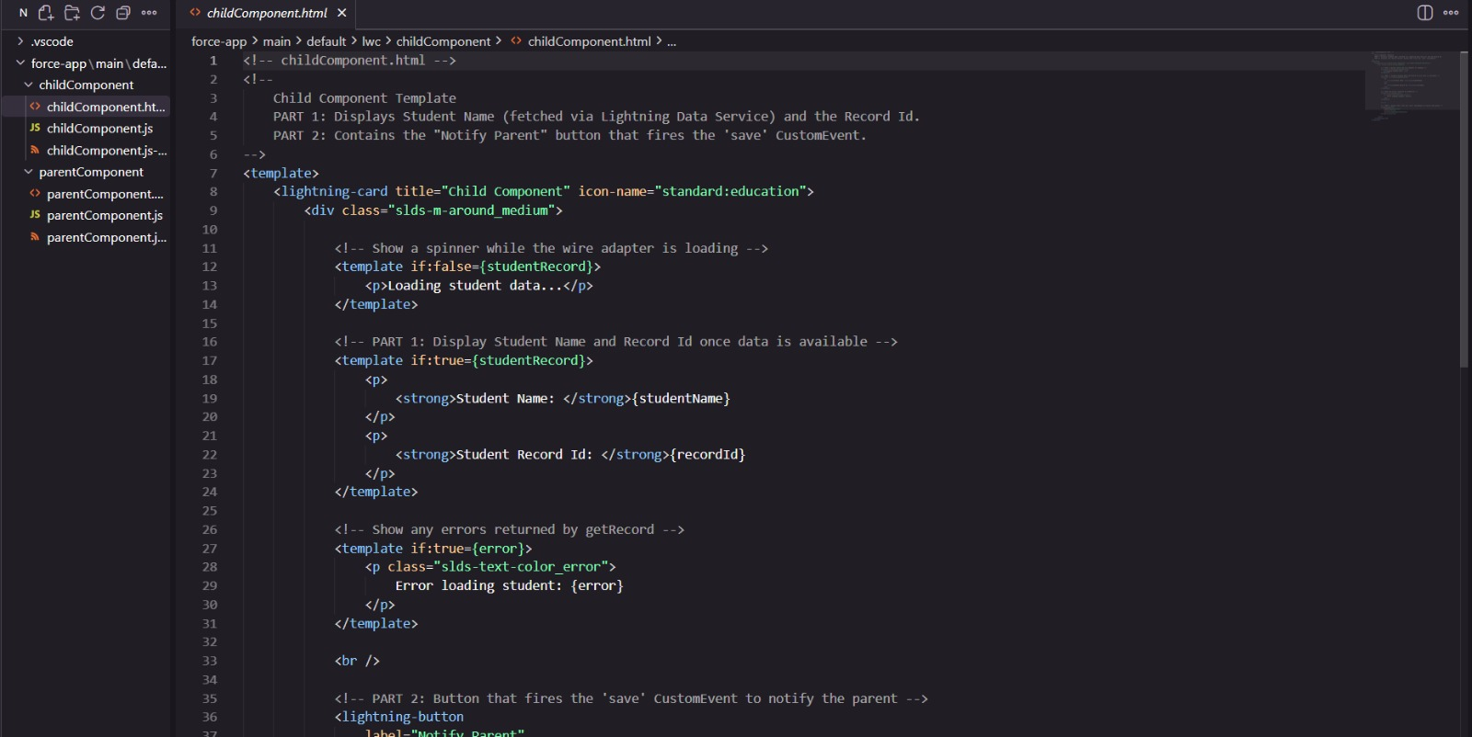
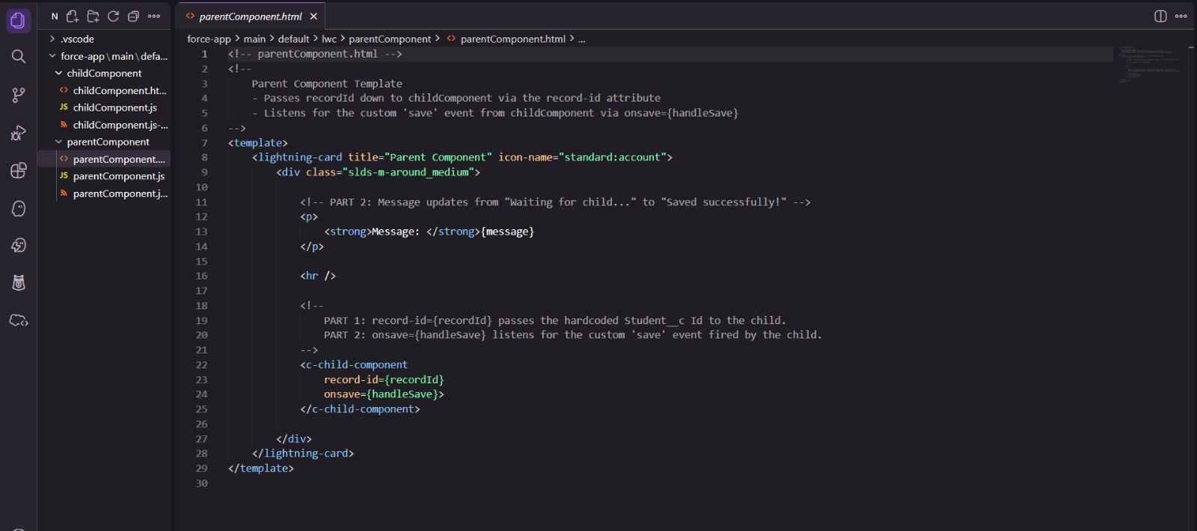
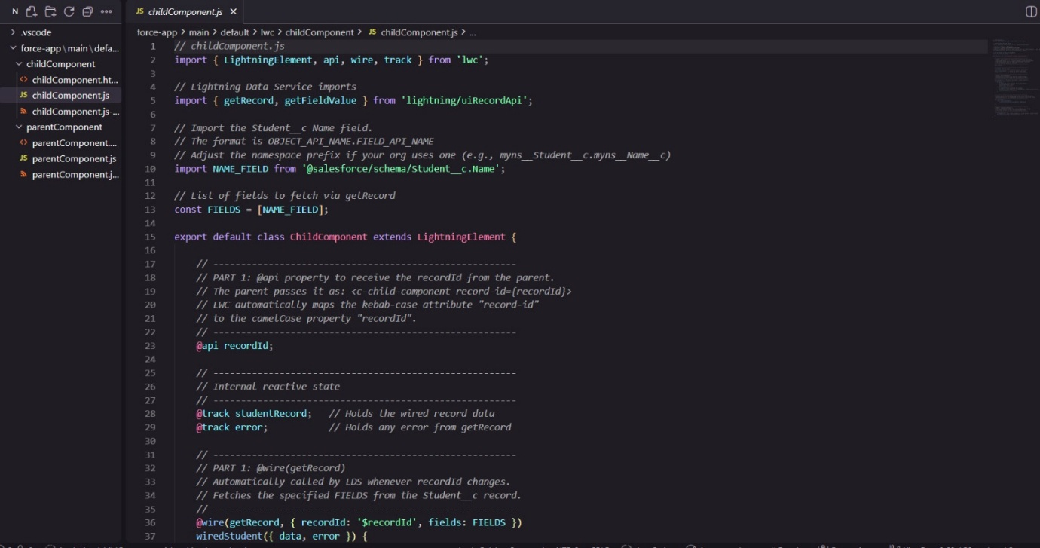
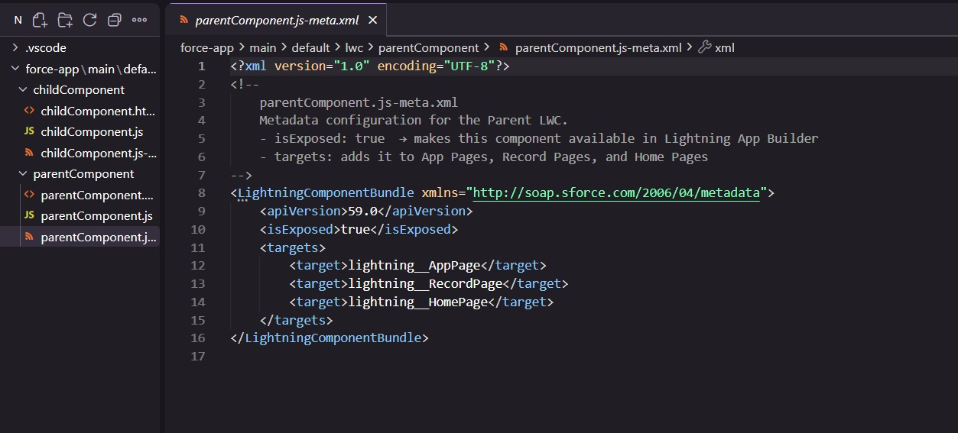

Interview Questions and Answers
What is a Governor Limit?
A Salesforce restriction that ensures fair usage of shared resources.
Why should SOQL not be used inside loops?
It can exceed the maximum query limit and cause runtime failures.
What is Bulkification?
Writing code that efficiently processes multiple records at once.
Difference Between Trigger.new and Trigger.newMap
Trigger.new:
- Returns a list of records
Trigger.newMap:
- Returns a map of Id to record
What is a Future Method?
A method that executes asynchronously in the background.
Difference Between Future and Queueable Apex
Queueable Apex is more flexible and supports job chaining, while Future methods are simpler and support only primitive parameters.
What is the purpose of List?
Stores ordered collections.
What is the purpose of Set?
Stores unique values.
What is the purpose of Map?
Stores key-value pairs for fast lookups.

Challenges Faced
- Understanding Map lookups
- Identifying SOQL inside loops
- Understanding Governor Limit errors
- Learning asynchronous execution concepts

