**Mongo Db Query Handling:  
CURD Operation, Limits, Offsets, Insert&Delete Many, Find, FindOnce, {$gt,$lt,$lte,$gte,$eq,$neq} , $and,$or, Query with Projection.**

**Quest:1** Find all the information about each products

Query: **db.products.find();**

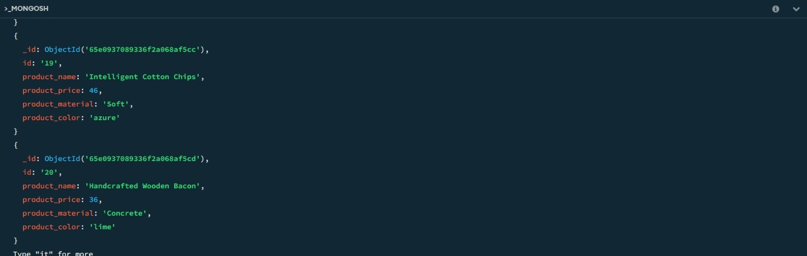

**Quest: 2** Find the product price which are between 400 to 800

Query: **db.products.find({'price':{$gte:400,$lte:800}});**

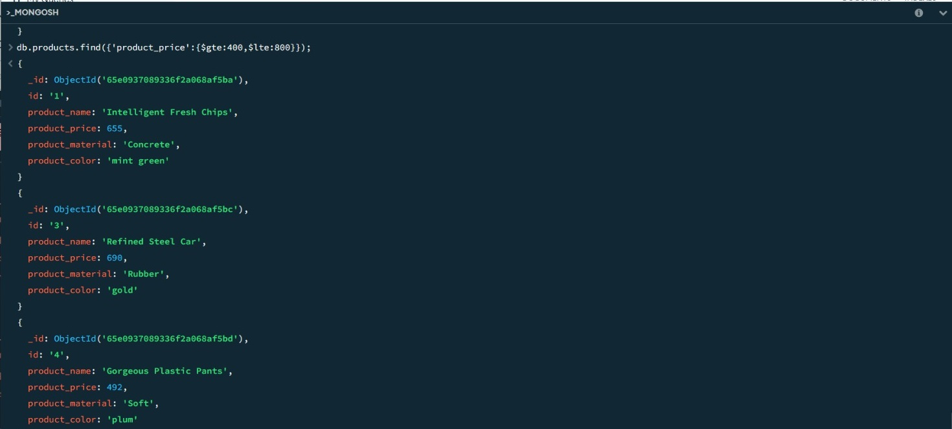

**Quest: 3** Find the product price which are not between 400 to 600

Query: **db.products.find({$or:[{'product_price':{$lt:400}},{'product_price':{$gt:600}}]});**

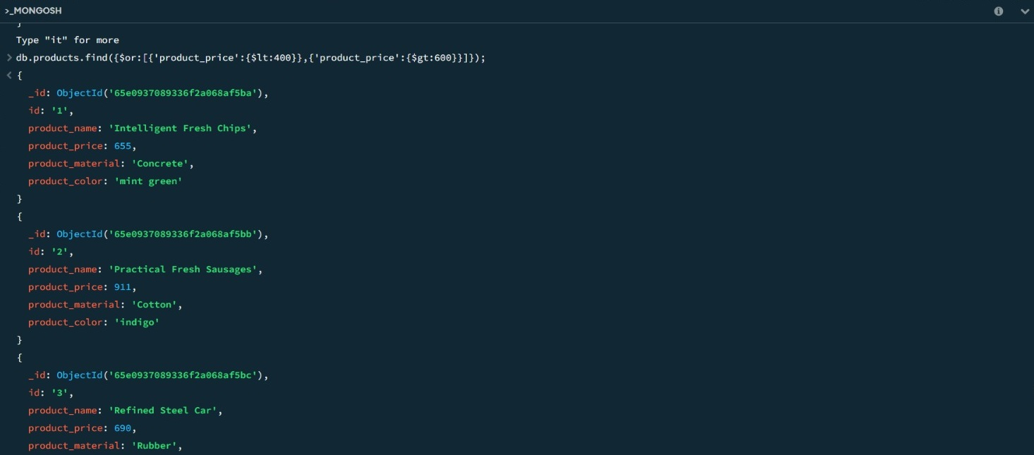

**Quest: 4** List the four product which are greater than 500 in price.

Query**: db.products.find({'product_price':{$gt:500}}).limit(4);**

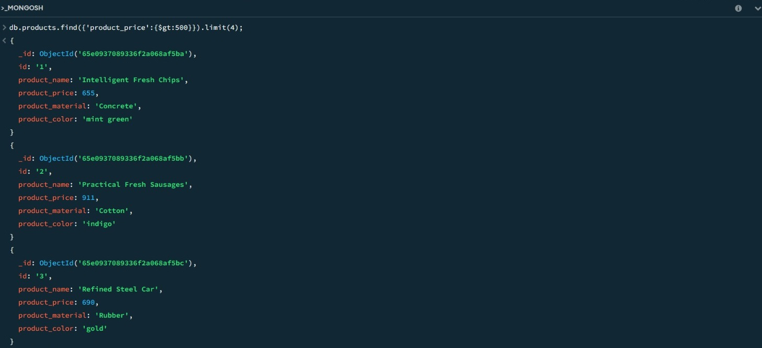

**Quest: 5** Find the product name and product material of each products

Query: **db.products.find({},{'product_name':1,'product_material':1});**

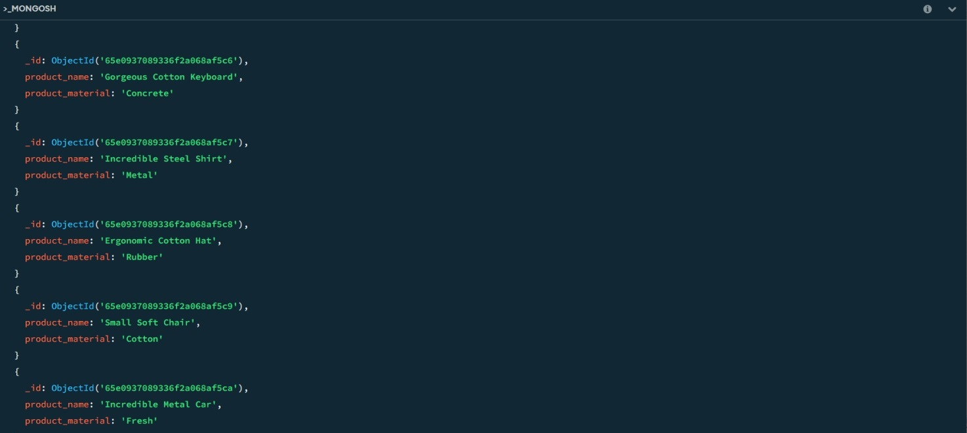

**Quest: 6** Find the product with a row id of 10

Query: **db.products.findOne({'id':’10’});**

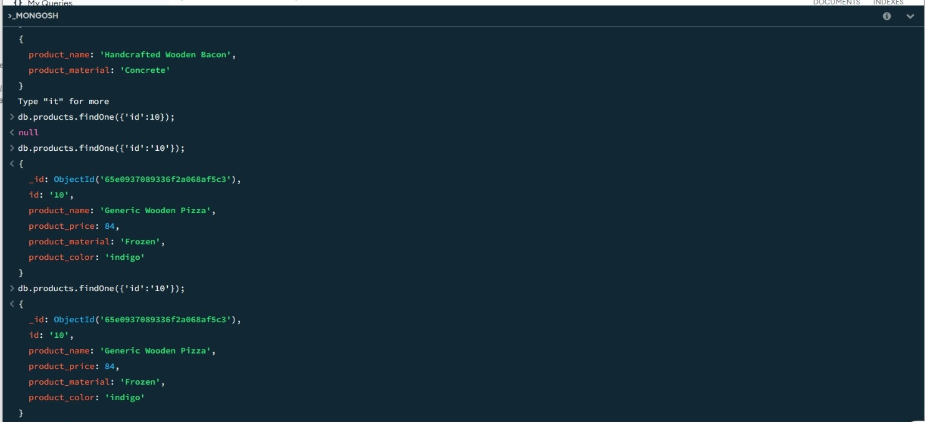

**Quest: 7** Find only the product name and product material

Query: **db.products.find({},{'product_name':1,'product_material':1,'_id':0});**

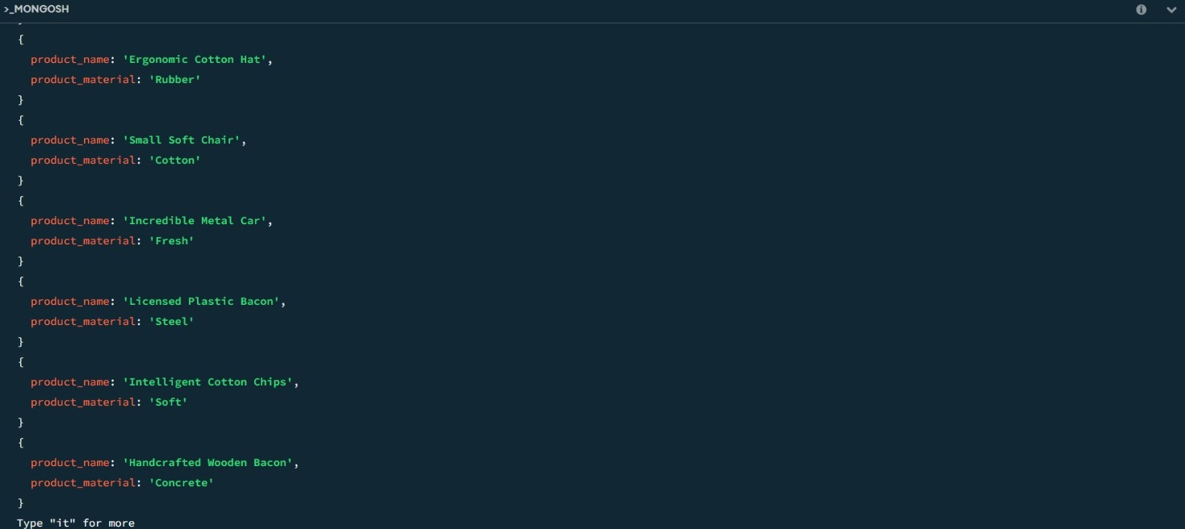

**Quest: 8** Find all products which contain the value of soft in product material

Query: **db.products.find({product_material:{$regex:/soft/i}});**

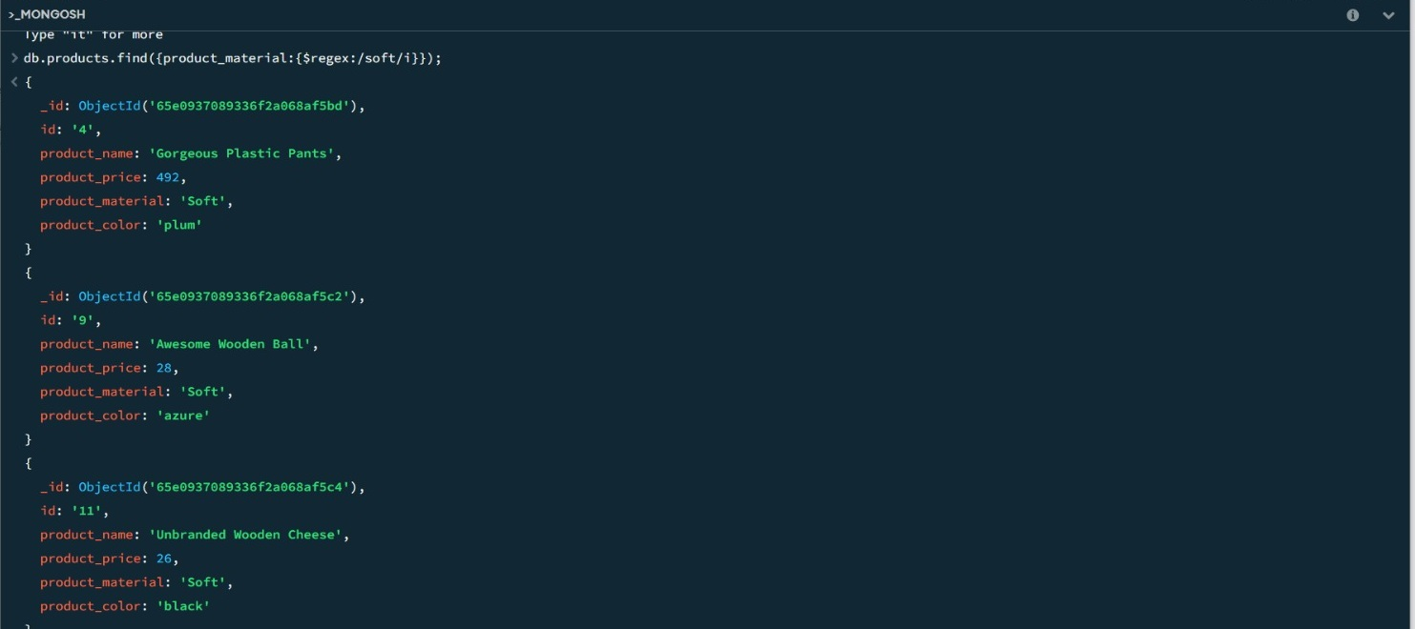

**Quest: 9** Find products which contain product color indigo  and product price 492.00

Query Way 1: **db.products.find({$and:[{'product_color':'indigo'},{'product_price':492}]});**

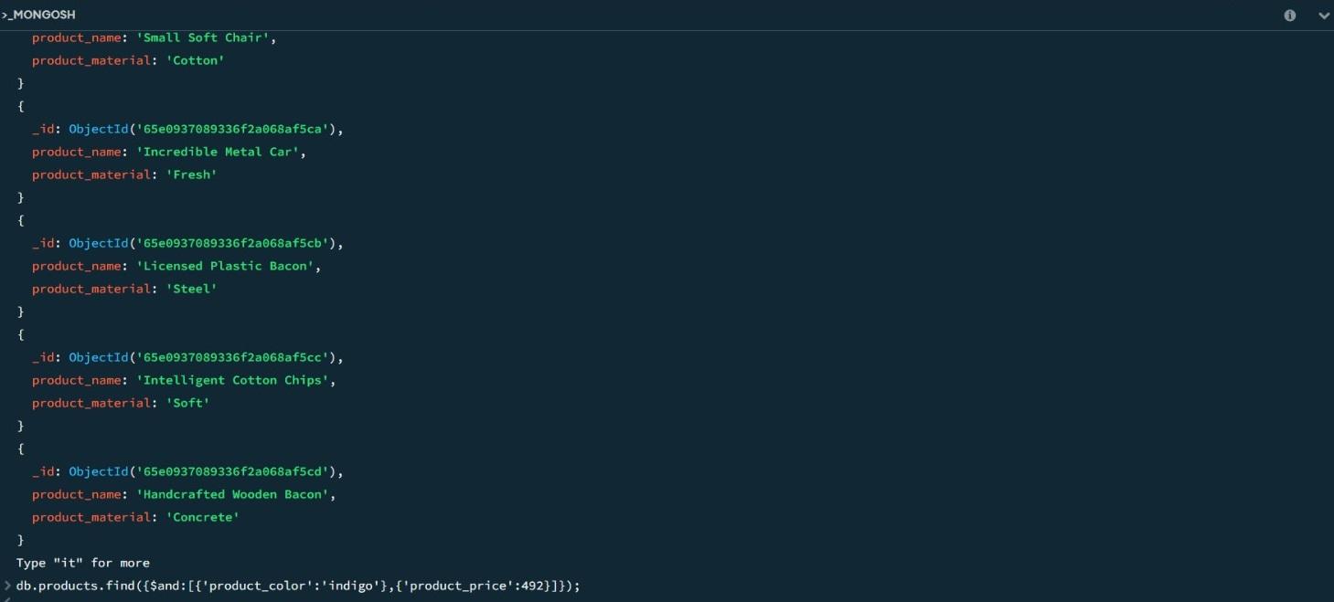

**“NO result for this. Because there is no document contain that both values”;**

**Quest: 10** Find products which contain product color indigo  and product price 492.00

Query Way 1: **db.products.deleteMany({'product_price':{$eq:36}});**

**db.products.aggregate([**

**{**

**$group: {**

**_id: "$product_price",**

**count: { $sum: 1 }**

**}**

**},**

**{**

**$match: {**

**count: { $gt: 1 }**

**}**

**}**

**]).forEach((e) => {**

**db.products.deleteMany({ product_price: e._id });**

**});**

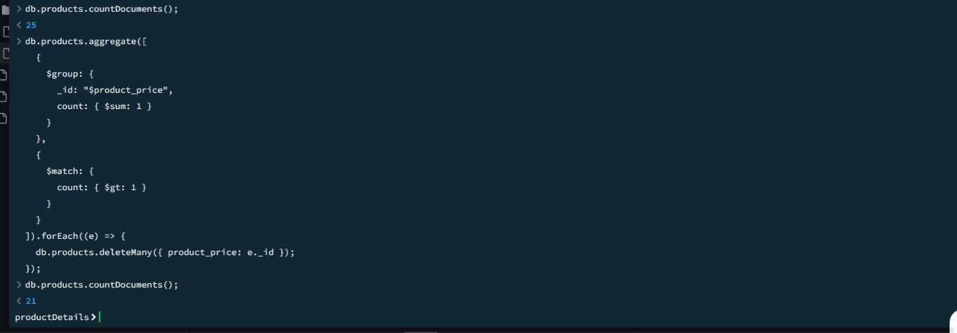

Query Way 2:

**db.products.deleteMany({$or:[{'product_price':47 },{'product_price':36}]});**

output:

**{**

**acknowledged: true,**

**deletedCount: 4**

**}**