**Mongo db Query Handling**

**-------------------------------------------**

Structures of the Zen_Class_Program DB

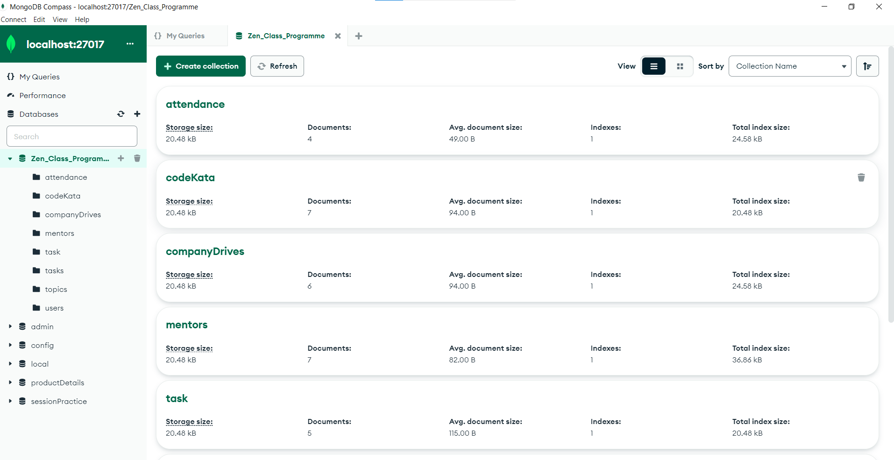

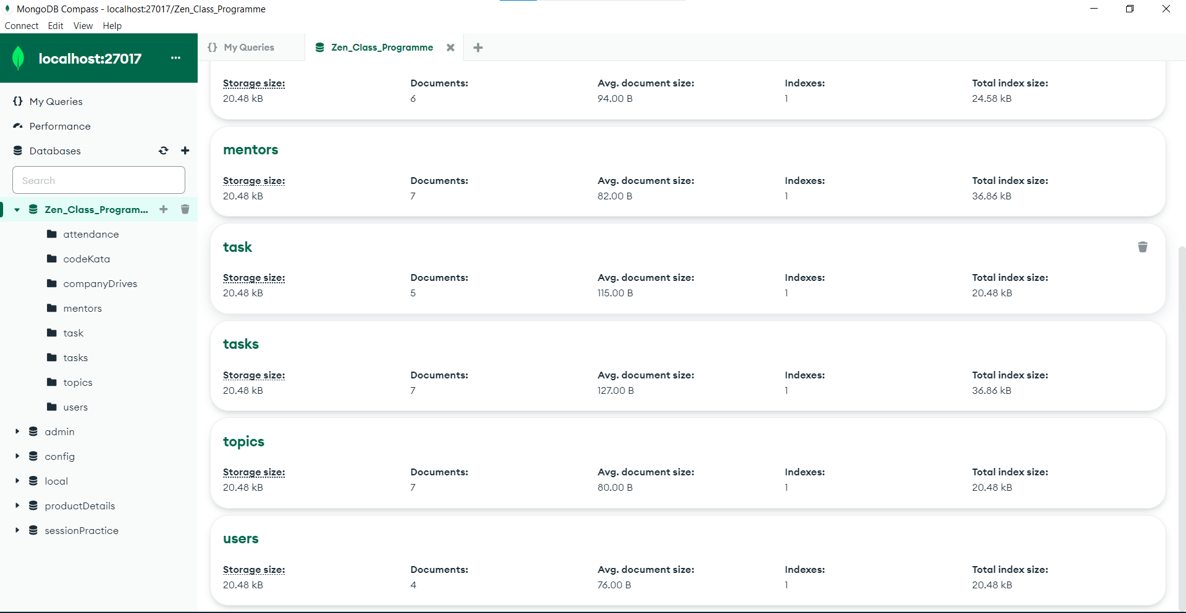

Structures of the Collections & Documents

User Collection:

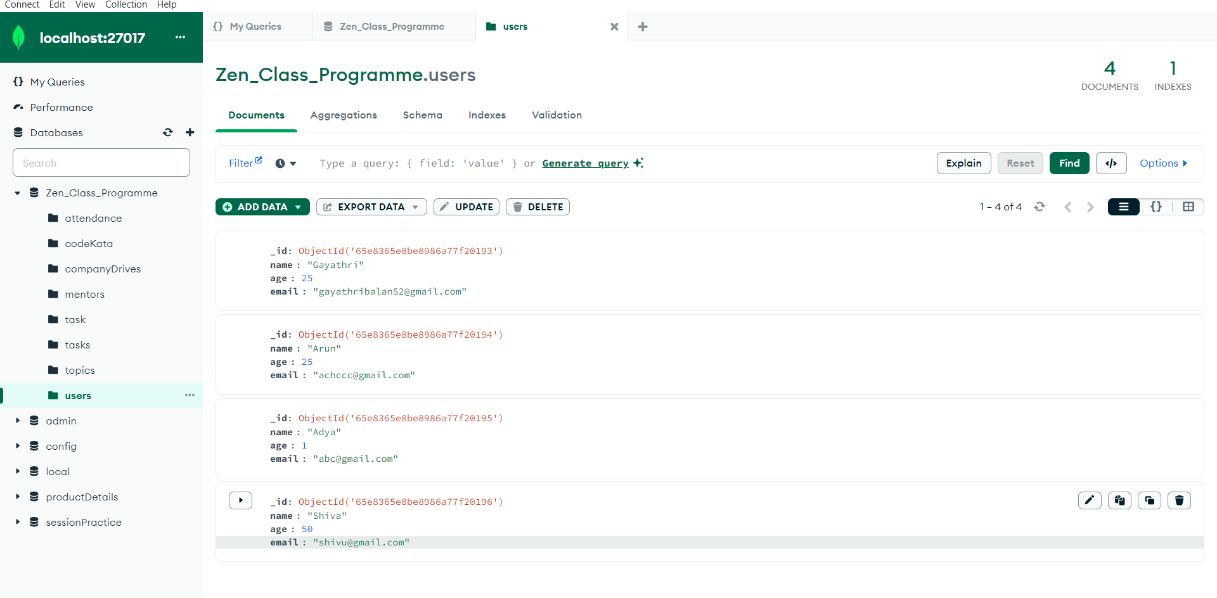

Topics Collection:

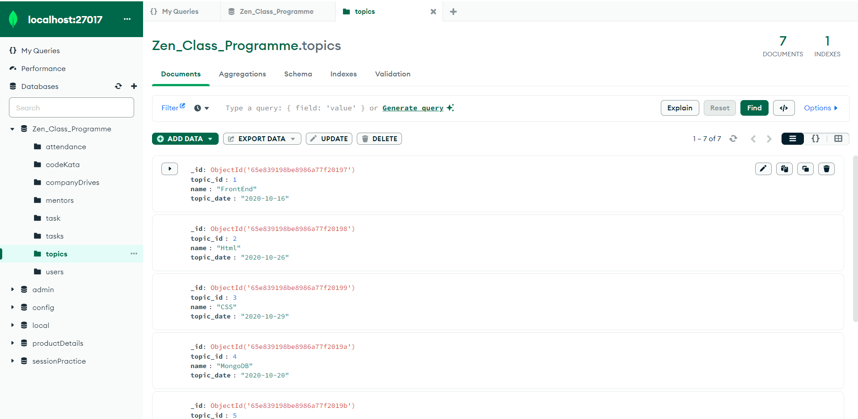

Tasks Collection: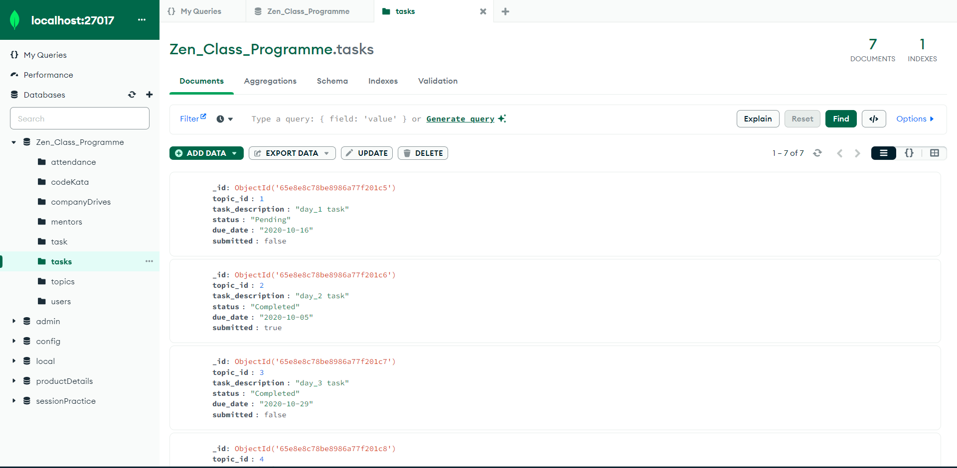

Mentor Collection:

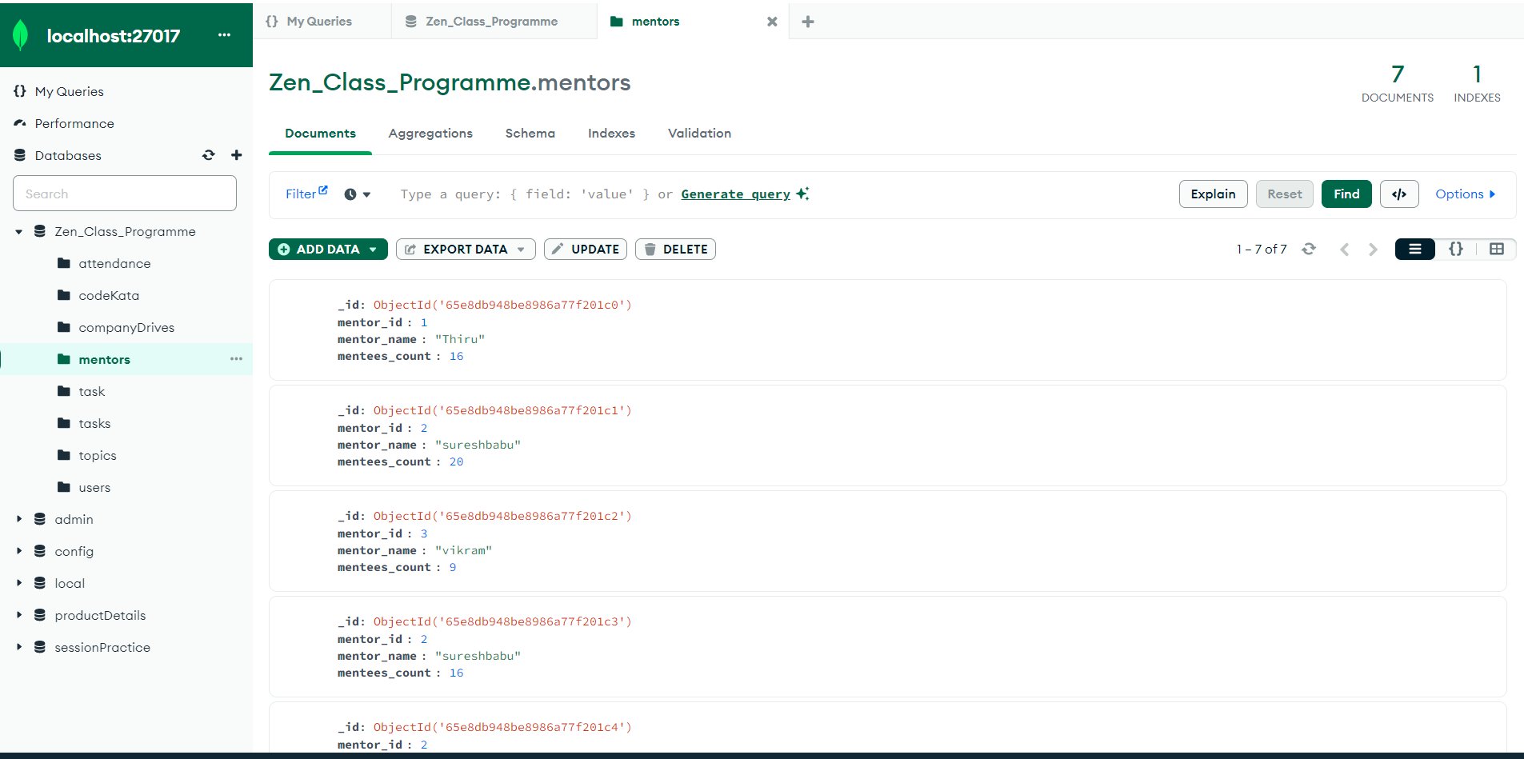

Company Drives Collections: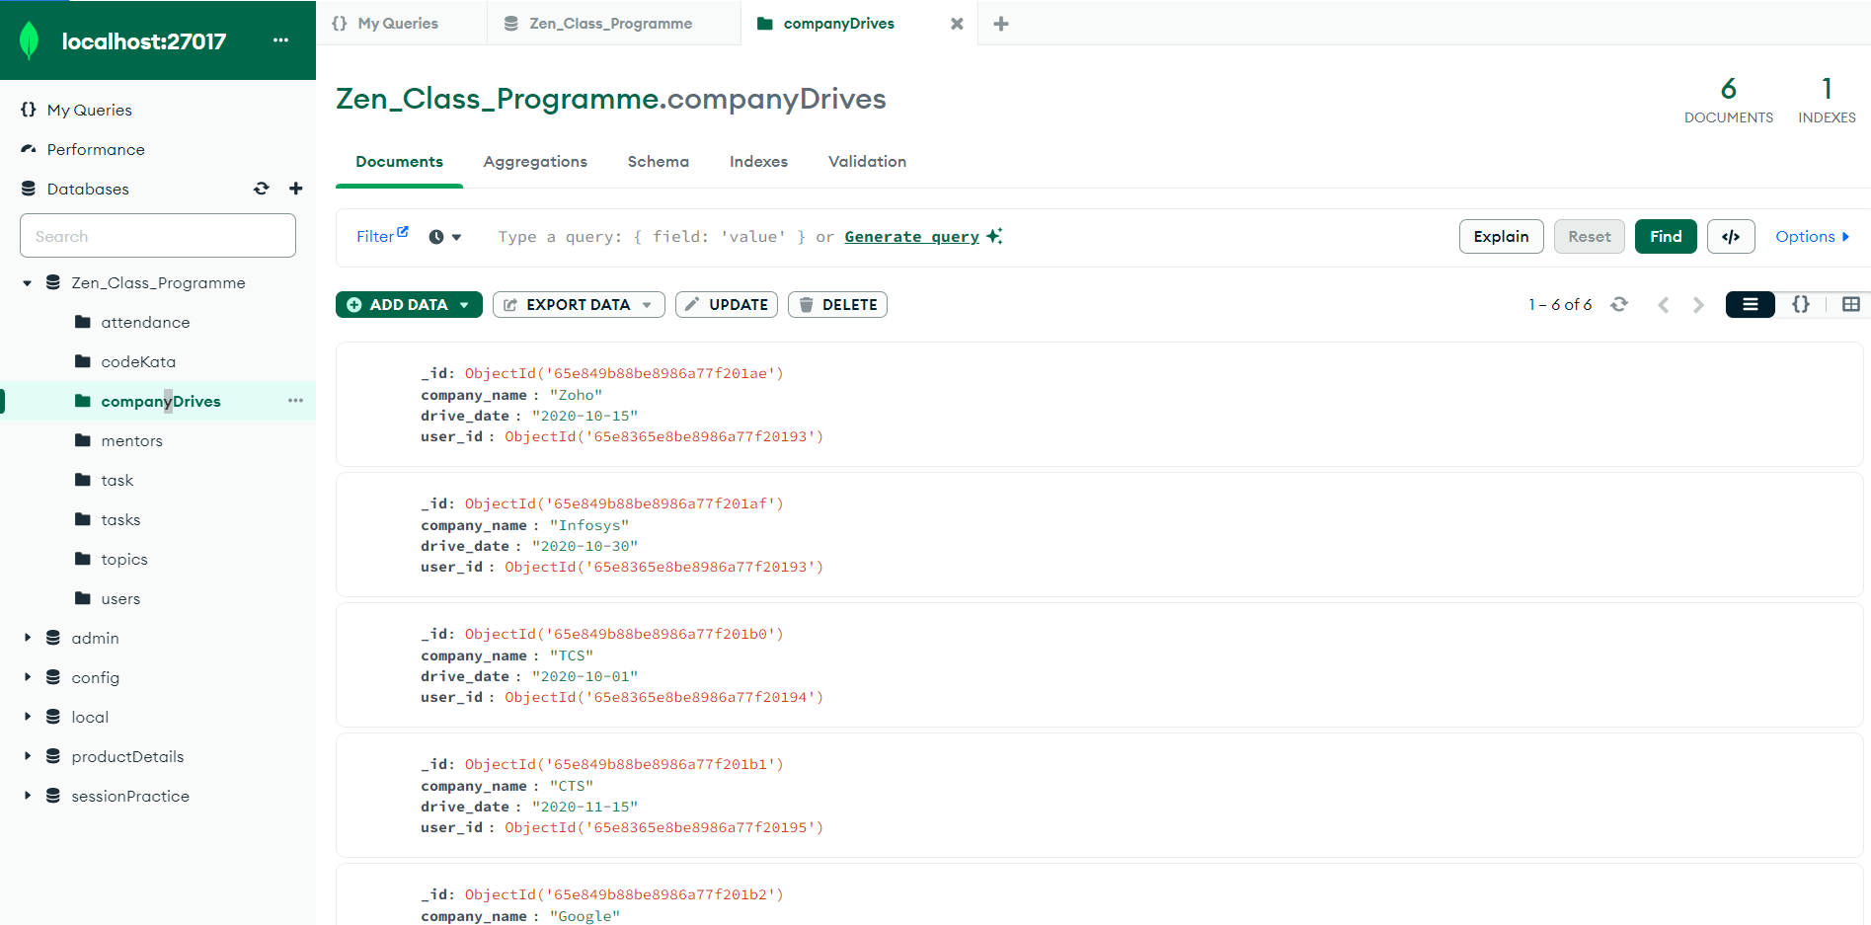

Attendance Collection:

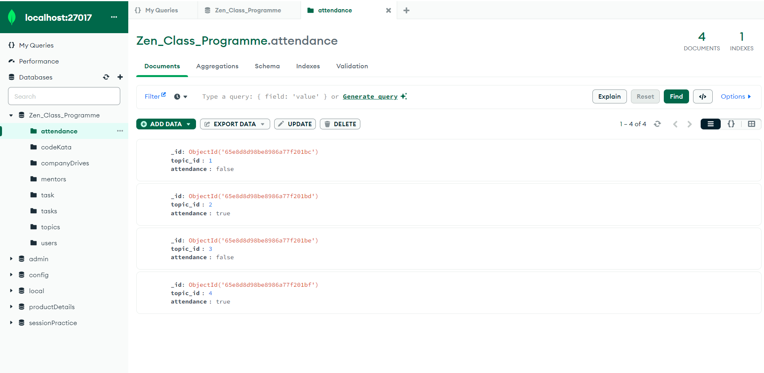

CodeKata Collection: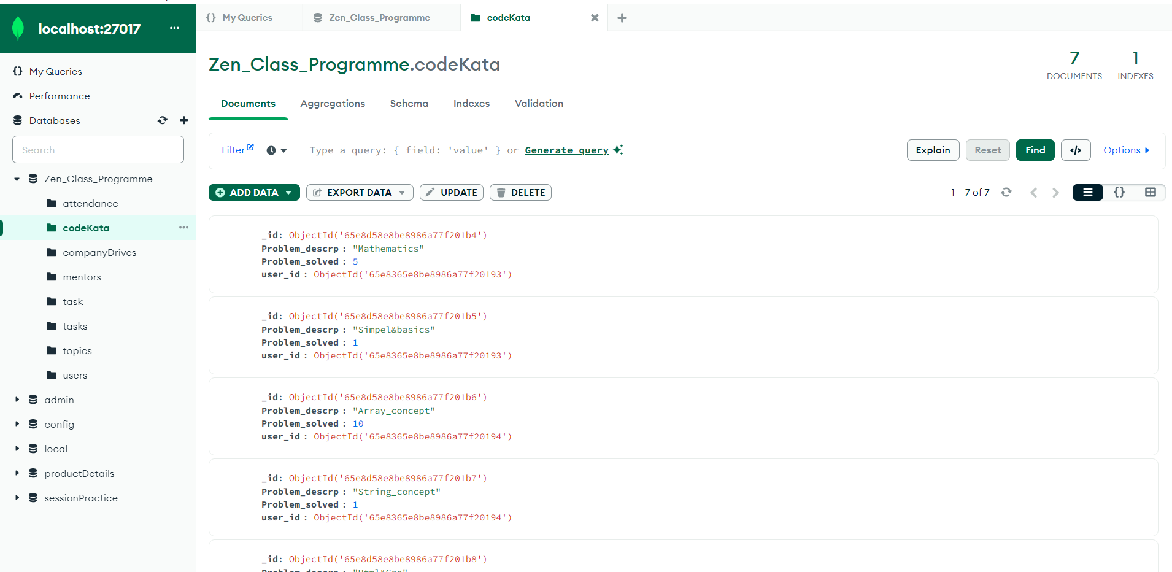

Query Problems & Solutions

1. Find all the topics and tasks which are thought in the month of October

**Query:**

db.topics.aggregate([

  {

  $lookup:{

  from:"tasks",

  localField:"topic_id",

  foreignField:"topic_id",

  as:"taskinfo"

  }

  },

    {$match:

  {$and:

  [{topic_date:{$gte:"2020-10-01",$lt:"2020-11-01"}},

  {

  $or:[{

  "taskinfo.due_date":{$gte:"2020-10-01",$lt:"2020-11-01"}},

       {"taskinfo.due_date":{$exists:false}}

  ]}

  ]}

  },

  {

  $project:{

  _id:0,topic_id:1,topic_date:1,topic:1,due_date:"$taskinfo.due_date",task_description:"$taskinfo.task_description"}

  }

  ]);

**Sample Output:**

{

  topic_id: 1,

  topic_date: '2020-10-1',

  due_date: [

    '2020-10-01'

  ],

  task_description: [

    'day_1 task'

  ]

}

{

  topic_id: 2,

  topic_date: '2020-10-5',

  due_date: [

    '2020-10-05'

  ],

  task_description: [

    'day_2 task'

  ]

}

1. **Find all the company drives which appeared between 15 oct-2020 and 31-oct-2020**

**Query:**

Query: db.companyDrives.find({

$or:[{drive_date:{$gte:"2020-10-15",$lte:"2020-10-31"}}]

});

**Sample Output:**

{

_id: ObjectId('65e849b88be8986a77f201ae'),

  company_name: 'Zoho',

  drive_date: '2020-10-15',

  user_id: ObjectId('65e8365e8be8986a77f20193'),

  userInfo: [

    {

      _id: ObjectId('65e8365e8be8986a77f20193'),

      name: 'Gayathri',

      age: 25,

      email: 'gayathribalan52@gmail.com'

    }

  ]

}

{

  _id: ObjectId('65e849b88be8986a77f201af'),

  company_name: 'Infosys',

  drive_date: '2020-10-30',

  user_id: ObjectId('65e8365e8be8986a77f20193'),

  userInfo: [

    {

      _id: ObjectId('65e8365e8be8986a77f20193'),

      name: 'Gayathri',

      age: 25,

      email: 'gayathribalan52@gmail.com'

    }

  ]

}

1. Find all the company drives and students who are appeared for the placement.

**Query:**

Way:1

db.companyDrives.aggregate([

  {

  $lookup:{

  from:"users",

  localField:"user_id",

  foreignField:"_id",

  as:"userInfo"

  }

  },

    {$unwind:"$userInfo"},

  {

  $project:{

  _id:0,

  company_name:1,

  drive_date:1,

  userId:"$userInfo._id",

  userName:"$userInfo.name",

  age:"$userInfo.age",

  email:"$userInfo.email"

  }

  }

  ]);

Way: 2

{

 db.companyDrives.aggregate([

{$lookup:{

from:"users",

localField:"user_id",

foreignField:"_id",

as:"userInfo"

}

},

{$project:{

_id:0,

company_name:1,

drive_date:1,

userInfo:"$userInfo"

}

}

]);

Sample Output 1

 {

      company_name: 'Zoho',

      drive_date: '2020-10-15',

      userId: ObjectId('65e8365e8be8986a77f20193'),

      userName: 'Gayathri',

      age: 25,

      email: 'gayathribalan52@gmail.com'

    }

    {

      company_name: 'Infosys',

      drive_date: '2020-10-30',

      userId: ObjectId('65e8365e8be8986a77f20193'),

      userName: 'Gayathri',

      age: 25,

      email: 'gayathribalan52@gmail.com'

    }

Sample Output 2:

{

      company_name: 'Zoho',

      drive_date: '2020-10-15',

      userInfo: [

        {

          _id: ObjectId('65e8365e8be8986a77f20193'),

          name: 'Gayathri',

          age: 25,

          email: 'gayathribalan52@gmail.com'

        }

      ]

    }

    {

  company_name: 'Infosys',

  drive_date: '2020-10-30',

  userInfo: [

    {

      _id: ObjectId('65e8365e8be8986a77f20193'),

      name: 'Gayathri',

      age: 25,

      email: 'gayathribalan52@gmail.com'

    }

  ]

}

1. Find the number of problems solved by the user in codekata

**Query:**

db.codeKata.aggregate([

  {$lookup:{

  from:"users",

  localField:'user_id',

  foreignField:"_id",

  as:"userInfo"

  }},

  {$group:

  {

  _id:"$user_id",

  userName:{$first:"$userInfo.name"},

  total_problem_solved:{$sum:"$Problem_solved"}

  }}

  ]);

**Sample Output:**

{

    _id: ObjectId('65e8365e8be8986a77f20193'),

    userName: [

      'Gayathri'

    ],

    total_problem_solved: 6

  }

  {

    _id: ObjectId('65e8365e8be8986a77f20194'),

    userName: [

      'Arun'

    ],

    total_problem_solved: 11

  },

  {

    _id: ObjectId('65e8365e8be8986a77f20196'),

    userName: [

      'Shiva'

    ],

    total_problem_solved: 2

  }

1. Find all the mentors with who has the mentee's count more than 15

Query:

db.mentors.aggregate([

    {

  $group:{

  _id:"$mentor_id",

  mentor_id:{$first:"$mentor_id"},

  mentor_name:{$first:"$mentor_name"},

  total_mentees_count:{$sum:"$mentees_count"}

  }

  },

    {$match:{total_mentees_count:{$gt:15}

  }},

    {$project:{

  _id:0,

  mentor_id:1,

  mentor_name:1,

  total_mentees_count:1

  }

  }

  ])

**Sample Output:**

{

    mentor_id: 2,

    mentor_name: 'sureshbabu',

    total_mentees_count: 54

  }

  {

    mentor_id: 1,

    mentor_name: 'Thiru',

    total_mentees_count: 16

  }

1. Find the number of users who are absent and task is not submitted  between 15 oct-2020 and 31-oct-2020

**Query:**

 db.attendance.aggregate([

    {$lookup:

    {from:"topics",

    localField:"topic_id",

    foreignField:"topic_id",

    as:"topics_info"

    }},

     {

      $lookup:

    {from:"tasks",

    localField:"topic_id",

    foreignField:"topic_id",

    as:"tasks_info"

    }},

  {$match:{

attendance:false,

"tasks_info.submitted":false,

$and:[{"topics_info.topic_date":{$gte:"2020-10-15",$lte:"2020-10-31"}},

      {"tasks_info.due_date":{$gte:"2020-10-15",$lte:"2020-10-31"}}]

}

}

])

**Sample Output:**

{

  _id: ObjectId('65e8d8d98be8986a77f201bc'),

  topic_id: 1,

  attendance: false,

  topics_info: [

    {

      _id: ObjectId('65e839198be8986a77f20197'),

      topic_id: 1,

      name: 'FrontEnd',

      topic_date: '2020-10-16'

    }

  ],

  tasks_info: [

    {

      _id: ObjectId('65e8e8c78be8986a77f201c5'),

      topic_id: 1,

      task_description: 'day_1 task',

      status: 'Pending',

      due_date: '2020-10-16',

      submitted: false

    }

  ]

}

{

  _id: ObjectId('65e8d8d98be8986a77f201be'),

  topic_id: 3,

  attendance: false,

  topics_info: [

    {

      _id: ObjectId('65e839198be8986a77f20199'),

      topic_id: 3,

      name: 'CSS',

      topic_date: '2020-10-29'

    }

  ],

  tasks_info: [

    {

      _id: ObjectId('65e8e8c78be8986a77f201c7'),

      topic_id: 3,

      task_description: 'day_3 task',

      status: 'Completed',

      due_date: '2020-10-29',

      submitted: false

    }

  ]

}

*************************************End******************************************

**Thank You!**