Title: Exploring the Differences Between the Document and Window Objects in JavaScript

**Introduction:**

When delving into the world of web development, understanding the intricacies of JavaScript is crucial. Two fundamental objects that play a significant role in client-side scripting are the **document** and **window** objects. Although they may seem similar at first glance, they serve distinct purposes and have unique properties and methods. In this blog, we'll explore the key differences between the **document** and **window** objects in JavaScript.

Title: Exploring the Differences Between the Document and Window Objects in JavaScript

Introduction:

When delving into the world of web development, understanding the intricacies of JavaScript is crucial. Two fundamental objects that play a significant role in client-side scripting are the **document** and **window** objects. Although they may seem similar at first glance, they serve distinct purposes and have unique properties and methods. In this blog, we'll explore the key differences between the **document** and **window** objects in JavaScript.

1. **Scope and Hierarchy:**
   * The **window** object represents the browser window or tab. It is the global object and acts as the top-level container for all other objects, including the **document** object.
   * The **document** object, on the other hand, represents the HTML document loaded in the browser. It is a property of the **window** object and is essentially a child of the **window**.
2. **Global vs. Document-Specific:**
   * The **window** object is global and remains constant throughout the entire lifecycle of the web page. It encompasses properties and methods that are not tied to a specific HTML document.
   * The **document** object, however, is specific to the loaded HTML document. It provides access to the content within the document, such as elements, styles, and other document-specific details.

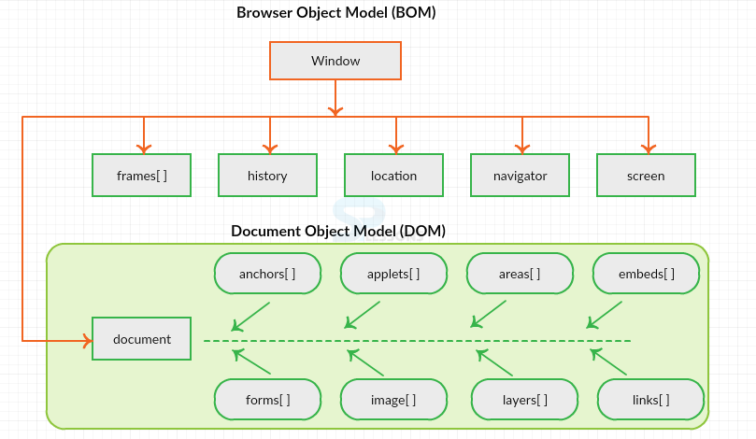

1. **Properties and Methods:**
   * The **window** object contains properties and methods that are not directly related to the document structure. Examples include **window.innerWidth**, which provides the inner width of the browser window, and **window.alert()**, which displays an alert dialog.
   * The **document** object, on the other hand, deals specifically with the content of the HTML document. Common properties include **document.title** for the document title and methods like **document.getElementById()** to access elements by their ID.

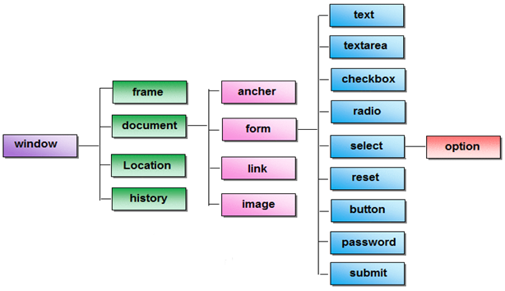

1. **Lifecycle and Events:**
   * The **window** object handles global events and aspects of the browser window, such as resizing, scrolling, and navigation. It also manages the overall lifecycle events of the page, like **onload** and **onunload**.
   * The **document** object is more focused on events related to the content within the HTML document. Events like **onclick**, **onchange**, and **onsubmit** are associated with elements within the document and are managed by the **document** object.
2. **Relationship Between window and document:**
   * The **document** object is a property of the **window** object. You can access it using **window.document** or simply **document**.
   * While the **window** object encompasses the entire browser window, the **document** object represents the specific HTML document loaded in that window.

Conclusion:

In summary, the **document** and **window** objects in JavaScript serve distinct roles in web development. The **window** object deals with global aspects of the browser window, while the **document** object focuses on the content within the loaded HTML document. Understanding the differences between these two objects is crucial for effective client-side scripting and manipulation of web page elements.

------------------------------------------------------------***END***---------------------------------------------------------------