**Step 1.2.1:** Creating a dynamic web project

* Open Eclipse
* Go to the **File** menu. Choose **New->Dynamic Web Project**
* Enter the project name as **FirstServlet**. Click on **Next**
* Enter nothing in the next screen and click on **Next**
* Check the checkbox **Generate web.xml deployment descriptor** and click on **Finish**
* This will create the project files in the Project Explorer

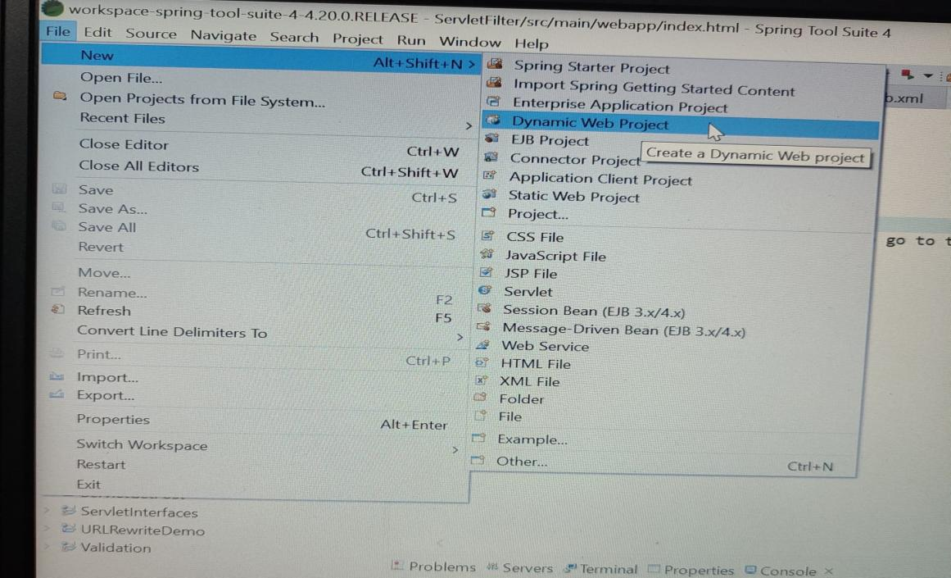

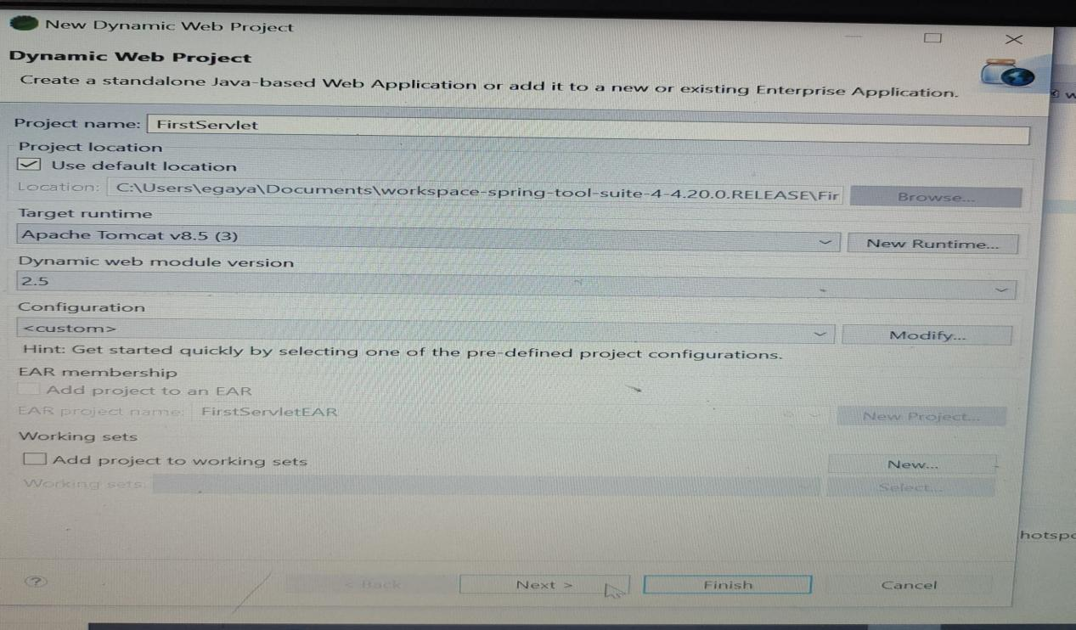

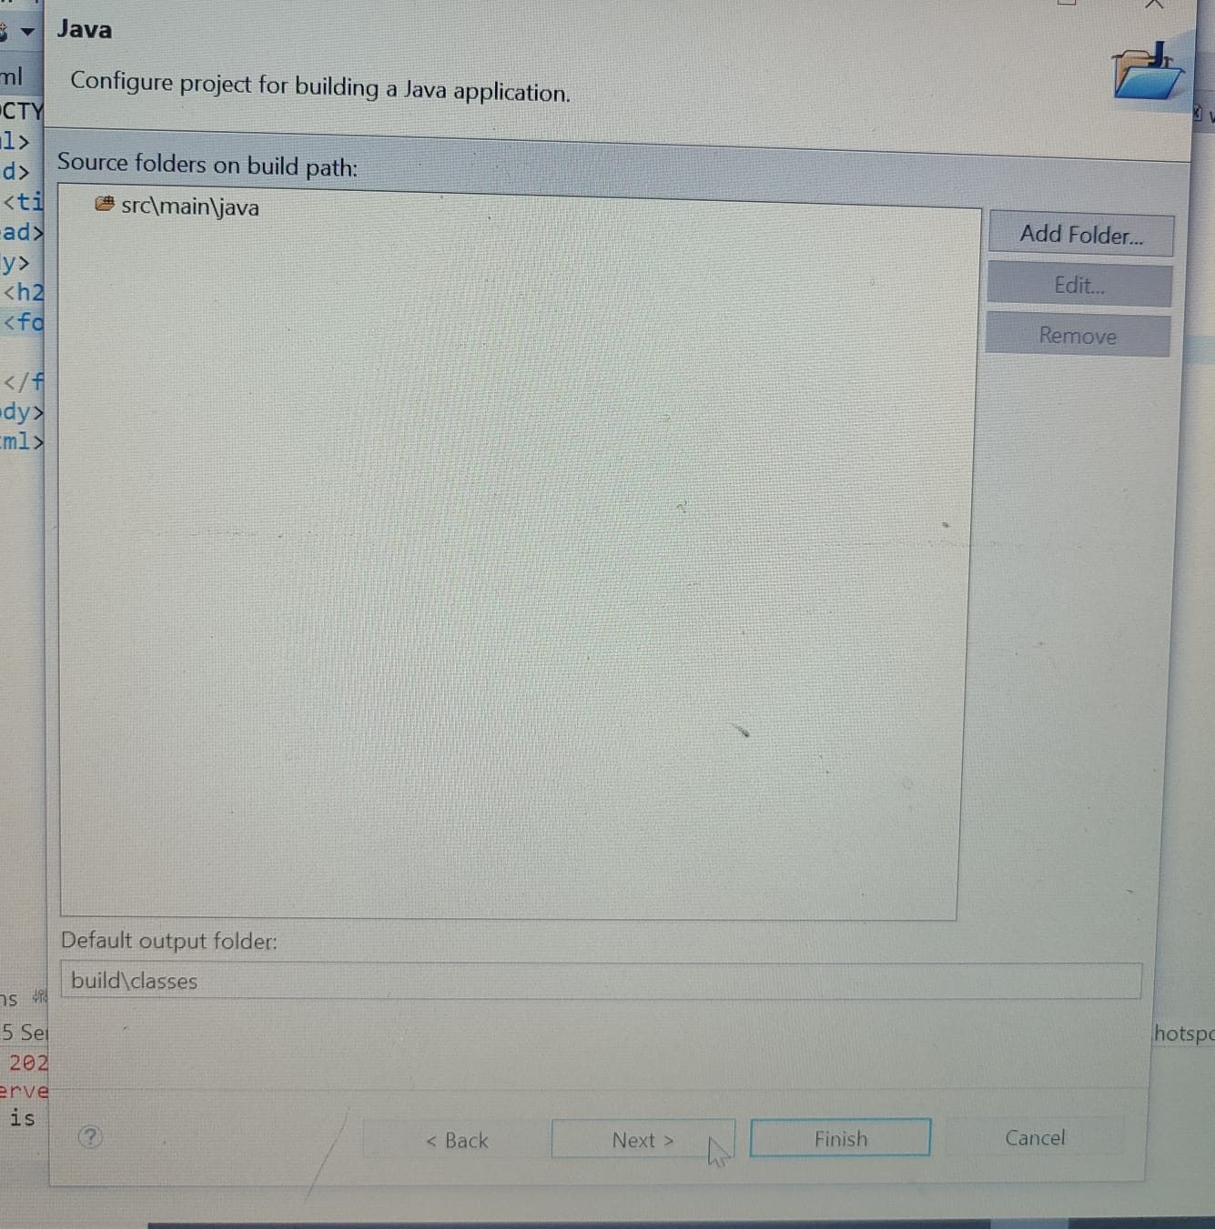

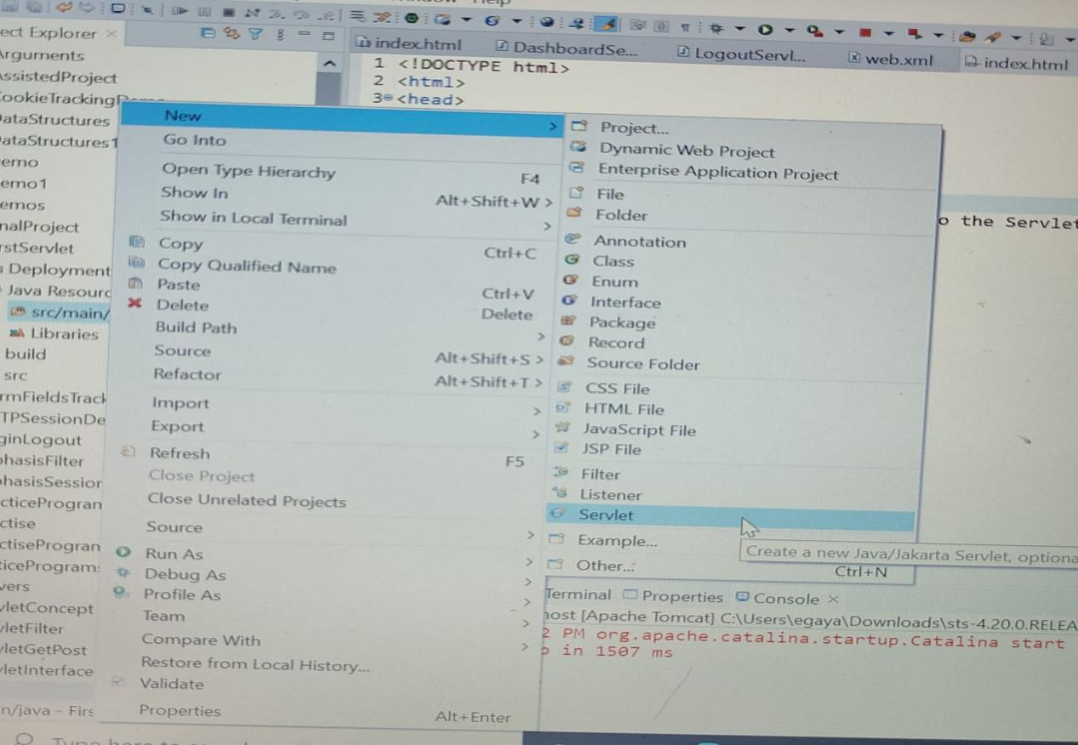

**Step 1.2.2:** Creating a servlet

* In the Project Explorer, expand **ServletConcept->Java Resources**
* Right click on **src** and choose **New->Servlet**
* In **Class Name,** enter **FirstServlet** and click on **Finish**

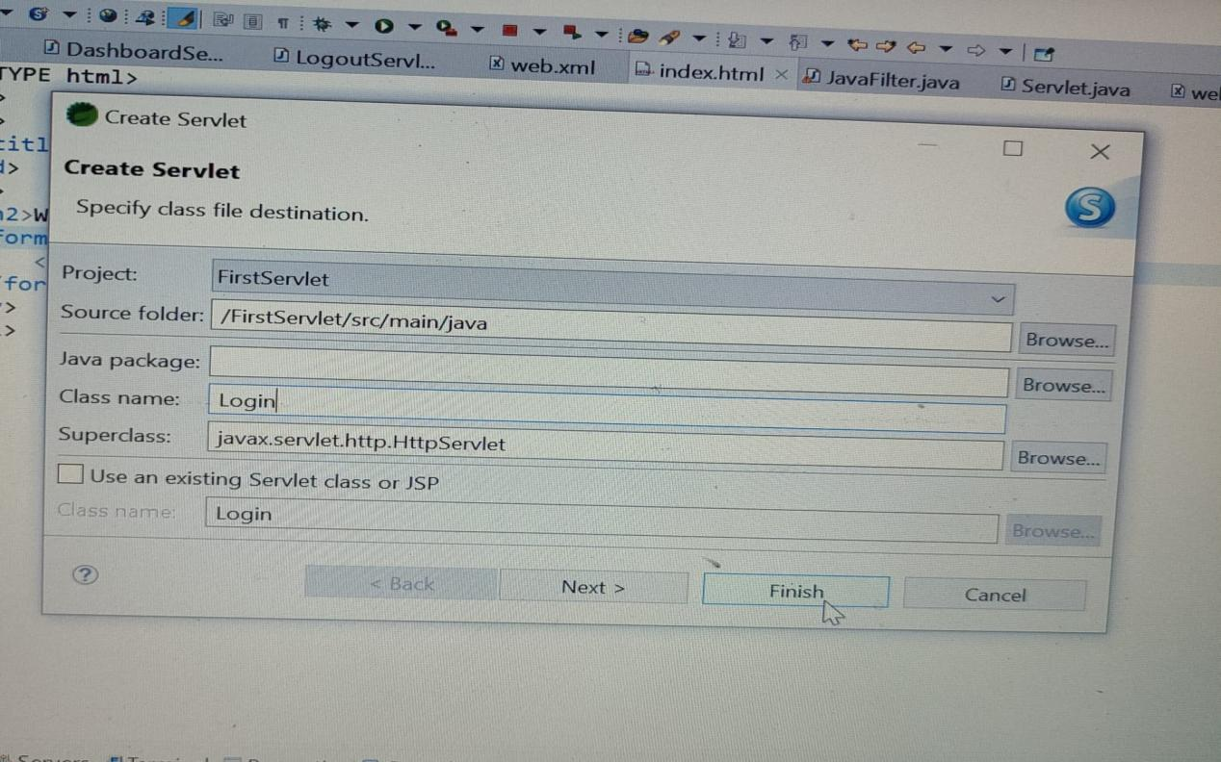

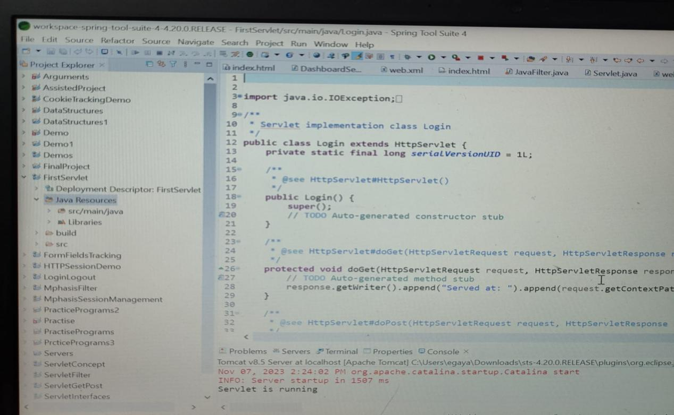

**Step 1.2.3:** Checking for servlet-api.jar

* Before building the project, we need to add servlet-api.jar to the project
* To add it to the project, follow the below mentioned steps:
  + In the Project Explorer, right click on **FirstServlet** and choose **Properties**
  + Select **Java Build Path** from the options on the left

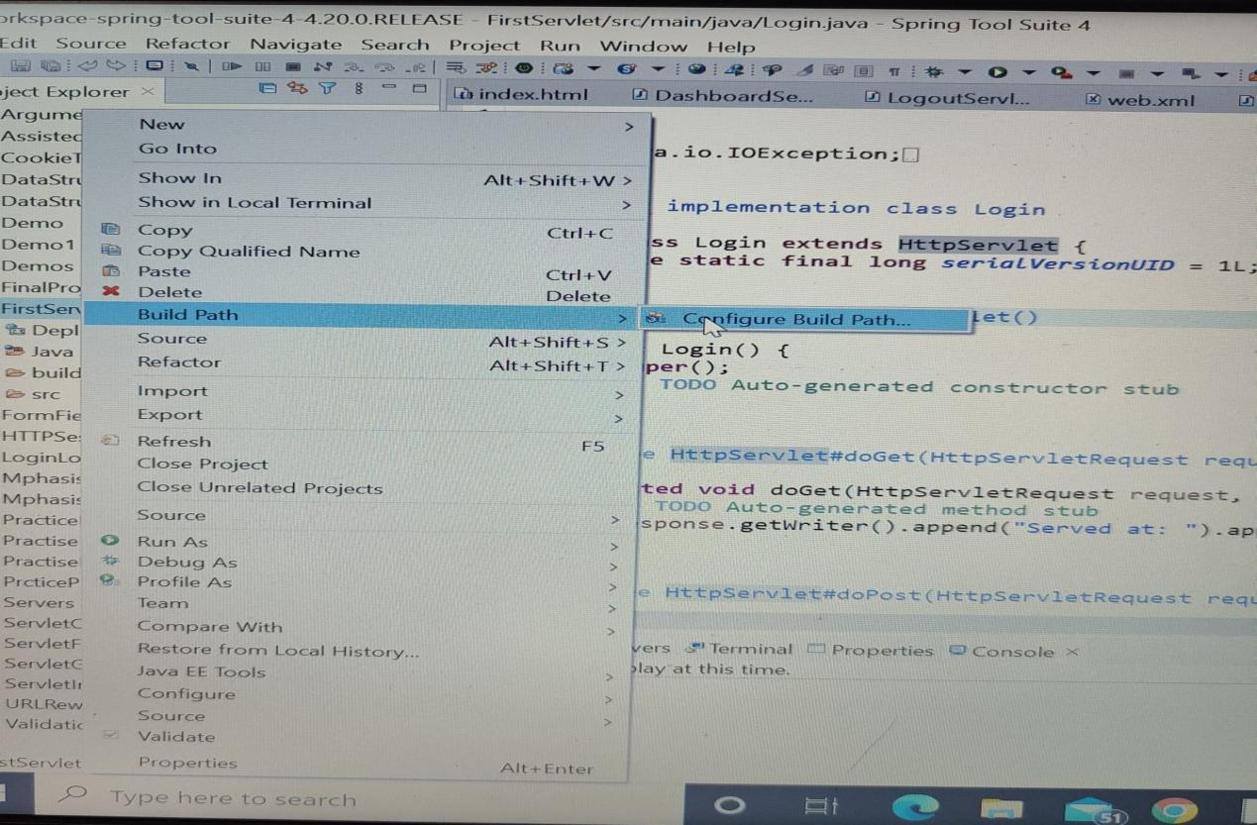

* + Click on **Libraries** tab on the right
  + Under **ClassPath,** expand the node that says **Apache Tomcat**
  + If there is an existing entry for servlet-api.jar, then click on **Cancel** and exit the window
  + If it is not there, then click on **Classpath** entry and click on **Add External JARs** button on the right
  + From the file list, select servlet-api.jar file and click **Ok**
  + Click on **Apply and Close**

**Step 1.2.4:** Building the project

* From the **Project** menu at the top, click on **Build**
* If any compile errors are shown, fix them as required

**Step 1.2.6:** Running the project

* To run the project, open a web browser and type: **<http://localhost:8080/ServletConcept>**