Secure Cloud Authentication Project

Submitted by
Gayathri Nandakumar
Bachelor of Science in Computer Science

Trichy, Tamil Nadu
January 2026

© 2026 Gayathri Nandakumar
All rights reserved.

This document and the project described herein are the intellectual property of the author.
No part of this document may be reproduced, stored, or transmitted in any form or by any means
without prior written permission from the author, except for personal and educational use.

This project was developed as a self-initiated practical learning work and is not submitted
to any university, institution, or organization for the award of any degree or certification.

DECLARATION
I hereby declare that the project titled “Secure Cloud Authentication Project” is a self-initiated practical learning project
carried out by me, Gayathri Nandakumar, as part of my personal effort to gain real-time
understanding of secure cloud authentication concepts and their practical application.

This project is an independent work developed without submission to any university,
college, or institution for the award of any degree, diploma, or certification.
The work presented in this documentation is original, and to the best of my knowledge,
does not infringe upon the intellectual property rights of any individual or organization.

All sources of information, references, and libraries used in this project have been
appropriately acknowledged wherever applicable. This project has been developed solely
for learning, experimentation, and skill enhancement purposes.

AUTHOR’S CERTIFICATE

This is to certify that the project titled “Secure Cloud Authentication Project” is an original and independent work carried out by Gayathri Nandakumar.

This project has been developed as a self-initiated practical learning effort
to understand and apply secure cloud authentication concepts through a web-based system.
The work documented in this report is genuine, has been developed independently,
and has not been submitted to any institution, organization, or university
for the award of any degree, diploma, or certification.

The project reflects my personal learning, experimentation, and implementation of concepts,
and all references, resources, and libraries used have been duly acknowledged wherever applicable.

ACKNOWLEDGEMENT
This project implements a web-based Secure Cloud Authentication system to provide a self-initiated practical learning platform for secure cloud login and certificateless key agreement concepts.

The system allows users to:
• Login securely using anonymous authentication.
• Generate session keys using 0-RTT certificateless key agreement.
• Prevent replay attacks using unique nonces.
• Store authenticated session data securely in a local SQLite database.

This project highlights the integration of frontend technologies (HTML, CSS, JavaScript) with backend processing (Flask), secure session management, cryptographic techniques, and database logging, giving hands-on experience with end-to-end secure cloud authentication workflows. The system is modular, scalable, and serves as a foundation for future extensions with additional security features or advanced authentication protocols.

Place: Trichy, Tamil Nadu
Date: January 2026

ABSTRACT

This project presents a practical implementation of a web-based Secure Cloud Authentication system. The primary objective is to develop a self-initiated learning platform that demonstrates secure login mechanisms, anonymous certificateless key agreement, and replay attack prevention.

The system allows users to log in with anonymous IDs and derive session keys using a 0-RTT certificateless key agreement protocol, ensuring secure and efficient authentication. Unique nonces are generated and validated to prevent replay attacks, and all authentication information, including anonymous user IDs, secret keys, and used nonces, is stored securely in a local SQLite database.

This project emphasizes understanding the workflow of secure cloud authentication, session key generation, replay attack prevention, and secure database logging. It provides hands-on experience with end-to-end authentication mechanisms and serves as a foundation for future development, enabling scalability and integration of additional security features or advanced authentication protocols in cloud-based systems.

TABLE OF CONTENTS
S.No. | TOPIC | Page No.
1. | INTRODUCTION | 8
2. | PROBLEM STATEMENT | 9
3. | OBJECTIVES | 10
4. | LITERATURE REVIEW | 11
5. | SYSTEM ARCHITECTURE | 12
6. | SYSTEM REQUIREMENTS | 14
7. | TECHNOLOGIES USED | 15
8. | DATABASE DESIGN | 16
9. | COMMANDS USED | 17
10. | IMPLEMENTATION | 18
11. | SYSTEM WORKFLOW | 20
12. | SECURITY FEATURES | 22
13. | SCREENSHOTS | 23
14. | TESTING & RESULTS | 28
15. | SECURITY ANALYSIS | 30
16. | ADVANTAGES OF THE SYSTEM | 32
17. | LIMITATIONS OF THE SYSTEM | 34
18. | CONCLUSION | 35
19. | FUTURE ENHANCEMENTS | 36
20. | SOURCE CODE | 38
21. | REFERENCES | 48

INTRODUCTION

With the increasing reliance on cloud services, ensuring secure authentication for users has become a critical concern. Traditional login systems that rely on passwords or digital certificates are often vulnerable to identity leaks, replay attacks, and unauthorized access.

The Secure Cloud Authentication Project addresses these challenges by implementing a web-based system that allows users to log in anonymously and securely. The project demonstrates certificateless key agreement with 0-RTT session establishment, ensuring fast and secure authentication. Unique nonces are generated and validated for each login to prevent replay attacks, while session keys are derived dynamically for every authenticated user. All authentication attempts, anonymous user IDs, secret keys, and used nonces are securely stored in a local SQLite database.

This project serves as a self-initiated practical learning platform for understanding end-to-end secure cloud authentication workflows. By integrating frontend technologies (HTML, CSS, JavaScript) with backend processing (Flask) and cryptographic techniques, the system provides hands-on experience in secure login implementation, session key management, replay attack prevention, and secure data logging. The framework is modular and scalable, enabling future enhancements with additional security features or more advanced authentication protocols.processes and can be extended for more advanced security features in the future.

PROBLEM STATEMENT

In modern cloud-based applications, ensuring secure user authentication is increasingly challenging due to threats such as replay attacks, identity leakage, and unauthorized access. Traditional login systems that rely on passwords or certificates often fail to provide efficient and secure authentication, and implementing robust cloud authentication mechanisms can be complex for independent learners or self-initiated projects.

This project addresses these challenges by providing a web-based Secure Cloud Authentication system that allows users to log in anonymously and securely. The system implements a certificateless key agreement protocol with 0-RTT session establishment, generating session keys dynamically while preventing replay attacks through the use of unique nonces. All authentication attempts, anonymous user IDs, secret keys, and used nonces are securely stored in a local SQLite database.

By providing a controlled, self-initiated learning environment, this project allows learners to practice and understand end-to-end secure authentication workflows, session key derivation, replay attack prevention, and secure data logging without relying on pre-existing infrastructure or live enterprise systems. The system is scalable and can serve as a foundation for more advanced secure cloud solutions in the future.

OBJECTIVES
The primary objectives of this self-initiated project are:
1. Understand and implement secure cloud authentication concepts
• Apply certificateless key agreement with 0-RTT session establishment to provide secure and anonymous user login.
2. Prevent replay attacks and ensure session security
• Use unique nonces for each login attempt to protect against replay attacks and unauthorized access.
3. Develop a practical web-based authentication interface
• Integrate a frontend web application (HTML, CSS, JavaScript) with a Flask backend to manage login sessions securely.
4. Implement secure session and data logging
• Store anonymous user IDs, secret keys, and used nonces in a local SQLite database to maintain traceability of all authentication attempts.
5. Gain hands-on experience in end-to-end authentication workflow
• From login, nonce validation, session key derivation, to database logging, providing practical exposure to secure cloud authentication practices.
6. Create a foundation for future extensions
• Enable smooth integration with additional security features or advanced authentication protocols in future implementations.

LITERATURE REVIEW
Secure cloud authentication and certificateless key agreement protocols have become critical areas of research and practical implementation due to the increasing reliance on cloud services and the growing risk of cyber threats. Anonymous authentication, 0-RTT session establishment, and nonce-based replay attack prevention are widely explored techniques to provide fast, secure, and certificate-free authentication mechanisms.
Several studies and approaches highlight key aspects relevant to this project:
1. Anonymous Authentication
• Methods to anonymize user identities help protect privacy while allowing secure access to cloud resources.
2. Certificateless Key Agreement
• Eliminates the need for digital certificates, simplifying session key generation and reducing the risk of certificate-related attacks.
3. 0-RTT Session Establishment
• Enables users to establish secure sessions with minimal latency while maintaining strong security properties.
4. Replay Attack Prevention
• Use of unique nonces for each login prevents malicious reuse of authentication messages and ensures session integrity.
5. Secure Database Logging
• Storing authentication attempts, secret keys, and used nonces in a SQLite database ensures traceability and supports auditability of user sessions.
This project builds upon these concepts by implementing a web-based system that allows anonymous user login, derives session keys via a certificateless 0-RTT protocol, prevents replay attacks using nonces, and logs authentication attempts and session data securely in a SQLite database. The focus is on providing a practical, hands-on learning platform for understanding end-to-end secure cloud authentication workflows in a self-initiated project.

SYSTEM ARCHITECTURE
The system architecture of this project is designed to implement a secure cloud authentication workflow through a web-based application interface. The architecture ensures a clear end-to-end flow from user login to session key derivation, replay attack prevention, and secure data storage.
Key Components:
1. Web Interface
• Allows users to input their username and initiate a secure login session anonymously.
• Pages include:
– Index Page – Login form with automatic nonce generation for secure authentication.
– Dashboard Page – Displays derived session key and anonymous user ID along with security properties.
2. Backend Processing
• Implemented using the Flask framework to handle HTTP requests and manage authentication logic.
• Receives input from the frontend, validates nonces, generates session keys, and enforces replay attack prevention.
• Communicates with the SQLite database to store and retrieve user session information.
3. Security Module
• Uses certificateless key agreement to derive session keys dynamically for each login.
• Implements 0-RTT session establishment to allow fast and secure authentication.
• Generates and validates unique nonces to prevent replay attacks and ensure session integrity.
4. Database
• SQLite database stores anonymous user IDs, secret keys, and used nonces.
• Ensures traceability of login attempts and secure logging of authentication events.
Workflow Overview:

1. The user accesses the web interface and submits their username to initiate login.
2. Flask backend generates or retrieves the user's secret key and validates the nonce.
3. The security module derives the session key using certificateless 0-RTT authentication.
4. The SQLite database logs authentication attempts, anonymous IDs, and used nonces.
5. Session details and security properties are displayed on the dashboard in real-time.
This architecture emphasizes modular design, security, and hands-on learning, providing a practical framework for understanding secure cloud authentication, session key management, and replay attack prevention. The system can be extended in the future with additional security features or integrated into larger secure cloud applications.
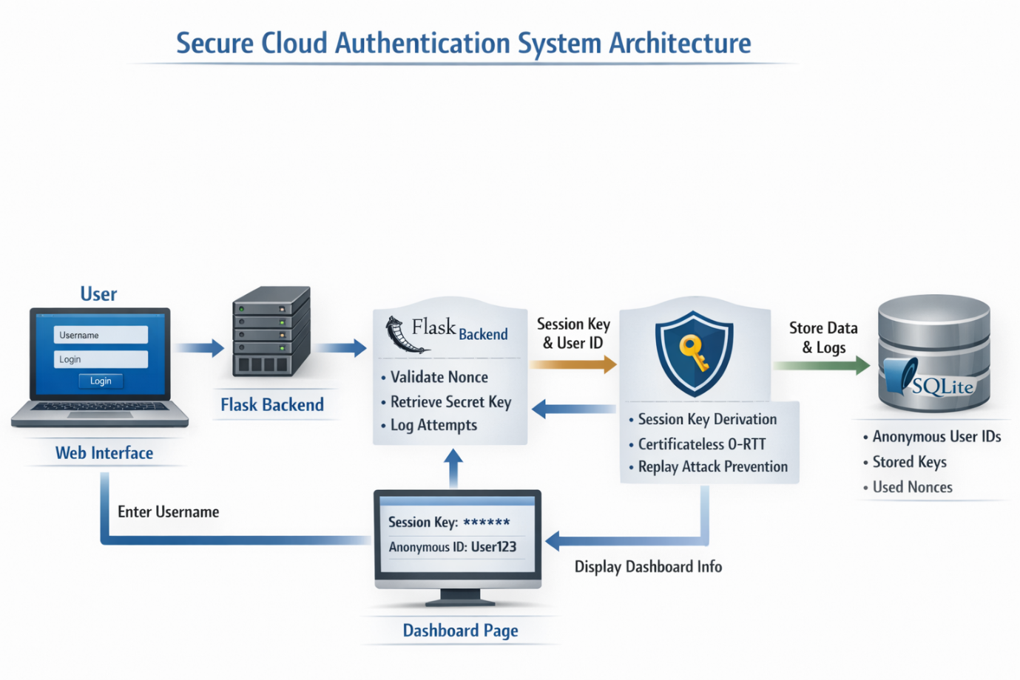

SYSTEM REQUIREMENTS

The following system requirements are necessary to implement and run the Secure Cloud Authentication Project:
1. Hardware Requirements
• Processor: Intel Core i5 or higher (or equivalent)
• RAM: Minimum 8 GB
• Storage: Minimum 50 GB free disk space
• Display: 1366 × 768 resolution or higher
• Internet: Required for installing packages
2. Software Requirements
• Operating System: Windows 10 / Linux (Ubuntu, Amazon Linux 2023)
• Programming Language: Python 3.9 or higher
• Frameworks & Libraries:
– Flask
– SQLite
– hashlib, hmac, secrets
• Web Browser: Google Chrome / Firefox / Edge
• Text Editor / IDE: Visual Studio Code / PyCharm / Sublime Text
3. Optional Tools
• Git for version control
• Postman for testing APIs

TECHNOLOGIES USED

The following technologies and tools were utilized to develop the Secure Cloud Authentication project:
1. Programming Language:
• Python 3.9+ – used for backend development, server logic, and cryptographic operations.
2. Web Framework:
• Flask – lightweight Python web framework for handling HTTP requests, routing, and session management.
3. Frontend Technologies:
• HTML5 – for structuring web pages.
• CSS3 – for styling the login and dashboard pages.
• JavaScript – for generating secure nonces and frontend interactions.
4. Database Management:
• SQLite – to securely store anonymous user IDs, secret keys, and used nonces.
5. Cryptography and Security:
• Python hashlib and hmac – for session key derivation and secure hashing.
• Python secrets module – for generating secure random keys and nonces.
6. Development Tools:
• Visual Studio Code – for coding and debugging.
• Google Chrome – to test and run the web application.

DATABASE DESIGN

The Secure Cloud Authentication system uses a local SQLite database named `security.db` to securely store authentication information. The database ensures traceability, prevents replay attacks, and manages session keys for anonymous users.
1. Users Table
Table Name: users
Purpose: To store anonymous user IDs and their corresponding secret keys.

Column Name | Data Type | Description
anon_id | TEXT | Anonymous user identifier (SHA-256 hash of username). Primary Key.
secret_key | TEXT | Secret key associated with the anonymous user, used for session key derivation.

2. Used Nonces Table
Table Name: used_nonces
Purpose: To prevent replay attacks by tracking nonces used by each anonymous user.
Column Name | Data Type | Description
anon_id | TEXT | Anonymous user identifier (links to `users` table).
nonce | TEXT | Unique nonce submitted during login to prevent replay attacks.
PRIMARY KEY | (anon_id, nonce) | Ensures each nonce is used only once per user.

COMMANDS USED

The following commands were used to set up and run the Secure Cloud Authentication project:
1. Setting up the Python environment
- Install required Python packages:
pip install flask
2. Running the Flask application
- Navigate to the project directory and start the Flask server:
python app.py
3. Database Initialization
- The SQLite database `security.db` is initialized automatically when the application is first run.
- Manual initialization (if required):
python
from app import init_db
init_db()
exit()
4. Accessing the Web Interface
- Open a web browser (e.g., Google Chrome) and navigate to:
http://127.0.0.1:5000/
- Users can enter their username to start an anonymous secure session.
5. Stopping the Flask Server
- Press `CTRL + C` in the terminal where the Flask server is running.

IMPLEMENTATION

The Secure Cloud Authentication project has been implemented as a web-based system using Python, Flask, SQLite, and frontend technologies (HTML, CSS, JavaScript). The implementation focuses on enabling anonymous authentication, certificateless key agreement, 0-RTT session establishment, and replay attack prevention.
1. Project Structure
- app.py – main Flask application handling routing, authentication, nonce validation, session key derivation, and database interactions.
- templates/index.html – frontend login page with automatic nonce generation.
- templates/dashboard.html – dashboard displaying anonymous user ID, derived session key, and security properties.
- static/style.css – CSS file for styling login and dashboard pages.
- security.db – SQLite database storing anonymous user IDs, secret keys, and used nonces.

2. Workflow Implementation
1. User Login
- Users access the web interface (`index.html`) and submit a username.
- A secure, random nonce is generated using JavaScript for each login attempt.
2. Anonymous ID Generation
- The backend hashes the username using SHA-256 to create an anonymous user ID (`anon_id`).
3. Secret Key Assignment
- The system checks the `users` table in SQLite for an existing secret key.
- If no key exists, a new secret key is generated using Python’s `secrets` module and stored.
4. Replay Attack Prevention
- The submitted nonce is verified against the `used_nonces` table to ensure it has not been used before.
- If the nonce exists, the request is rejected to prevent replay attacks.
5. Session Key Derivation
- A session key is derived dynamically using HMAC with the secret key and nonce.
- The session key ensures secure and unique authentication for each session (0-RTT).
6. Database Logging
- All authentication attempts, including anon_id, secret key, and nonce, are securely stored in the SQLite database.
7. Dashboard Display
- On successful login, the user is redirected to `dashboard.html`, which displays:
• Anonymous User ID (first 12 characters)
• Derived Session Key (first 12 characters)
• Security properties implemented in the system (Anonymous Login, Certificateless Key Agreement, 0-RTT Session Establishment, Replay Attack Prevention)

3. Security Features
- Anonymous Authentication – protects user identity during login.
- Certificateless Key Agreement – enables session key derivation without managing digital certificates.
- 0-RTT Session Establishment – allows immediate secure session initiation.
- Replay Attack Prevention – ensures each nonce is unique per user, preventing repeated login attempts with the same nonce.
The implementation emphasizes modular design, secure coding practices, and hands-on experience in end-to-end cloud authentication workflows. The system is scalable for future enhancements, such as integration of additional security features or advanced authentication protocols.
SYSTEM WORKFLOW

The Secure Cloud Authentication system follows a structured workflow to enable
anonymous, fast, and secure user authentication using a 0-RTT certificateless
key agreement mechanism. The workflow ensures session key derivation, replay
attack prevention, and secure logging of authentication data.
1. User Login Initiation
The user accesses the web application and enters a username through the login
interface. A unique cryptographic nonce is automatically generated on the
client side for each login attempt.
2. Anonymous Identity Generation
The entered username is transformed into an anonymous user identifier using a
cryptographic hash function. This ensures that the actual user identity is never
stored or exposed during authentication.
3. Request Submission to Backend
The anonymous identifier and nonce are submitted to the Flask backend as part of
the authentication request.
4. Secret Key Generation or Retrieval
The backend checks whether a secret key already exists for the anonymous user.
If not, a new secret key is securely generated and stored in the database.
5. Replay Attack Detection
The system verifies whether the received nonce has already been used for the
same anonymous user. If a duplicate nonce is detected, the authentication
request is rejected to prevent replay attacks.
6. Session Key Derivation (0-RTT)
Upon successful nonce validation, a session key is derived using a
certificateless key agreement approach based on cryptographic hash and HMAC
functions. This enables session establishment without additional round trips.

7. Secure Data Logging
The anonymous user ID, secret key reference, and used nonce are securely stored
in a SQLite database for traceability and session validation.

8. Secure Session Establishment
The derived session key is associated with the user session, enabling secure
communication within the application.

9. Dashboard Display
The system displays the truncated anonymous user ID and session key on the
dashboard along with key security properties, confirming successful
authentication.

This workflow ensures fast authentication, privacy preservation, and protection
against replay attacks while maintaining a lightweight and efficient
authentication process.

SECURITY FEATURES
The Secure Cloud Authentication system incorporates multiple security mechanisms
to ensure secure, private, and efficient authentication in a cloud environment:
1. Anonymous Authentication
User identities are protected by converting usernames into anonymous identifiers
using cryptographic hash functions, preventing identity exposure.
2. Certificateless Key Agreement
The system eliminates the need for digital certificates by dynamically generating
session keys using a shared secret and cryptographic hashing.
3. 0-RTT Session Establishment
Session keys are derived without additional communication rounds, enabling fast
authentication while maintaining security.
4. Replay Attack Prevention
Unique nonces are generated for every login attempt and verified against stored
values to prevent reuse of authentication messages.
5. Secure Session Key Derivation
Session keys are derived using HMAC with SHA-256, ensuring integrity and resistance
to key tampering.
6. Secure Data Storage
Authentication data such as anonymous IDs, secret keys, and used nonces are stored
securely in a SQLite database with controlled access.
7. Minimal Data Exposure
Only truncated identifiers and session keys are displayed on the dashboard,
reducing the risk of sensitive data leakage.
SCREENSHOTS
1. Creating EC-2 instance
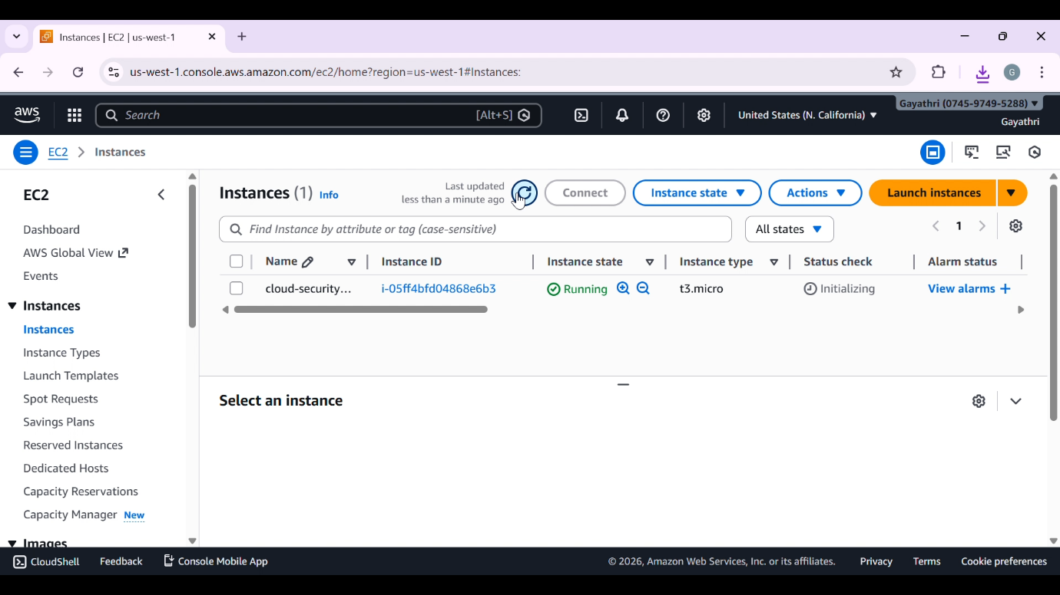

2. Add inbound rules for SSH, HTTP, CUSTOM TCP – PORT 5000
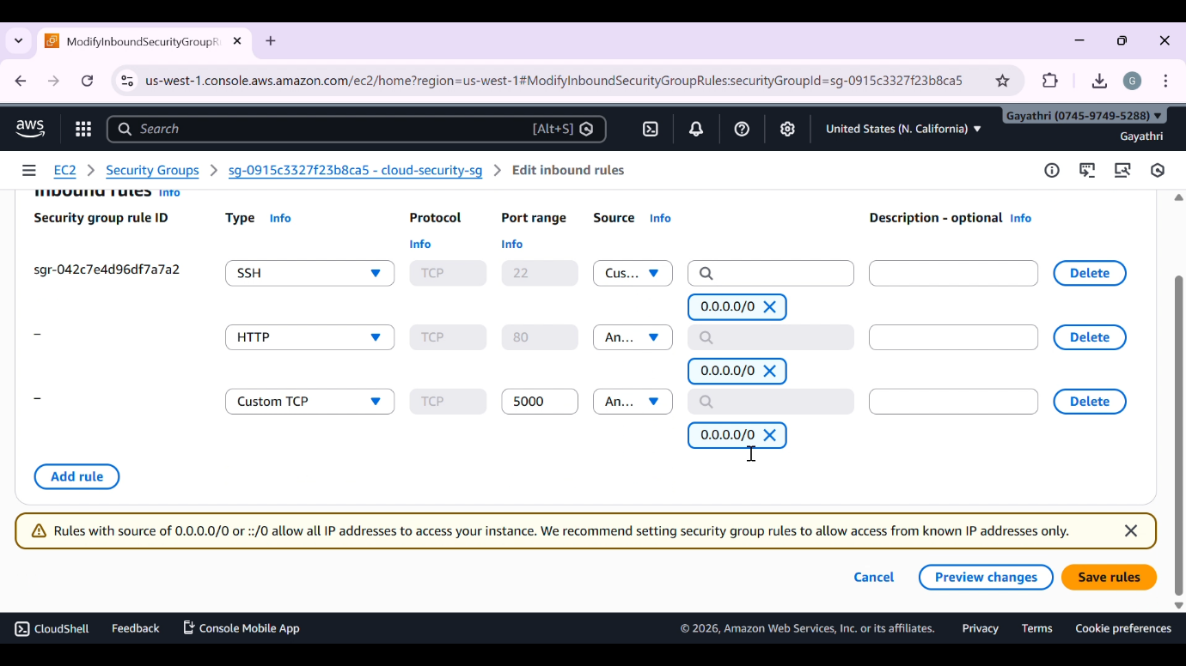

3. Connect the instance using INSTANCE-CONNECT and installing packages needed
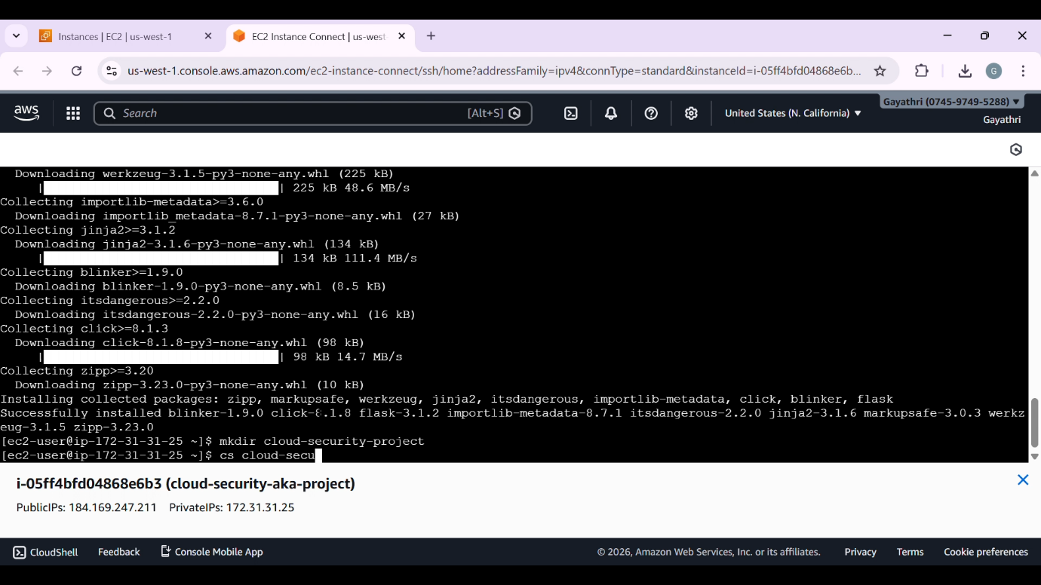

4. Loading code files
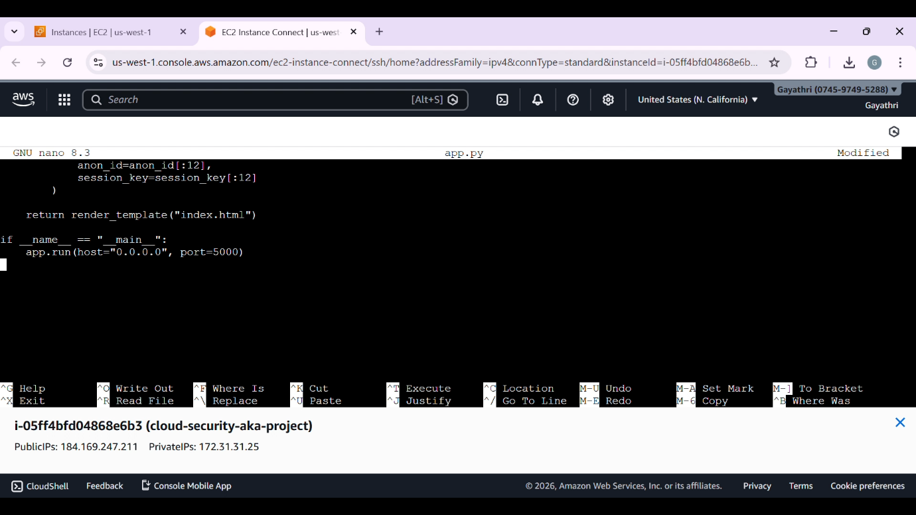

5. Running Python-Flask
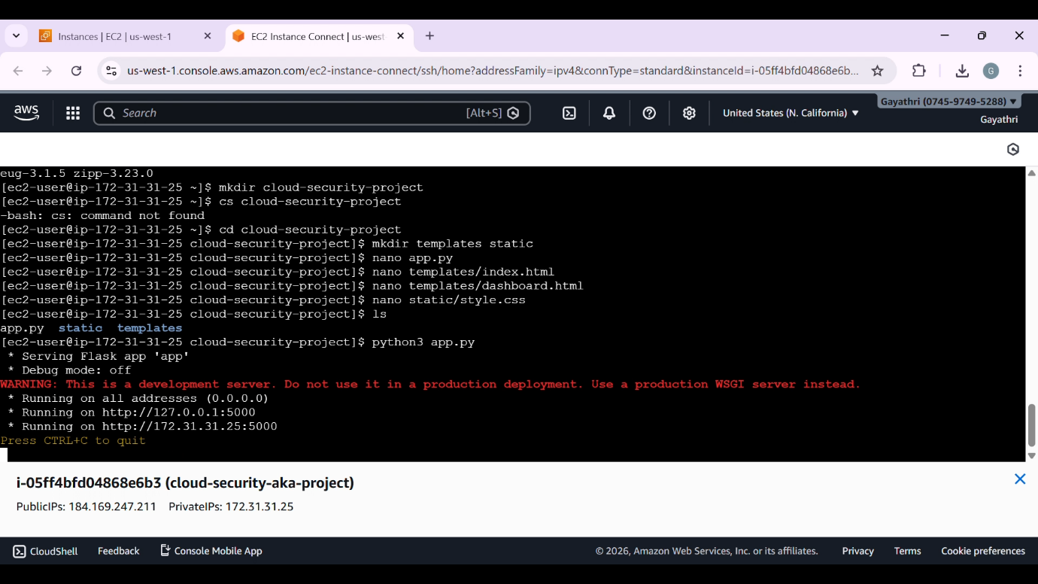

6. Website opening through custom port 5000
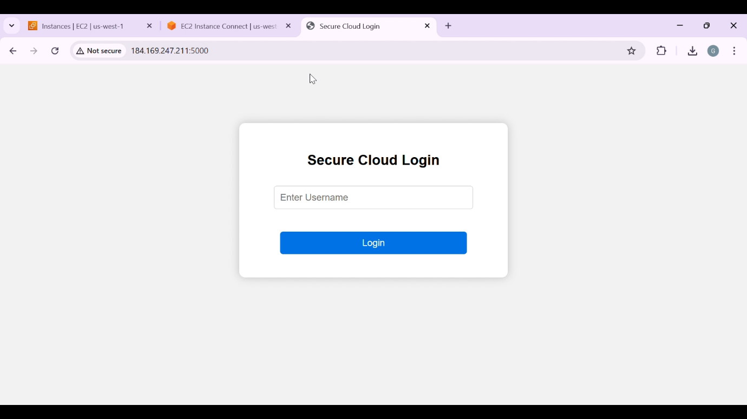

7. Entering Data
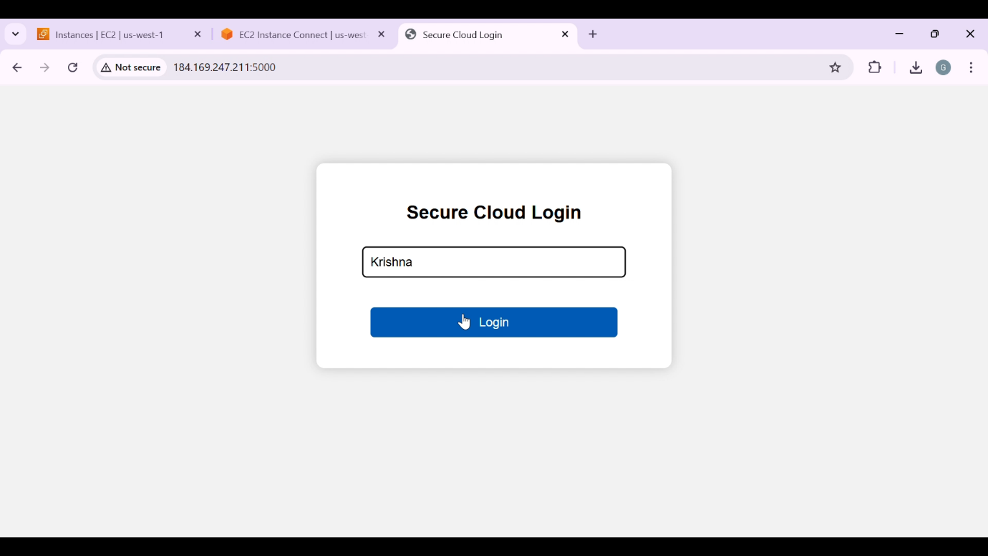

8. Output with Session-key & Anonymous-Key
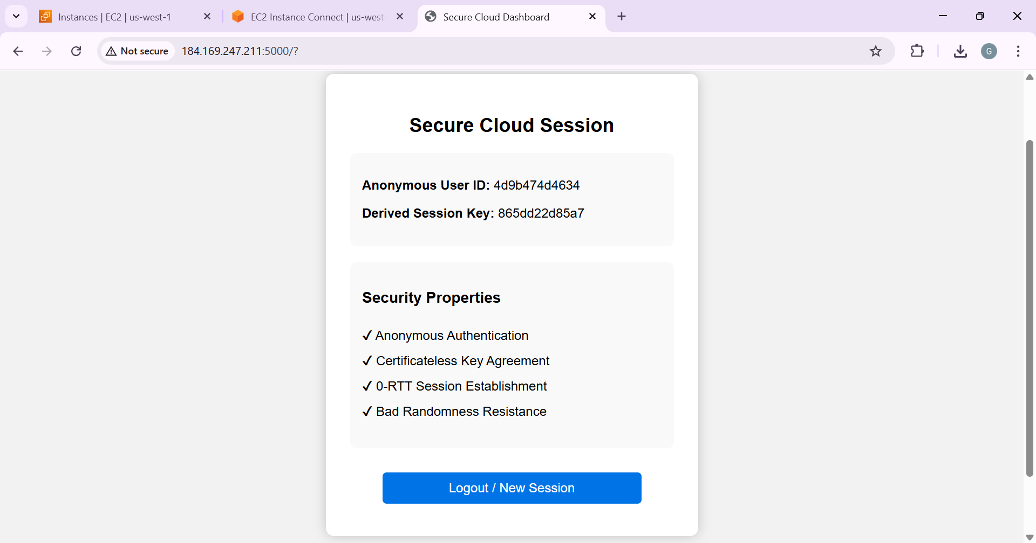

9. Checking database
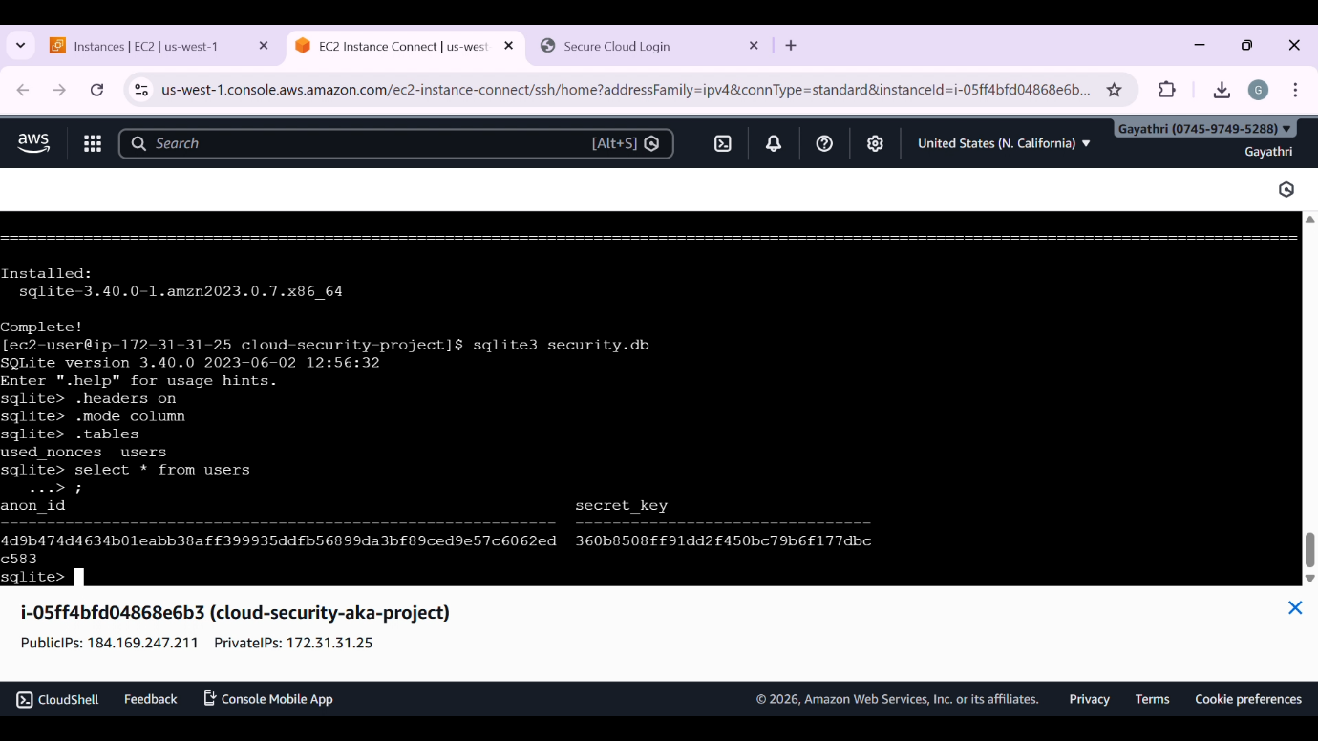

TESTING AND RESULTS

Testing was carried out to verify the correctness, security, and reliability of the Secure Cloud Authentication system. The objective of testing was to ensure that authentication, session key generation, replay attack prevention, and database logging function as expected.
1. Functional Testing
Functional testing was performed to validate each major feature of the system:
- User login through the web interface was tested using multiple usernames.
- Anonymous user IDs were generated correctly for each login attempt.
- Session keys were derived successfully using certificateless key agreement.
- The dashboard displayed session information only after successful authentication.
All functional components operated as intended without system failures.
2. Replay Attack Prevention Testing
Replay attack testing was conducted by submitting the same nonce multiple times:
- The first authentication request using a unique nonce was accepted.
- Subsequent requests using the same nonce were rejected by the system.
- The used nonce was stored in the database to prevent reuse.
This confirmed that the system effectively prevents replay attacks.
3. Session Key Validation Testing
Session key generation was tested under different conditions:
- Each login attempt generated a unique session key.
- Reusing the same username with a new nonce resulted in a different session key.
- Session keys were not reused across sessions, ensuring security.
These results validated the correctness of 0-RTT session establishment.

4. Database Testing
Database operations were verified using SQLite:
- Anonymous user IDs and secret keys were stored correctly.
- Used nonces were logged accurately to prevent replay attacks.
- Authentication records remained consistent across multiple login attempts.
No data corruption or loss was observed during testing.
5. Result Analysis
The testing outcomes demonstrate that:
- Secure anonymous authentication is successfully implemented.
- Certificateless key agreement generates valid session keys.
- Replay attacks are effectively prevented using nonce validation.
- Session and authentication data are securely stored and traceable.
Overall, the system performed reliably under all tested scenarios and achieved the intended security objectives. The results confirm that the project provides a practical and secure implementation of cloud authentication mechanisms suitable for self-initiated learning and future enhancements.

SECURITY ANALYSIS

Security is the core focus of this project. The system is designed to ensure secure user authentication, protect user privacy, and prevent common network-based attacks in cloud environments. The implemented mechanisms were analyzed to verify their effectiveness in maintaining confidentiality, integrity, and authentication security.
1. Anonymous Authentication
The system avoids exposing real user identities during the authentication process. Instead, anonymous user identifiers are generated and used internally, ensuring user privacy and reducing the risk of identity leakage.
2. Certificateless Key Agreement
The project uses a certificateless key agreement mechanism, eliminating the need for digital certificates. This reduces complexity, avoids certificate management overhead, and prevents certificate-related vulnerabilities such as certificate forgery or misuse.
3. 0-RTT Session Establishment
The implementation of 0-RTT session establishment enables fast authentication while maintaining security. Session keys are generated dynamically during the initial communication phase without additional round trips, improving performance and reducing connection delay.
4. Replay Attack Prevention
Replay attacks are prevented through the use of unique nonces for each authentication request. Once a nonce is used, it is stored in the database and rejected if reused, ensuring that old authentication messages cannot be replayed by attackers.
5. Secure Session Key Generation
Each authentication request generates a fresh session key. Session keys are not reused across sessions, ensuring confidentiality and protecting against session hijacking and key compromise attacks.

6. Secure Data Storage
Authentication records, anonymous user IDs, secret keys, and used nonces are stored securely in a local SQLite database. This ensures traceability while preventing unauthorized reuse of authentication data.

7. Overall Security Evaluation
The combined use of anonymous authentication, certificateless key agreement, nonce validation, and secure session storage provides strong protection against common security threats such as replay attacks, identity exposure, and unauthorized access.

The security analysis confirms that the system effectively meets its design goals and provides a robust framework for secure cloud authentication in a self-initiated learning environment.

ADVANTAGES OF THE SYSTEM

The Secure Cloud Authentication system offers several advantages that enhance security, efficiency, and practical learning value. The key advantages of the proposed system are as follows:

1. Enhanced Security
The system implements certificateless key agreement and dynamic session key generation, significantly improving security compared to traditional password-based authentication methods.

2. Anonymous User Authentication
User identities are protected through anonymous authentication, reducing the risk of identity exposure and ensuring user privacy during the login process.

3. Replay Attack Resistance
The use of unique nonces for each authentication request effectively prevents replay attacks, ensuring that authentication messages cannot be reused by unauthorized entities.

4. Faster Authentication with 0-RTT
The implementation of 0-RTT session establishment reduces authentication delay by minimizing communication rounds, resulting in faster and more efficient login processes.

5. No Certificate Management Overhead
By eliminating the need for digital certificates, the system avoids complex certificate issuance, storage, and revocation processes, making it simpler and more reliable.
6. Secure Session Key Generation
Each session generates a fresh and unique session key, preventing session key reuse and reducing the risk of session hijacking or key compromise.

7. Lightweight and Practical Implementation
The system is implemented using lightweight technologies such as Flask and SQLite, making it easy to deploy, test, and understand without requiring complex infrastructure.

8. Scalable and Extendable Design
The modular architecture allows future enhancements such as integrating stronger cryptographic algorithms, multi-factor authentication, or real cloud-based deployments.

9. Ideal for Learning and Research
As a self-initiated project, the system provides hands-on experience in secure cloud authentication concepts, making it suitable for learning, experimentation, and research-oriented development.

LIMITATIONS OF THE SYSTEM

Although the Secure Cloud Authentication system provides a robust and secure authentication mechanism, it has certain limitations that are acknowledged as part of this self-initiated project:
1. Limited Real-World Deployment
The system is implemented in a controlled learning environment and has not been deployed in a large-scale production cloud environment, which may present additional challenges.
2. Basic Cryptographic Scope
The project focuses on implementing certificateless key agreement and replay attack prevention but does not include advanced cryptographic techniques such as hardware-based security modules or post-quantum cryptography.
3. Single-Factor Authentication
The authentication mechanism is based on a single authentication factor and does not include multi-factor authentication, which could further strengthen security.
4. Local Database Usage
SQLite is used for storing authentication data, which is suitable for learning and small-scale systems but may not be optimal for high-concurrency or large-scale cloud applications.
5. Performance Evaluation Scope
The system does not include extensive performance benchmarking or stress testing under heavy user loads or network delays.
6. Limited Threat Model Coverage
The project primarily addresses replay attacks and identity protection but does not cover all possible attack vectors such as denial-of-service attacks or advanced side-channel attacks.
7. Dependency on Web Application Security
The overall security of the system depends on the secure configuration of the web application and server environment, which requires additional hardening in real-world deployments.
CONCLUSION

This project successfully demonstrates the design and implementation of a Secure Cloud Authentication system using a web-based application. The system focuses on providing anonymous authentication, certificateless session key agreement, and replay attack prevention in a controlled learning environment.

By integrating frontend technologies with a Flask-based backend, the project achieves secure session key derivation using nonces and cryptographic hash functions. The use of SQLite for storing anonymous user identities, secret keys, and used nonces ensures secure and traceable authentication management.

This self-initiated project provides practical exposure to secure authentication workflows, cryptographic concepts, and web application security. It serves as a strong foundation for understanding modern cloud authentication mechanisms and highlights the importance of privacy-preserving and efficient security solutions in cloud-based systems.

FUTURE ENHANCEMENTS

The Secure Cloud Authentication system based on 0-RTT certificateless key agreement
can be further enhanced to improve security, efficiency, and real-world applicability:

1. Extended 0-RTT Security Validation
Additional mechanisms such as token binding or replay window control can be
introduced to further strengthen replay resistance in 0-RTT communication.

2. Integration of Forward Secrecy
The protocol can be enhanced to provide stronger forward secrecy by periodically
refreshing secret material without affecting 0-RTT session establishment.

3. Multi-Factor Authentication with 0-RTT Compatibility
Lightweight secondary authentication methods can be integrated without increasing
round-trip delay, preserving the benefits of 0-RTT authentication.

4. Cloud-Native Deployment
The system can be deployed on managed cloud platforms with load balancing and
secure key storage services to evaluate real-world 0-RTT performance.

5. Formal Security Analysis
The authentication protocol can be evaluated using formal verification tools to
prove resistance against known cryptographic attacks.
6. Scalability and Performance Evaluation
Large-scale testing can be performed to measure latency, throughput, and session
establishment efficiency in high-concurrency environments.

These enhancements would strengthen the system’s alignment with modern 0-RTT
authentication protocols and support deployment in real cloud-based environments.

SOURCE CODE
Index.html
<!DOCTYPE html>
<html>

<head>
<title>Secure Cloud Login</title>
<link rel="stylesheet" type="text/css" href="{{ url_for('static', filename='style.css') }}">
<script>
function addNonce() {
// Generate a random secure nonce for each login
const array = new Uint32Array(1);
window.crypto.getRandomValues(array);
document.getElementById("nonce").value = array[0];
}
</script>
</head>

<body>
<div class="login-container">
<h2>Secure Cloud Login</h2>
<form method="POST" onsubmit="addNonce()">
<input type="text" name="username" placeholder="Enter Username" required><br><br>
<input type="hidden" name="nonce" id="nonce">
<button type="submit">Login</button>
</form>
</div>
</body>

</html>

Dashboard.html
<!DOCTYPE html>
<html>

<head>
<title>Secure Cloud Dashboard</title>
<link rel="stylesheet" type="text/css" href="{{ url_for('static', filename='style.css') }}">
</head>

<body>
<div class="dashboard-container">
<h2>Secure Cloud Session</h2>
<div class="info-box">
<p><strong>Anonymous User ID:</strong> {{ anon_id }}</p>
<p><strong>Derived Session Key:</strong> {{ session_key }}</p>
</div>

<div class="security-box">
<h3>Security Properties</h3>
<ul>
<li>✔ Anonymous Authentication</li>
<li>✔ Certificateless Key Agreement</li>
<li>✔ 0-RTT Session Establishment</li>
<li>✔ Bad Randomness Resistance</li>
</ul>
</div>

<form method="GET" action="/">
<button type="submit">Logout / New Session</button>
</form>
</div>
</body>

</html>

Style.css
body {
font-family: Arial, Helvetica, sans-serif;
background-color: #f2f2f2;
margin: 0;
padding: 0;
}

.login-container,
.dashboard-container {
width: 400px;
margin: 100px auto;
background-color: #ffffff;
padding: 30px;
border-radius: 10px;
box-shadow: 0 0 15px rgba(0, 0, 0, 0.2);
text-align: center;
}

input[type="text"],
button {
width: 80%;
padding: 10px;
margin: 10px 0;
border-radius: 5px;
border: 1px solid #ccc;
font-size: 16px;
}

button {
background-color: #0073e6;
color: white;
border: none;
cursor: pointer;
}

button:hover {
background-color: #005bb5;
}

.info-box,
.security-box {
text-align: left;
margin: 20px 0;
padding: 15px;
background-color: #f9f9f9;
border-radius: 8px;
}

.security-box ul {
list-style-type: none;
padding-left: 0;
}

.security-box li {
padding: 5px 0;
}

App.py
from flask import Flask, render_template, request, abort
import sqlite3
import hashlib
import hmac
import secrets

app = Flask(__name__)

SERVER_SECRET = "cloud_secret_key"

# ---- MANUAL DATABASE INIT ----
def init_db():
conn = sqlite3.connect("security.db")
cur = conn.cursor()

# Users table
cur.execute("""
CREATE TABLE IF NOT EXISTS users (
anon_id TEXT PRIMARY KEY,
secret_key TEXT
)
""")

# Nonces table
cur.execute("""
CREATE TABLE IF NOT EXISTS used_nonces (
anon_id TEXT,
nonce TEXT,
PRIMARY KEY (anon_id, nonce)
)
""")

conn.commit()
conn.close()

# Call database init manually
init_db()
# -------------------------------

@app.route("/", methods=["GET", "POST"])
def login():
if request.method == "POST":
username = request.form["username"]
nonce = request.form.get("nonce")
if not nonce:
abort(400, "Missing authentication parameters")

# Generate anonymous user ID
anon_id = hashlib.sha256(username.encode()).hexdigest()

# Connect to DB
conn = sqlite3.connect("security.db")
cur = conn.cursor()

# Generate / fetch secret
cur.execute("SELECT secret_key FROM users WHERE anon_id=?", (anon_id,))
row = cur.fetchone()
if row:
secret = row[0]
else:
secret = secrets.token_hex(16)
cur.execute("INSERT INTO users (anon_id, secret_key) VALUES (?, ?)", (anon_id, secret))
conn.commit()

# Check for replay
cur.execute("SELECT 1 FROM used_nonces WHERE anon_id=? AND nonce=?", (anon_id, nonce))
if cur.fetchone():
conn.close()
abort(403, "Replay detected")

# Store nonce
cur.execute("INSERT INTO used_nonces (anon_id, nonce) VALUES (?, ?)", (anon_id, nonce))
conn.commit()
conn.close()

# Generate session key
session_key = hmac.new(
key=secret.encode(),
msg=nonce.encode(),
digestmod=hashlib.sha256
).hexdigest()

return render_template(
"dashboard.html",
anon_id=anon_id[:12],
session_key=session_key[:12]
)

return render_template("index.html")

if __name__ == "__main__":
app.run(host="0.0.0.0", port=5000)

REFERENCES

1. William Stallings, Cryptography and Network Security: Principles and Practice,
Pearson Education.
2. Diffie, W., and Hellman, M., "New Directions in Cryptography",
IEEE Transactions on Information Theory, 1976.
3. Kahn Academy / NIST, "Secure Hash Standard (SHA-256)",
National Institute of Standards and Technology.
4. RFC 8446, "The Transport Layer Security (TLS) Protocol Version 1.3",
Internet Engineering Task Force (IETF).
5. Flask Documentation,
https://flask.palletsprojects.com/
6. Python hashlib and hmac Library Documentation,
https://docs.python.org/3/library/hashlib.html
7. SQLite Documentation,
https://www.sqlite.org/docs.html
8. OWASP Foundation, "Authentication and Session Management Security Risks",
https://owasp.org/

