**Intro**

Staying Healthy and Fit is most important...

In today's world obesity is the important factor affecting Many people.This app will help you to predict the ingredients and it's calorie for the food image given.

Which will help you to keep track of your calorie intake

Project flow

This project is developed based on convolution neural network by trainig the model using inception V3.

The main model python code is inside the f00d_recognization.py which is developed in streamlit.

* First the data sets are collected.
* Then the images are labelled using labelImg tool
* Next step is image processing
* Then the processed image is trained using inception v3 model
* A .h5 file is created which has the trained data in it.

To run the file type the following command

streamlit run f00d_rcognization.py

The streamlit app is deployed in streamlit cloud .The web app is developed using the python in flask framework .the main file is the app.py to the web appThe app contains additional modules to calculate the BMI of individual And water consumption tracker by clicking on the the icons.

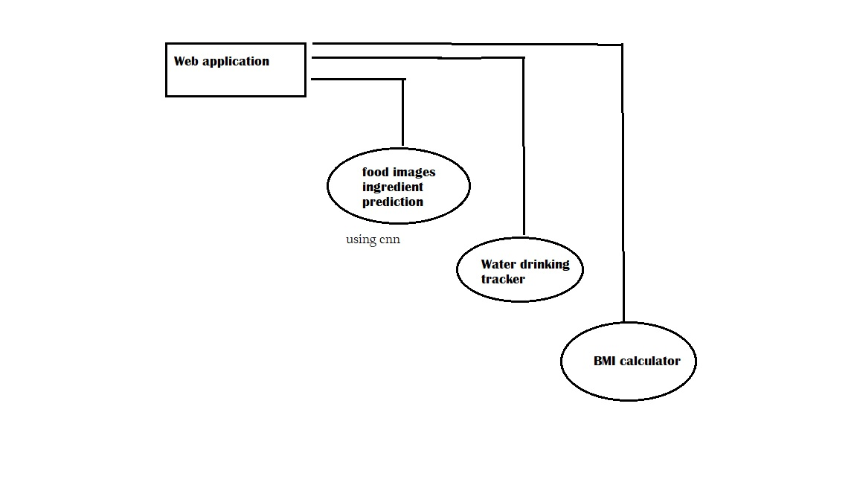

OUTPUT

