Sonarqube (Code quality checker)

**Step1:**

* Start the sonar server using command prompt
* Add the sonar quebe path in cmd

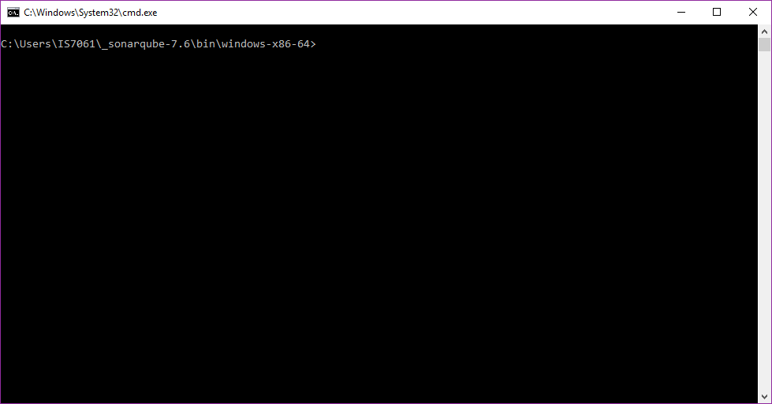 (**Like** C:\Users\IS7061\_sonarqube-7.6\bin\windows-x86-64)

* 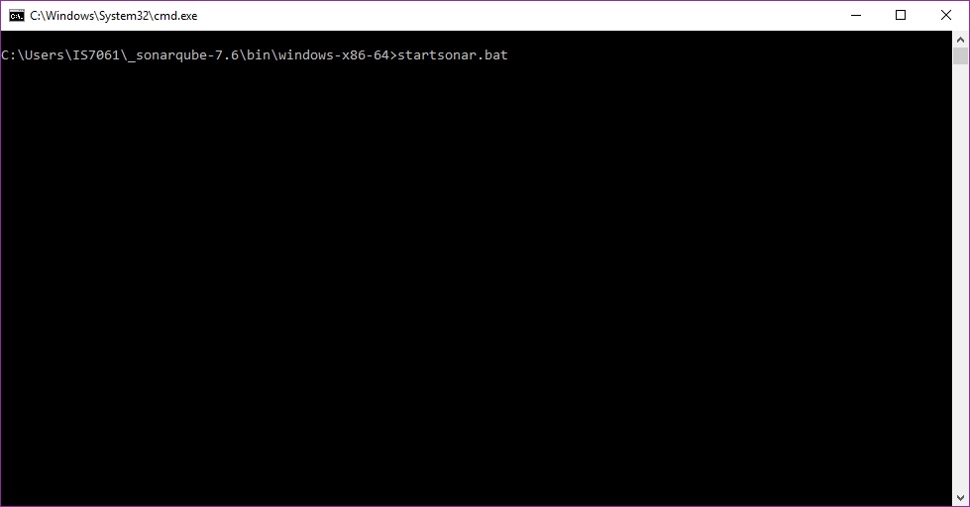Type the command **startsonar.bat**

* 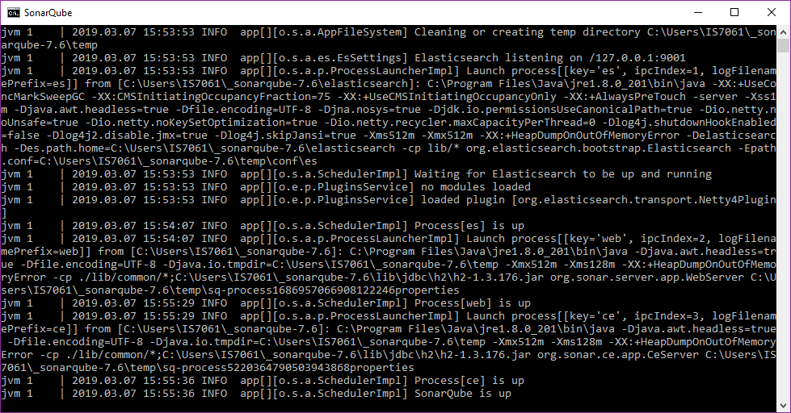Press enter and it will load the sonar server like below picture and simultaneously load the url path <http://localhost:9000> in browser
* In browser , the page will look like below picture

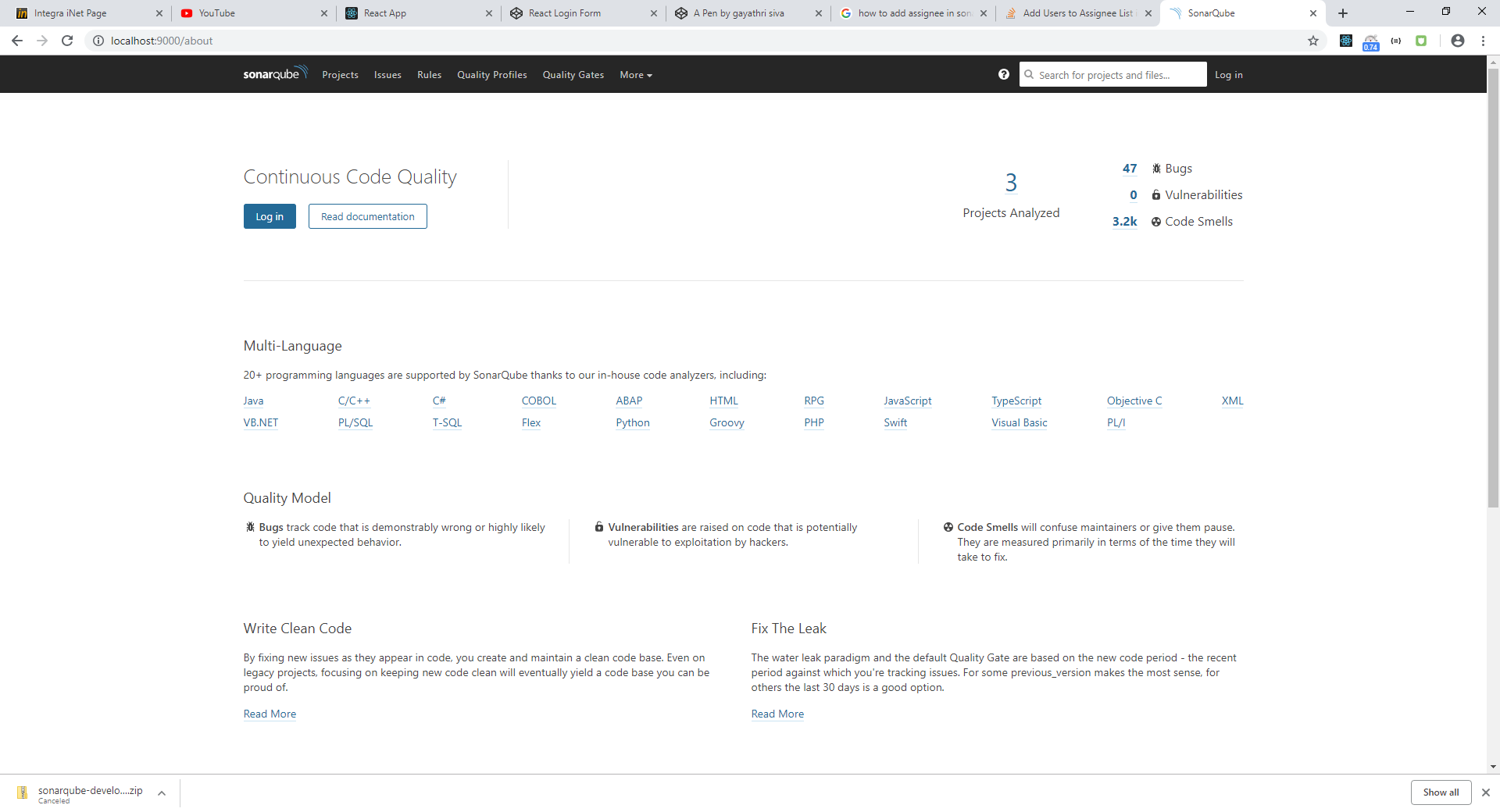

* 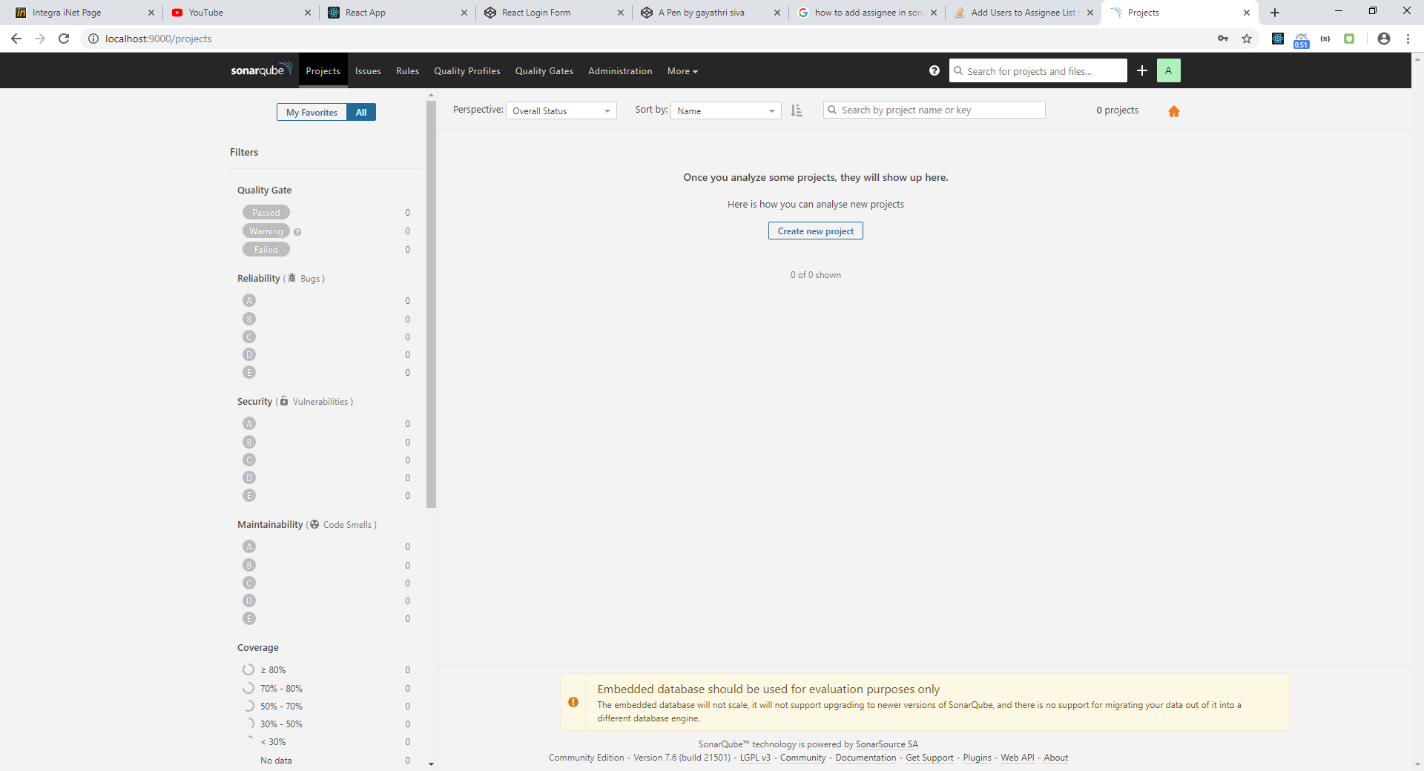Login the page with default username and password (admin and admin)
* Press new project and type the project name to generate the unique token

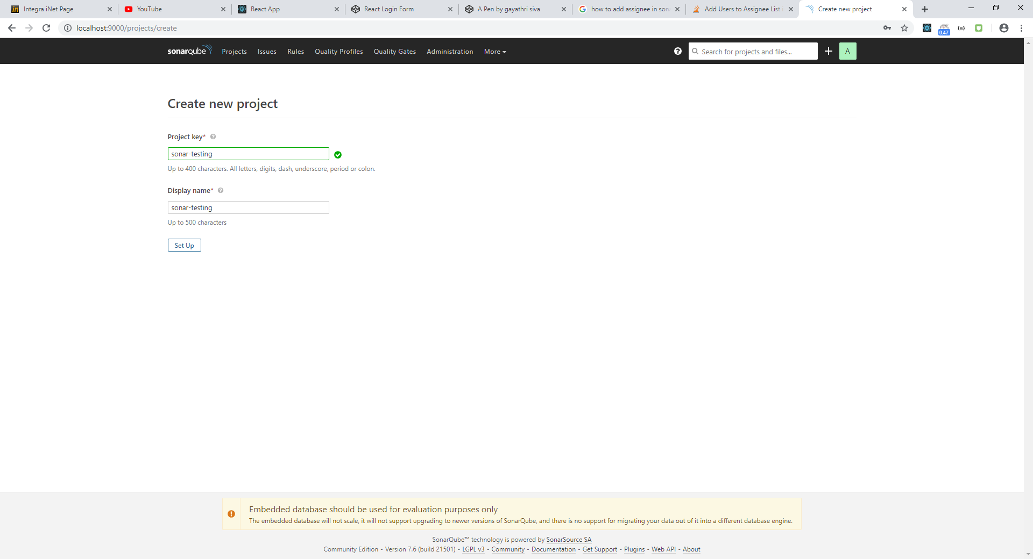

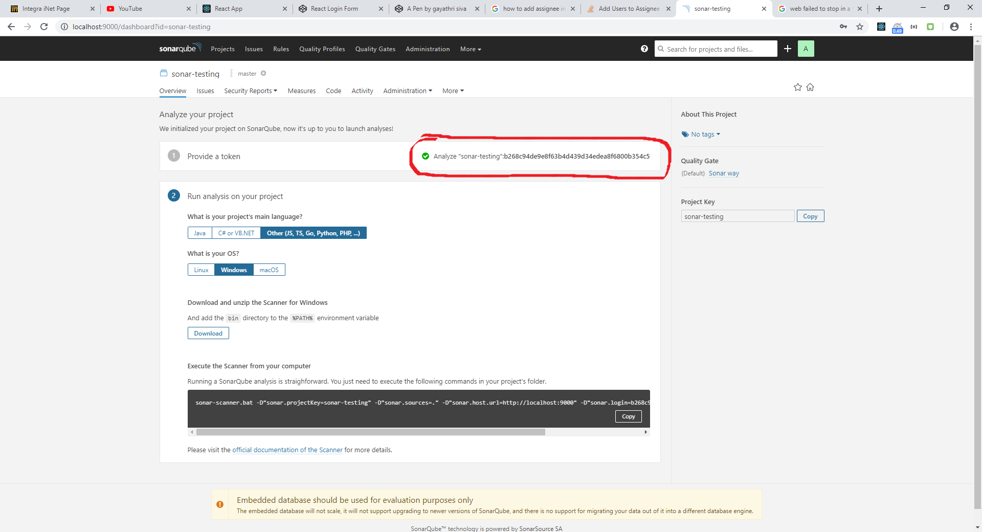

* Copy the path from the Sonarqube to run the sonar-scanner for analyzing the project code
* Download the sonar scanner
* 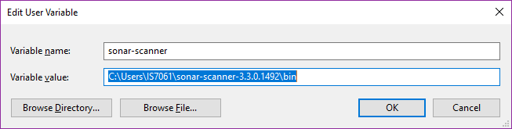Before run the sonar-scanner , add the path **C:\Users\IS7061\sonar-scanner-3.3.0.1492\bin** to environment variable
* After adding the environment variable, get the path of your project in cmd and add the path of sonar-scanner and paste the copied path from the sonar quebe

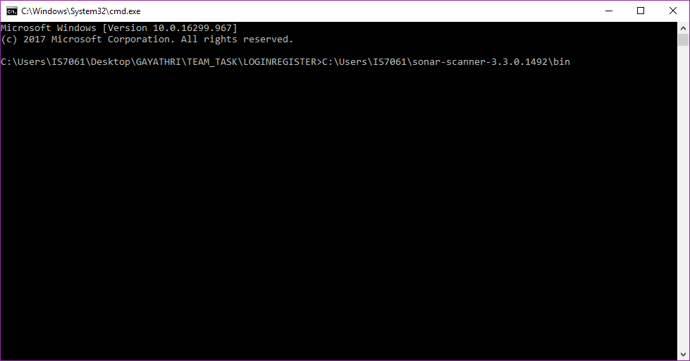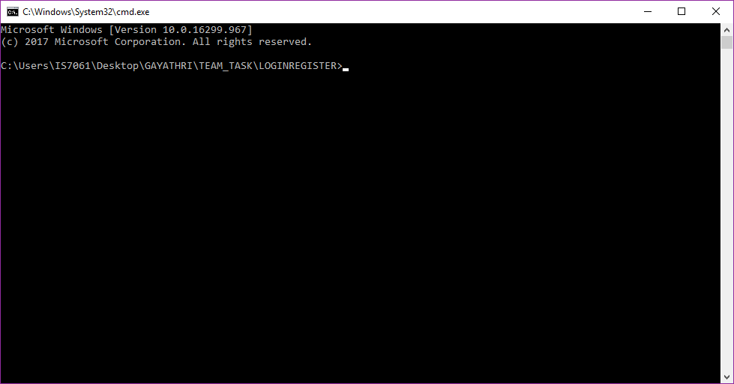

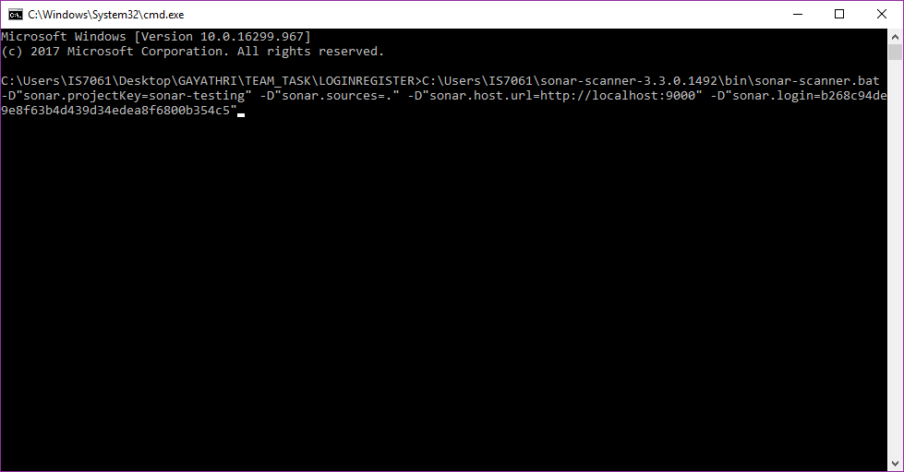

* 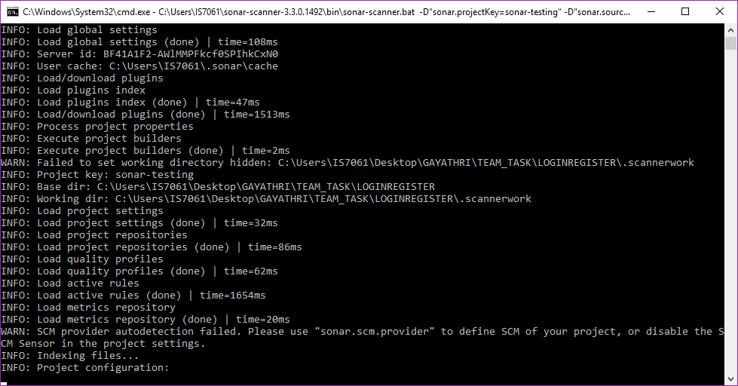Press enter to analyze the project code

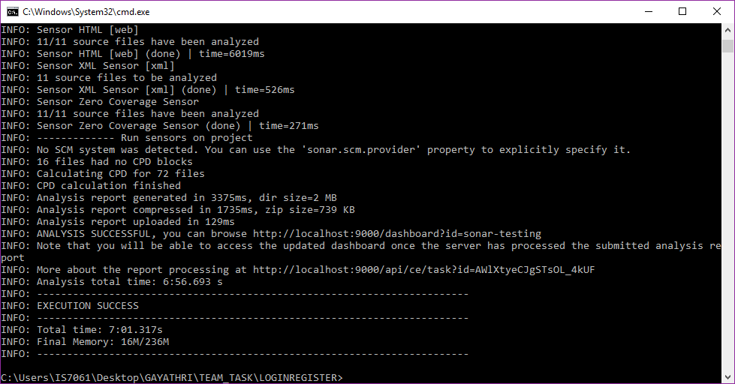

* 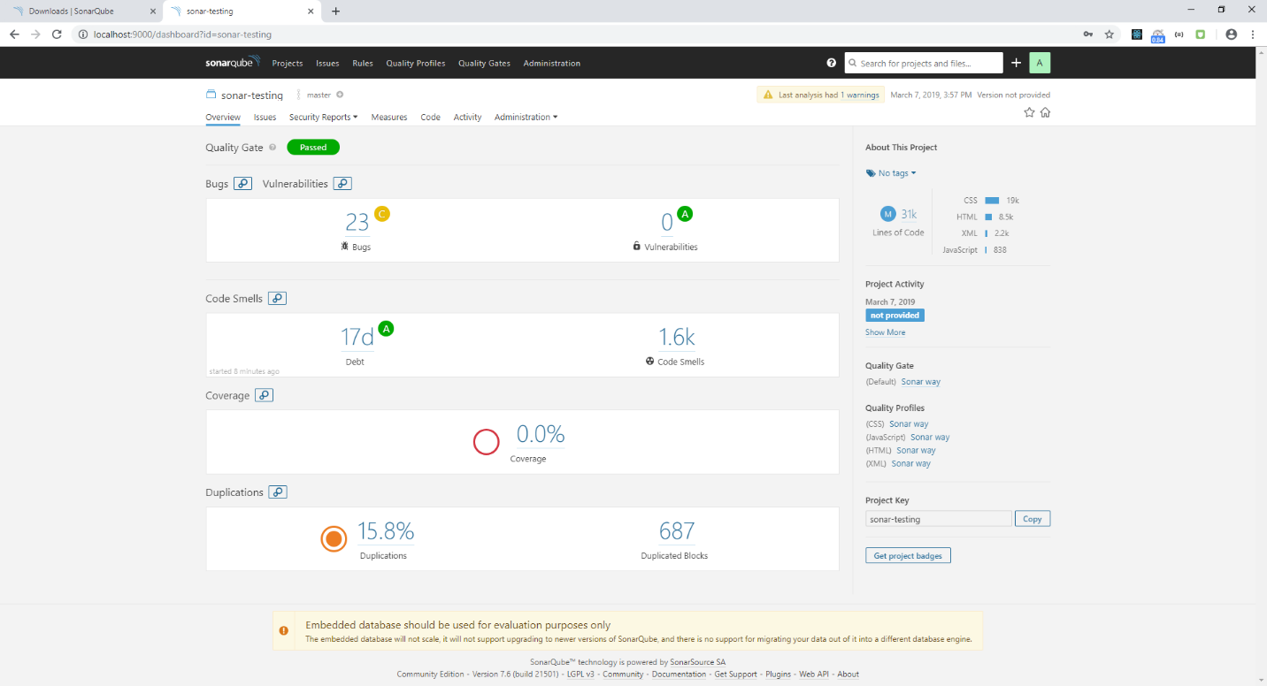After loading the sonar-scanner , refresh the browser

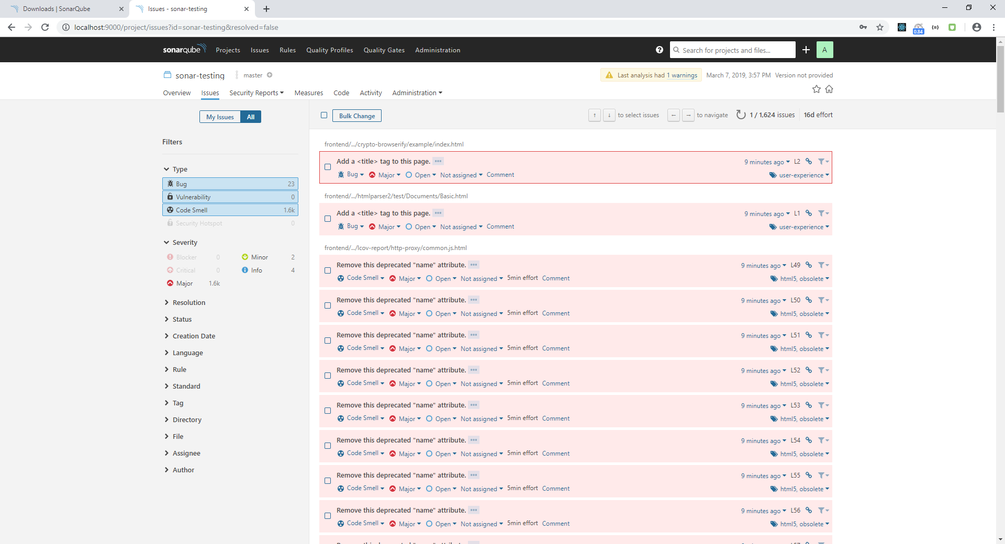

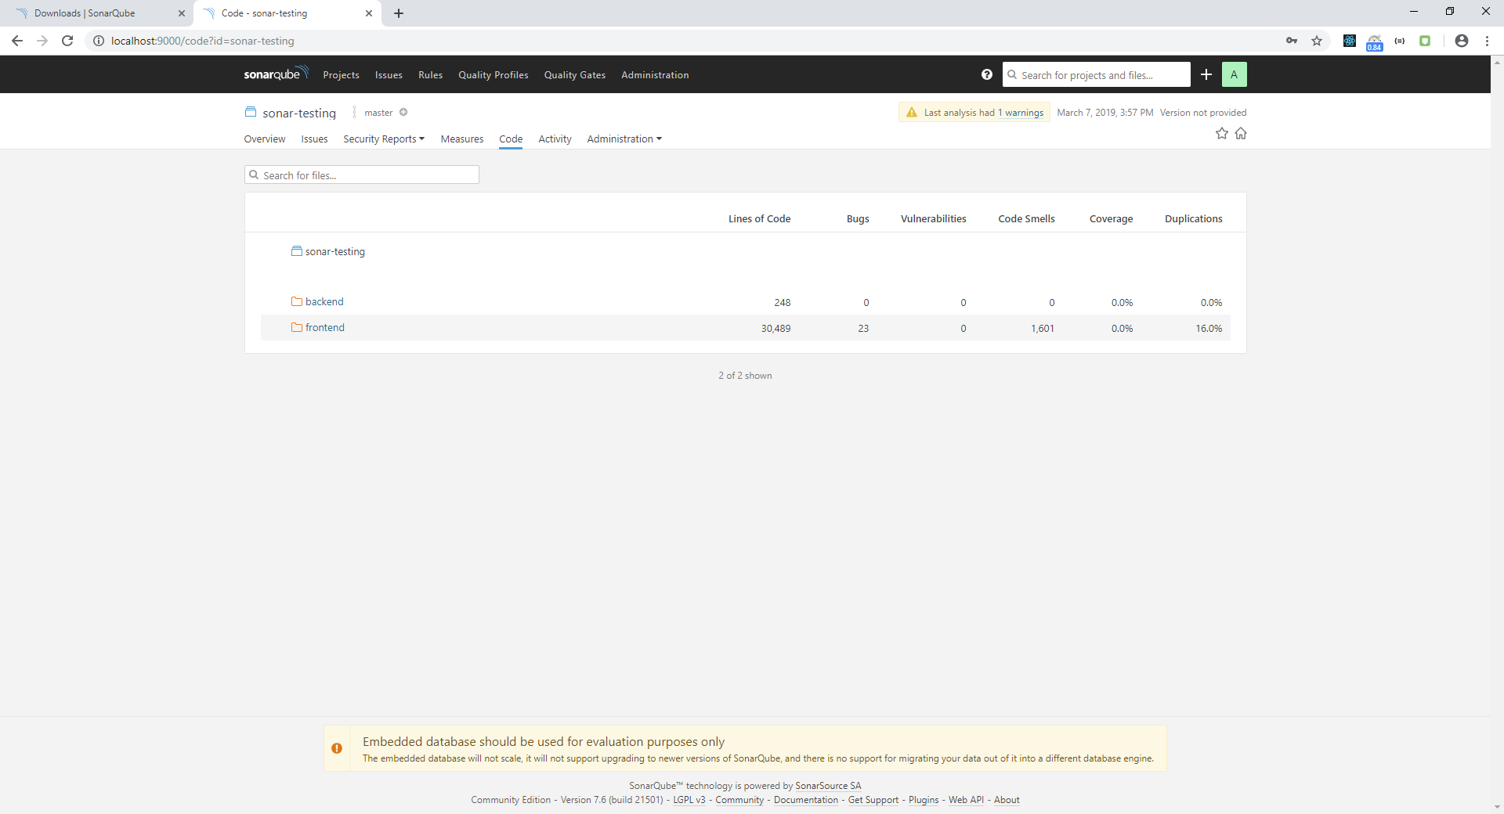

* After updating the code, rerun the sonar-scanner in cmd and refresh the browser

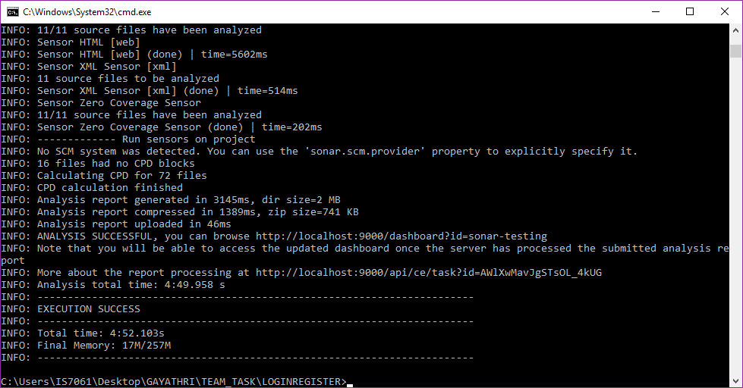

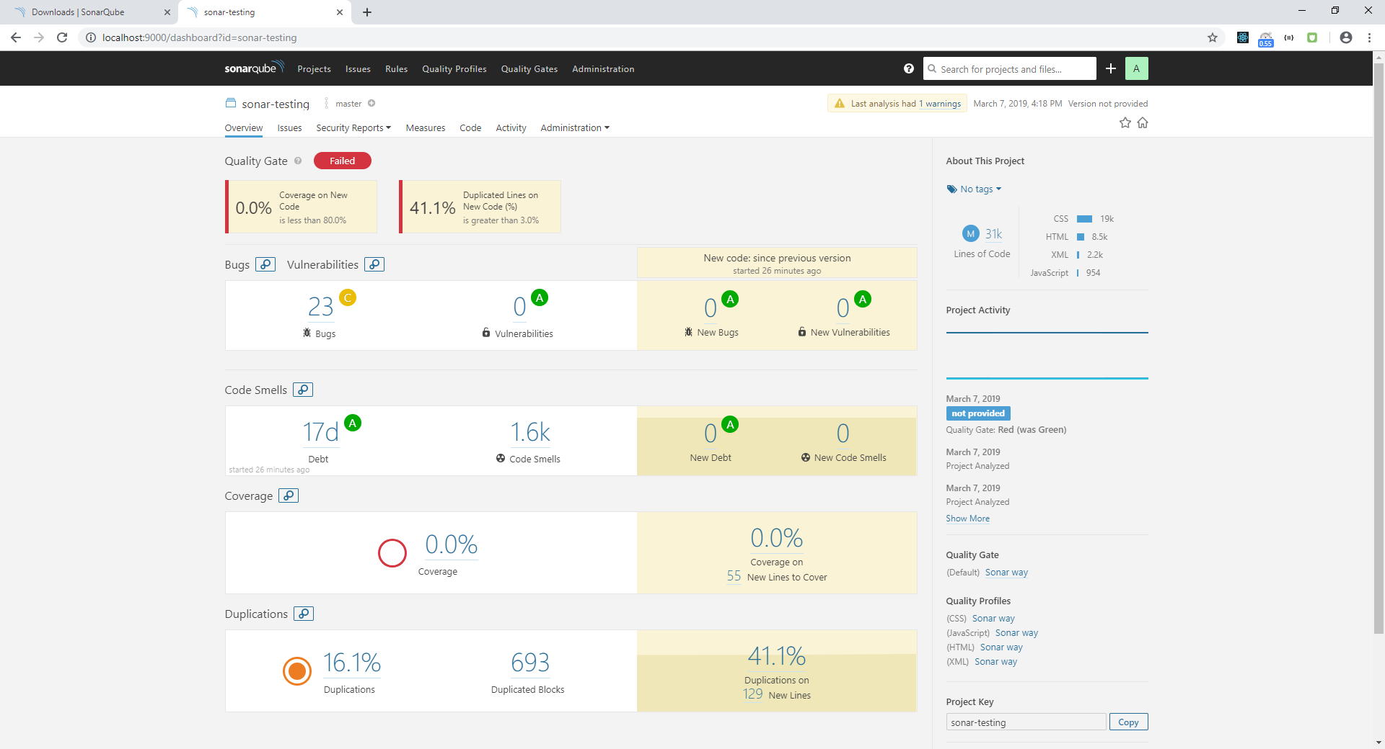

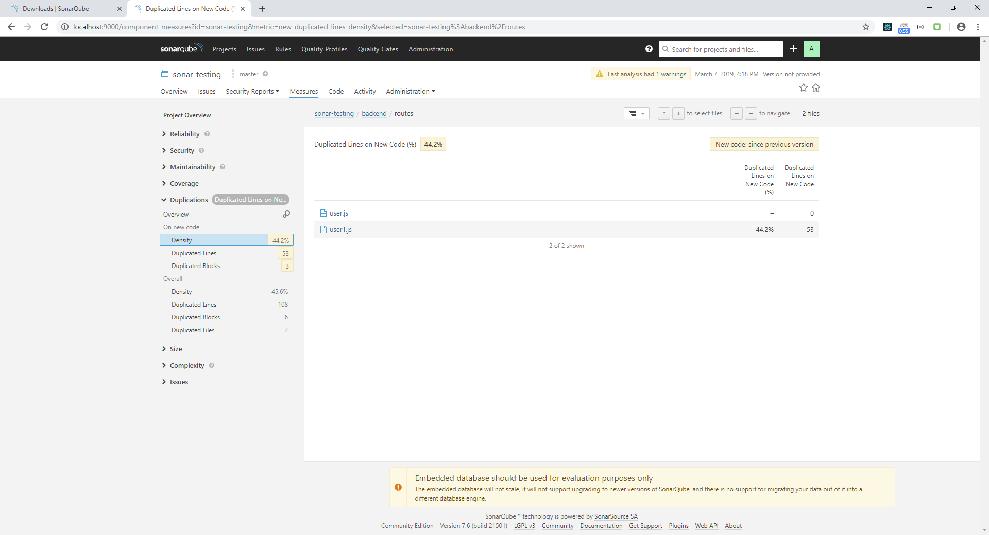

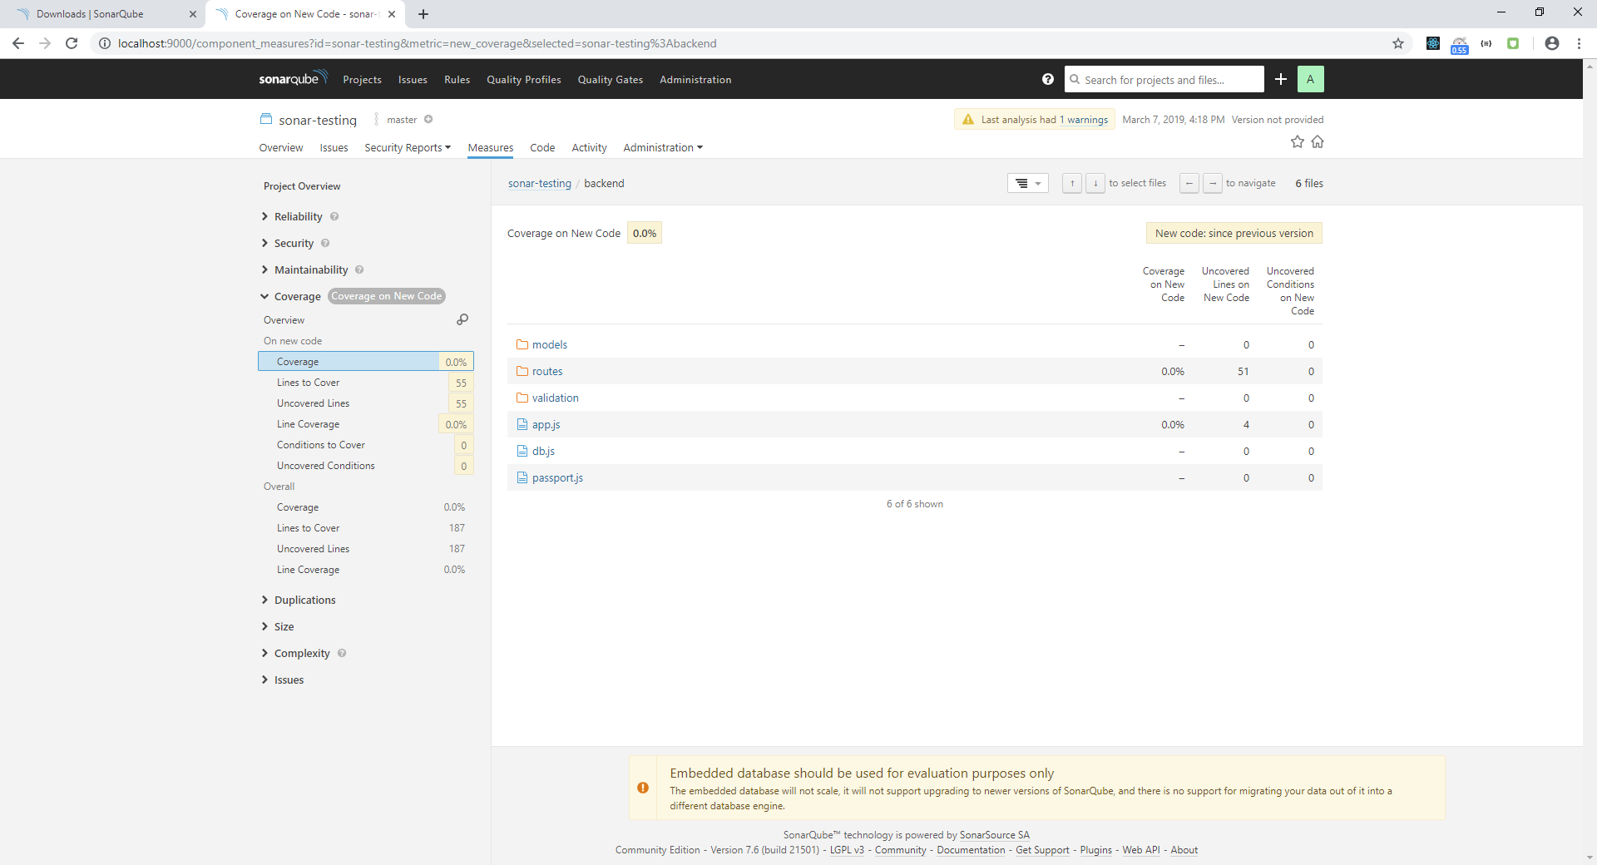

* Add the users for assigning the issues

Note: Administrator only create the users

Go to **Administration 🡪 security 🡪 users** and click the create user to add the user

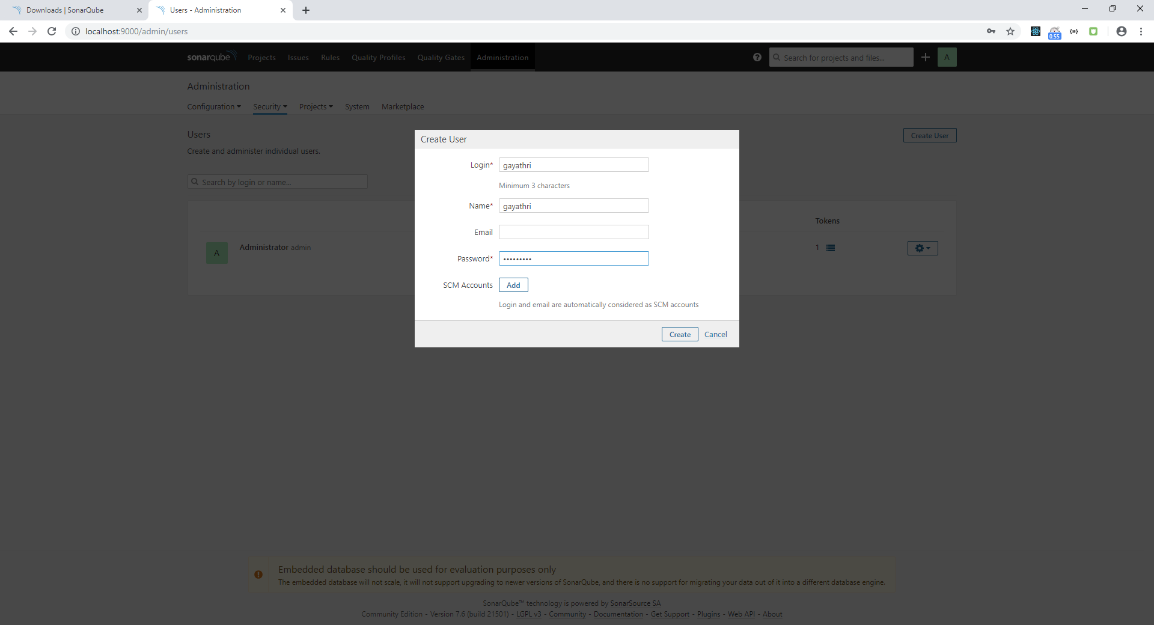

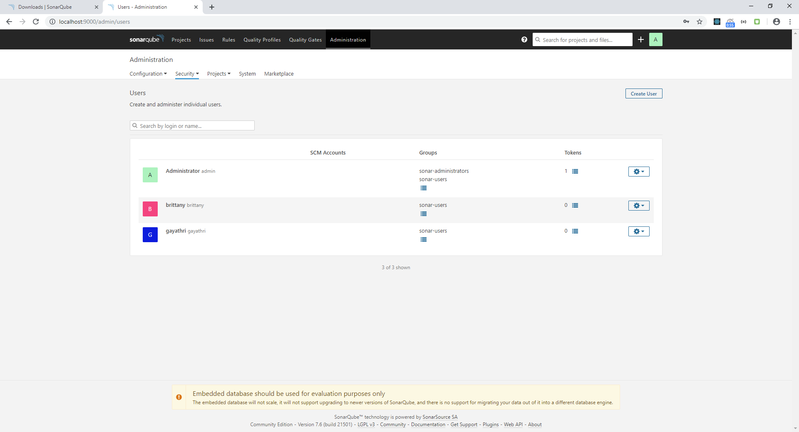

Assign the issues to users

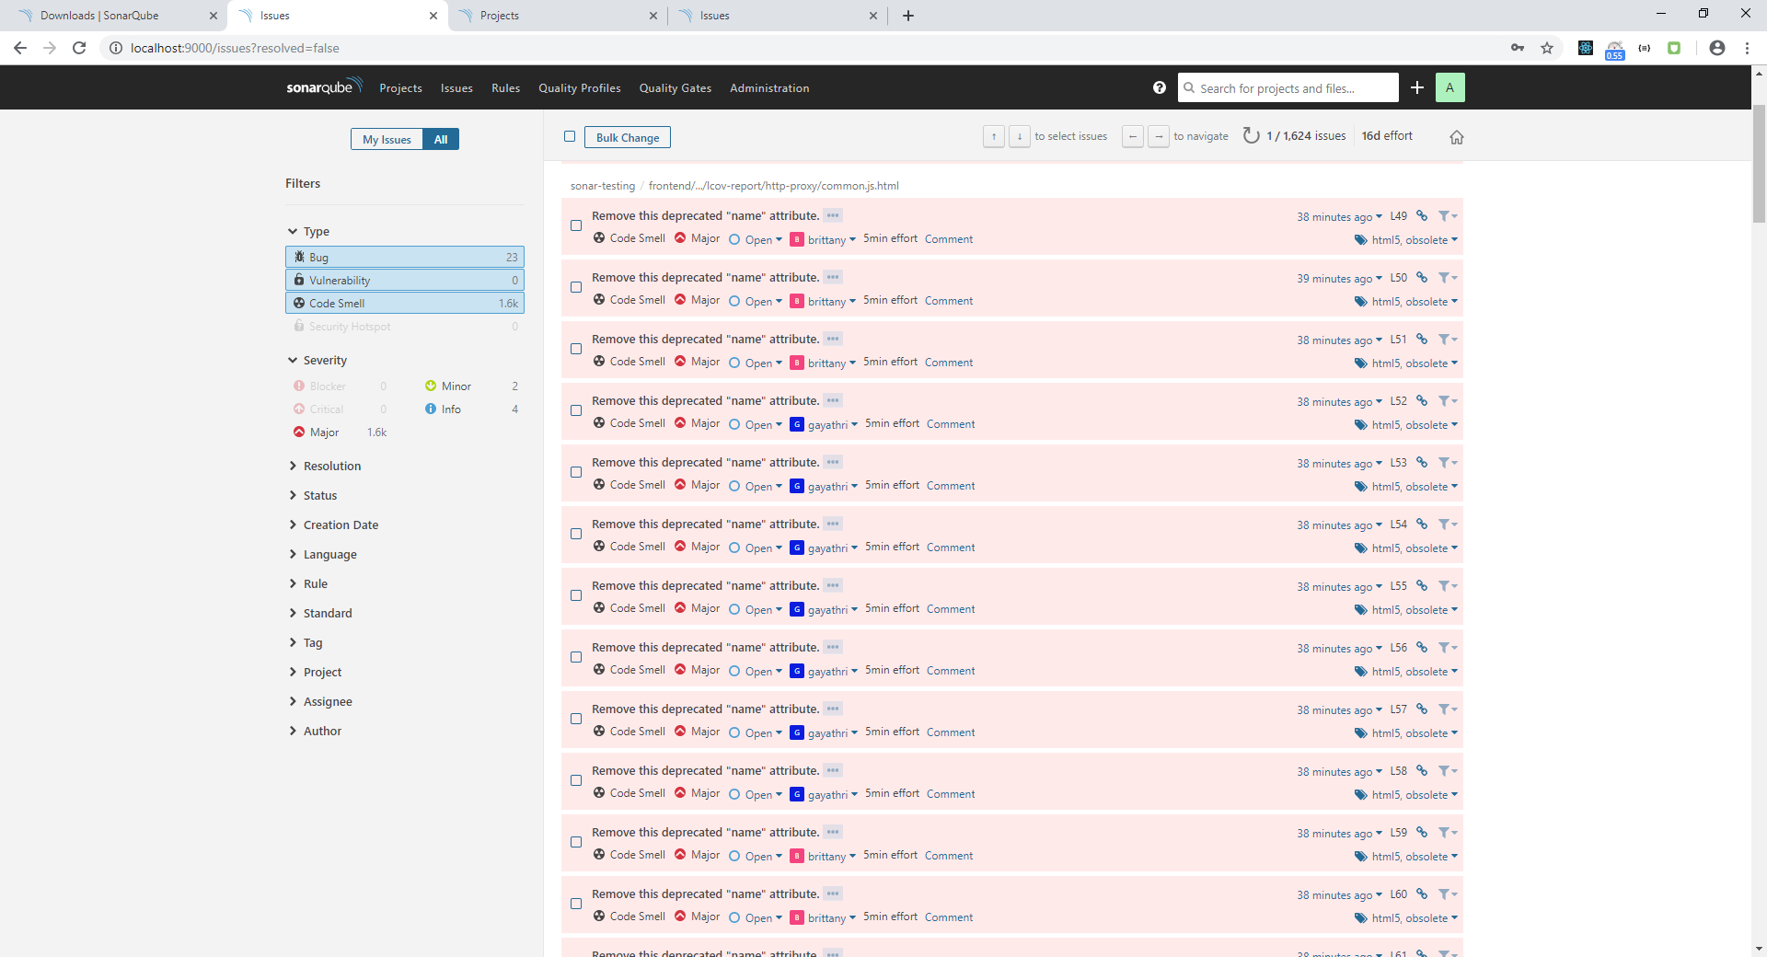

In user1 account , display issues like below

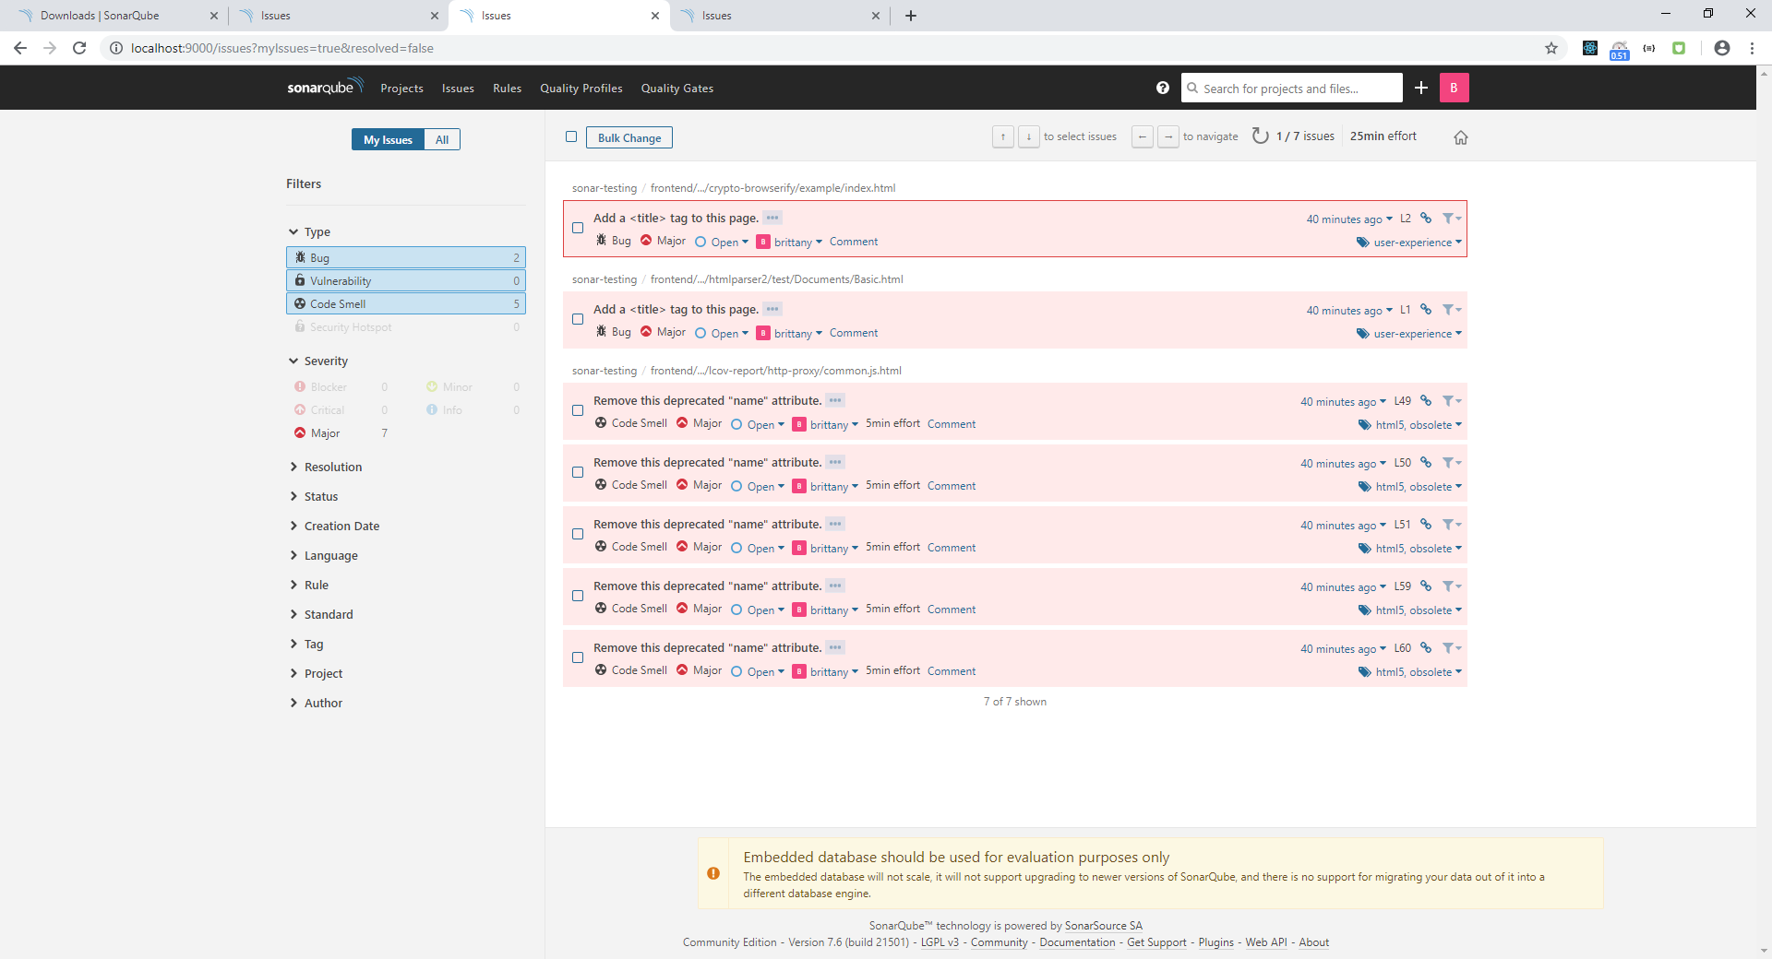

In user2 account , display issues like this

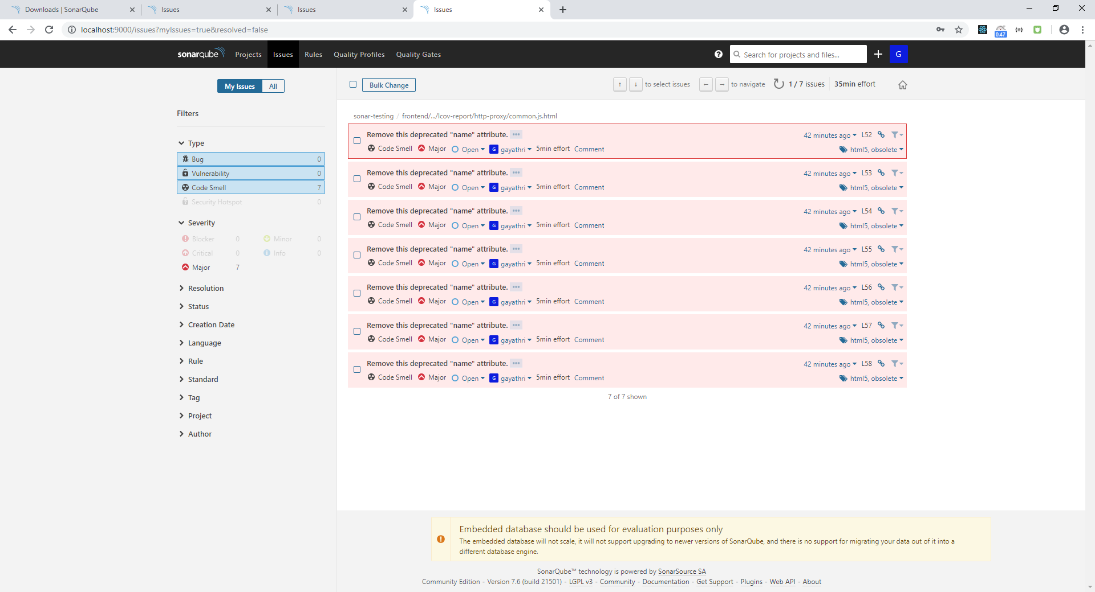

* Download the **sonar-csv-export-plugin jar file** for export the issues in excel sheet and add the jar file in **C:\Users\IS7061\_sonarqube-7.6\extensions\plugins**

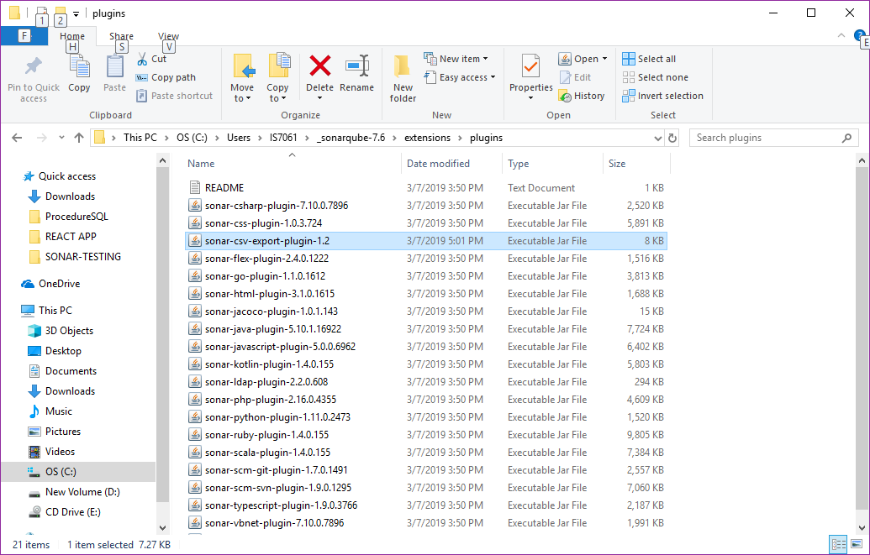

* 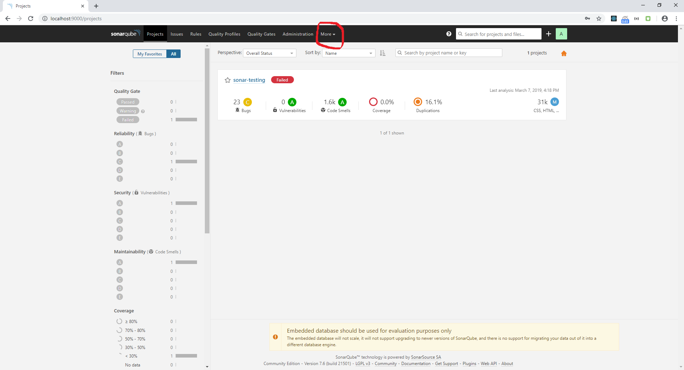Refresh the browser to view the more dropdown tab in top of the page and click it

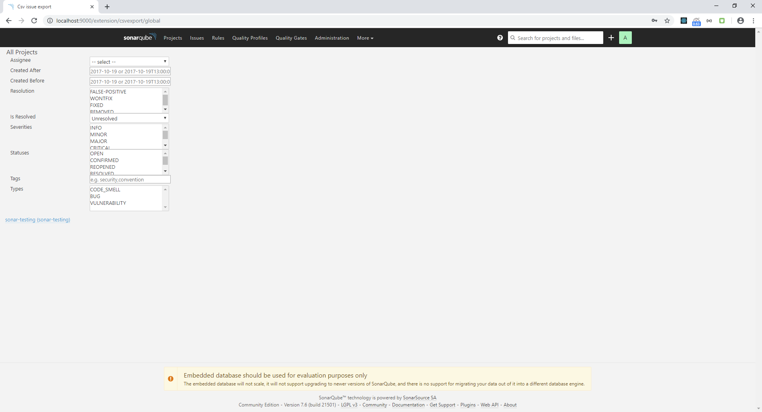

Also use filter to get the data to export in excel sheet and click the project name to download the excel sheet

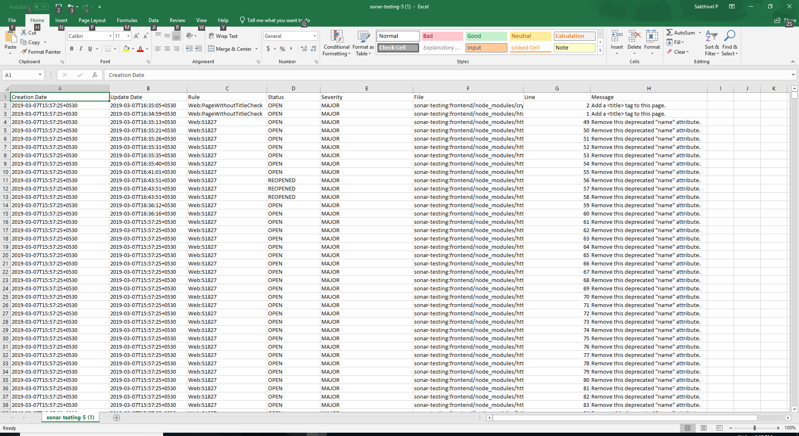

If Exclude the folders from analyzing process,

Go to administration 🡪 Analysis scope and type the folder name

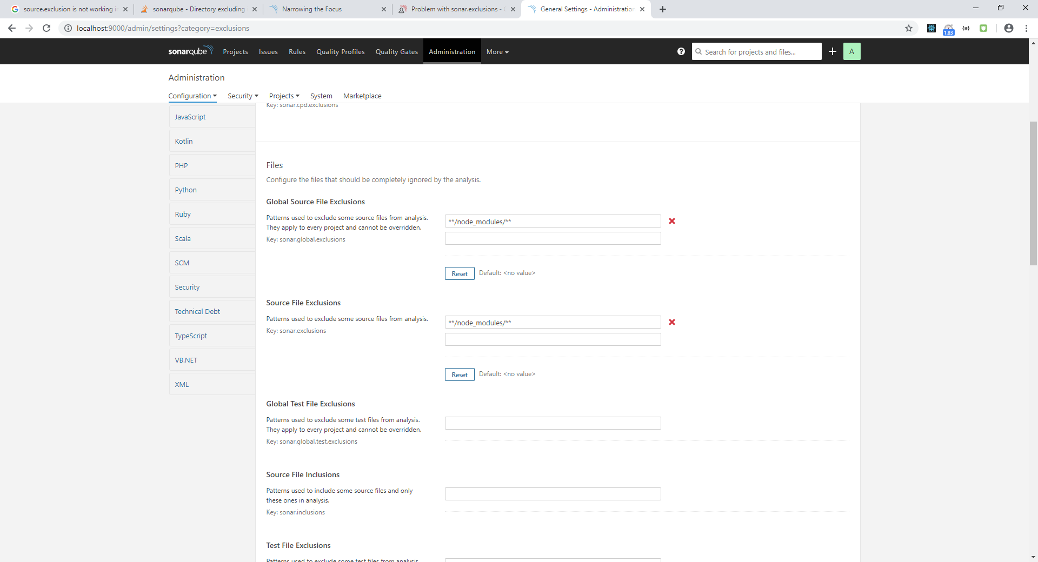(eg. node_module) in source file exclusion