PROJECT FLOW:

LOGIN PAGE

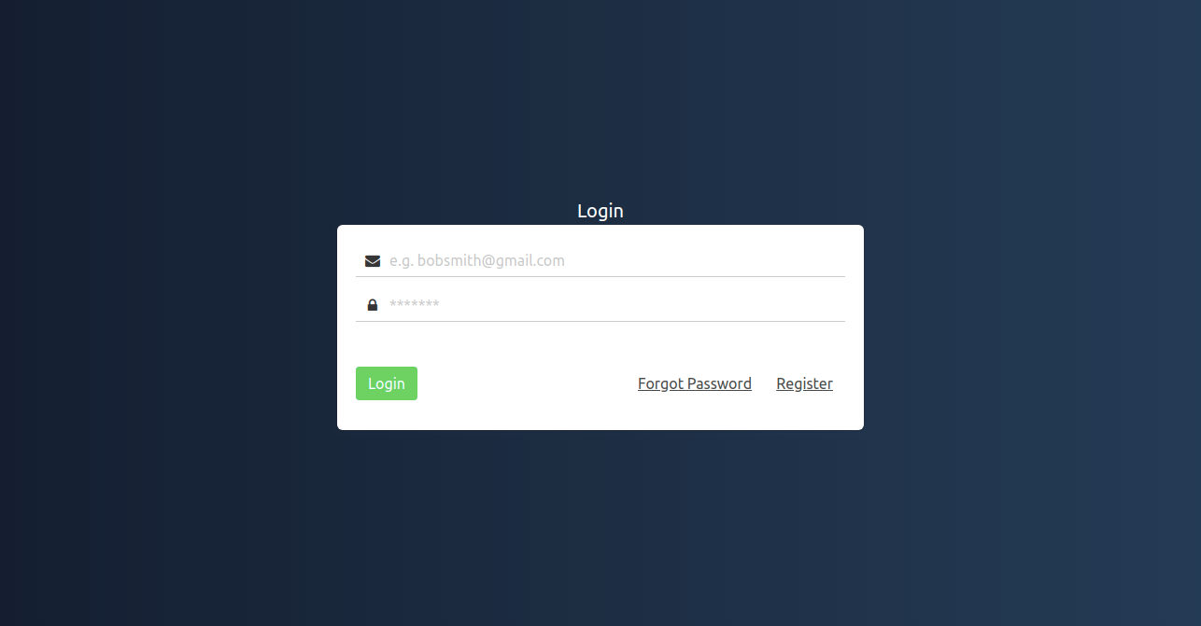

- The Login Page has Two input fields namely Email and Password,The Registered User has to login with their mailId and password which they have given at the time of registeration,onclick of Login button it will redirect to Project Creation Page.
- In case if the user Forgot the password,they can click the Forgot Password button it will redirect to Forgot Password Page.
- If the user didn’t Register they have to click the register button it will redirect to Registration Page.

FORGOT PASSWORD

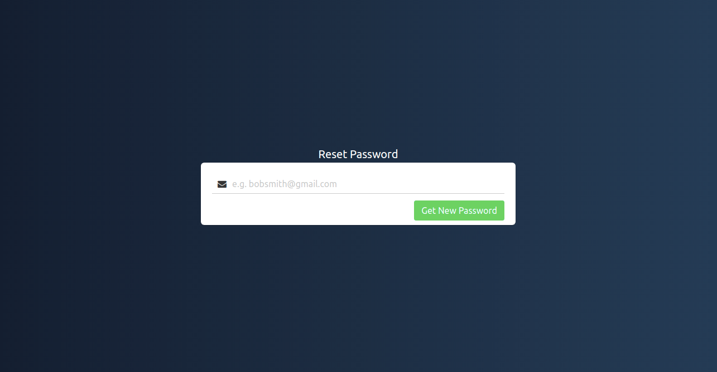

- User Can Reset the password by entering their registered mail id.
- On click of Get New Password Button the user will get a new password to their mail id.

REGISTRATION FLOW
REGISTRATION

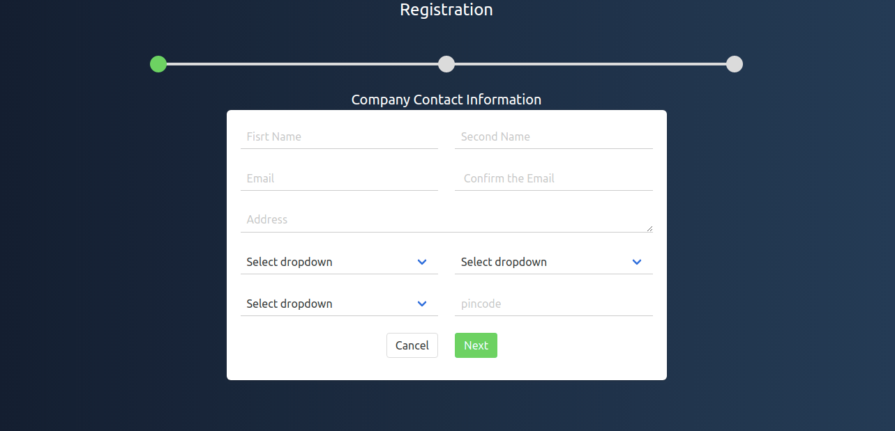
- Registration has Three wizards,In this Wizard the New User has to enter the details which is given in the Company Contact Information Form and click on Next Button.
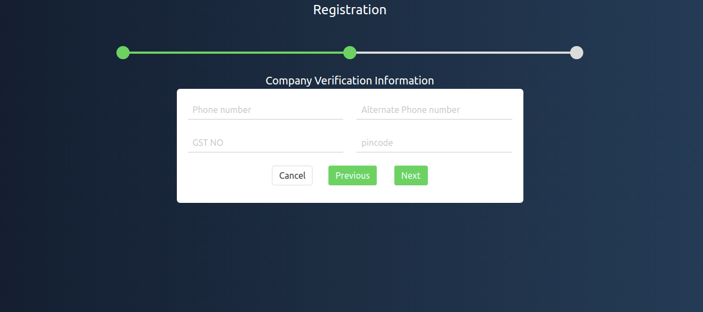
- User has to enter the Company Verification Information form and click the next button.

- If the User click the PREVIOUS Button it will go to the previous wizard and if the user click the CANCEL button the form filling process will get cancelled.

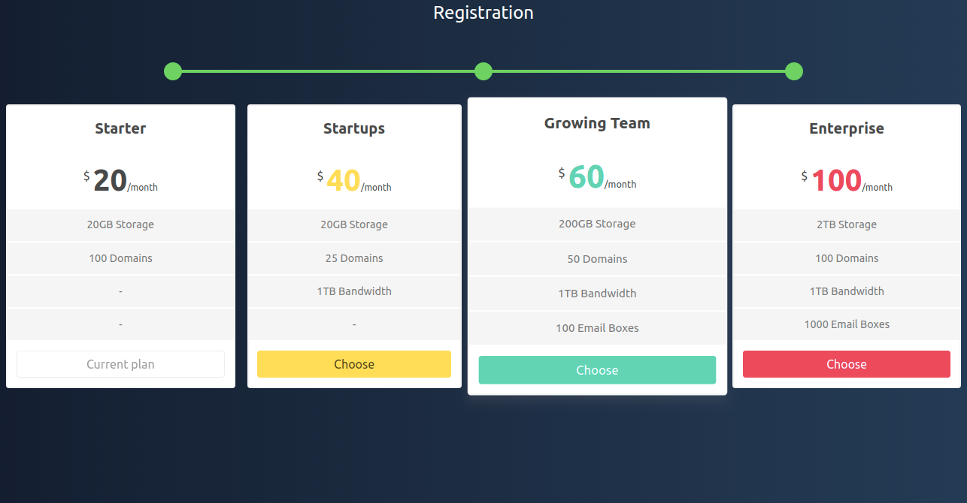
- Once the company verification process is done it will go to the third wizard for subscription,Here the user can choose their plan which they need.
- After choosing the plan The User can Login to create their Project.

PROJECT CREATION:

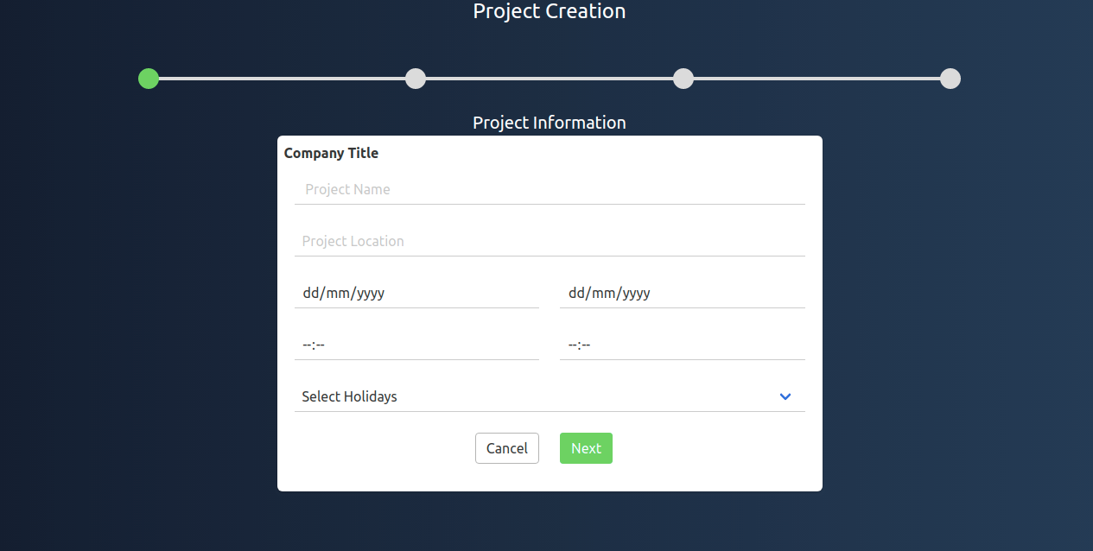
- User has to enter the Project details which is given in the Project information form and to click NEXT to move to wizard Two.

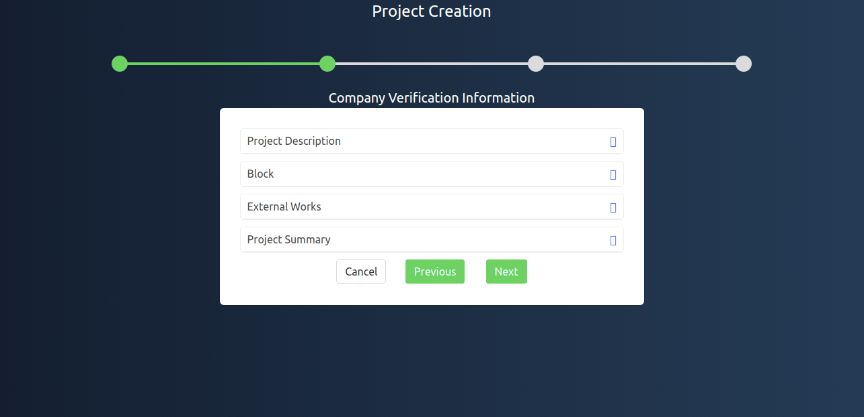
- Wizard Two has Four Collapsable tabs where the user has to fill all the details which is given in each tabs.

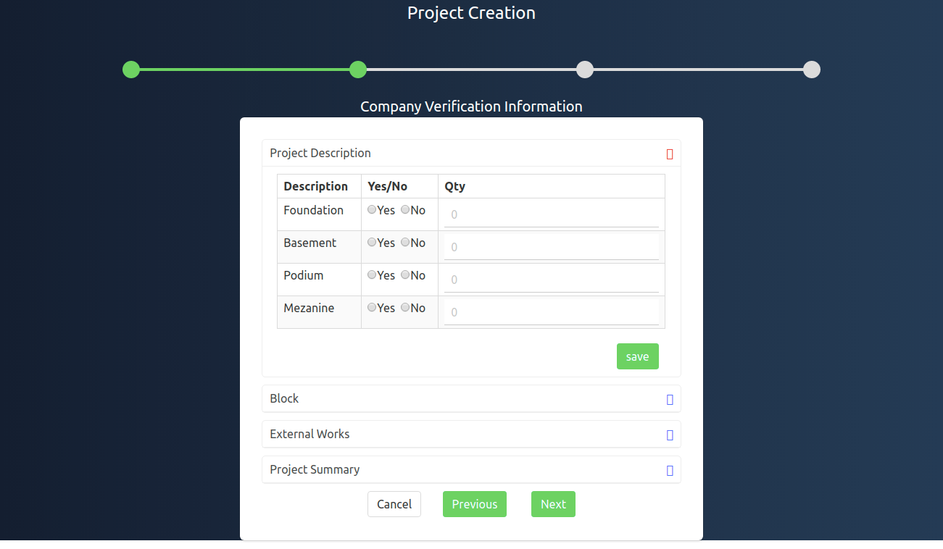
- In Project Description tab the user has to fill the details and click Save button ,where the entered items will get saved in DataBase.
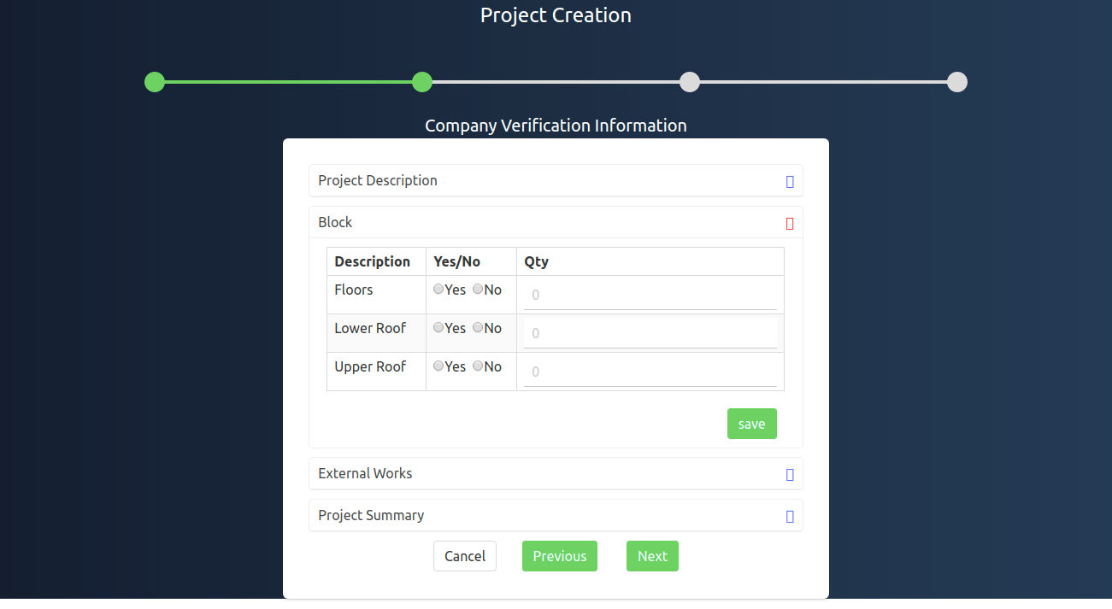
- In Block tab the user has to fill the details and click Save button ,where the entered items will get saved in DataBase.

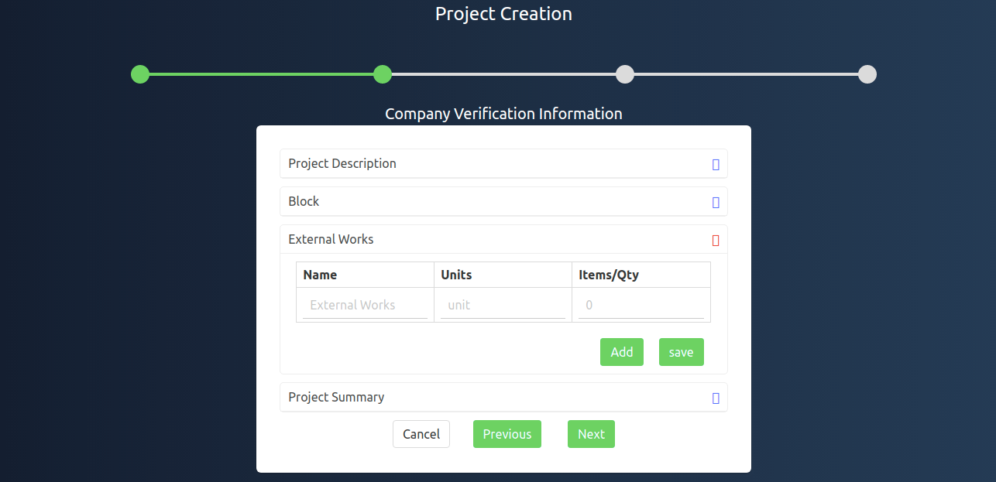
- In External Works tab the user can add the additional items,By clicking ADD button the user can add more items what they need and click SAVE button to save the items in DB.

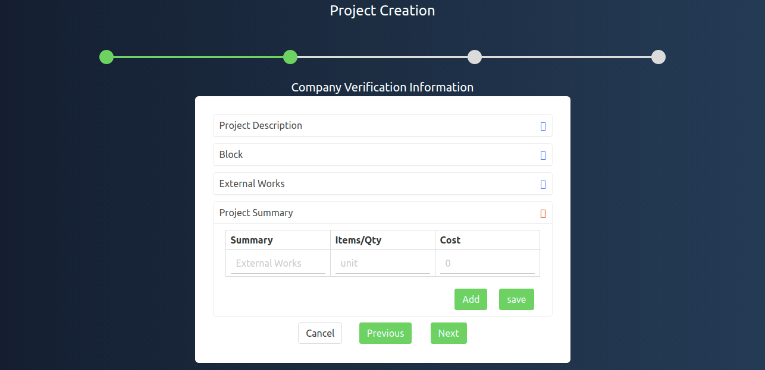
- In Project Summary the user can add the summary of the item and enter the cost of the item ,By clicking ADD user can add more items and SAVE button has to be clicked to get saved in DB.

- Once all the tabs are filled user has to click NEXT button to go to Third Wizard.

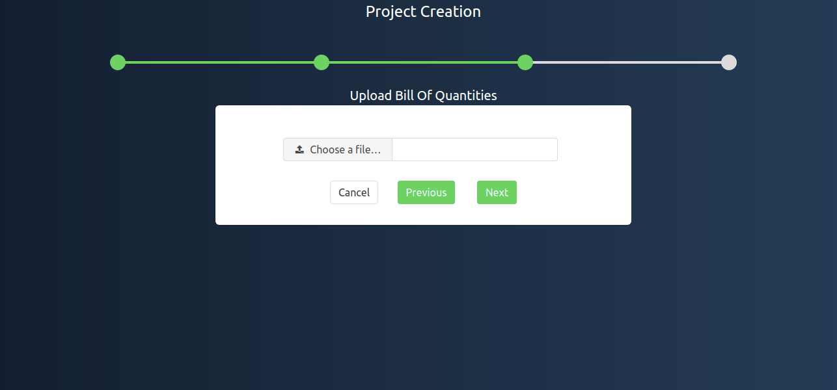
- User has to upload the Bill Of Quatities Excel sheet,Once the file is uploaded the items which is in the excel sheet get splitted into break downs like Main item,Sub item and Sub Sub items.

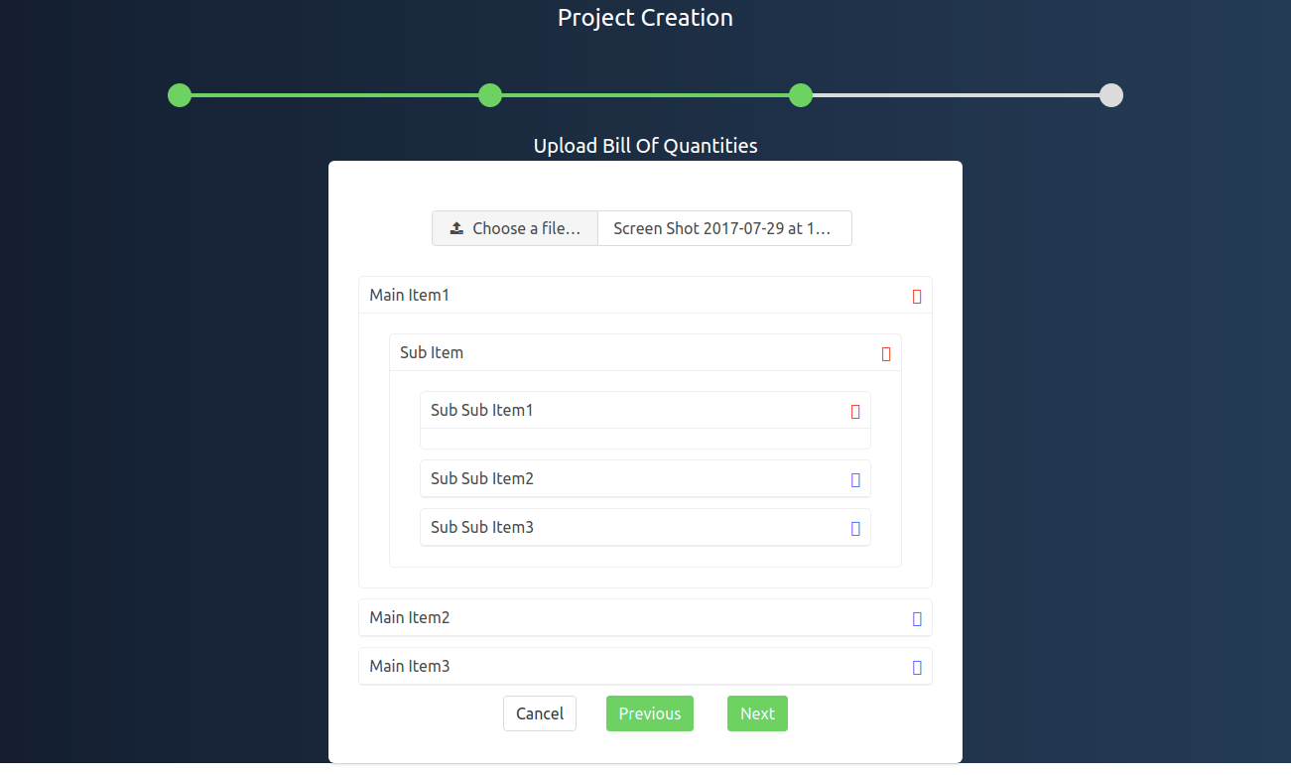

- Now the user has to click the NEXT button to go to last wizard.

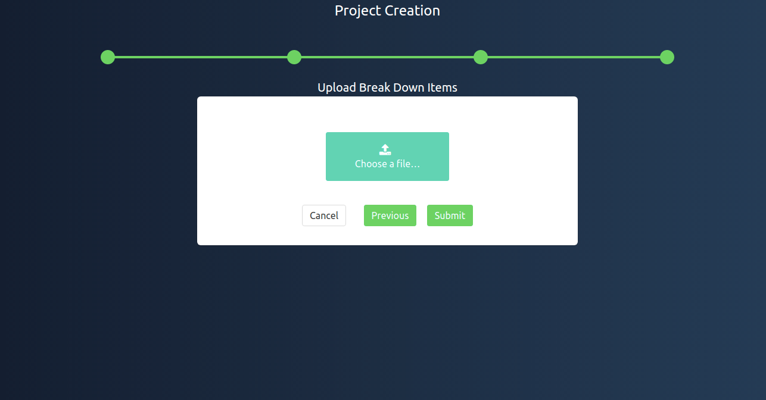

- User has to upload the Excel Sheet of individual breakdown items and to click SUBMIT button,where all the items in the Excel sheet is stored in the DataBase.
- After clicking SUBMIT button it will take the user to Dashboard.

