**NATURAL LANGUAGE PROCESSING LAB**

**PROJECT REPORT**

**Done By,**  Gayathri SK (71762233014)

Vaisaali priyankaa R (71762233056)

**TASK MANAGEMENT APP**

**Abstract:**

The Personal Assistant system aims to enhance user experience by organizing conversations into personal and professional categories, supporting event scheduling, reminders, and natural language querying of events. This application leverages Natural Language Processing (NLP) techniques, combined with advanced AI models, to deliver an intelligent assistant that helps users efficiently manage personal and professional tasks.

**Major Concepts:**

* **Classification Algorithm:**

A text classification algorithm (Logistic Regression) is used to categorize conversations into either personal or professional contexts. The classifier is trained on labelled conversation data, helping it recognize patterns and distinctions between various types of messages.

* **Syntax Analysis:**

The input from the user undergoes syntax analysis to break down the structure of each query. This process identifies essential components, such as nouns (indicating event names), dates, and times, which are critical for properly understanding and processing user commands.

* **Semantic Analysis with Test Generation:**

The system performs semantic analysis using BERT for contextual embeddings and GPT-2 for test generation:

BERT (Bidirectional Encoder Representations from Transformers): BERT helps the system grasp the deeper meaning behind user queries by understanding context, which is essential when commands include ambiguous or complex phrases. BERT’s embeddings enable the system to interpret the nuances of user intent.

GPT-2 for Test Generation: GPT-2 is used to generate varied, realistic conversational data, providing synthetic examples that train the system to respond accurately to real-world requests. This enhances the system's ability to handle diverse user inputs.

* **Tagging Techniques:**

Named Entity Recognition (NER) and Part of Speech (POS) Tagging identify important information within queries, such as dates, times, event names, and categories. This tagging allows for the effective extraction and organization of data, which is especially useful in scheduling and managing events.

* **Chunking and Information Extraction:**

After tagging, the system chunks relevant information, grouping details like dates, times, and event descriptions into structured formats. This helps the assistant retrieve and display event details effectively, making it easier for users to query and manage their tasks.

**Tools and Technologies Used**

* **NLP Libraries:**

spaCy and NLTK for initial syntax and semantic analysis tasks.

BERT and GPT-2 for advanced semantic understanding and test data generation, which brings a deep-learning layer to natural language interpretation.

* **Classification Models:**

Logistic Regression model for classifying conversations as personal or professional. These models are trained to detect distinct conversational patterns based on labelled data, improving the system’s classification accuracy.

* **Database for Event Management:**

Excel to store event details, ensuring quick retrieval and organization of scheduled events for users.

**Code:**

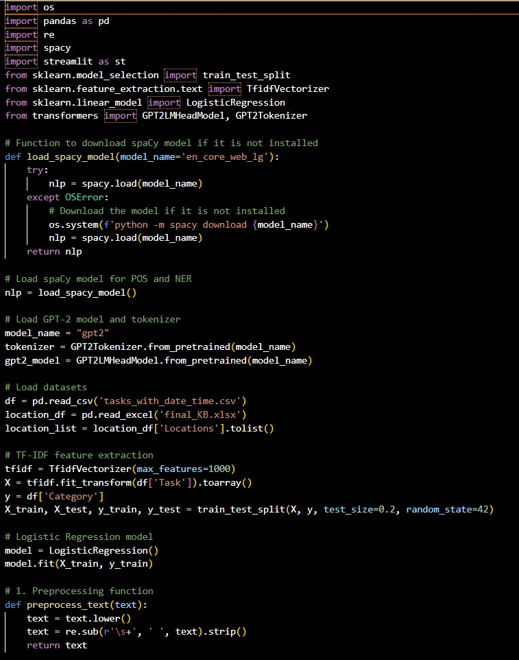 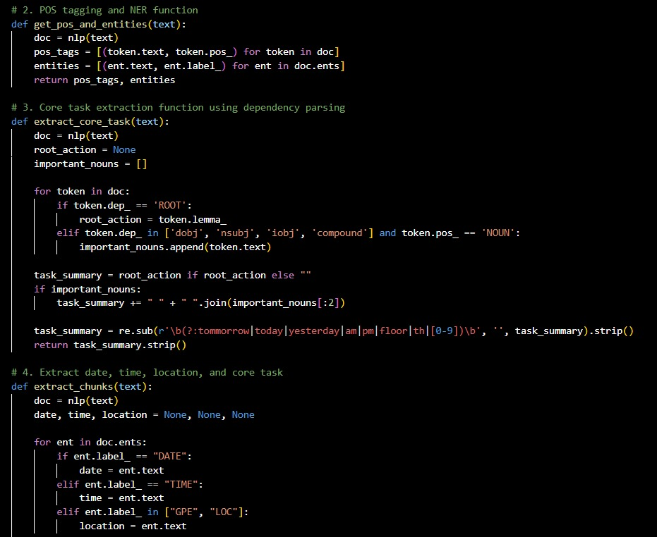

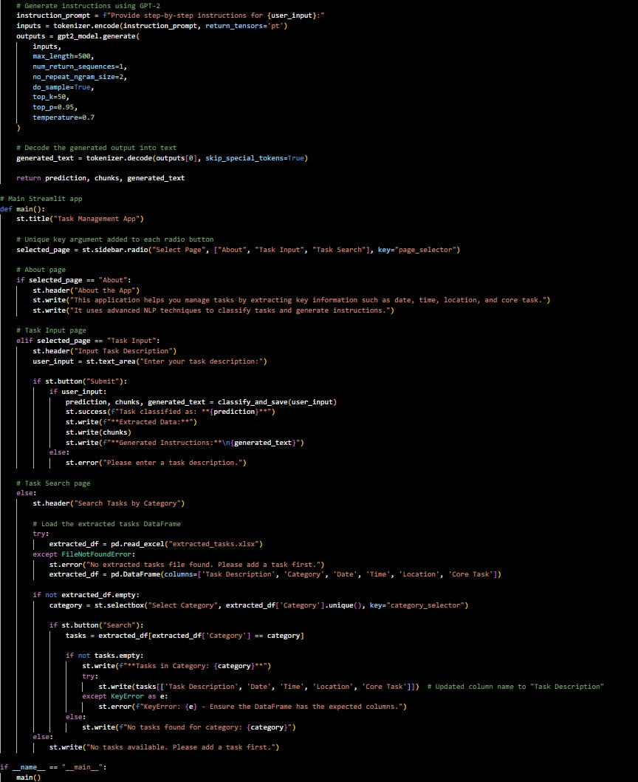

**Output:**

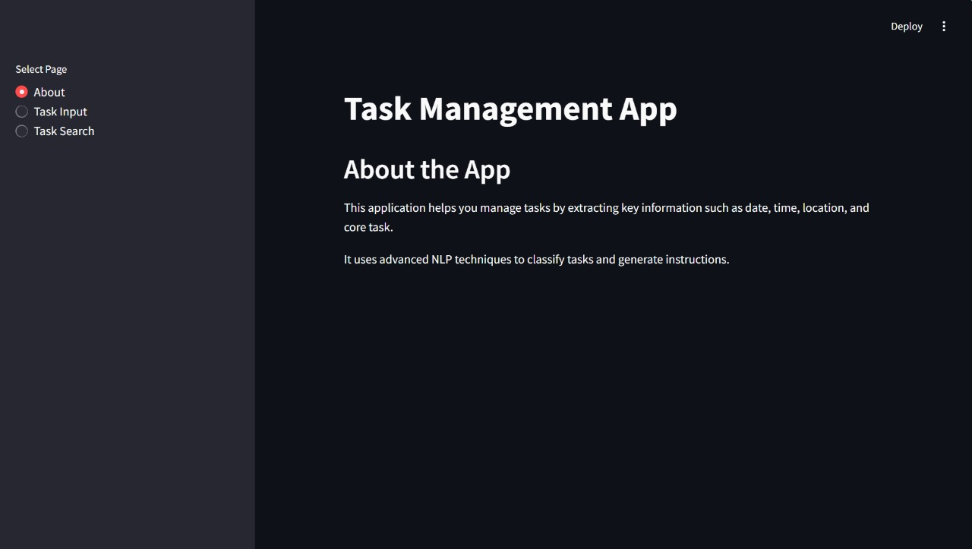

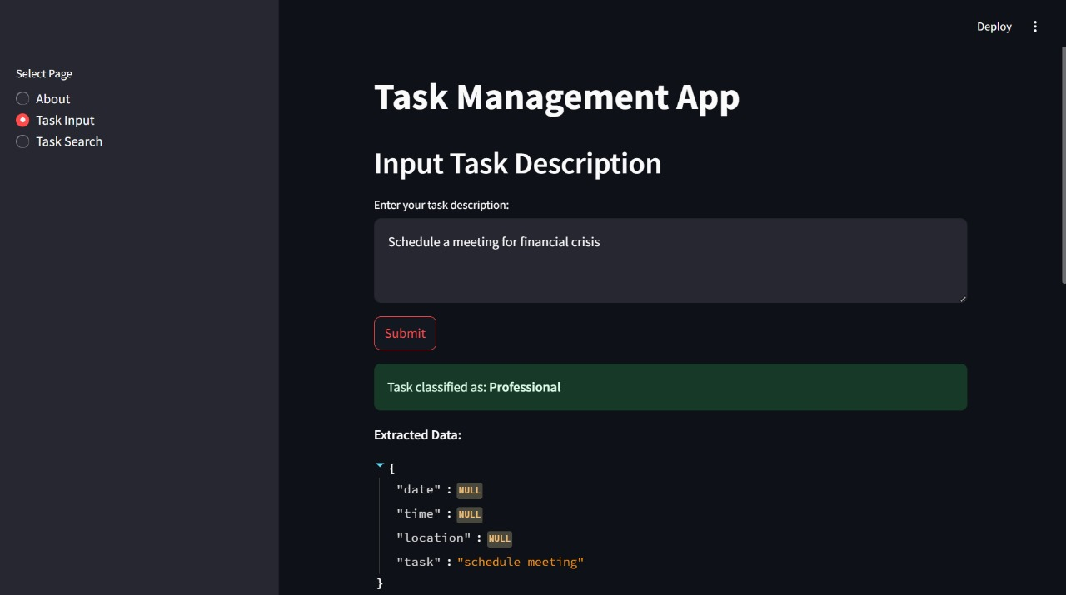

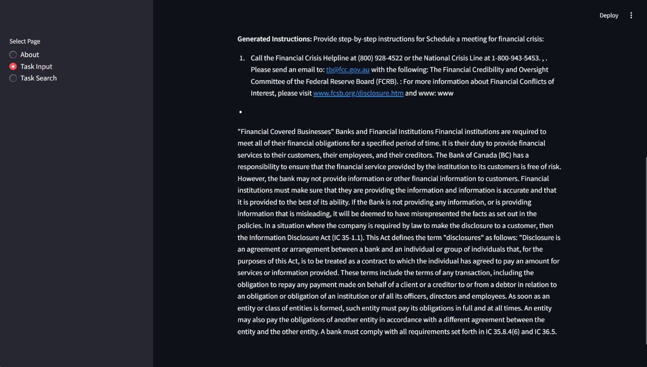

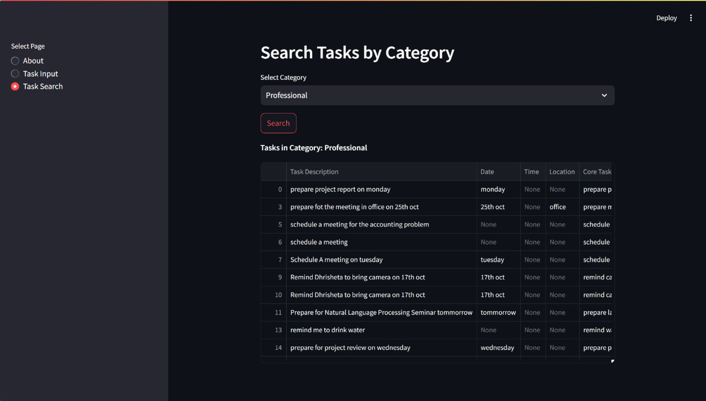

**Conclusion:**

This project integrates classification algorithms, syntax and semantic analysis, and information extraction to create a powerful personal assistant. By categorizing user interactions and managing events seamlessly, it boosts productivity and organizes tasks effectively. Through advanced NLP techniques, the assistant bridges natural language understanding and structured event management, offering a streamlined, intelligent solution for personal and professional task management.