**Data Warehousing with IBM Cloud Db2 Warehouse**

**Project Documentation & Submission**

**Phase5 Submission**

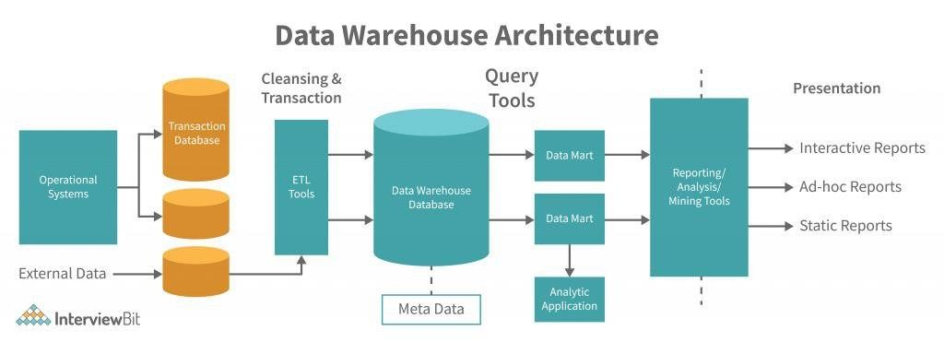

**A data warehouse typically has a structure that includes:**

* **Data Sources:** Information is collected from various operational systems or external sources.
* **ETL (Extract, Transform, Load):** Data is extracted from these sources, transformed to fit the warehouse schema, and loaded into the warehouse.
* **Warehouse Database:** This structured data is stored in a centralized repository optimized for query and analysis.
* **Schema:** Data is organized in a dimensional or normalized structure for reporting and analysis.
* **Metadata:** Information about the data (its origin, meaning, relationships, etc.) is stored to facilitate understanding and management.
* **Access Tools:** Querying tools, reporting applications, and other software for analyzing and accessing the data.

The structure can vary based on the specific design, business needs, and the way the data is used within an organization.

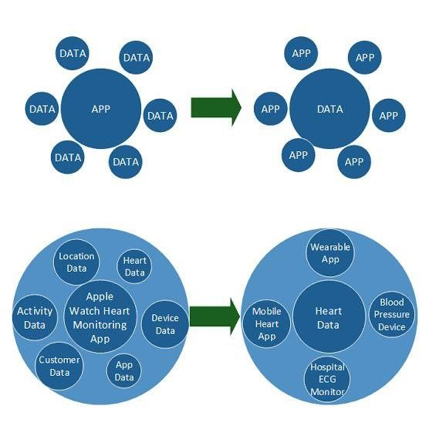

Data integration involves combining and unifying data from various sources into a single, coherent view. Several strategies facilitate this process:

1. **ETL (Extract, Transform, Load):** Data is extracted from the source systems, transformed to fit the target schema, and loaded into the destination system (like a data warehouse).
2. **ELT (Extract, Load, Transform):** In this approach, data is extracted from the source, loaded into the target system, and then transformed within the target system. It's beneficial when the target system has significant processing power.
3. **API Integration:** Utilizing Application Programming Interfaces (APIs) to directly connect different systems and enable data transfer and interaction.
4. **Data Replication:** Copying and synchronizing data in real-time or at intervals from source systems to a centralized location. This can include database replication, log-based replication, or change data capture (CDC).
5. **Data Virtualization:** Providing a unified view of data without physically consolidating it. It allows querying data from various sources in real-time without moving the data.
6. **Enterprise Service Bus (ESB):** A software architecture that enables communication among various systems using a messaging backbone, facilitating data exchange.
7. **Master Data Management (MDM):** Focusing on identifying, linking, and managing critical data to provide a single point of reference.

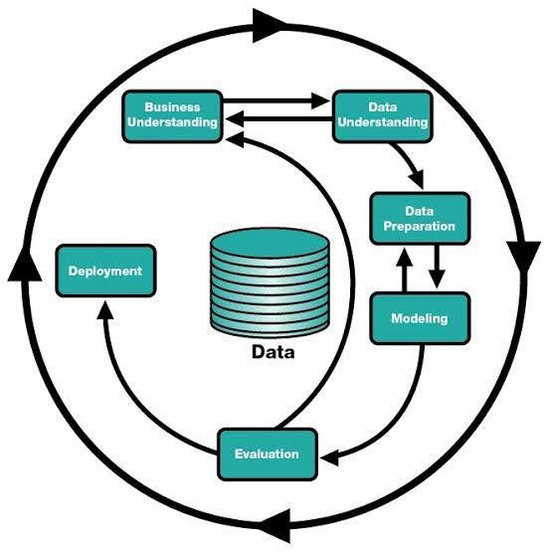.

Exploring data within a data warehouse involves specific techniques tailored to the characteristics of these repositories. Some techniques for data exploration within a data warehouse include:

1. **Metadata Analysis:** Studying the metadata to understand the structure, relationships, and content of the stored data.
2. **Querying and Sampling:** Running exploratory queries to sample and analyze subsets of data to understand its characteristics.
3. **OLAP (Online Analytical Processing) Cubes:** Analyzing data using multidimensional structures to quickly aggregate, slice, and dice data for exploration.

1. **Data Profiling:** Examining data quality, distributions, and patterns to identify anomalies, missing values, or inconsistencies.
2. **Data Mining and Machine Learning:** Applying algorithms to identify patterns, correlations, or anomalies within the vast data sets.
3. **Drill-Down and Drill-Up:** Navigating hierarchies of data by drilling down into details or rolling up to higher-level summaries to understand specific data segments.
4. **Data Visualization Tools:** Leveraging visualization tools specific to data warehouses to create reports, dashboards, or visual representations of complex data structures.
5. **ETL (Extract, Transform, Load) Analysis:** Investigating the ETL processes to understand how data is transformed and loaded, identifying potential issues or data quality problems.
6. **Advanced Analytics:** Using statistical analysis, regression, forecasting, and other advanced analytical techniques to derive insights from the data warehouse content.

Data exploration within a data warehouse is crucial for understanding the data's nature, ensuring data quality, and extracting valuable insights for business intelligence, decision-making, and further data driven operations.

Data warehouses serve as a foundational component for data architects to deliver actionable insights by providing a structured, integrated, and optimized environment for data analysis. Here's how they enable this:

1. **Centralized Data Storage:** Data warehouses consolidate data from various sources into a single, unified repository. This centralized structure allows data architects to work with consistent, integrated data, making it easier to analyze and derive insights.
2. **Optimized for Query Performance:** Data warehouses are designed with optimized schemas and indexing, allowing for faster query performance. This speed enables data architects to quickly extract, transform, and analyze large volumes of data, facilitating rapid insights.
3. **Historical Data Retention:** They store historical data, enabling trend analysis and comparisons over time. Data architects can utilize this historical information to identify patterns, make forecasts, and support strategic decision-making.
4. **Support for Complex Queries:** With their ability to handle complex queries and support advanced analytics, data warehouses empower data architects to perform intricate analysis, including predictive modeling, statistical analysis, and machine learning.
5. **Scalability and Flexibility:** Data warehouses are often scalable, allowing for the addition of new data sources and the processing of increasing data volumes. This scalability offers flexibility in accommodating changing business needs.
6. **Business Intelligence and Reporting:** Data warehouses facilitate the creation of business intelligence reports, dashboards, and visualizations. This empowers stakeholders to understand data more easily and make informed decisions based on the insights provided.
7. **Data Governance and Security:** They provide a framework for implementing data governance and security measures, ensuring compliance and maintaining the integrity and confidentiality of the data.
8. **Facilitation of Data Integration:** Data warehouses enable the integration of various data sources, making it possible to blend structured and unstructured data for comprehensive analysis.

By leveraging these features, data architects can harness the power of the data warehouse to extract, transform, and analyze data, delivering actionable insights that support informed decision-making and drive business strategy.

**TEAM MEMBERS:**

**JEYALAKSHMI SUBIKSHA S**

**HUDHA N**

**GAYATHRI S**