Assignment-4

Create an infographic illustrating the Test-Driven Development(TDP) process.Highlight steps like writing tests before code,benefits such as bug reduction,and how it fosters software reliability.

**TDD Cycle: Step-by-Step**

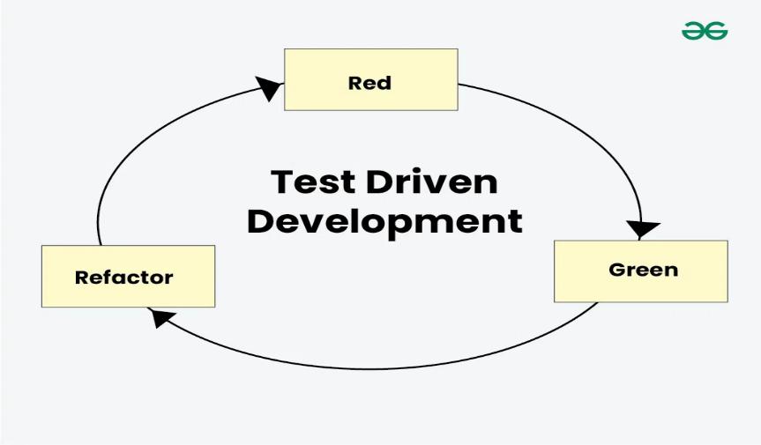

* Run all the test cases and make sure that the new test case fails.
* Red – Create a test case and make it fail, Run the test cases
* Green – Make the test case pass by any means.
* Refactor – Change the code to remove duplicate/redundancy.Refactor code – This is done to remove duplication of code.
* Repeat the above-mentioned steps again and again.

**Key Benefits of TDD**

* **Bug Reduction**  
  Catch errors early by testing every new feature before implementation.
* **Improved Code Design**  
  Writing tests first encourages modular, loosely coupled code.
* **Safe Refactoring**  
  Tests ensure you can improve code without breaking functionality.
* **Faster Debugging**  
  Failures are caught at the exact moment changes are made.
* **Increased Reliability**  
  A growing suite of tests serves as a safety net over time.