Assignment-7

Write a summary on different project methodologies.

**Agile model:**

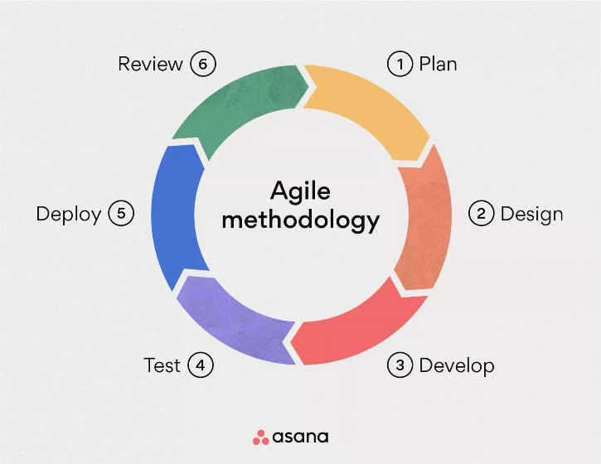

-> Agile methodology is a project management framework that breaks projects down into several dynamic phases, commonly known as sprints.

-> The Agile framework is an [iterative methodology](https://asana.com/resources/iterative-process).

-> After every sprint, teams reflect and look back to see if there was anything that could be improved so they can adjust their strategy for the next sprint.

**Waterfall Model:**

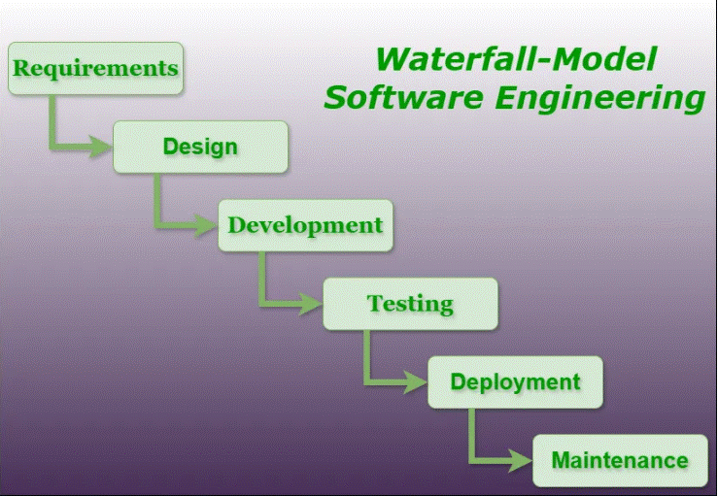

-> The Waterfall Model is one of the traditional software development methodologies, characterized by a linear and sequential approach.

-> Each phase of the project must be completed before the next one begins, and there is little to no overlap between phases.

-> The Waterfall Model follows a linear, step-by-step approach to software development, where each phase flows down into the next.

**Spiral model:**

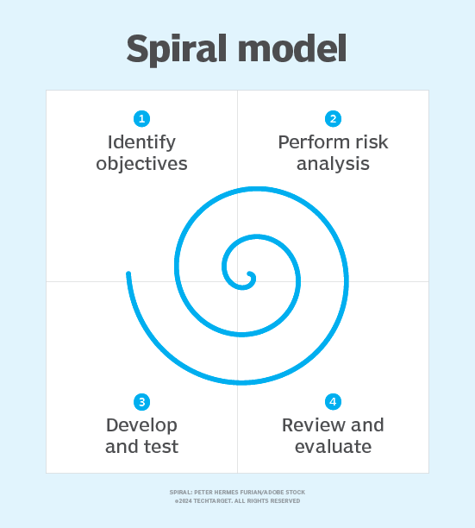

-> The spiral model is a systems development lifecycle method used for risk management that combines the iterative development process model with elements of the waterfall model.

->The spiral model is used by software engineers and is favored for large, expensive and complicated projects.

-> The spiral model of software development looks like a coil with many loops.

**V-Model:**

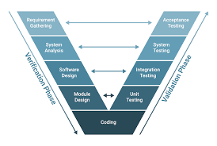

-> The V-model is an SDLC model where execution of processes happens in a sequential manner in a V-shape. It is also known as Verification and Validation model.

-> The V-Model is an extension of the waterfall model and is based on the association of a testing phase for each corresponding development stage.