Assignment-5: Write a brief summary on SCRUM Framework.

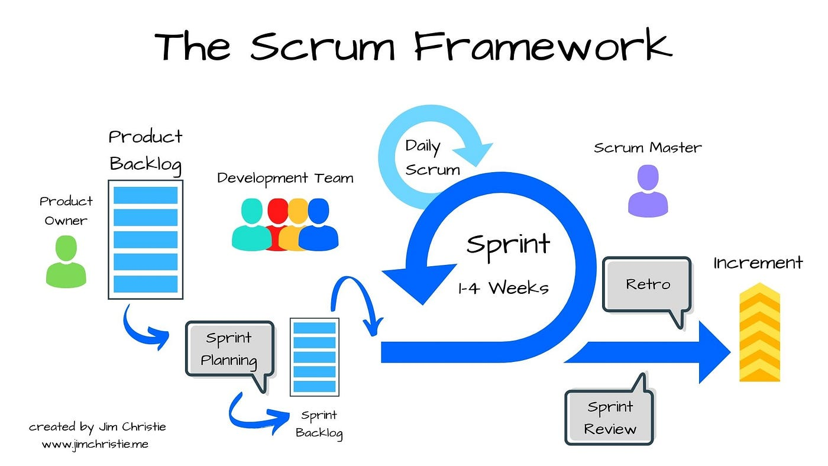

Scrum is a lightweight, agile framework designed to help teams collaborate effectively on complex projects, delivering high-value products incrementally.

Originally developed for software development, Scrum has since been applied across various industries, including marketing, education, and manufacturing .​

**1. Scrum Team**

* **Product Owner**: Represents stakeholders and customers, prioritizes work, and ensures the team delivers value.​
* **Scrum Master**: Facilitates the Scrum process, removes impediments, and ensures the team adheres to Scrum practices.​
* **Development Team**: A self-organizing group responsible for delivering the product increment.​

**2. Scrum Events (Ceremonies)**

Scrum employs a set of structured events to facilitate collaboration and continuous improvement.

* **Sprint**: A time-boxed iteration (usually 1–4 weeks) during which a potentially releasable product increment is created.
* **Sprint Planning**: A meeting where the team defines the sprint goal and selects items from the product backlog to work on.​
* **Daily Scrum**: A short, daily meeting where team members synchronize their activities and plan for the next 24 hours.​
* **Sprint Review**: A meeting at the end of the sprint to inspect the increment and adapt the product backlog if needed.​
* **Sprint Retrospective**: A meeting where the team reflects on the sprint to identify improvements for the next iteration.​

**3. Scrum Artifacts**

Artifacts provide transparency and opportunities for inspection and adaptation:​

* **Product Backlog**: An ordered list of all desired work on the product, maintained by the Product Owner.
* **Sprint Backlog**: A list of tasks the team commits to completing during the sprint.​
* **Increment**: The sum of all completed product backlog items during a sprint, representing a usable version of the product.