Assignment-6:

Speak a couple of minutes about Kanban and Lean Principles.

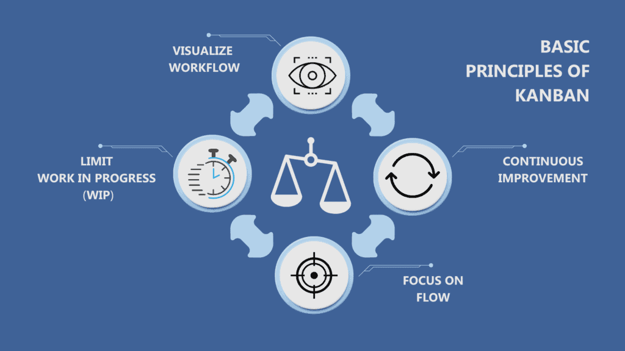

Kanban is a visual work management system used to visualize workflows, manage work in progress, and improve efficiency.

In Kanban, There are 4 principles

1.**visualizing workflow**: Work items are represented as cards on a board, typically divided into columns such as "To Do," "In Progress," and "Done." This visualization helps teams track progress and identify bottlenecks.

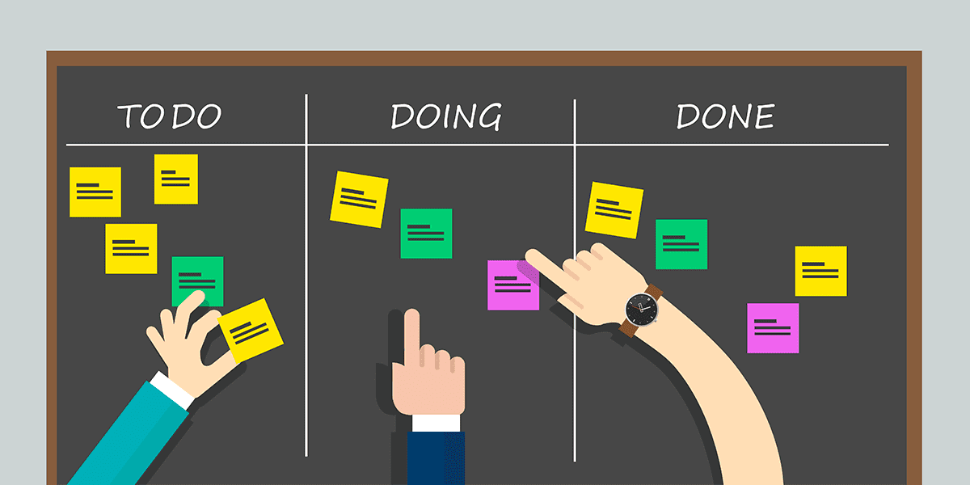

2.**limiting work in progress (WIP):**

By limiting the number of work items in any given stage, teams can focus on completing tasks before taking on new ones, reducing multitasking and improving quality.

3.**focusing on flow:**

Kanban emphasizes smooth and continuous flow of work, aiming to **minimize delays and interruptions**.

4. **continuous improvement:**

Teams regularly review their processes to **identify areas for improvement**

Lean Principles:

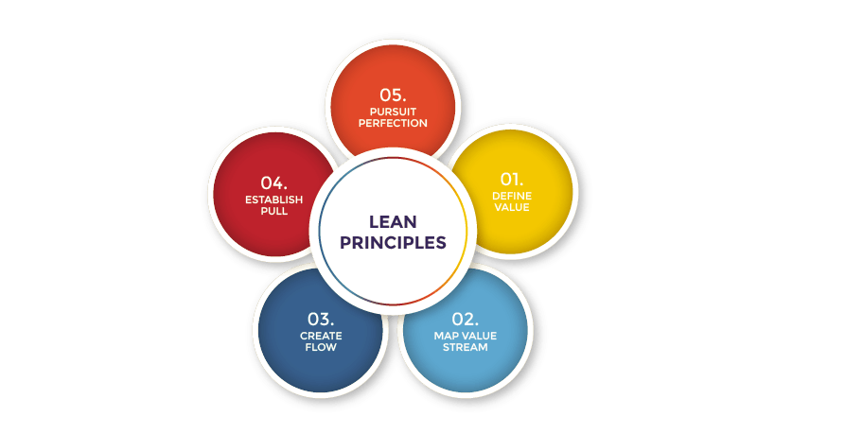

**Define value:**

Value is determined by the customer and is what they are willing to pay for.

Understanding customer needs and expectations is crucial to identifying value.​

**Map the value stream:**

The second Lean principle is identifying and mapping the value stream.

Activities that do not add any value are considered waste.

The waste can be broken into 2 types

1. non-valued added but necessary
2. non-value & unnecessary.

Eliminating unnecessary waste and minimizing necessary waste will help businesses meet customer needs more efficiently while also reducing costs.

**Create flow:**

After removing the wastes from the value stream, the following action is to ensure that the flow of the remaining steps run smoothly without interruptions or delays.

By adding activity for flow smoothly

1. breaking down steps, reconfiguring the production steps, leveling out the workload, creating cross-functional departments, and training employees to be multi-skilled and adaptive.

**Establish pull:**

Produce items only when there is customer demand, avoiding overproduction.

Implement systems like Kanban to manage inventory and production based on actual demand.

**Pursue Perfection:**

Continuously improve processes by eliminating root causes of waste.

Foster a culture of continuous improvement and learning.