GitHub Repository:
https://github.com/Gayathri191/Python_and_Bash_Gayathri

1. Grade Checker
Take a score as input and print the grade based on the following:
- 90+ : “A”
- 80–89 : “B”
- 70–79 : “C”
- 60–69 : “D”
- Below 60 : “F”
- Use a basic if / else statement to determine the grade.

The task is to create a Python program that accepts a score from the user and determines the grade using if, elif, and else conditional statements.
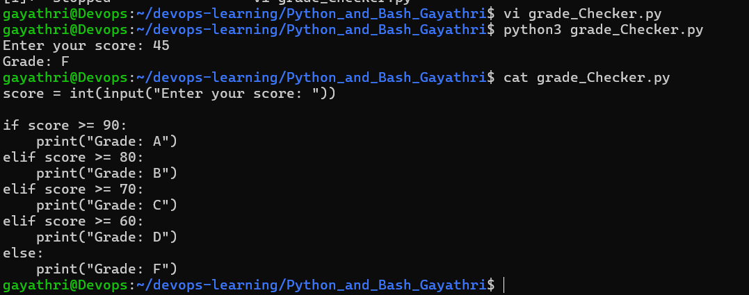

2. Student Grades
Create a dictionary where the keys are student names and the values are their grades. Allow the user to:
- Add a new student and grade.
- Update an existing student's grade.
- Print all student grades.
- Use a dictionary and basic operations with if / else.

This task is for use of a Python dictionary to store student names and all grades. The program allows me to add a new student or update an existing student's grade.
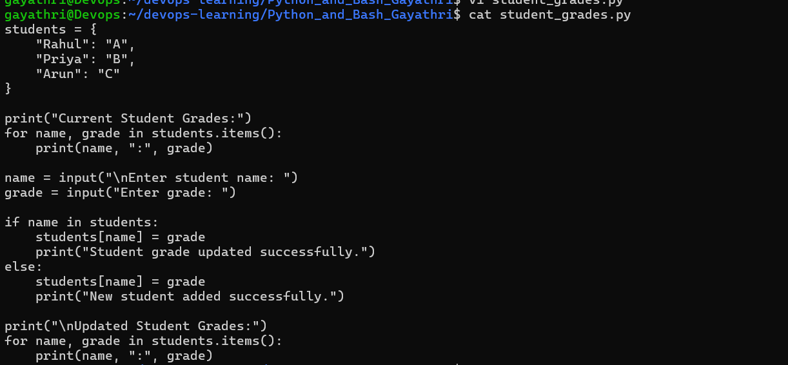

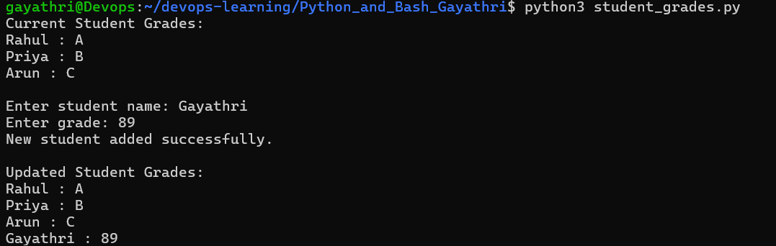

3. Write to a File
- Write a program to create a text file and write some content to it, using file functions like open() and write().

This program is for a text file and also to write content to it using Python file handling functions such as open(), write(), and close(). In the script I also used close function here.
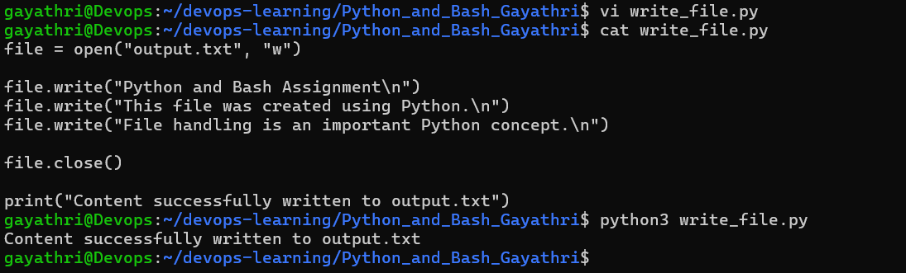

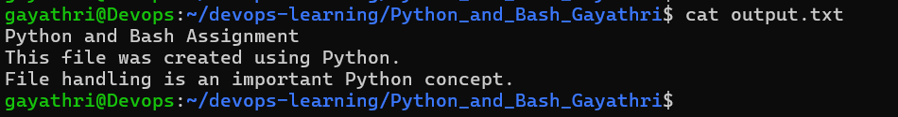

4. Read from a File
- Open the file in read mode and use file.read() to read and display its content.

Below program opens the text file I created previously in read mode and uses the read() function to display its contents.
