INDEX

S.NO | Date | Project Title | QR Code | Signature
1. |  | Setting up the python environment and libraries | 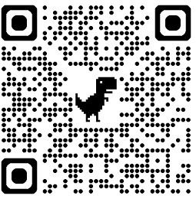
2. |  | EDA-Data Import and Export | 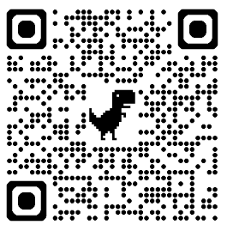
3. |  | EDA- Data Cleaning | 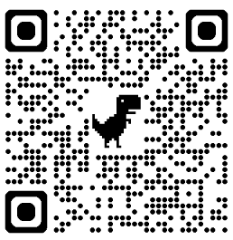
4. |  | EDA-Data Inspection and Analysis | 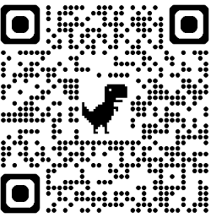
5. |  | EDA-Data Visualization | 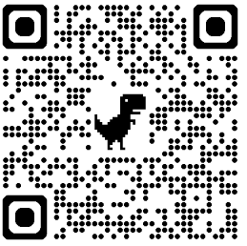
6. |  | Data Visualization Using PowerBI | 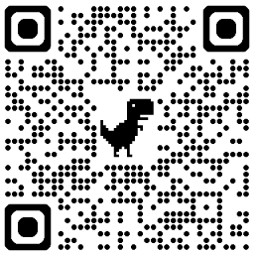
7. |  | Data Visualization Using Tableau | 