Step by Step process:
Inputs:
- userid
- username
- event_date
- event
- timings of an event
- number of seats the user wants

Step 1. User has to register with giving their details like their name, mail id, password and confirm password.
Step 2: Once the user got registered those data will be stored in Database.
Step 3: When the user want to login, he/she give the details which are there in the Database, otherwise it shows us to register.
Step 4:Once the user got logged in, he/she can see the details of all the events which are inbuilt in the web page. (Predefined by Admin)
Step 5: When the user want to book seats on particular event, he/she has to click the user button.
Step 6: Now the tkinter GUI will be presented by providing the following fields:

1. Add new – to add new data about the event like for which date he/she want to book some particular number of seats and can also give about which event and the function timings.
In this function, if event_date filed is entered by a date which is nearer to 10days, it will popup a box by showing an information.

2. Display – to display the all people data who are presented in the database
3.Update – This function is used to update the particular data
4. Delete – This function is used to delete the particular data
5. Search – By using this function, we can search particular user is there in database or not. This search field can work with userid or username
6. Reset – To clear the screen’s data we can use this field
7.Exit – To exit from the tkinter window we can use this button.

Registration GUI:
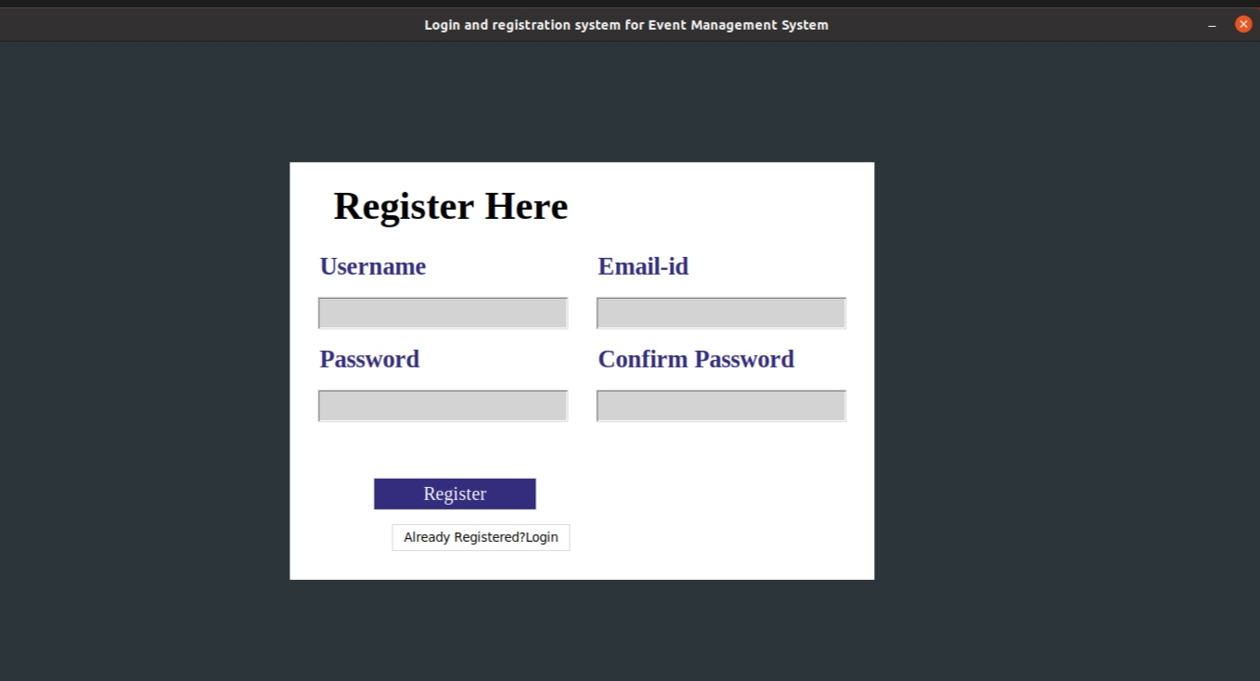

Login GUI:

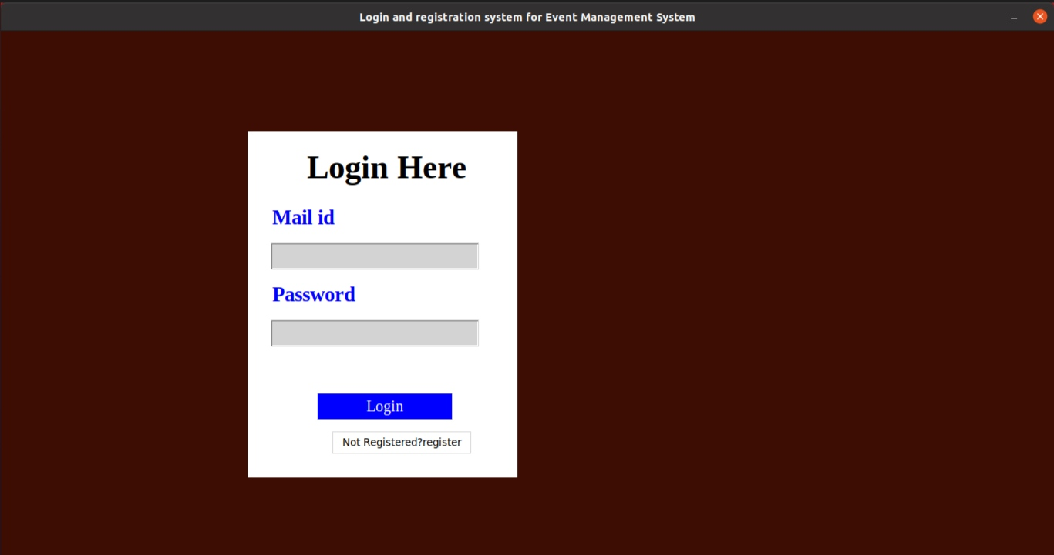

The tkinter GUI of the user:
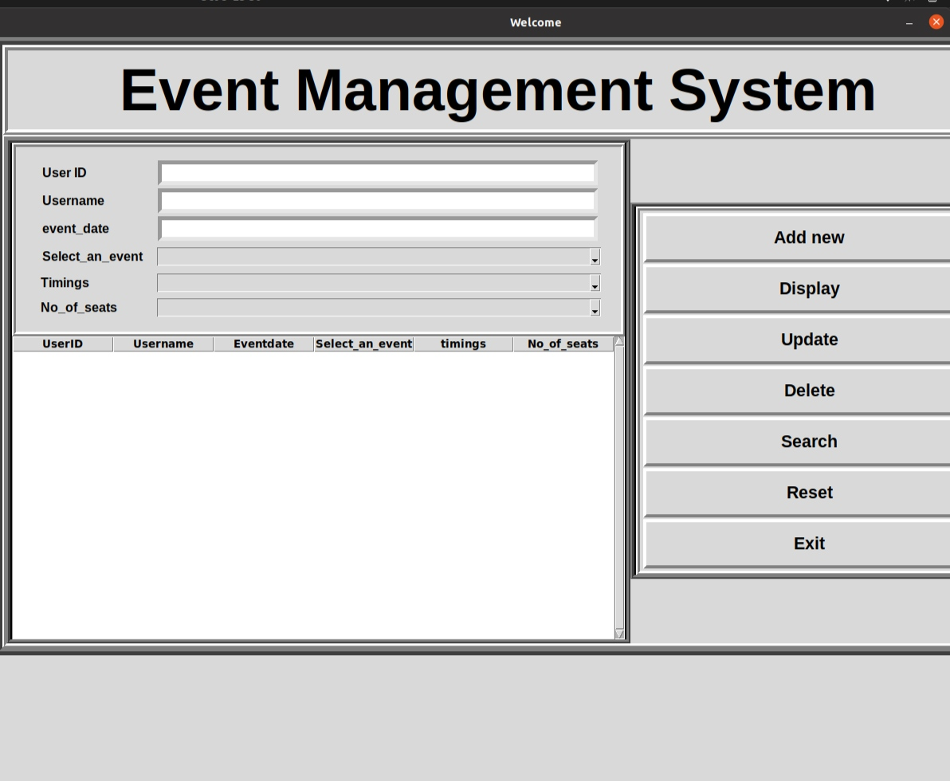

All registered users and the users who are booking for the events will be stored in the database by using 2 tables.
One is for Login page and another one is for user event details.

The table for Login:
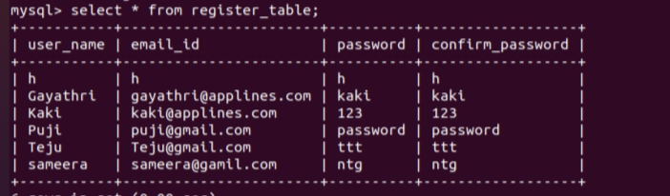

The table for User:
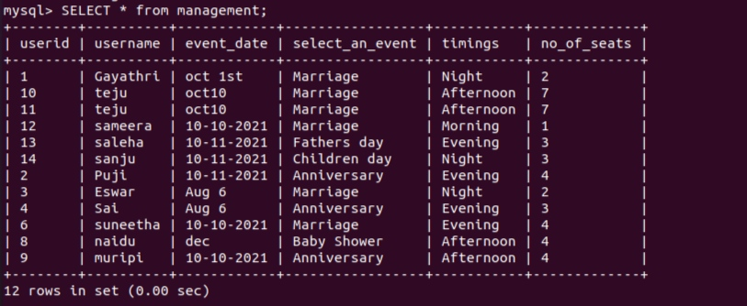

The data entered in the GUI fields will be fetched here.

