# **Day 07 Assignment**

**/*1. Rank employees by their total sales (Total sales = Total no of orders handled, JOIN employees and orders table)*/**

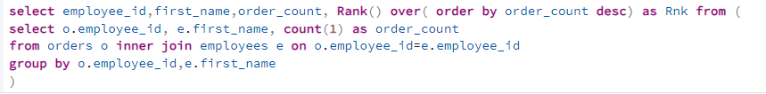

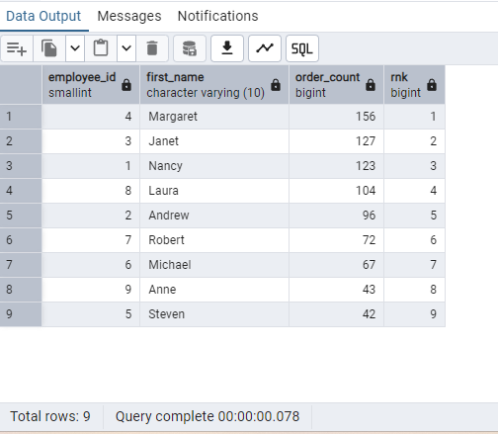

**2.      Compare current order's freight with previous and next order for each customer.(Display order_id,  customer_id,  order_date,  freight,Use lead(freight) and lag(freight).**

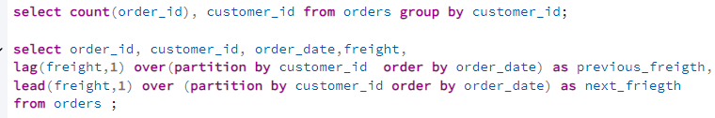

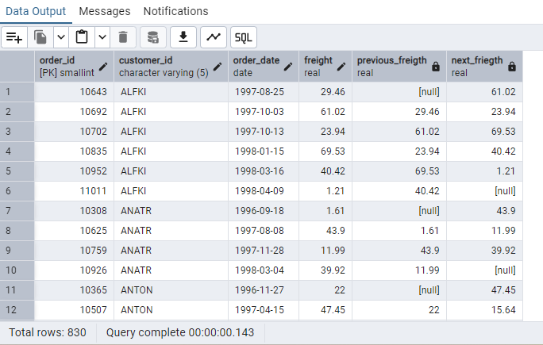

**/*3.Show products and their price categories, product count in each category, avg price:*/**

