**DAY 4**

1.List all customers and the products they ordered with the order date.

**Query**  
 select c.company_name as customer, o.order_id, p.product_name, od.quantity, o.order_date from customers c inner join orders o on c.customer_id =o.customer_id inner join order_details od on o.order_id= od.order_id inner join products p on od.product_id=p.product_id

**Output:**

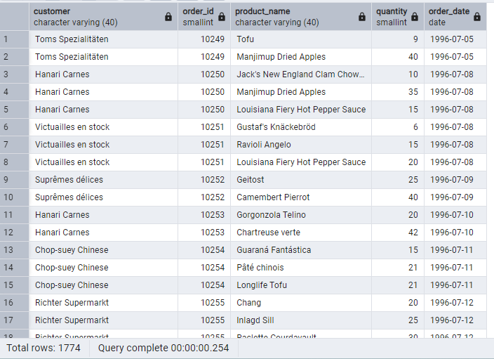

2. Show each order with customer, employee, shipper, and product info — even if some parts are missing. (Left Join)

**Tables used: orders, customers, employees, shippers, order_details, products**

**Query**

select o.order_id, c.company_name as customer, e.first_name||'_'||e.last_name as employees, s.shipper_id, p.product_name from orders o left join customers c on c.customer_id =o.customer_id left join employees e on e.employee_id=o.employee_id left join shippers s on s.shipper_id=o.ship_via left join order_details od on o.order_id= od.order_id left join products p on od.product_id=p.product_id **Output:**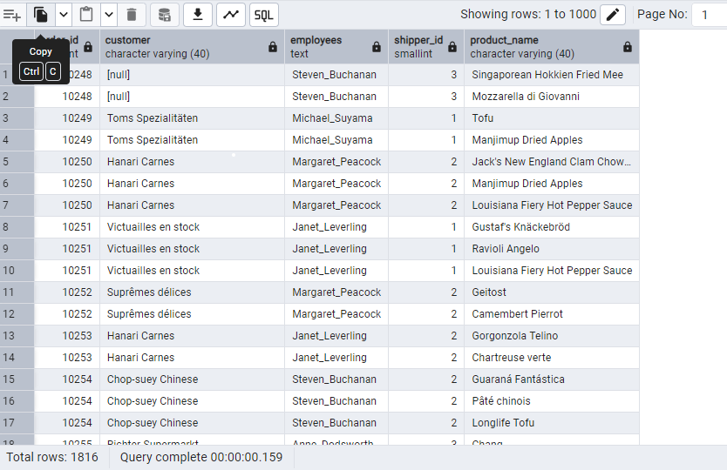

3. Show all order details and products (include all products even if they were never ordered). (Right Join)

select od.order_id,od.product_id,od.quantity,p.product_name from products p right join order_details od on p.product_id=od.product_id

**OUTPUT:**

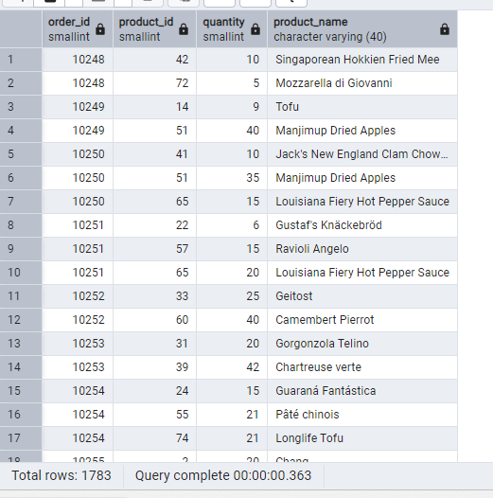

4. List all product categories and their products — including categories that have no products, and products that are not assigned to any category.(Outer Join)

**Tables used: categories, products**

SELECT p.product_name,c.category_name from categories c full outer join products p on c.category_id = p.category_id where p.product_id is null or c.category_id is null

**OUTPUT:**

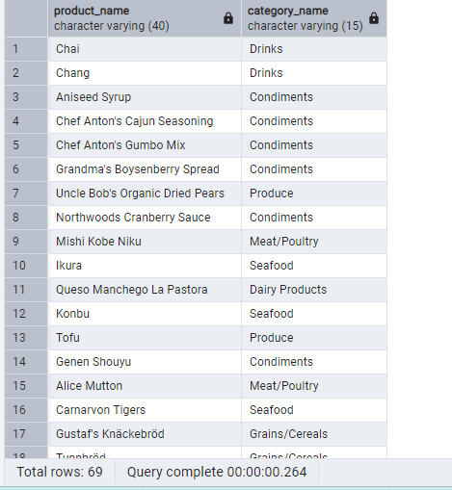

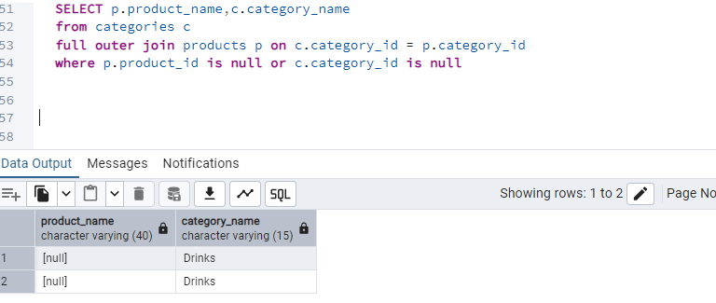

5. Show all possible product and category combinations (Cross join).

select p.product_name,p.product_id, c.category_name from products p cross join categories c

**Output**

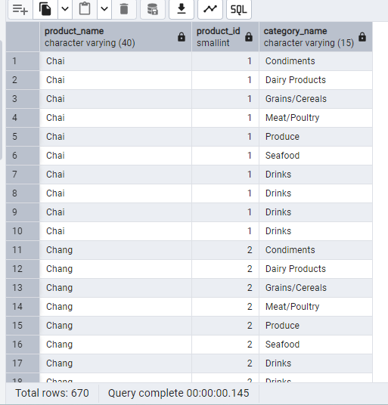

6. Show all employees and their manager(Self join(left join))

select e1.first_name || '*'|| e1.last_name as manager, e2.first_name ||'*'|| e2.last_name as employee from employees e1 left join employees e2 on e1.employee_id=e2.reports_to where e1.employee_id!=e2.employee_id

**Output:**

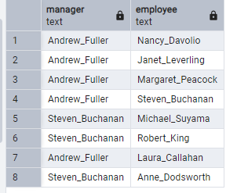

7. List all customers who have not selected a shipping method.

**Tables used:** customers, orders **(Left Join, WHERE o.shipvia IS NULL)**

select c.customer_id,c.company_name,o.ship_via from customers c left join orders o on c.customer_id=o.customer_id where o.ship_via is null

**Output:**

