--Day2

--1) Alter Table:

-- Add a new column linkedin_profile to employees table to store LinkedIn URLs as varchar.

ALTER TABLE employees

ADD COLUMN linkedin_profile VARCHAR(255);

OUTPUT

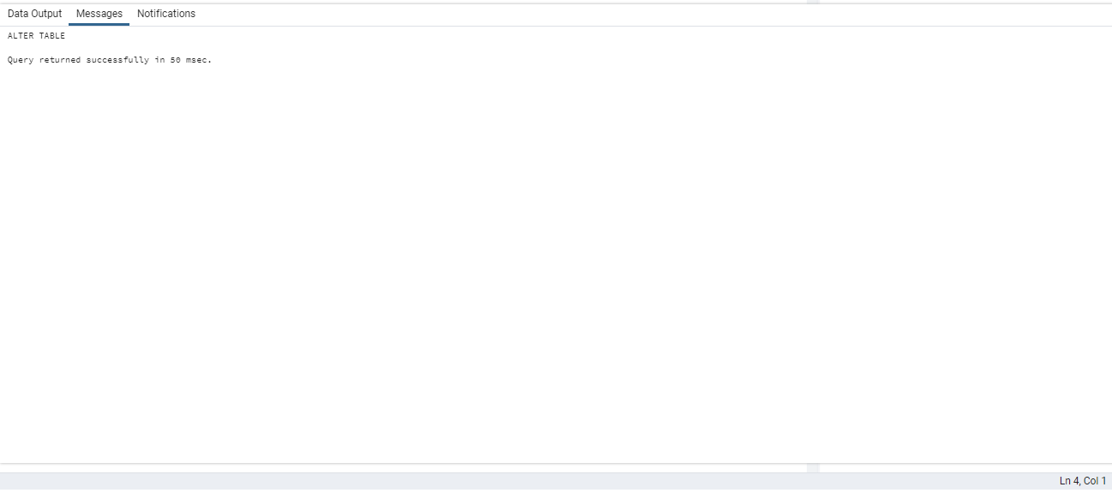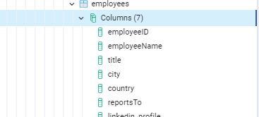

--Change the linkedin_profile column data type from VARCHAR to TEXT.

ALTER TABLE employees

ALTER COLUMN linkedin_profile

SET DATA TYPE text;

OUTPUT

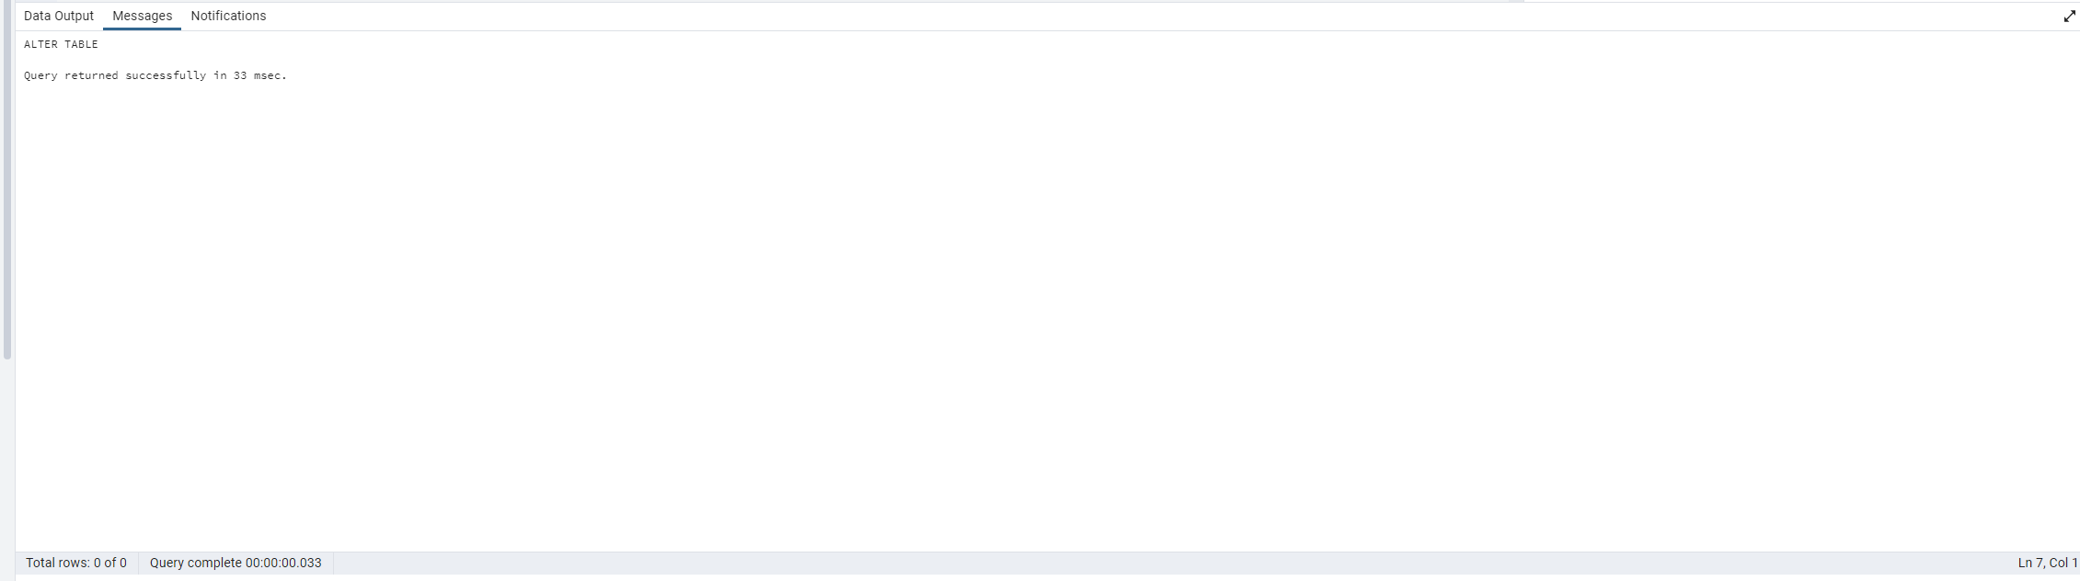

-- Add unique, not null constraint to linkedin_profile

ALTER TABLE employees

ALTER COLUMN linkedin_profile SET NOT NULL,

ADD CONSTRAINT unique_linkedin UNIQUE (linkedin_profile);

OUTPUT

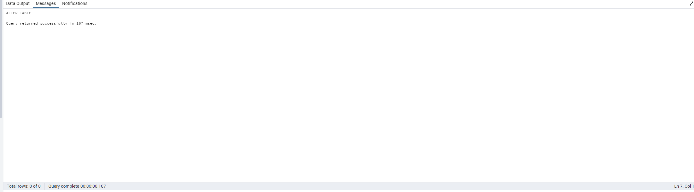

--Drop column linkedin_profile

ALTER TABLE employees

DROP COLUMN linkedin_profile;

OUTPUT

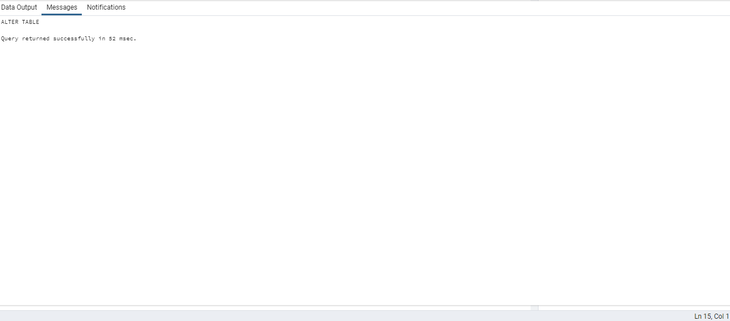

---2) Querying (Select)

-- Retrieve the employee name and title of all employees

SELECT "employeeName" ,"title"

FROM employees;

OUTPUT

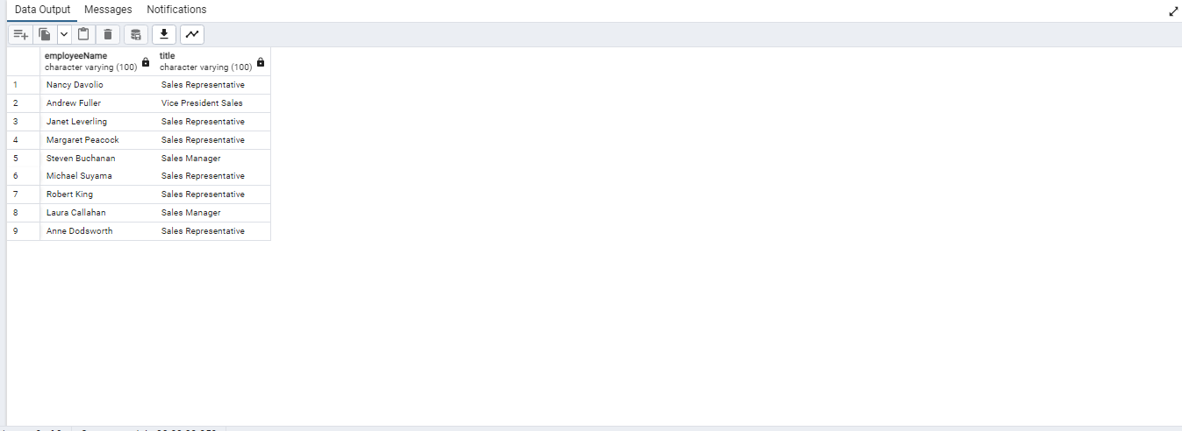

-- Find all unique unit prices of products

SELECT DISTINCT "unitPrice"

FROM products

ORDER BY "unitPrice";

-- List all customers sorted by company name in ascending order

SELECT "companyName" FROM customers

ORDER BY "companyName" ASC;

OUTPUT

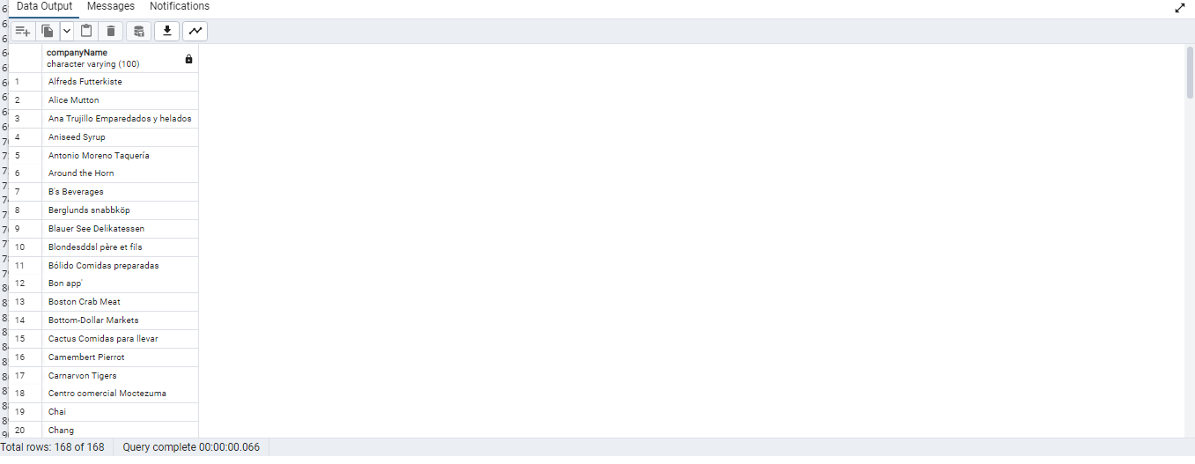

-- Display product name and unit price, but rename the unit_price column as price_in_usd

SELECT

"productName",

"unitPrice" AS "price_in_usd"

FROM products;

OUTPUT

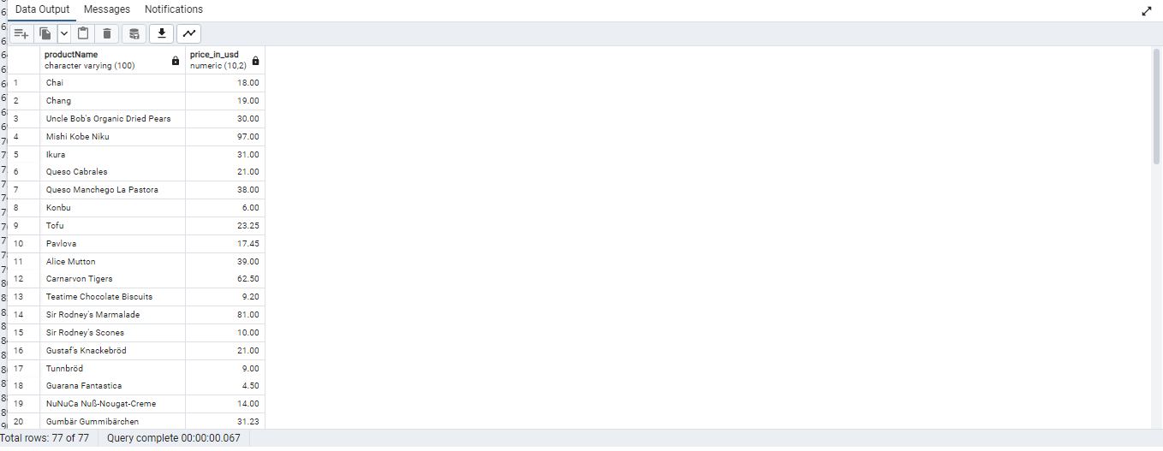

--3) Filtering

--Get all customers from Germany.

SELECT *

FROM customers

WHERE "country" = 'Germany';

OUTPUT

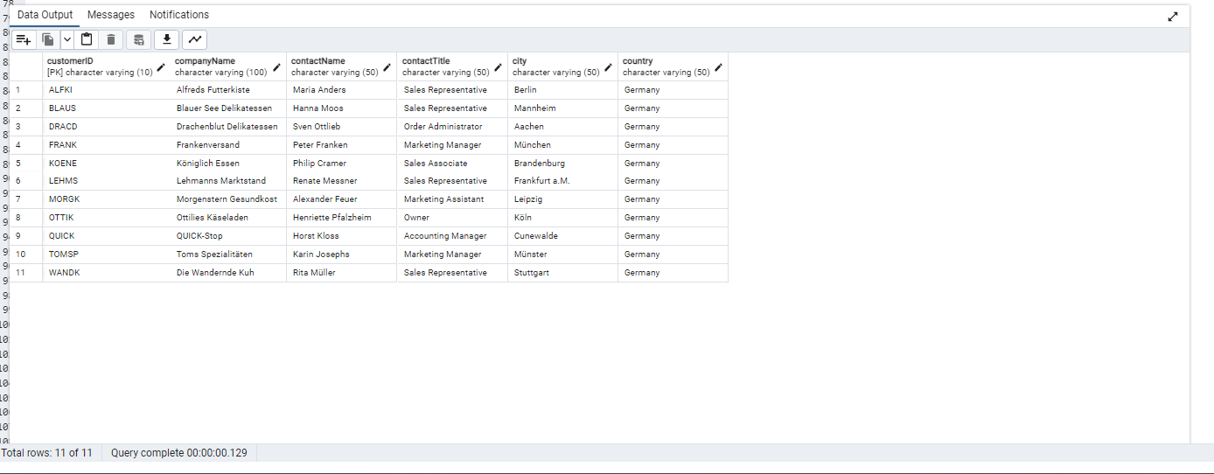

--Find all customers from France or Spain

SELECT *

FROM customers

WHERE "country" = 'France' OR "country" = 'Spain';

OUTPUT

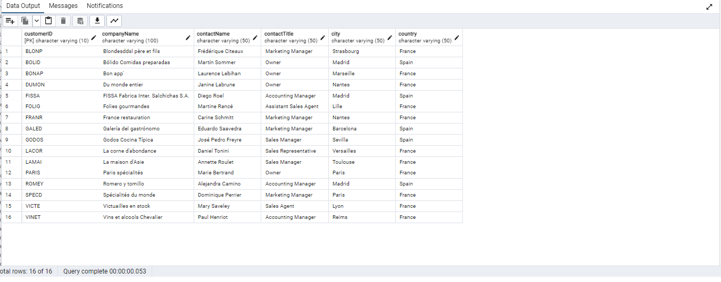

--Retrieve all orders placed in 2014 (based on order_date), and either have freight greater than 50 or the shipped date available (i.e., non-NULL) (Hint: EXTRACT(YEAR FROM order_date))

SELECT *

FROM orders

WHERE EXTRACT(YEAR FROM "orderDate") = 2014

AND ("freight" > 50 OR "shippedDate" IS NOT NULL);

OUTPUT

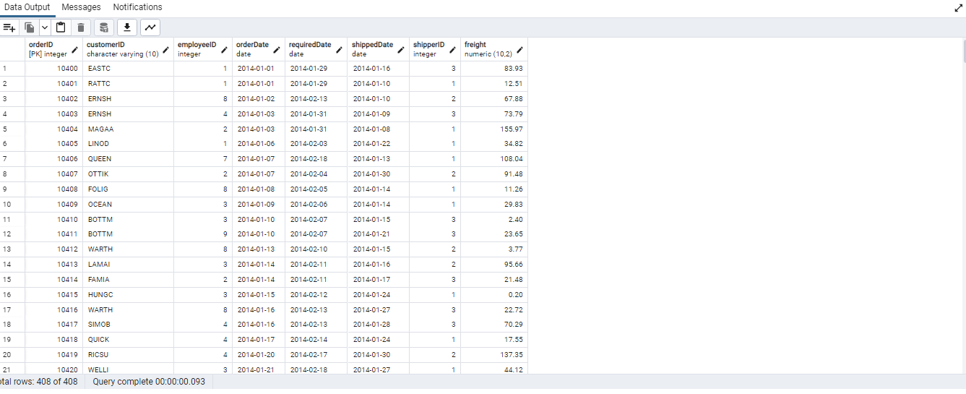

--4)Filtering

-- Retrieve the product_id, product_name, and unit_price of products where the unit_price is greater than 15.

SELECT "productID","productName","unitPrice"

FROM products

WHERE "unitPrice" >15;

OUTPUT

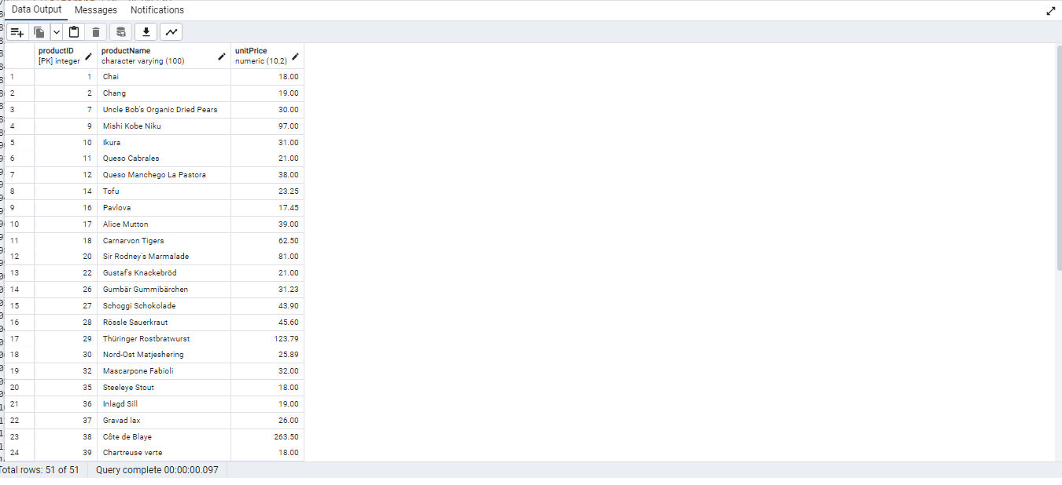

--List all employees who are located in the USA and have the title "Sales Representative".

SELECT * FROM employees

WHERE "country"='USA' AND "title"='Sales Representative';

OUTPUT

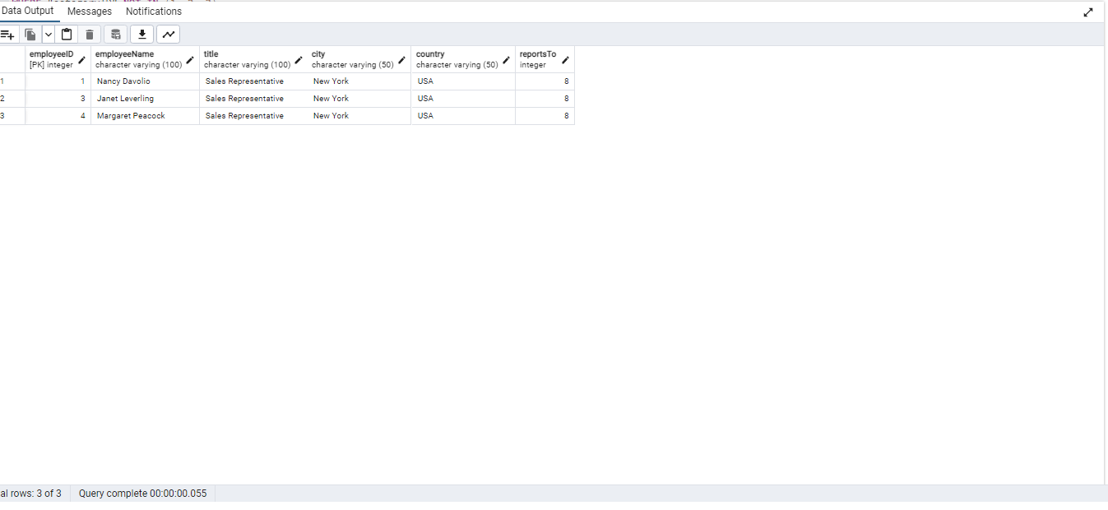

--Retrieve all products that are not discontinued and priced greater than 30.

SELECT *

FROM products

WHERE discontinued = false AND "unitPrice" > 30;

OUTPUT

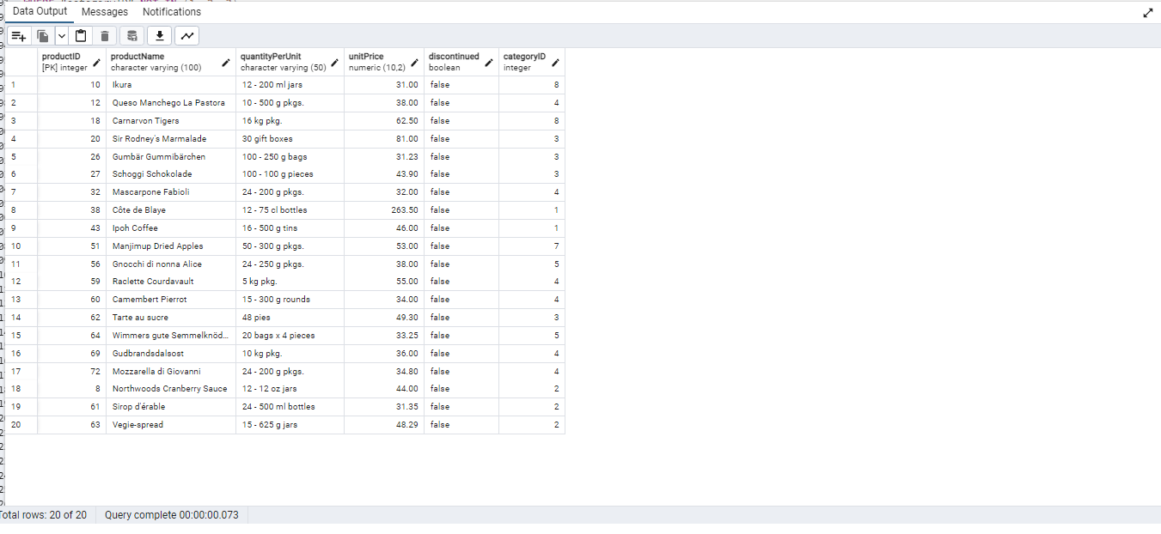

--5) LIMIT/FETCH

-- Retrieve the first 10 orders from the orders table.

SELECT * FROM orders

ORDER BY "orderID"

LIMIT 10;

OUTPUT

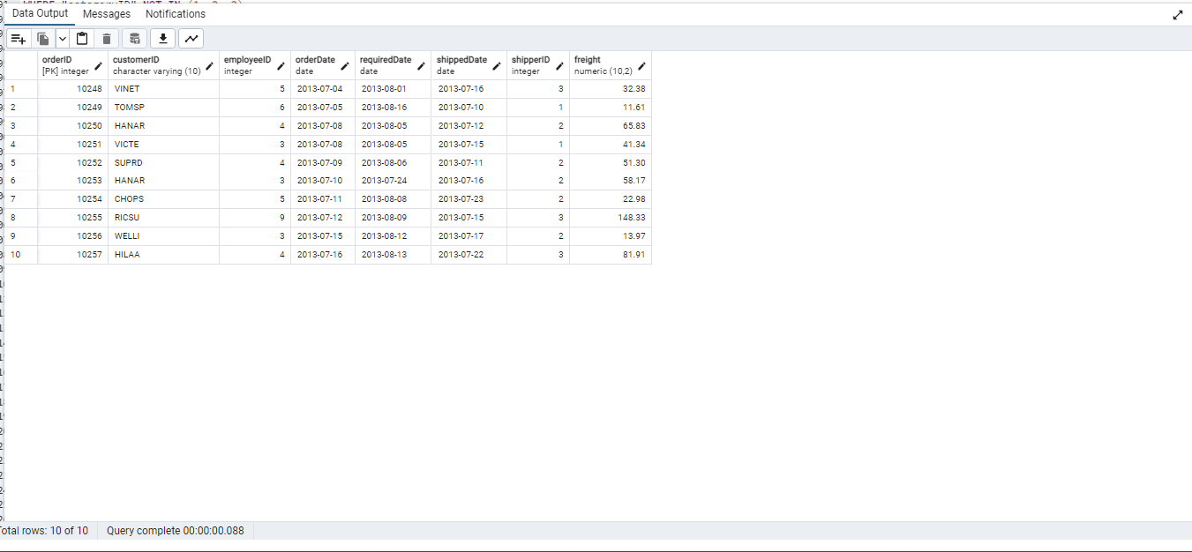

--Retrieve orders starting from the 11th order, fetching 10 rows (i.e., fetch rows 11-20).

SELECT *

FROM orders

ORDER BY "orderID"

OFFSET 10 ROWS

FETCH NEXT 10 ROWS ONLY;

OUTPUT

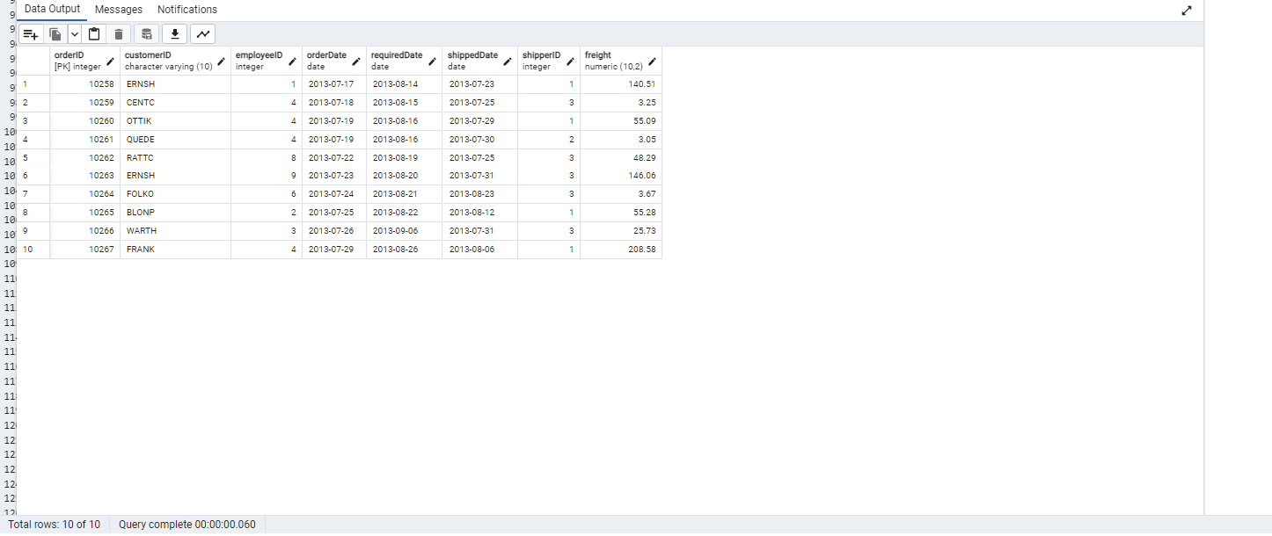

--6)Filtering (IN, BETWEEN)

--List all customers who are either Sales Representative, Owner

SELECT * FROM customers

WHERE "contactTitle" IN('Sales Representative', 'Owner')

OUTPUT

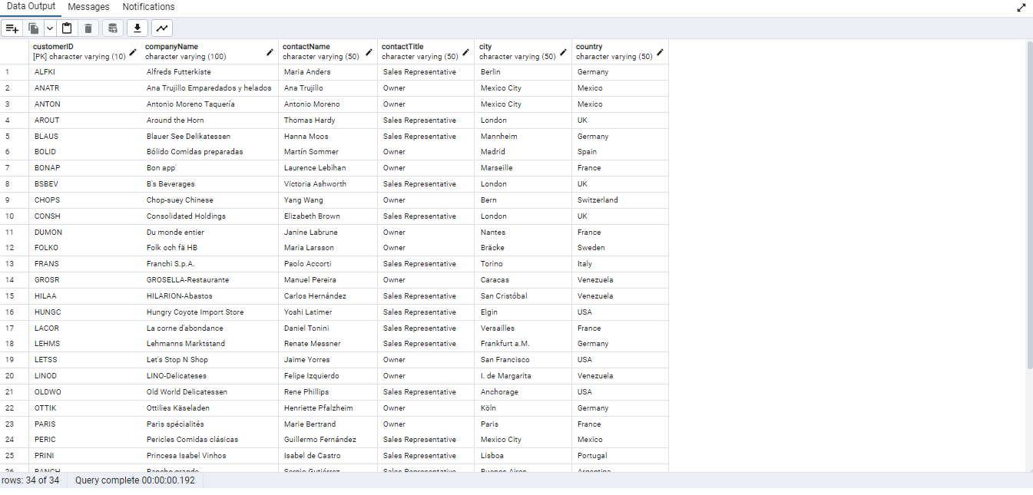

--Retrieve orders placed between January 1, 2013, and December 31, 2013.

SELECT * FROM orders

WHERE "orderDate" BETWEEN '2013-01-01' AND '2013-12-31'

OUTPUT

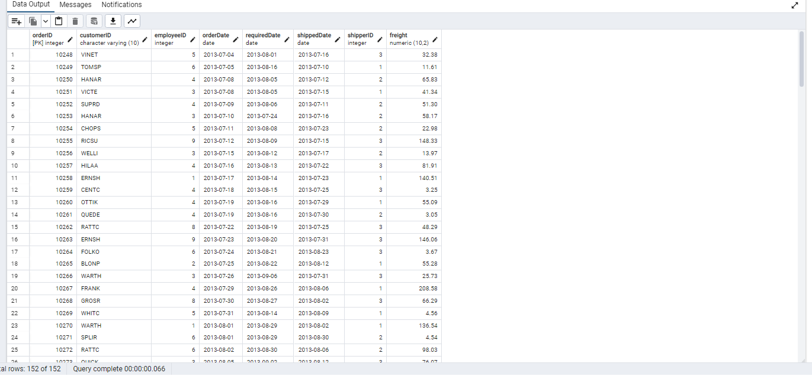

--7) Filtering

--List all products whose category_id is not 1, 2, or 3.

SELECT *

FROM products

WHERE "categoryID" NOT IN (1, 2, 3)

ORDER BY "productName";

OUTPUT

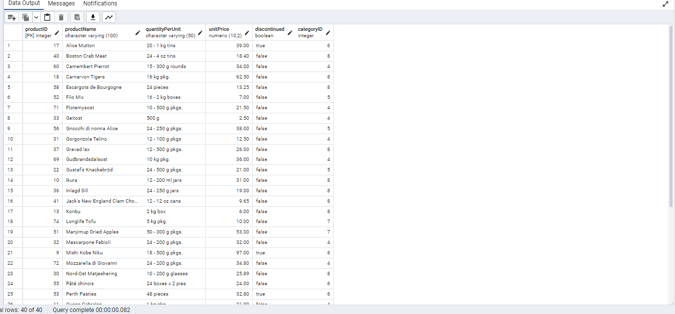

--Find customers whose company name starts with "A".

SELECT *

FROM customers

WHERE "companyName" LIKE 'A%'

ORDER BY "companyName";

OUTPUT

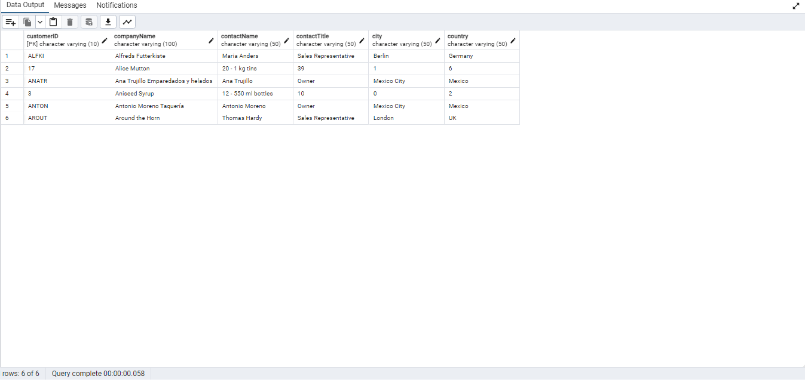

--8)INSERT into orders table:

--Task: Add a new order to the orders table with the following details:

--Order ID: 11078

--Customer ID: ALFKI

--Employee ID: 5

--Order Date: 2025-04-23

--Required Date: 2025-04-30

--Shipped Date: 2025-04-25

--shipperID:2

--Freight: 45.50

INSERT INTO orders(

"orderID",

"customerID",

"employeeID",

"orderDate",

"requiredDate",

"shippedDate",

"shipperID",

"freight"

)VALUES (

11078,

'ALFKI',

5,

'2025-04-23',

'2025-04-30',

'2025-04-25',

2,

45.50

);

SELECT * FROM orders;

OUTPUT

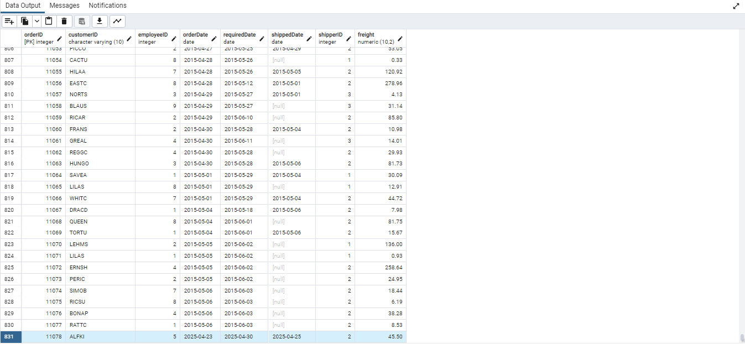

-- 9.Increase(Update) the unit price of all products in category_id =2 by 10%.

--(HINT: unit_price =unit_price * 1.10)

UPDATE products

SET "unitPrice" = "unitPrice" * 1.10

WHERE "categoryID" = 2;

------

--10) Sample Northwind database:

--Download

-- Download northwind.sql from below link into your local. Sign in to Git first https://github.com/pthom/northwind_psql

--Manually Create the database using pgAdmin:

--Right-click on "Databases" → Create → Database

--Give name as ‘northwind’ (all small letters)

--Click ‘Save’

--Import database:

-- Open pgAdmin and connect to your server

-- Select the database ‘northwind’

-- Right Click-> Query tool.

-- Click the folder icon to open your northwind.sql file

-- Press F5 or click the Execute button.

-- You will see total 14 tables loaded

-- Databases → your database → Schemas → public → Tables

OUTPUT

