--Day 3

--1)**Update the categoryName From “Beverages” to "Drinks" in the categories table**.

SELECT * FROM categories

ORDER BY "categoryID";

UPDATE categories

SET "categoryName" = 'Drinks'

WHERE "categoryID" = 1

**OUTPUT**

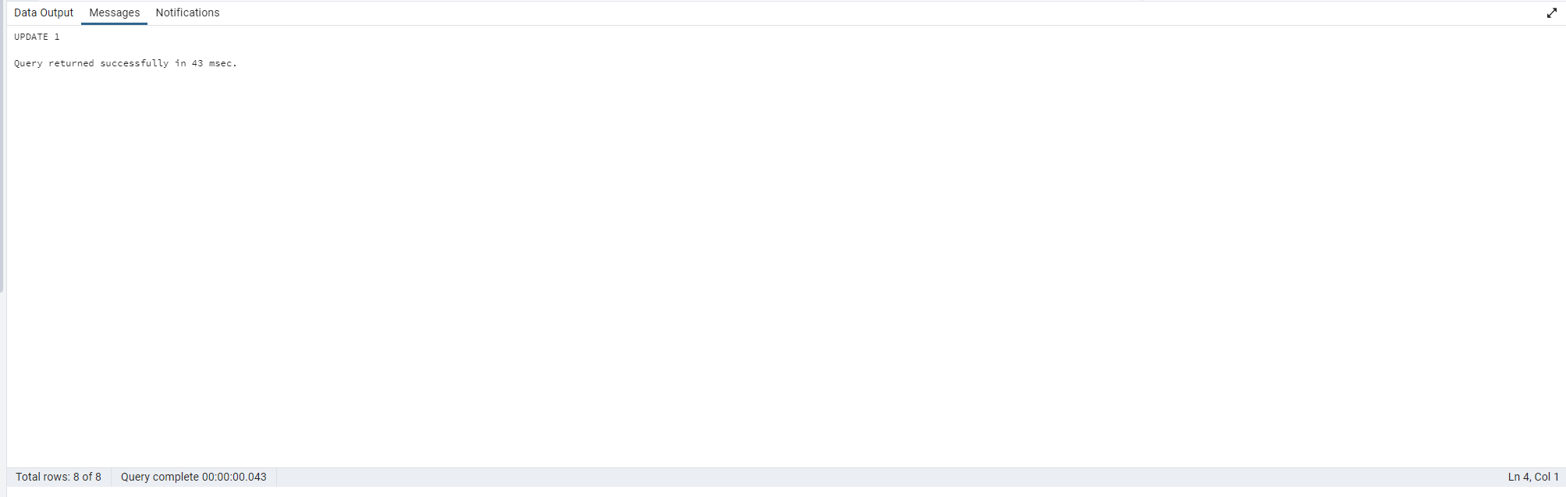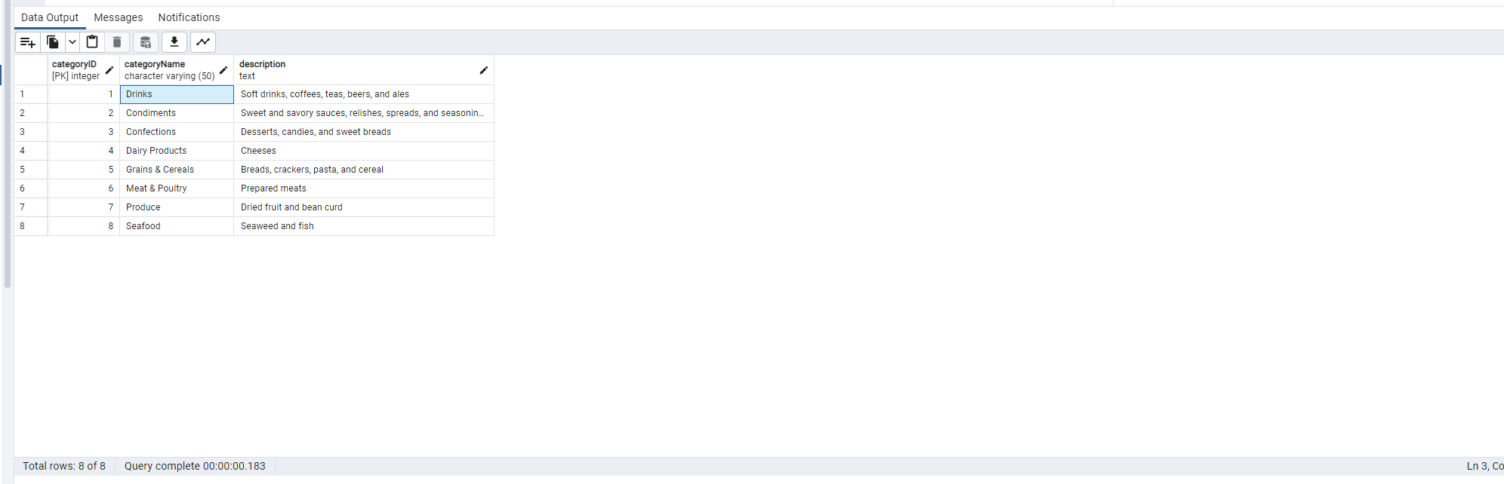

--2**) Insert into shipper new record (give any values) Delete that new record from shippers table.**

INSERT INTO shippers ("shipperID","companyName")

VALUES(4,'United Express')

SELECT * FROM shippers;

DELETE FROM shippers

WHERE "shipperID"=4;

**OUTPUT**



**--3)Update categoryID=1 to categoryID=1001. Make sure related products update their categoryID too.Display the both category and products table to show the cascade.**

-- Drop the existing foreign key constraint

ALTER TABLE products

DROP CONSTRAINT products_categoryid_fk;

ALTER TABLE products

ADD CONSTRAINT products_categoryid_fk

FOREIGN KEY ("categoryID")

REFERENCES categories("categoryID")

ON UPDATE CASCADE;

UPDATE categories

SET "categoryID" = 1001

WHERE "categoryID"=1;

SELECT * FROM categories

WHERE "categoryID" = 1001;

SELECT * FROM products

WHERE "categoryID" = 1001;

**-- Delete the categoryID= “3” from categories. Verify that the corresponding records are deleted automatically from products**

ALTER TABLE products

DROP CONSTRAINT products_categoryid_fk;

ALTER TABLE products

ADD CONSTRAINT products_categoryid_fk

FOREIGN KEY ("categoryID")

REFERENCES categories("categoryID")

ON DELETE CASCADE;

DELETE FROM categories

WHERE "categoryID"= 3

SELECT * FROM categories

WHERE "categoryID" = 3;

**OUTPUT**

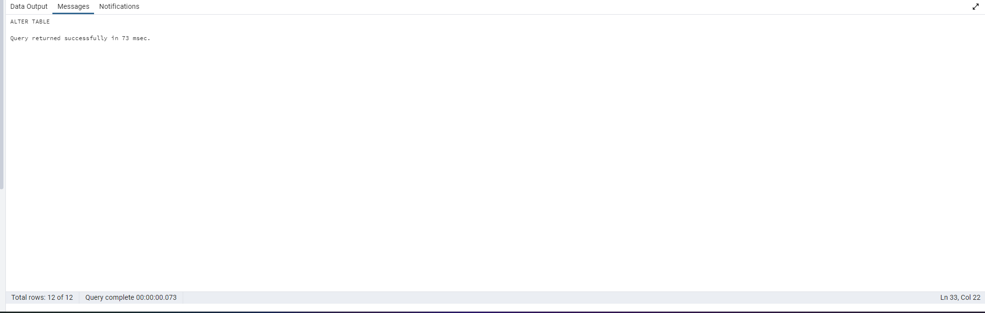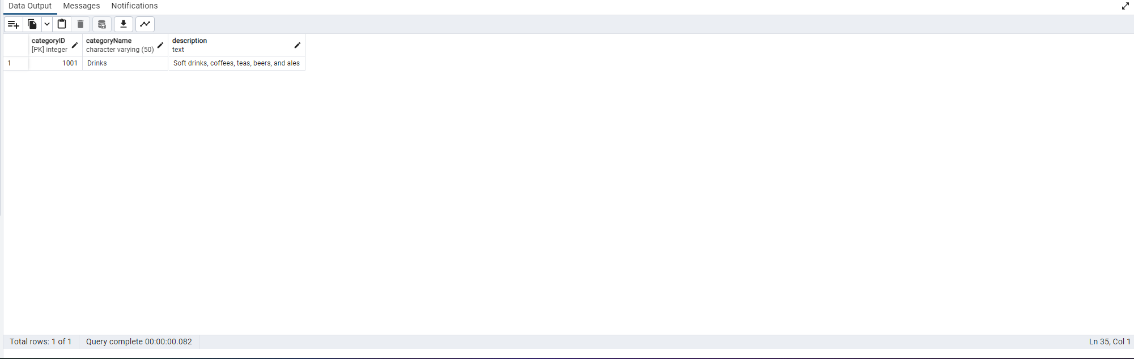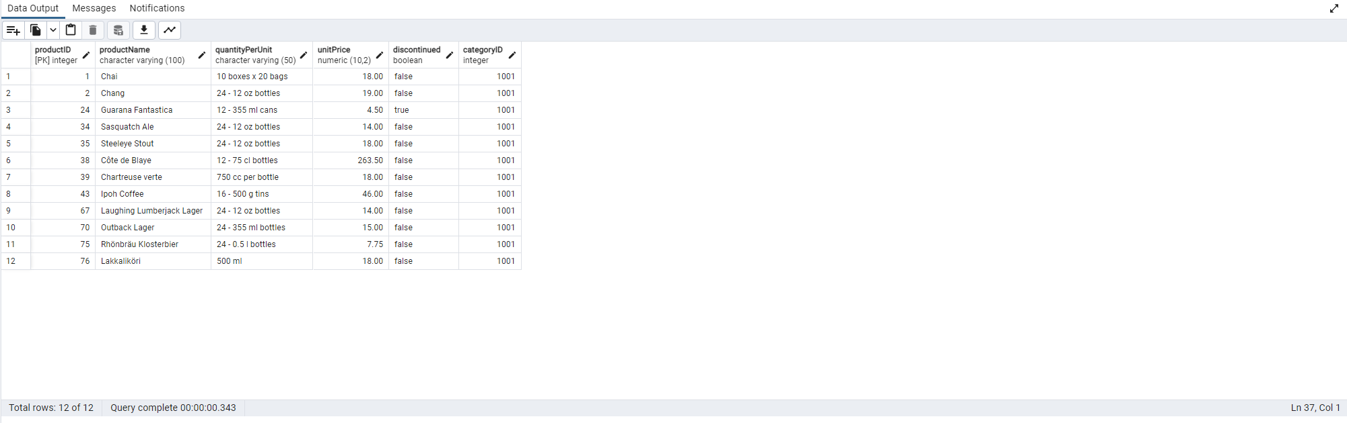

AFER DELETE

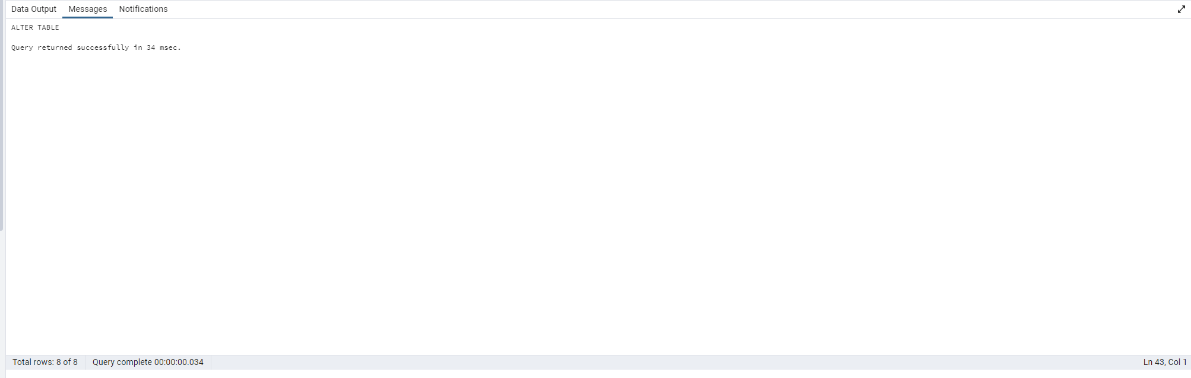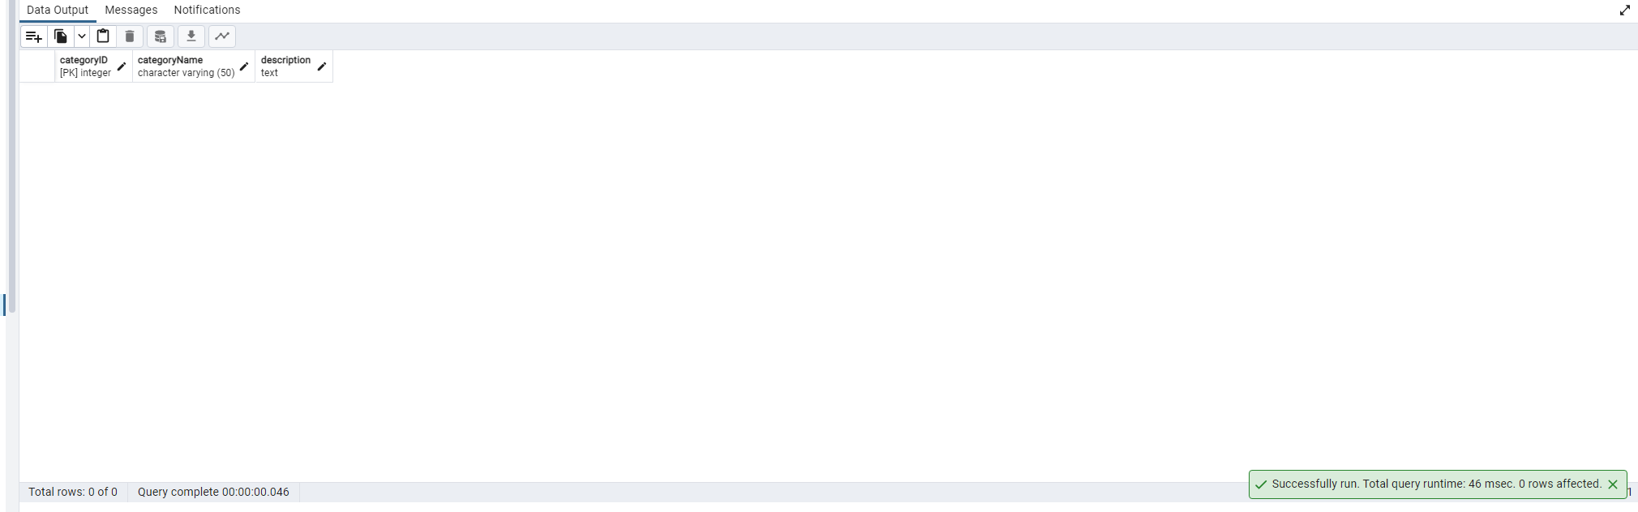

**--4)Delete the customer = “VINET” from customers. Corresponding customers in orders table should be set to null (HINT: Alter the foreign key on orders(customerID) to use ON DELETE SET NULL)**

ALTER TABLE orders

DROP CONSTRAINT orders_customerid_fk;

ALTER TABLE orders

ADD CONSTRAINT orders_customerid_fk

FOREIGN KEY("customerID")

REFERENCES customers("customerID")

ON DELETE SET NULL;

DELETE FROM customers

WHERE "customerID" = 'VINET'

SELECT * FROM customers

**OUTPUT**

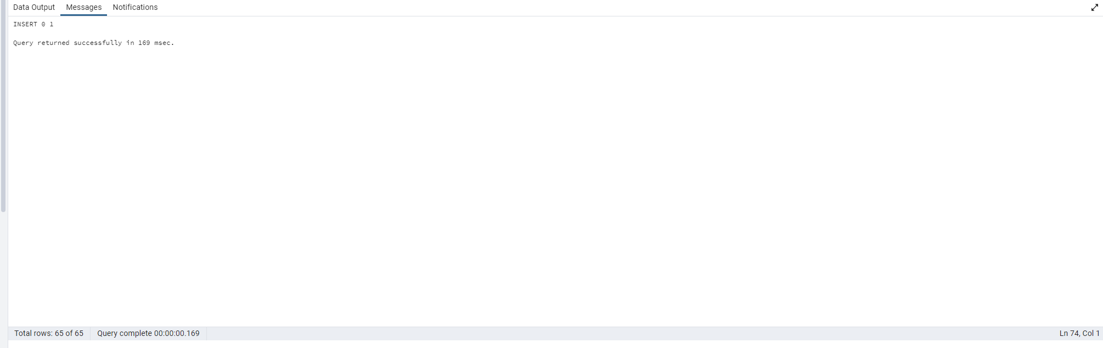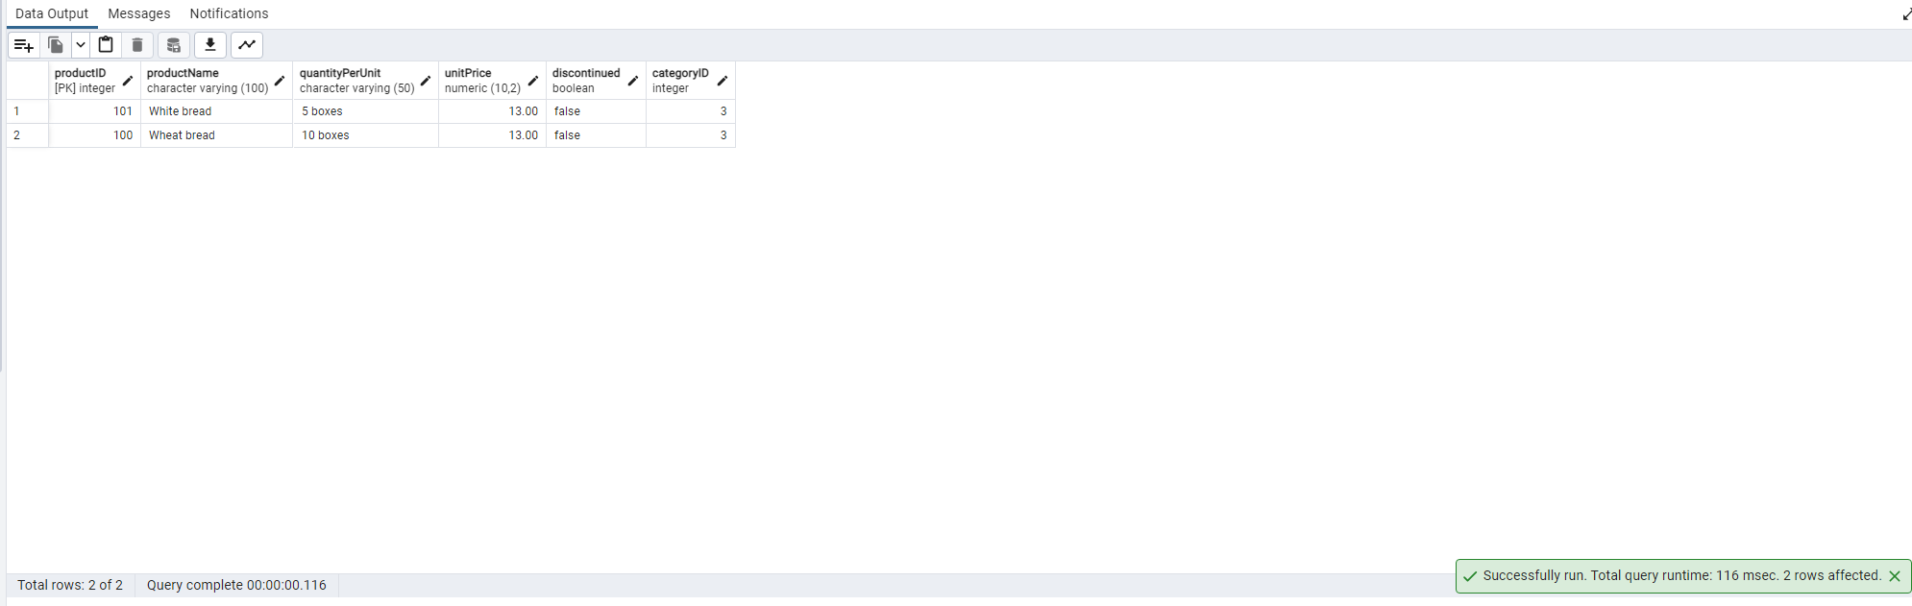

**--5)Insert the following data to Products using UPSERT:**

--product_id = 100, product_name = Wheat bread, quantityperunit=1,unitprice = 13, discontinued = 0, categoryID=3

--product_id = 101, product_name = White bread, quantityperunit=5 boxes,unitprice = 13, discontinued = 0, categoryID=3

--product_id = 100, product_name = Wheat bread, quantityperunit=10 boxes,unitprice = 13, discontinued = 0, categoryID=3

--(this should update the quantityperunit for product_id = 100)

INSERT INTO products ("productID", "productName", "quantityPerUnit", "unitPrice", "discontinued", "categoryID")

VALUES (100, 'Wheat bread', '1', 13, false, 3)

ON CONFLICT ("productID")

DO UPDATE SET

"productName" = EXCLUDED."productName",

"quantityPerUnit" = EXCLUDED."quantityPerUnit",

"unitPrice" = EXCLUDED."unitPrice",

"discontinued" = EXCLUDED."discontinued",

"categoryID" = EXCLUDED."categoryID";

INSERT INTO products ("productID", "productName", "quantityPerUnit", "unitPrice", "discontinued", "categoryID")

VALUES (101, 'White bread', '5 boxes', 13, false, 3)

ON CONFLICT ("productID")

DO UPDATE SET

"productName" = EXCLUDED."productName",

"quantityPerUnit" = EXCLUDED."quantityPerUnit",

"unitPrice" = EXCLUDED."unitPrice",

"discontinued" = EXCLUDED."discontinued",

"categoryID" = EXCLUDED."categoryID";

INSERT INTO products ("productID", "productName", "quantityPerUnit", "unitPrice", "discontinued", "categoryID")

VALUES (100, 'Wheat bread', '10 boxes', 13, false, 3)

ON CONFLICT ("productID")

DO UPDATE SET

"productName" = EXCLUDED."productName",

"quantityPerUnit" = EXCLUDED."quantityPerUnit",

"unitPrice" = EXCLUDED."unitPrice",

"discontinued" = EXCLUDED."discontinued",

"categoryID" = EXCLUDED."categoryID";

SELECT * FROM products WHERE "productID" IN (100, 101);

**OUTPUT**



**--6) Write a MERGE query:**

**--Create temp table with name: ‘updated_products’ and insert values as below:**

**--Update the price and discontinued status for from below table ‘updated_products’ only if there are matching products and updated_products .discontinued =0**

CREATE TABLE updated_products(

productID INT PRIMARY KEY,

productName VARCHAR (100) NOT NULL,

quantityPerUnit VARCHAR(50),

unitPrice DECIMAL(10,2),

discontinued BOOLEAN,

categoryID INT

);

INSERT INTO updated_products(productID, productName, quantityPerUnit, unitPrice, discontinued, categoryID)

VALUES (100, 'Wheat bread', '10', 20, true, 3),

(101, 'White bread', '5 boxes', 19.99, false, 3),

(102, 'Midnight Mango Fizz', '24 - 12 oz bottles', 19, false, 1),

(103, 'Savory Fire Sauce', '12 - 550 ml bottles', 10, false, 2)

WHEN MATCHED AND updated_products .discontinued =0 THEN

UPDATE updated_products

SET

unitPrice = products.unitPrice,

discontinued = products.discontinued

FROM products

WHERE updated_products.productID = products.productID

AND updated_products.discontinued = false;

SELECT * FROM products WHERE "productID" IN (100, 101, 102, 103);

**--If there are matching products and updated_products .discontinued =1 then delete**

CREATE TABLE updated_products(

productID INT PRIMARY KEY,

productName VARCHAR (100) NOT NULL,

quantityPerUnit VARCHAR(50),

unitPrice DECIMAL(10,2),

discontinued BOOLEAN,

categoryID INT

);

INSERT INTO updated_products(productID, productName, quantityPerUnit, unitPrice, discontinued, categoryID)

VALUES (100, 'Wheat bread', '10', 20, true, 3),

(101, 'White bread', '5 boxes', 19.99, false, 3),

(102, 'Midnight Mango Fizz', '24 - 12 oz bottles', 19, false, 1),

(103, 'Savory Fire Sauce', '12 - 550 ml bottles', 10, false, 2)

**--MERGE**

MERGE INTO products p

USING updated_products up

ON (p."productID" = up.productID)

WHEN MATCHED AND up.discontinued = false THEN

UPDATE SET

"unitPrice" = up.unitPrice,

"discontinued" = up.discontinued

WHEN MATCHED AND up.discontinued = true THEN

DELETE

WHEN NOT MATCHED AND up.discontinued = false THEN

INSERT ("productID", "productName", "quantityPerUnit", "unitPrice", "discontinued", "categoryID")

VALUES (up.productID, up.productName, up.quantityPerUnit, up.unitPrice, up.discontinued, up.categoryID);

SELECT * FROM products;

**OUTPUT**

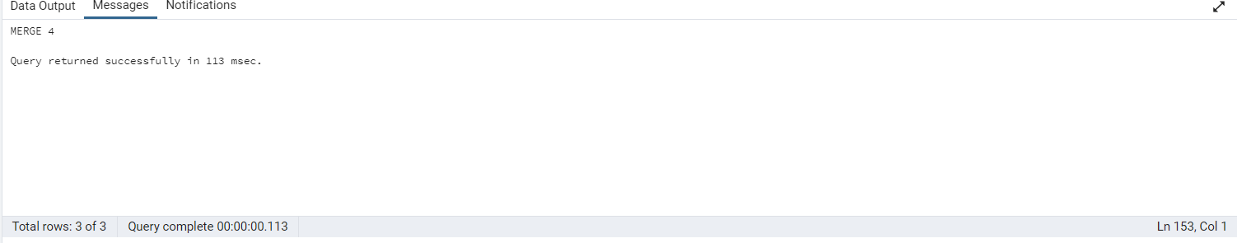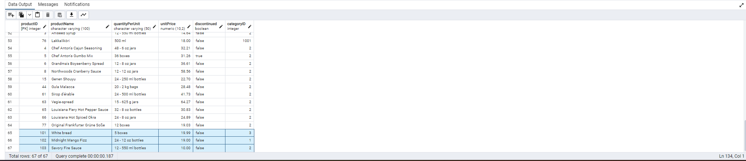

**--7)List all orders with employee full names. (Inner join)**

SELECT

o.order_id,

o.order_date,

o.required_date,

o.shipped_date,

o.ship_via,

o.freight,

o.ship_name,

o.ship_address,

o.ship_city,

o.ship_region,

o.ship_postal_code,

o.ship_country,

e.employee_id,

e.first_name || ' ' || e.last_name AS employeefullname

FROM

orders o

INNER JOIN

employees e ON o.employee_id = e.employee_id

ORDER BY

o.order_id;

**OUTPUT**

