**Day2**

1) Alter Table:

* Add a new column linkedin_profile to employees table to store LinkedIn URLs as varchar.

ALTER TABLE employees

ADD COLUMN linkedin_profile varchar(100);

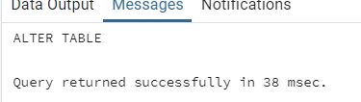

* Change the linkedin_profile column data type from VARCHAR to TEXT.

ALTER TABLE employees

ALTER COLUMN linkedin_profile SET DATA TYPE TEXT;

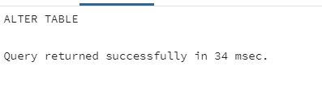

* Add unique, not null constraint to linkedin_profile

ALTER TABLE EMPLOYEES

ALTER COLUMN linkedin_profile SET NOT NULL;

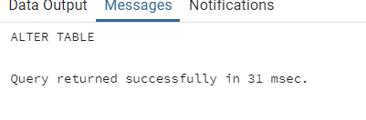

ALTER TABLE EMPLOYEES

ADD CONSTRAINT linkedin_unique UNIQUE (linkedin_profile);

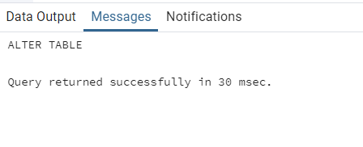

* Drop column linkedin_profile

ALTER TABLE EMPLOYEES

DROP COLUMN linkedin_profile;

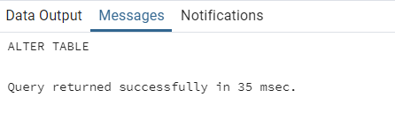

2) Querying (Select)

* Retrieve the employee name and title of all employees

SELECT employee_name, title from employees;

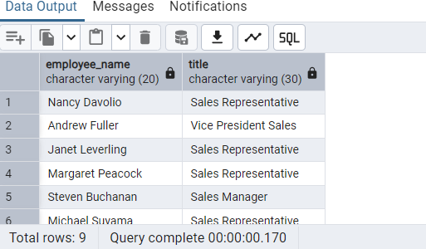

* Find all unique unit prices of products

SELECT DISTINCT unit_price from products;

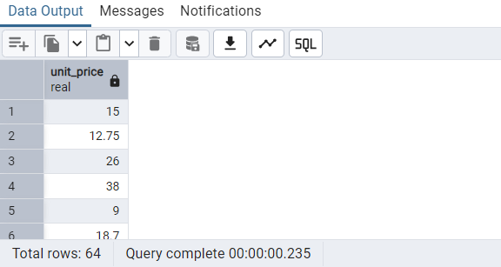

* List all customers sorted by company name in ascending order

SELECT customer_id,company_name FROM customers

ORDER BY company_name;

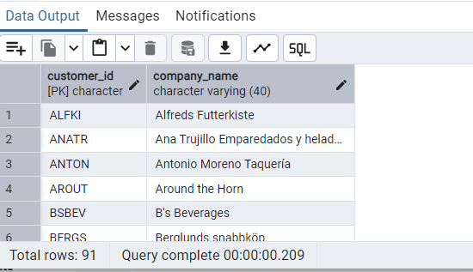

* Display product name and unit price, but rename the unit_price column as price_in_usd

SELECT product_name, unit_price as price_in_usd FROM products;

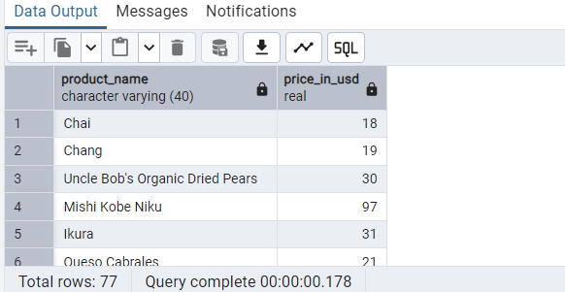

3) Filtering

* Get all customers from Germany.

SELECT company_name, country FROM customers WHERE country = 'Germany'

ORDER BY company_name;

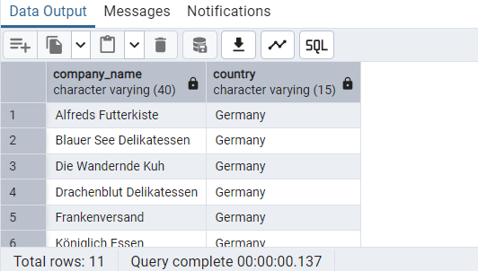

* Find all customers from France or Spain

SELECT company_name, country FROM customers WHERE country = 'France' or

country = 'Spain' ORDER BY company_name;

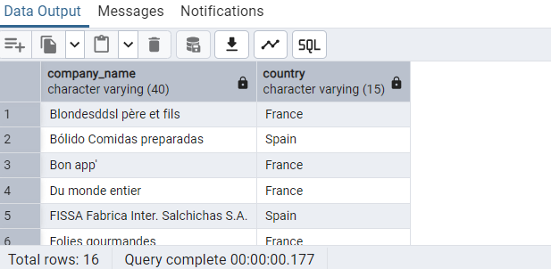

* Retrieve all orders placed in 2014(based on order_date), and either have freight greater than 50 or the shipped date available (i.e., non-NULL) (Hint: EXTRACT(YEAR FROM order_date))

SELECT * FROM orders where EXTRACT(YEAR FROM order_date) = 2014 AND

(freight > 50 or shipped_date IS NOT NULL);

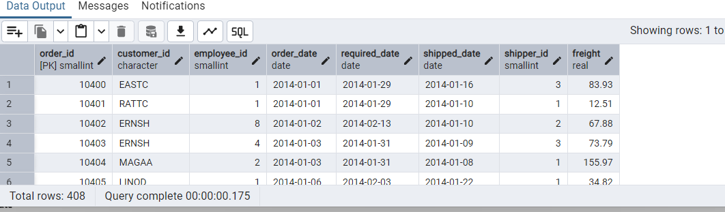

4) Filtering

* Retrieve the product_id, product_name, and unit_price of products where the unit_price is greater than 15.

SELECT product_id,product_name,unit_price FROM products WHERE unit_price > 15;

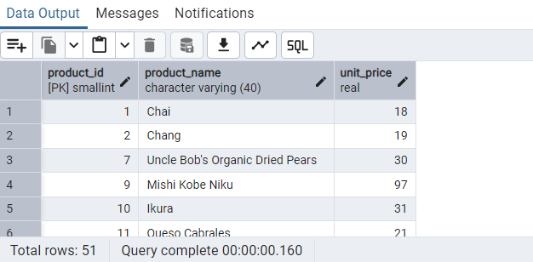

* List all employees who are located in the USA and have the title "Sales Representative".

SELECT employee_name, country, title from employees WHERE country = 'USA' and

title = 'Sales Representative';

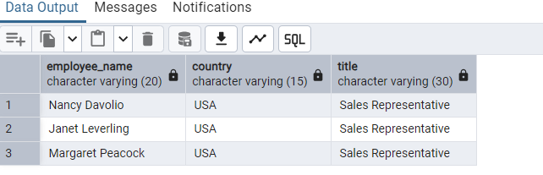

* Retrieve all products that are not discontinued and priced greater than 30.

SELECT * FROM products where discontinued = 0 and unit_price > 30 order by

product_id;

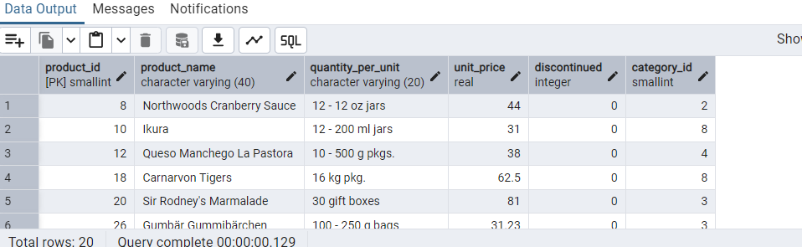

5) LIMIT/FETCH

* Retrieve the first 10 orders from the orders table.

SELECT * FROM ORDERS ORDER BY order_id

LIMIT 10;

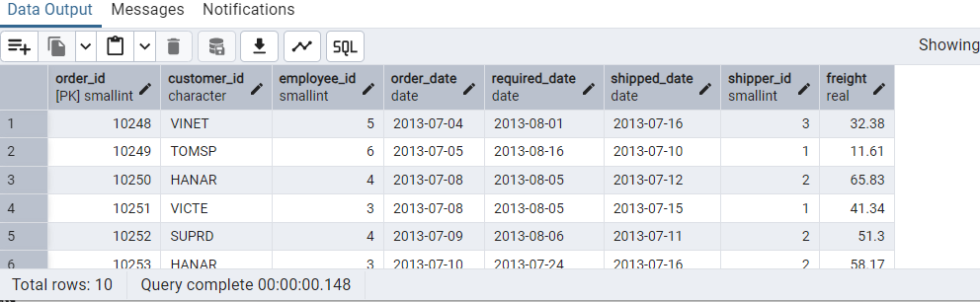

* Retrieve orders starting from the 11th order, fetching 10 rows (i.e., fetch rows 11-20).

SELECT * FROM ORDERS ORDER BY order_id

OFFSET 10

LIMIT 10;

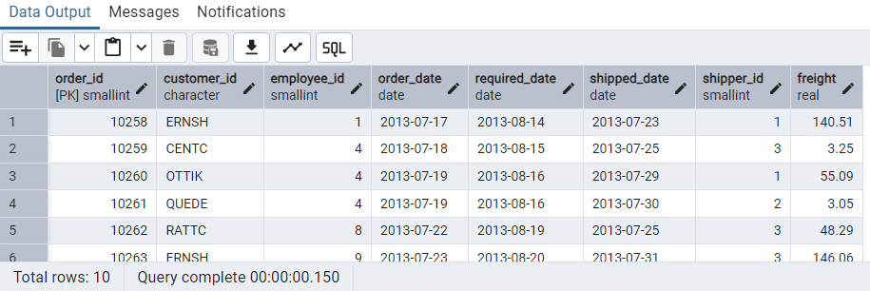

6) Filtering (IN, BETWEEN)

* List all customers who are either Sales Representative, Owner

SELECT * FROM customers WHERE contact_title in ('Sales Representative', 'Owner');

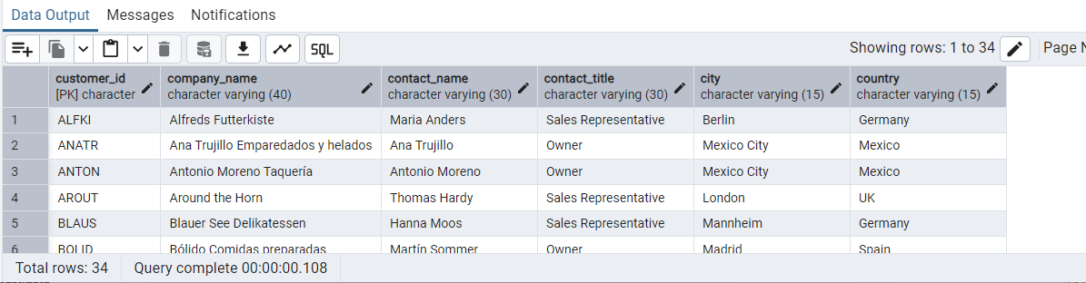

* Retrieve orders placed between January 1, 2013, and December 31, 2013.

SELECT * FROM orders WHERE order_date BETWEEN '2013-01-01' AND '2013-12-31';

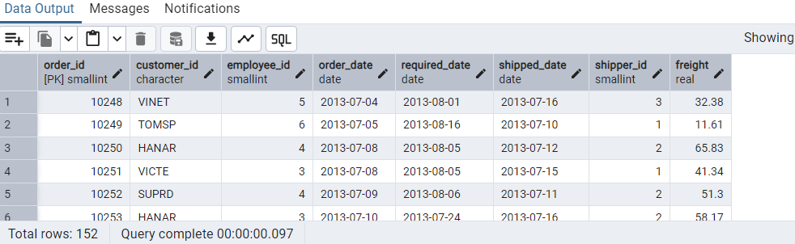

7) Filtering

* List all products whose category_id is not 1, 2, or 3.

SELECT * FROM products where category_id not in (1,2,3);

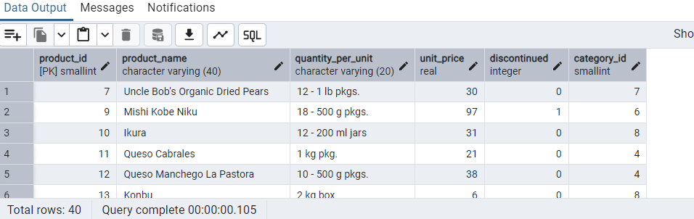

* Find customers whose company name starts with "A".

SELECT * FROM customers WHERE company_name like 'A%';

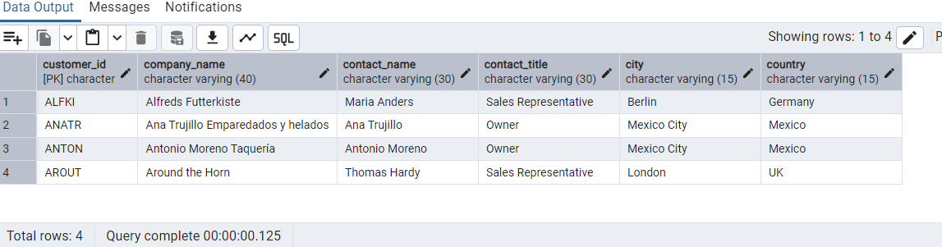

8) INSERT into orders table:

Task: Add a new order to the orders table with the following details:

Order ID: 11078

Customer ID: ALFKI

Employee ID: 5

Order Date: 2025-04-23

Required Date: 2025-04-30

Shipped Date: 2025-04-25

shipperID:2

Freight: 45.50

INSERT INTO orders VALUES ( 11078, 'ALFKI', 5, '2025-04-23', '2025-04-30','2025-04-25',2,45.50);

SELECT * FROM ORDERS WHERE ORDER_ID = 11078;

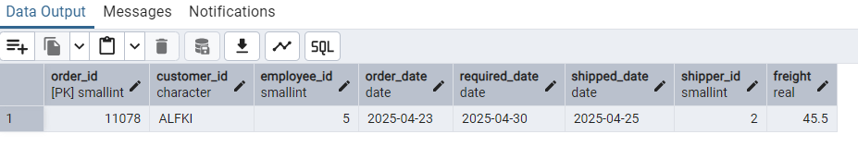

9) Increase(Update) the unit price of all products in category_id =2 by 10%.

(HINT: unit_price =unit_price * 1.10)

UPDATE products SET unit_price = unit_price * 1.10 WHERE category_id = 2;

SELECT * FROM products where category_id = 2;

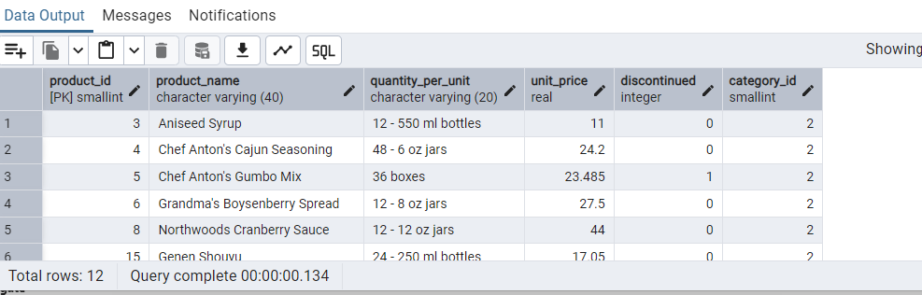

10) Sample Northwind database:

Download

1. Download northwind.sql from below link into your local. Sign in to Git first <https://github.com/pthom/northwind_psql>
2. Manually Create the database using pgAdmin:
   1. Right-click on "Databases" → Create → Database
   2. Give name as ‘northwind’ (all small letters)
   3. Click ‘Save’

Import database:

1. Open pgAdmin and connect to your server
2. Select the database ‘northwind’
3. Right Click-> Query tool.
4. Click the folder icon to open your northwind.sql file
5. Press F5 or click the Execute button.
6. You will see total 14 tables loaded
7. Databases → your database → Schemas → public → Tables

