**11.Create a sample dataset, having linearly separable data, from sklearn.dataset.sample_generator for classification using SVM**

**SOURCE CODE:**

**# Import the necessary libraries**

from sklearn.datasets import make_classification

from sklearn.model_selection import train_test_split

from sklearn.svm import SVC

from sklearn.metrics import accuracy_score

# Create a sample dataset with 500 samples and two features

X, y = make_classification(n_samples=500, n_features=2, n_informative=2, n_redundant=0, n_clusters_per_class=1, random_state=0)

# Split the dataset into training and testing sets

X_train, X_test, y_train, y_test = train_test_split(X, y, test_size=0.3, random_state=0)

# Create the SVM and train the model

svm = SVC(kernel='linear')

svm.fit(X_train, y_train)

# Evaluate the model

y_pred = svm.predict(X_test)

accuracy = accuracy_score(y_test, y_pred)

print('Accuracy:', accuracy)SVC(kernel='linear')

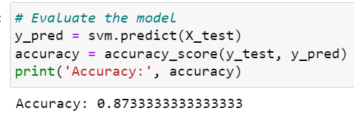

**OBSERVATION:**

* we use the make_classification function from the scikit-learn library to create a sample dataset with 500 samples and two features. We set the n_informative parameter to 2 to ensure that the data is linearly separable. We also set n_redundant to 0 to avoid creating redundant features.
* We then split the dataset into training and testing sets using the train_test_split function. In this example, we use 30% of the data for testing.
* We create an SVM model with a linear kernel and train the model using the fit() function and passing the training data and labels.
* Finally, we evaluate the performance of the SVM model on the testing set using the predict() function and calculating the accuracy using the accuracy_score function from scikit-learn.
* **Accuracy: 0.8733333333333333=87.33%**