Guvi Task12 – MySQL

- Created the Empl table and inserted the table values

Query:
- create database Employee;
- use Employee;
- create table Empl (empno int(10) primary key ,name varchar(20),job varchar(20), mgr int(10),hiredate date, sal float, comm float, deptno int );
- insert into Empl values
(8369,'SMITH','CLERK',8902,'1990-12-18', 800.00, null , 20),
(8499,'ANYA','SALESMAN',8698,'1991-02-20', 1600.00, 300.00 , 30),
(8521,'SETH','SALESMAN',8698,'1991-02-22', 1250.00, 500.00 , 30),
(8566,'MAHADEVAN','MANAGER',8839,'1991-04-02', 2985.00, null , 20),
(8654,'MOMIN','SALESMAN',8698,'1991-09-28', 1250.00, 1400.00 , 30),
(8698,'BINA','MANAGER',8839,'1991-05-01', 2850.00, null , 30),
(8882,'SHIVANSH','MANAGER',8839,'1991-06-09', 2450.00, null , 10),
(8888,'SCOTT','ANALYST',8566,'1992-12-09', 3000.00, null , 20),
(8839,'AMIR','PRESIDENT',null,'1991-11-18', 5000.00, null , 10),
(8844,'KULDEEP','SALESMAN',8698,'1991-09-08', 1500.00, 0.00 , 10);
- select * from Empl;

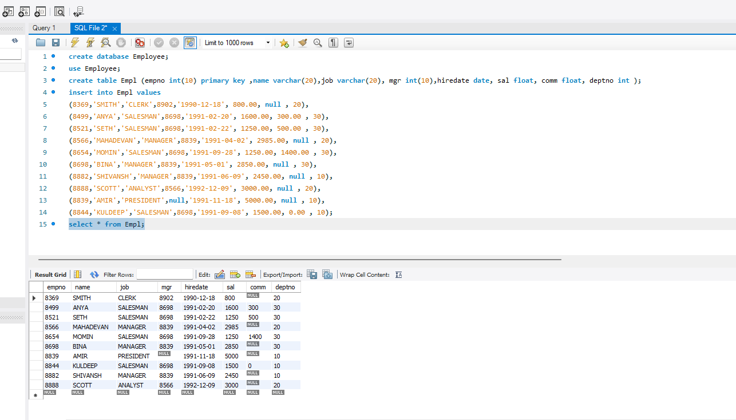

- Query : select name, sal from Empl where sal>=2200;

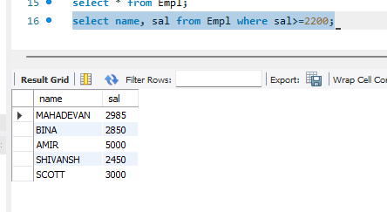

- Query : select * from Empl where comm=0;
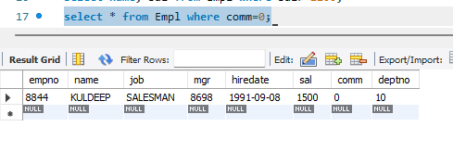

- Query : select name, sal from Empl where sal<2500 or sal>4000 ;

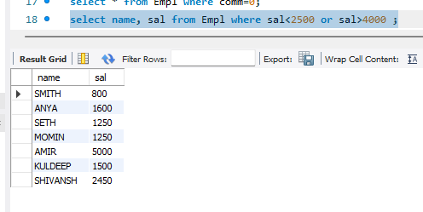

- Query : select name,job,sal from Empl where mgr is null;
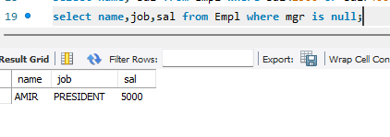

- select name from Empl where name like '__i%';
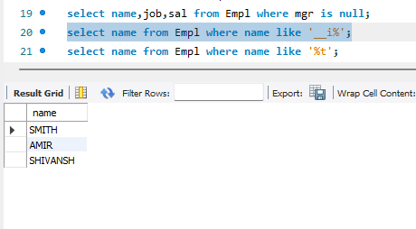

- Query : select name from Empl where name like '%t';
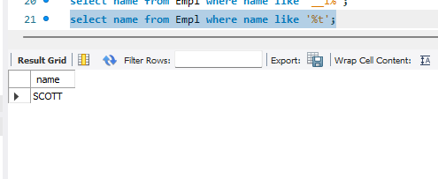

- JDBC connection
- To create DB
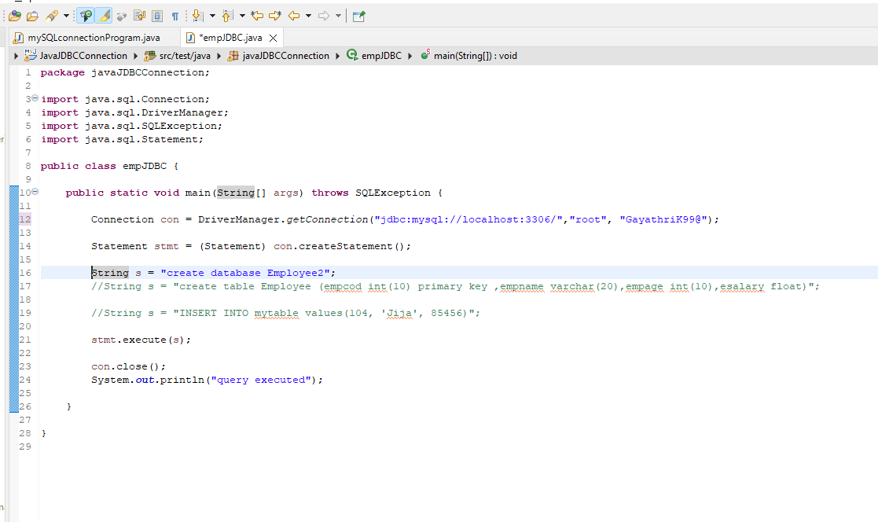

- To create Table :

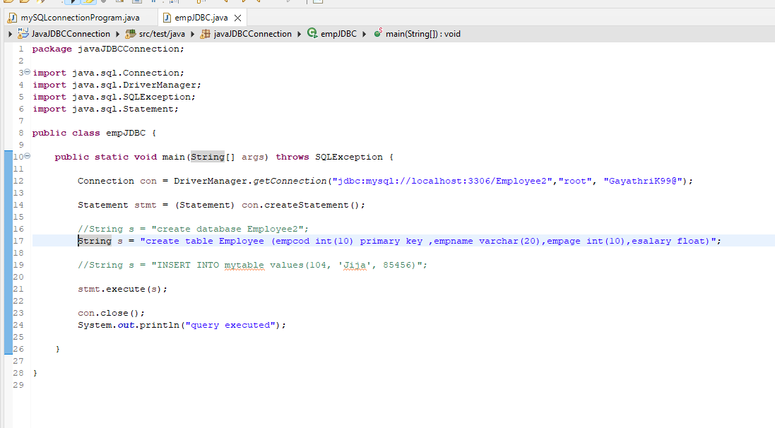

- To insert values
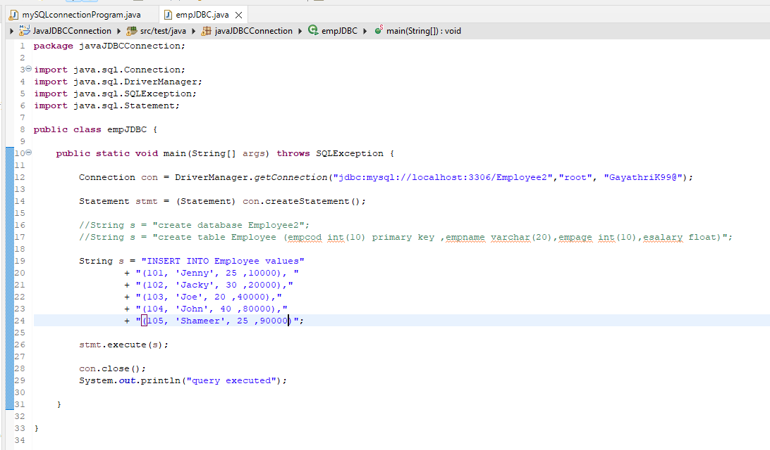

MYSQL output – JDBC

