FORM 2
THE PATENT ACT 1970
(39 of 1970)
&
The Patents Rules, 2003
PROVISIONAL/COMPLETE SPECIFICATION
(See Section 10 and rule 13)
1. TITLE OF THE INVENTION:

DripSense:An IoT-based system for detecting and alerting hidden water leakages
2. APPLICANT(S)

  - NAME: VNRVJIET
  - NATIONALITY: INDIAN
  - ADDRESS:

Inventors:
1. Dr.D.Manju, Assistant Professor, Department of CSE-(CyS,DS) and AI&DS.
2. S.R.Anand Kumar, Professor of Practice, Department of CSE-(CyS,DS) and AI&DS.
3. Panthangi Venkateswara Rao, Assistant Professor, Department of CSE-(CyS,DS) and AI&DS.
4. Y.Gayathri Karthikeya, Department of CSE-(CyS,DS) and AI&DS.
5. G.Vishnu Phani, Department of CSE-(CyS,DS) and AI&DS.
6. Mohammad Sohail, Department of CSE-(CyS,DS) and AI&DS.

3. PREAMBLE OF THE DESCRIPTION
PROVISIONAL  The following specification describes the invention. | COMPLETE  The following specification particular1y describes the invention and the manner in which it is to be performed.
4. Description (Description shall start from the next page.)
5. CLAIMS (not applicable for provisional specification. Claims should start with the preamble - "I/We claim on a separate page)
6. DATE AND SIGNATURE (to be given at the end of last page of specification)
7. ABSTRACT OF THE INVENTION (to be given along with complete specification on separate page)

FIELD OF THE INVENTION:
The present invention relates in general to systems for fluid management and conservation, and more particularly to an Internet of Things (IoT)-based water leakage detection and alert system designed for real-time monitoring of plumbing networks in residential, commercial, and institutional settings. The invention specifically integrates ultrasonic or flow sensors with wireless microcontrollers to detect hidden or abnormal water flow patterns and to communicate timely alerts via a web-based user interface.
BACKGROUND OF THE INVENTION:
Water is a critical natural resource that plays a vital role in domestic, agricultural, and industrial applications. With the growing global demand for water and increasing concerns over water scarcity, efficient utilization and management of water resources have become urgent priorities. One of the major challenges in water management is the problem of leakages in supply pipelines. Studies indicate that a substantial percentage of distributed water is lost before reaching the end consumer due to hidden or unattended leakages. These leakages may occur in underground pipelines, concealed joints, or within building walls and flooring. The cumulative impact of such leakages includes large-scale wastage of potable water, economic losses to utility providers, inflated costs for consumers, and secondary damages such as corrosion, dampness, and mold growth that compromise the safety and durability of infrastructures.
Traditionally, water leakage detection has relied heavily on manual inspection and routine monitoring of flow meters. These methods, however, are inefficient in detecting micro-leakages or slow drips, particularly in concealed areas. Manual inspections are labour-intensive, require skilled personnel, and often result in delayed identification of the leakage event, by which time significant damage may have already occurred. Furthermore, manual approaches are not scalable for large distribution networks.
In response to these limitations, smart water meters and electronic flow monitoring systems have been introduced. Some of these systems utilize ultrasonic sensors, pressure-based monitoring, or acoustic methods to detect abnormal flow behaviour. While such technologies represent a step forward, they still suffer from critical drawbacks. Many of the existing systems are designed for large-scale applications, making them costly and impractical for residential or small-scale use. Additionally, these systems often lack distributed sensing capability, resulting in poor localization of the leakage. Others are limited to detecting only major deviations in flow rate, thereby missing early-stage leakages that could be addressed with timely intervention.
Another limitation of conventional systems is the absence of user-centric features such as real-time alerts, remote monitoring, and data analytics. In many cases, the data is collected but not immediately accessible to the user, or it is available only through complex proprietary platforms. The lack of an integrated and user-friendly interface reduces the effectiveness of such systems in enabling proactive decision-making. Furthermore, installation of advanced leakage detection systems is often complex, requiring specialized infrastructure, and is therefore unsuitable for widespread deployment across existing residential or commercial buildings.
The present invention, referred to as the DripSense system, overcomes the shortcomings of conventional leakage detection methods by providing a distributed, intelligent, and cost-effective approach for real-time detection and alerting of hidden water leakages. The system employs a sensing unit comprising an HCSR04 ultrasonic sensor and a flow meter, which continuously monitor water flow characteristics such as rate, velocity, and pressure variation within a pipeline. The raw data collected from these sensors is preprocessed locally at Arduino Uno modules that act as intermediary computational nodes. This preprocessing utilizes a real-time filtering algorithm, such as a moving average or Kalman filter, to smooth transient fluctuations, eliminate electrical noise, and stabilize sensor readings. This low-signal processing approach allows the system to detect micro-leakages — very small, continuous drips that are typically undetectable by conventional systems.
The ESP32 microcontroller serves as the central control and decision-making unit. It performs data fusion and leakage detection by applying a weighted evaluation model to the processed inputs from both sensors. The flow meter is assigned a weightage of 0.6 for detecting large-scale or abrupt flow deviations, while the ultrasonic sensor (HCSR04) carries a weightage of 0.4, providing finer sensitivity to low-level or minor leaks through subtle distance or turbulence variations. The ESP32 combines these weighted values to compute a composite leakage index. When this index exceeds a predefined dynamic threshold, the system identifies it as a confirmed leakage event.
The system includes an instrumentation and calibration module that establishes baseline thresholds during setup. During the calibration phase, both sensors record flow data under normal conditions to define reference patterns. Periodic self-calibration routines are executed to update these baselines, compensating for sensor drift, pipe wear, or changing environmental conditions. The ESP32’s online algorithm continuously compares real-time weighted sensor readings with these adaptive thresholds to determine leak presence and severity.
Upon detection, the ESP32 activates the alert module and transmits data through its integrated Wi-Fi unit to a cloud-based dashboard built using Streamlit, providing real-time visualization, alert notifications, and historical flow analytics. The interface allows users to observe both sensor readings individually and the combined leakage probability score. Advanced versions may further incorporate machine learning algorithms to enhance leak classification, predict upcoming failures, and automatically adjust sensor weights based on historical detection accuracy.
By integrating low-signal preprocessing, multi-sensor weighted fusion, and adaptive calibration, the DripSense system provides highly accurate, scalable, and intelligent leak detection for both micro and macro leak scenarios. The system ensures efficient water conservation, infrastructure protection, and sustainable resource management through proactive, data-driven decision-making.
OBJECTIVE OF THE INVENTION:
The principal objective of the present invention is to provide an advanced IoT-based water leakage detection system, DripSense, that leverages a multi-sensor weighted fusion approach to accurately detect and analyze abnormal water flow patterns in plumbing systems. This enables early identification of leaks, preventing water wastage and minimizing potential property damage.
Another object of the present invention is to offer a real-time alert and analytics platform that communicates leak status, water usage patterns, and predictive insights to users via connected devices. This ensures timely intervention, enhances resource conservation, and improves the overall efficiency and reliability of plumbing maintenance.
Additionally, the invention aims to provide a robust, adaptive, and scalable solution, capable of integrating data from multiple sensor types—including moisture, acoustic, pressure, and temperature sensors—while dynamically adjusting sensor weights for optimal detection accuracy under varying environmental conditions.

SUMMARY OF THE INVENTION:
The present invention discloses an intelligent water leakage detection and alert system, herein referred to as DripSense, which utilizes Internet of Things (IoT) technology integrated with a multi-sensor weighted fusion mechanism to detect and report concealed water leakages in real time. The invention is designed for application in residential, commercial, and institutional infrastructures, wherein undetected plumbing leaks contribute to excessive water wastage, structural deterioration, and economic loss.
The system comprises a plurality of microcontrollers, including the ESP32 (110) and the Arduino Uno (111). The ESP32 operates as the primary control and communication unit, facilitating wireless data transmission via Wi-Fi, while the Arduino Uno is configured to perform signal preprocessing from distributed flow and ultrasonic sensors. The sensing assembly, consisting of ultrasonic sensors (120) and flow sensors (121), continuously monitors the water flow within pipelines to identify irregularities indicative of potential leakages.
A distinguishing feature of the invention is the implementation of a multi-sensor weighted fusion algorithm, wherein each sensor’s data is assigned an adaptive weight based on its confidence level and environmental reliability. This algorithmic fusion enhances the precision of leak detection, mitigates false positives, and ensures robust operation under variable hydraulic and environmental conditions. Upon detection of an abnormal flow pattern, the ESP32 processes the fused data and triggers a leak alert protocol.
The processed information is transmitted through the integrated Wi-Fi module (130) to a web-based monitoring dashboard developed using Streamlit (140). The dashboard provides real-time visualization of system status, flow rate metrics, and alert notifications. It also performs data logging and historical analysis, enabling users to review long-term consumption patterns and identify repetitive inefficiencies.
Alerts are displayed instantaneously on the dashboard and may optionally be extended to SMS or email notifications for remote supervision. The modular configuration of the system allows multiple sensing nodes to operate under centralized or distributed control schemes. All system components are mounted on a custom-printed circuit board (150) that facilitates compact assembly, stable sensor interfacing, and ease of installation.
In operation, DripSense performs continuous acquisition of flow data, executes weighted sensor fusion, and activates the alert mechanism upon breach of predefined thresholds. The system’s intuitive monitoring interface enables both technical and non-technical users to promptly respond to leakage incidents.
Through the integration of precise sensing technologies, intelligent data fusion, wireless communication, and cloud-based analytics, the present invention provides a cost-effective, adaptive, and scalable solution for proactive water management. It effectively enhances situational awareness, prevents infrastructural damage, and promotes environmental sustainability through timely detection and intervention against water leakage events.
BRIEF DESCRIPTION OF THE DRAWINGS
A preferred embodiment of the invention is now described in detail. Referring to the drawings, numbers indicate parts throughout the views. Unless explicitly stated in the following disclosure, the drawings are not necessarily drawn to scale. As used in the description herein and throughout the claims, the following terms take the meanings explicitly associated herein unless the context dictates otherwise: the meaning of "a," "an," and "the" includes plural references; the meaning of "in" includes both "in" and "on." The summary of the present invention, as well as the detailed description, are better understood when read in conjunction with the accompanying drawings that illustrate one or more possible embodiments of the present invention, which:
Fig. 1: SDG needs and service cycle
Fig. 2: Block diagram of the system
Fig. 3: WOKWI setup
Fig. 4: Excel sheet readings generated from simulation
Fig. 5: The working of leakage detection system
Fig. 6: Method for detecting and alerting hidden water leakages
DETAILED DESCRIPTION OF THE INVENTION
The present invention relates to an IoT-based water leakage detection and alert system named DripSense, designed to identify hidden leaks in plumbing infrastructure using sensor-based real-time monitoring, cloud-connected data visualization, and automated preventive actions.
The DripSense system (100) is an intelligent, modular solution to the critical problem of unnoticed water loss in residential, commercial, and industrial pipelines. At its core, the system integrates a sensing unit (120) comprising ultrasonic sensors (121, HC-SR04) and flow sensors (122, YF-S201), which continuously monitor water flow characteristics. The ultrasonic sensors detect variations in distance or fluid displacement in pipes, enabling indirect measurement of pressure drops or air gaps caused by leaks. The flow sensors monitor volumetric water flow and are calibrated to detect abnormal fluctuations associated with leakage or unauthorized usage. Sensor parameters—including minimum detectable flow (0.5 L/min), maximum flow range (30 L/min), and distance thresholds (2–400 cm for HC-SR04)—are stored in the system’s configuration database derived from experimental calibration values (from the Excel sheet generated using simulation).
Control and Communication Units
The control unit (110) comprises an ESP32 microcontroller (111), which processes raw sensor data and communicates wirelessly via the integrated Wi-Fi module (131). Optionally, an Arduino Uno (112) acts as a secondary preprocessing node, filtering noise, normalizing readings, and performing edge-level threshold analysis before forwarding data to the ESP32. This hierarchical data management reduces latency and improves system scalability for complex or large pipeline networks.
The data communication unit (130) handles cloud transmission of processed readings to a web-based dashboard (140) developed using Streamlit, providing interactive, graphical visualization of water flow metrics, real-time leakage alerts, and historical trend analysis.
Hardware Architecture
The hardware components are mounted on a custom printed circuit board (PCB, 150), which integrates sensor interfaces, microcontrollers, power management, and wiring connections. The HC-SR04 ultrasonic sensors are connected to ESP32 pins using a defined GPIO mapping (Trigger → GPIO 12, Echo → GPIO 14), while the flow sensors use digital input pins (YF-S201 → GPIO 27) with interrupt-driven counting for accurate flow rate measurement. Power supply modules ensure stable 5V and 3.3V outputs, while modular design allows quick sensor replacement or upgrades.
Service Cycle
The service cycle (170) is divided into three operational phases:
- Leak Detection Phase (171): Sensors continuously monitor water flow, pressure variations, and distance changes in pipelines. The Arduino preprocessing unit filters noise and transmits key metrics to the ESP32, which compares readings against threshold ranges stored in configuration memory (Excel-sourced reference values: flow < 0.8 L/min or sudden drops > 15% trigger alert).
- Notification Phase (172): Detected anomalies trigger immediate notifications on the dashboard and optionally via SMS/email. Threshold-based color coding in the dashboard highlights severity levels.
- Action Phase (173): The system can autonomously actuate a solenoid valve to stop water flow, preventing further leakage and structural damage.
Simulation and Verification
The system has been verified in a Wokwi-based simulation environment (JSON configuration previously used) to emulate real-time water leakage scenarios. Sensor nodes and ESP32 wiring were modeled to replicate flow conditions, confirm threshold-based detection, and test dashboard updates. The simulation validated:
- Correct distance readings from HC-SR04 ultrasonic sensors.
- Flow counting accuracy for YF-S201 sensors under variable flow rates.
- Alert generation and real-time dashboard updates via ESP32 Wi-Fi communication.
- Automatic solenoid control upon leakage detection.
Operational Method
The method for detecting and alerting hidden water leakages involves:
- Continuous real-time monitoring by the sensing unit (120).
- Preprocessing and noise reduction by Arduino Uno (112).
- Threshold-based analysis by ESP32 (111) using data from the Excel-stored calibration tables.
- Cloud transmission via Wi-Fi (131) to the Streamlit-based dashboard (140).
- Immediate user notification via visual alerts and optional SMS/email.
- Automatic or manual actuation of solenoid valves to stop water flow.
Advantages
DripSense offers:
- High accuracy via dual sensor types (ultrasonic and flow).
- Modularity and scalability for various installation sizes.
- Real-time alerts with actionable dashboard visualization.
- Automated preventive measures minimizing water wastage and structural damage.
- Simulation-verified design using Wokwi JSON-based models for ESP32-HC-SR04 integration.
By combining precise sensing, intelligent control, wireless communication, and user-friendly visualization, the DripSense system provides a proactive and scalable solution to the persistent problem of hidden water leakage, enabling efficient water management, sustainability, and cost reduction.

Dated this the 14th day of October 2025
CLAIMS
We claim:
- A system (100) for detecting and alerting hidden water leakages, comprising:
a) a sensing unit (120) including one or more ultrasonic sensors (121, e.g., HC-SR04) and one or more flow sensors (122, e.g., YF-S201), configured to monitor water flow characteristics within a pipeline, detect sudden drops or
abnormal flow, and provide real-time data;
b) a control unit (110) comprising an ESP32 microcontroller (111) configured to process sensor data, apply threshold-based leakage detection, and communicate wirelessly through an integrated Wi-Fi module (131);
c) a data communication unit (130) configured to transmit processed sensor data from the control unit (110) to a cloud-connected dashboard interface (140);
d) a visualization and alert interface (140) comprising a web-based dashboard developed using Streamlit, configured to display real-time system status, leakage alerts, flow analytics, and historical water usage patterns;
e) a custom printed circuit board (150) configured to interface sensors, controllers, power supply, and auxiliary modules in a compact, modular assembly;
f) wherein the system (100) operates through a service cycle (170) comprising leak detection, notification, and action to prevent water damage, based on configurable thresholds stored in a system database.
- The system of claim 1, further comprising an auxiliary microcontroller (112), e.g., Arduino Uno, configured to preprocess distributed sensor signals, filter noise, normalize readings, and provide edge-level analysis before transmission to the ESP32.
- The system of claim 1, wherein the service cycle (170) comprises:
a) a leak detection phase (171) in which one or more sensors (121, 122) monitor water flow, pressure variation, and distance changes in real time to detect anomalies indicative of hidden leakage;
b) a notification phase (172) in which the control unit (110) generates alerts and communicates them to the dashboard interface (140) and optional SMS or email channels;
c) an action phase (173) in which preventive measures are initiated, either automatically by the control unit (110) or manually by the user, including controlling a solenoid valve to stop water supply.
- The system of claim 1, wherein flow sensors (122) are calibrated using reference values stored in the system database to detect unauthorized, abnormal, or threshold-exceeding water usage patterns.
- The system of claim 1, wherein ultrasonic sensors (121) are configured to measure pipe displacement or distance changes from 2–400 cm, enabling indirect detection of leaks caused by pressure drops or air gaps.
- The system of claim 1, wherein the dashboard interface (140) provides interactive graphical visualization of water usage patterns, leakage anomalies, real-time alerts, and historical trend analytics, and is compatible with web browsers on any device.
- The system of claim 1, wherein alerts are displayed in real time on the dashboard (140) and can be additionally transmitted through SMS or email notifications.
- The system of claim 1, wherein the action phase (173) further comprises automatic control of a solenoid valve to stop water flow upon detection of a leakage event, minimizing water wastage and preventing structural damage.
- The system of claim 1, further configured to operate in a simulation environment, using a JSON-based configuration for Wokwi or similar platforms, to verify ESP32, HC-SR04, and flow sensor integration and test service cycle performance before deployment.
- A method for detecting and alerting hidden water leakages using the DripSense system (100), the method comprising:
a) continuously monitoring water flow conditions within a pipeline using the sensing unit (120);
b) preprocessing sensor data using the Arduino Uno (112) in distributed configurations, including noise filtering and signal normalization;
c) processing sensor data using the ESP32 microcontroller (111) of the control unit (110), performing threshold-based analysis and detecting deviations indicative of leakage;
d) transmitting processed data via the Wi-Fi module (131) to a web-based dashboard interface (140);
e) displaying, on the dashboard interface (140), real-time flow metrics, leakage alerts, and historical analytics;
f) notifying the user of detected leakage events via dashboard, SMS, or email;
g) optionally initiating preventive measures, including automatic solenoid valve control to stop water flow.
- The system and method of any preceding claim, wherein all sensor, threshold, and flow parameters are configurable and stored in a system database to adapt to diverse pipeline types and installation environments.

Dated this the 14th day of October 2025
ABSTRACT
DripSense:An IoT-based system for detecting and alerting hidden water leakages
The present invention relates to an intelligent IoT-based system (100) named DripSense for detecting and alerting hidden water leakages in pipelines. The system comprises a sensing unit (120) including ultrasonic sensors (121, e.g., HC-SR04) and flow sensors (122, e.g., YF-S201) to continuously monitor water flow, pressure variations, and pipe displacement. A control unit (110) with an ESP32 microcontroller (111) processes sensor data, applies threshold-based leakage detection, and communicates wirelessly via an integrated Wi-Fi module (131) within a data communication unit (130). Optionally, an auxiliary Arduino Uno (112) preprocesses distributed sensor signals, including noise filtering and signal normalization, before forwarding data to the ESP32.
Processed data is transmitted to a web-based dashboard interface (140), developed using Streamlit, providing real-time flow metrics, leakage alerts, historical water usage analytics, and configurable thresholds. Alerts can also be sent via SMS or email. The system is mounted on a custom printed circuit board (150) ensuring compact, modular assembly and stable interfacing of sensors, controllers, and power supply components.
The system operates through a service cycle (170) comprising leak detection, notification, and action, including automatic solenoid valve control to prevent water damage. The invention further provides a method for continuous monitoring, preprocessing, threshold-based analysis, wireless data transmission, real-time visualization, and immediate user notification, enabling proactive water management, leak prevention, and reduction of structural damage. The design is verified in a simulation environment using JSON-based configurations (e.g., Wokwi) for ESP32-HC-SR04 integration and service cycle validation.
.

Dated this the 14th day of October 2025

Applicants: No. of Sheets: 6
Application No.: Sheet No. 1

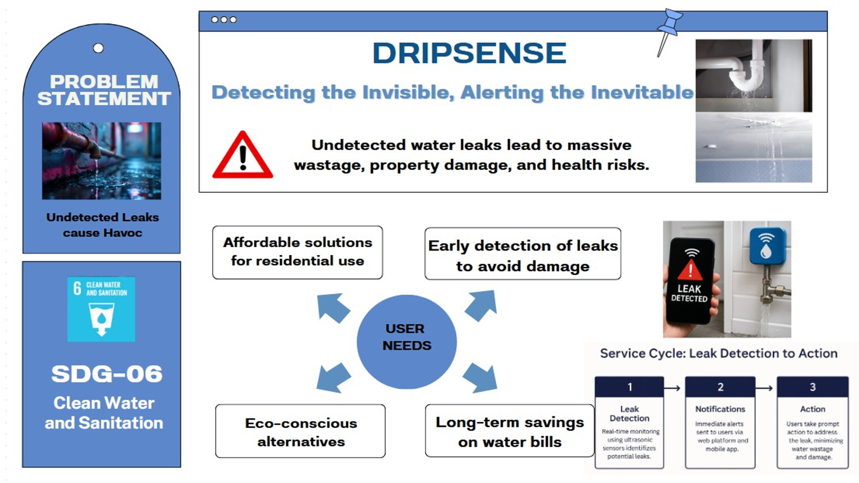
Fig. 1: SDG needs and service cycle

Dated this the 14th day of October 2025
Applicants: No. of Sheets: 6
Application No.: Sheet No. 2

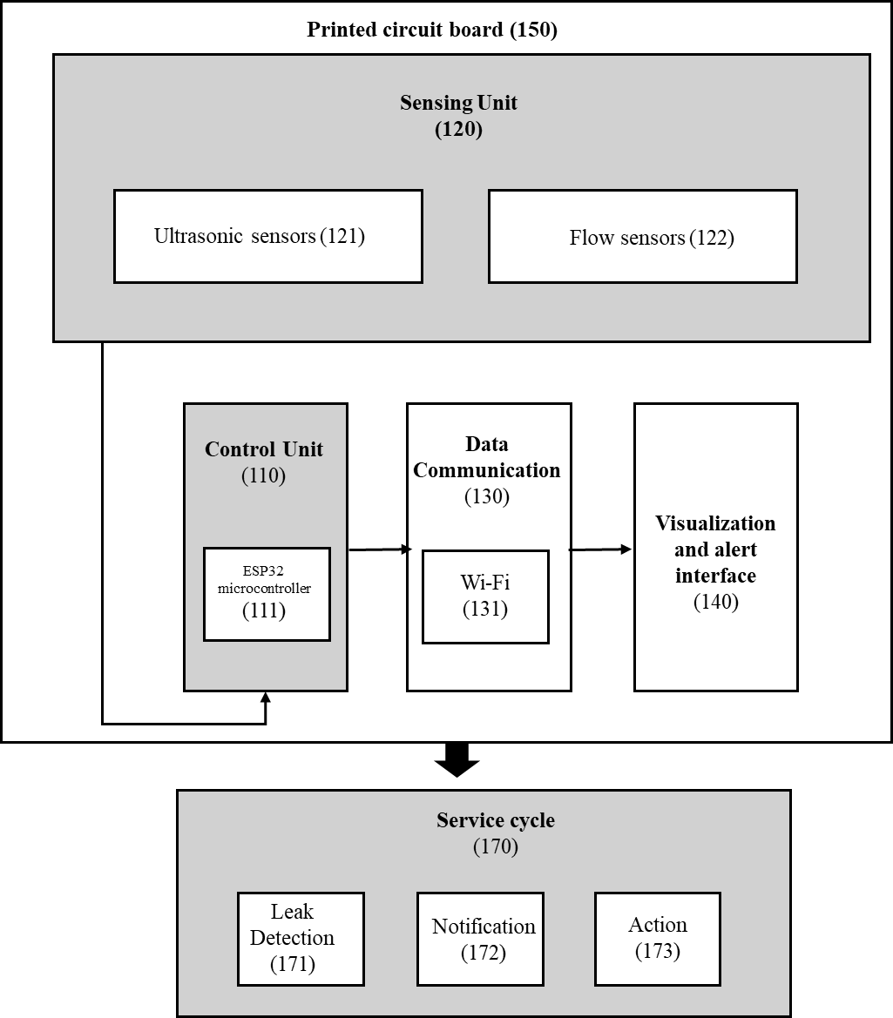
Fig. 2: Block diagram of the system

Dated this the 14th day of October 2025
Applicants: No. of Sheets: 6
Application No.: Sheet No. 3

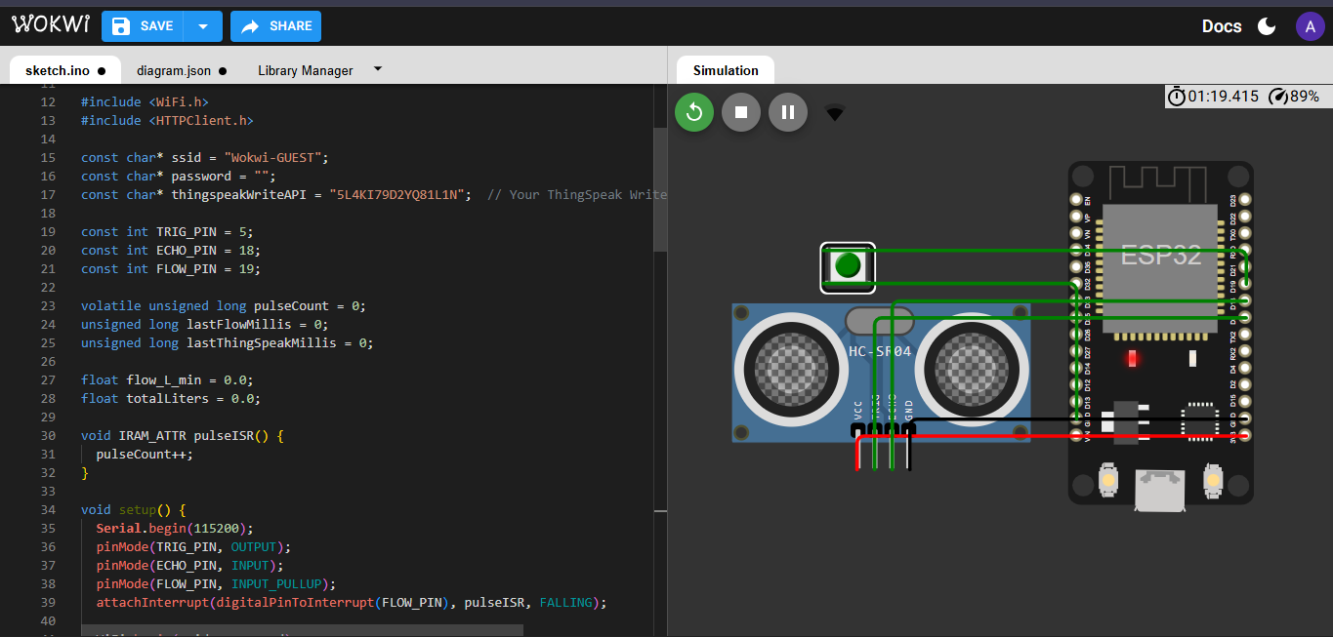

Fig. 3: WOKWI setup

Dated this the 14th day of October 2025
Applicants: No. of Sheets: 6
Application No.: Sheet No. 4

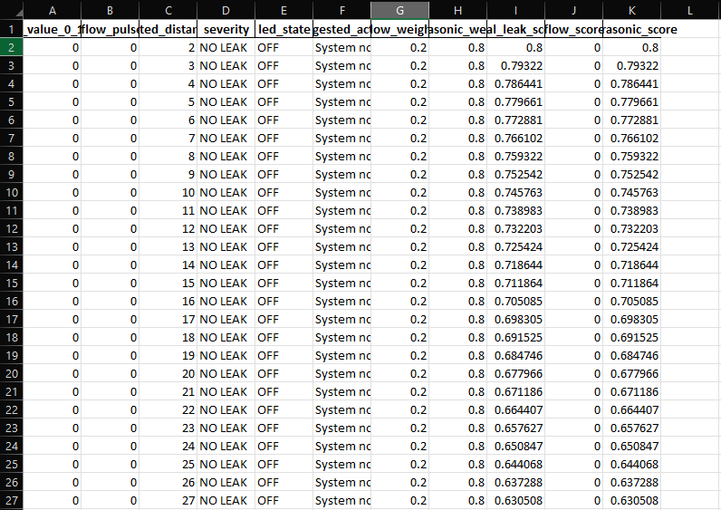

Fig. 4: Excel sheet readings generated from simulation

Dated this the 14th day of October 2025

Applicants: No. of Sheets: 6
Application No.: Sheet No. 5

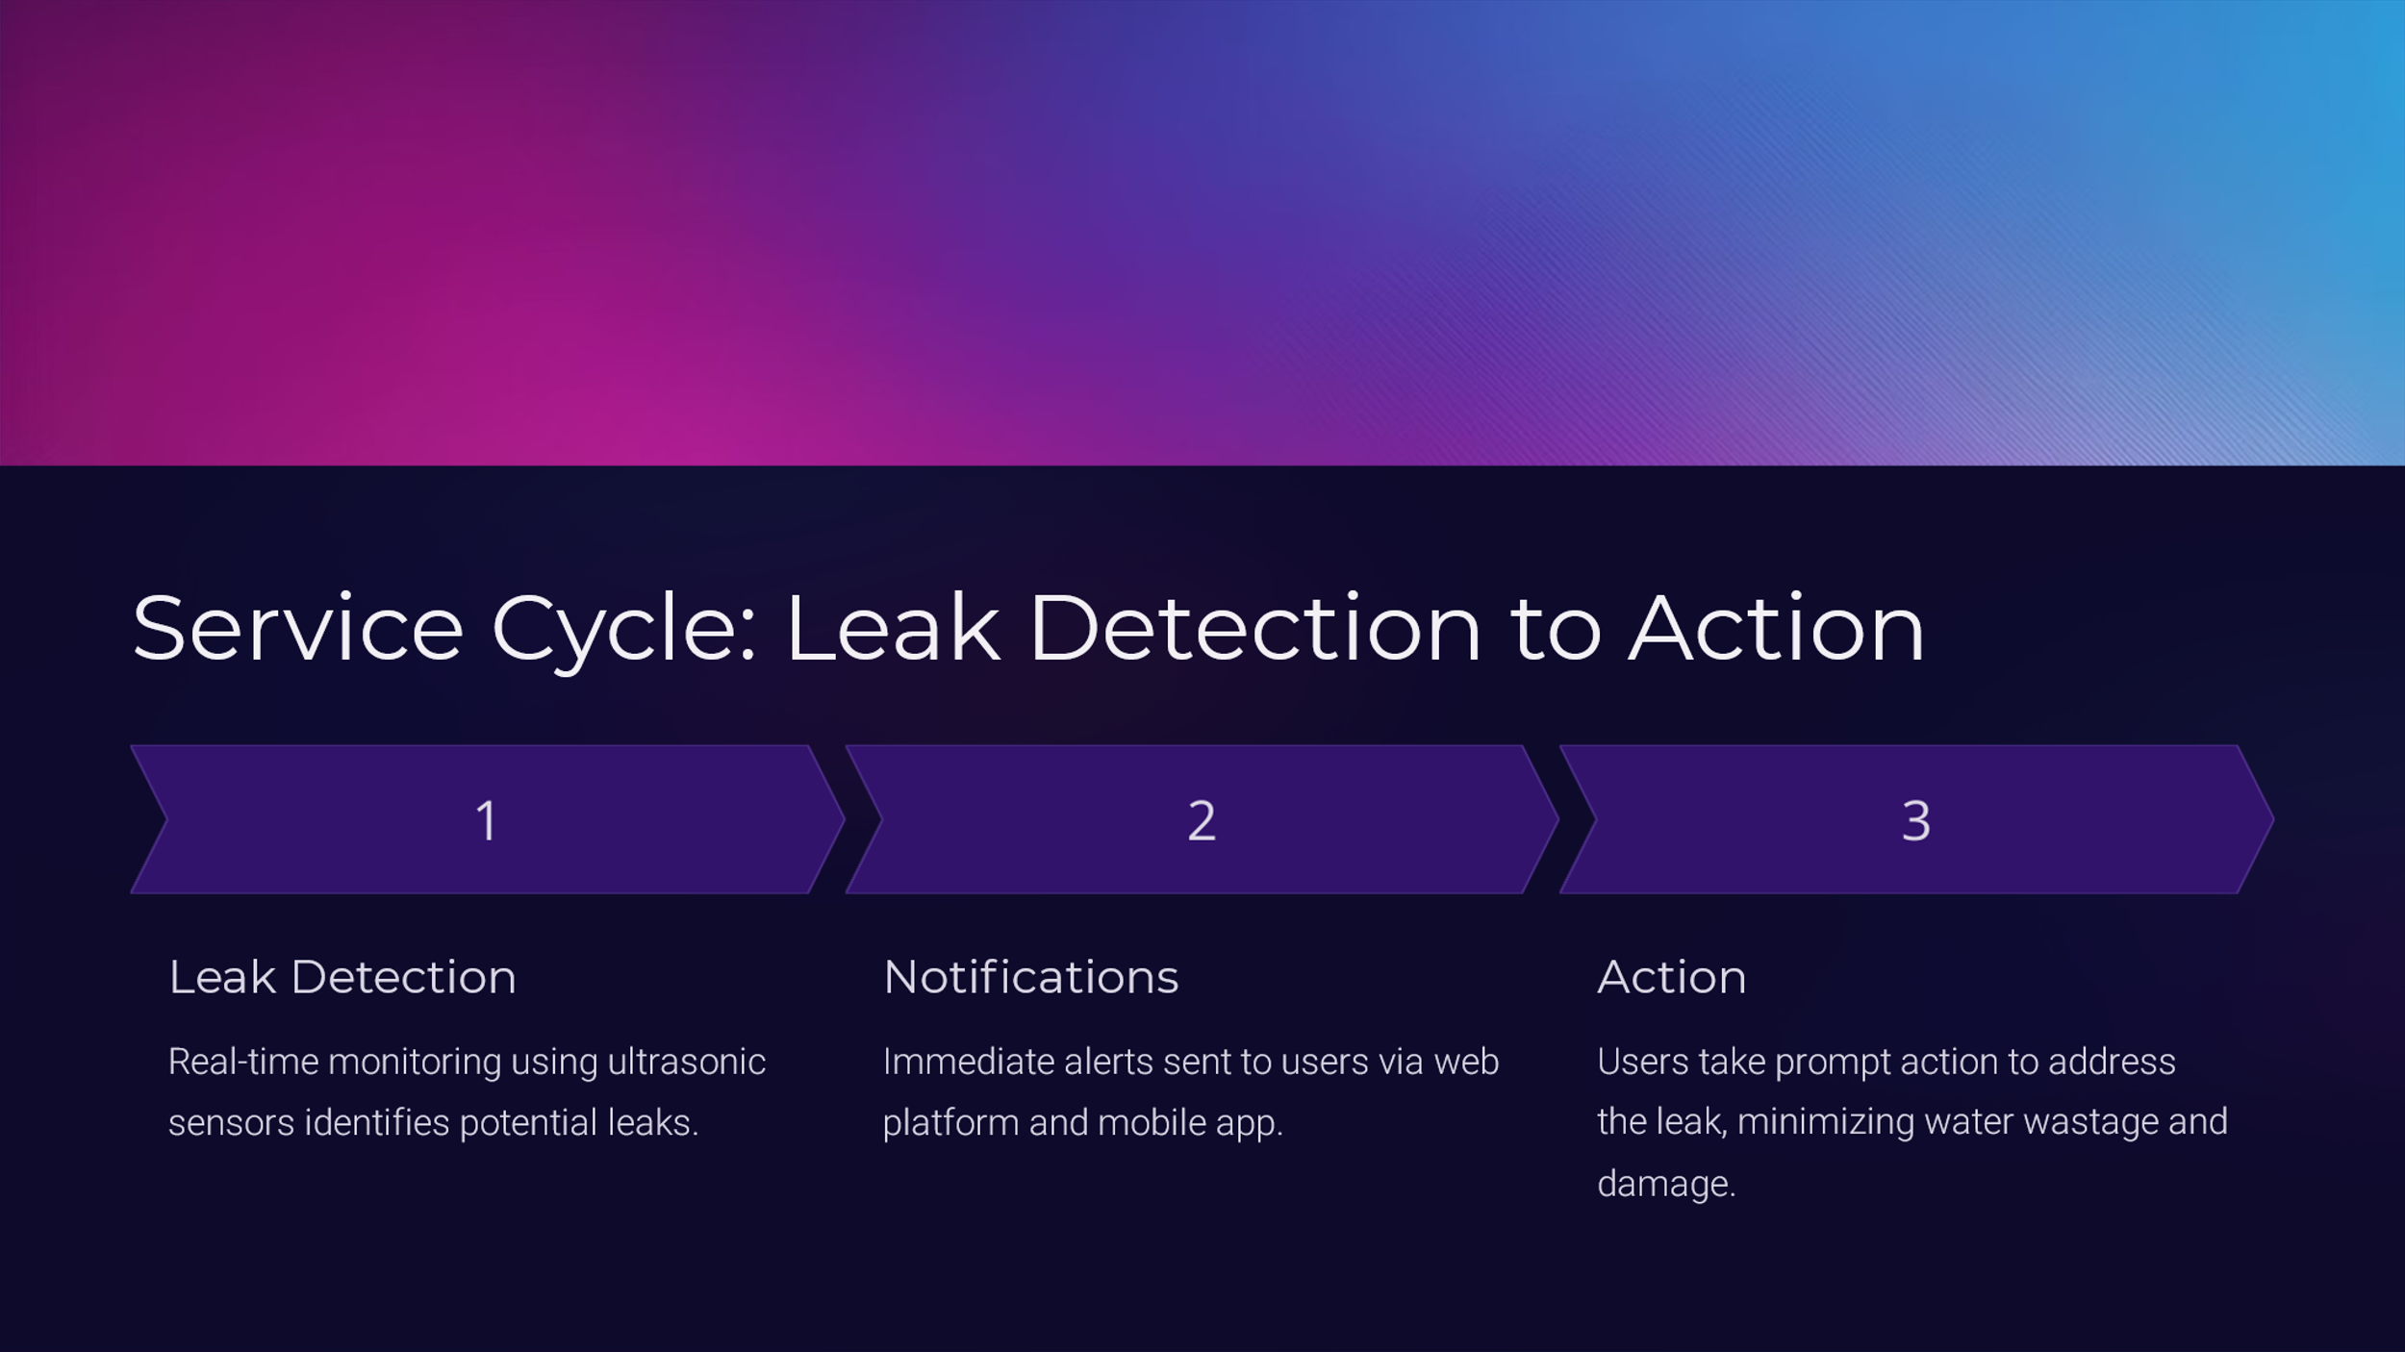
Fig. 5: The working of leakage detection system

Dated this the 14th day of October 2025
Applicants: No. of Sheets: 6
Application No.: Sheet No. 6

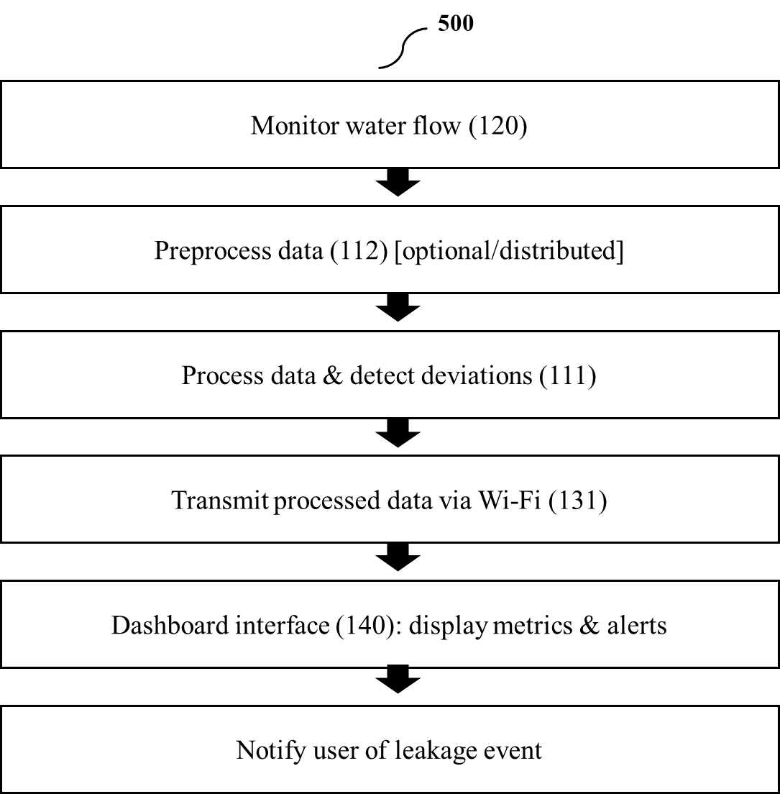
Fig. 6: Method for detecting and alerting hidden water leakages

Dated this the 14th day of October 2025

