FORM 2
THE PATENT ACT 1970
(39 of 1970)
&
The Patents Rules, 2003
PROVISIONAL/COMPLETE SPECIFICATION
(See Section 10 and rule 13)
1. TITLE OF THE INVENTION:

A health monitoring system for mine truck drivers and a method thereof (15 words only)

2. APPLICANT(S)

  - NAME: ……
  - NATIONALITY: Indian
  - ADDRESS: …..
3. PREAMBLE OF THE DESCRIPTION
PROVISIONAL  The following specification describes the invention. | COMPLETE  The following specification particular1y describes the invention and the manner in which it is to be performed.
4. Description (Description shall start from the next page.)
5. CLAIMS (not applicable for provisional specification. Claims should start with the preamble - "I/We claim on a separate page)
6. DATE AND SIGNATURE (to be given at the end of last page of specification)
7. ABSTRACT OF THE INVENTION (to be given along with complete specification on separate page)

FIELD OF THE INVENTION:
The present invention relates in general to systems related to monitoring systems for mine truck drivers, more specifically to an Arduino based mine truck driver health monitoring system.
BACKGROUND OF THE INVENTION:
Truck drivers spend extensive periods inside their cabins while navigating mining areas, where they are exposed to a host of harmful environmental factors. The presence of dust, fumes, gases, and dirt can significantly compromise air quality, as these contaminants can infiltrate the cabin environment. Small airborne particles enter through various means, including open doors, windows, and gaps in seals, as well as being carried in on the driver’s clothing and boots. Although these particles may be invisible to the naked eye, they can be easily inhaled, posing serious health risks. Once inhaled, these tiny particles can lodge deep within the lungs, leading to a range of respiratory issues. Working in such environments presents a multitude of health risks for drivers. The potential for exposure to airborne dust and hazardous gases is especially pronounced in specific locations, such as mines, quarries, and ports where loose materials are loaded or shifted, releasing significant amounts of dust into the air. In addition, workplaces that handle known hazardous substances can contribute to a toxic atmosphere. For instance, contaminants like asbestos fibers and organic materials can become airborne, exacerbating health risks for drivers. Continuous exposure to harmful substances, such as carbon monoxide and nitrogen dioxide—often resulting from combustion engine exhaust—can lead to severe lung conditions. These can include lung infections, allergic reactions, chronic bronchitis, and chronic obstructive pulmonary disease (COPD). Furthermore, the detrimental effects of poor air quality extend beyond respiratory illnesses, as it can also cause general discomfort, fatigue, and distraction, ultimately impairing the driver’s ability to perform their duties safely and effectively.
In light of these serious health concerns, our research aims to address the myriad risks faced by truck drivers, particularly those operating in hazardous environments. A promising existing methodology involves the development of an Internet of Things (IoT)-based air pollution monitoring system designed for real-time remote tracking of air quality. This innovative system employs various sensors, notably the MQ135 sensor, which effectively detects and measures a broad spectrum of hazardous substances present in the air. When air quality drops below safe thresholds, the system triggers alarms and displays real-time air quality readings in parts per million (PPM) on an LCD screen, as well as transmitting data to a cloud platform for convenient monitoring via computers or mobile devices. This capability allows for proactive management of air quality, ensuring that drivers and management are promptly alerted to potential hazards.
The safety and well-being of drivers in mining environments are of utmost importance. However, despite advancements in technology, wearable sensor systems for health monitoring remain in their infancy. The current market primarily focuses on tracking movement rather than assessing physiological conditions. This gap highlights the urgent need for more comprehensive health monitoring solutions that can quantify physical conditions, particularly those related to respiratory parameters and other vital signs. Researchers have suggested integrating wearable sensors with environmental assessment technologies to create a more holistic approach to health and safety in mining operations. Such innovations could provide critical insights into drivers' physical exertion levels, fitness, and fatigue, ultimately contributing to better health outcomes and enhancing the overall safety of mining work environments. By addressing these challenges, we hope to improve the standard of living for drivers and mitigate the risks associated with their essential roles in the economy. Truck drivers operating in mining areas face numerous challenges, including exposure to harmful air quality from dust, fumes, and hazardous gases, which can significantly compromise their health. Additionally, existing wearable technologies often fail to monitor vital health metrics accurately, leading to delayed responses to critical health risks. Traditional monitoring systems may also lack effective communication of air quality data, limiting timely intervention, while many do not leverage IoT technology effectively for remote monitoring.
US9589480B2 claims health monitoring systems and methods. In one embodiment, a method of providing a health coaching message to a user of a portable electronic coaching system includes receiving first data corresponding to a nutritional consumption of the user from the portable electronic coaching system of the user, receiving second data corresponding to a nutritional expenditure of the user from the portable electronic coaching system of the user, calculating, via a processor of the portable electronic coaching system, a nutritional value based on the first and second data, and receiving an electronic coaching message based on a comparison of the nutritional value to a predetermined value.
CN109591823B claims an automobile driver health monitoring and response system. A method of monitoring the health of a vehicle driver comprising: activating a wearable device configured to provide a driver health signal; and receiving, at the controller, a driver health signal. The method outputs a warning for display in response to the driver health signal indicating at least one of an impending driver health event or a current driver health event. The present disclosure may identify conditions where a driver may not be able to operate the vehicle, and may utilize the ADAS to maneuver the vehicle to inhibit an accident or even direct the vehicle toward a location.
CN110654393B teaches a method and system for monitoring health state of driver, computer equipment and storage medium. The application provides a method and a system for monitoring the health state of a driver, computer equipment and a storage medium. The method comprises the following steps: acquiring current electrocardiogram data of a driver; judging whether the current electrocardiogram data of the driver is abnormal or not; if the current electrocardiogram data of the driver is determined to be abnormal, judging whether the current facial feature data of the driver are abnormal or not; if the current facial feature data are determined to be abnormal, determining the current body state abnormal level of the driver according to the current electrocardiogram data and the facial feature data of the driver; and controlling the vehicle according to the current body state abnormal level of the driver. By the method, the health state of the driver can be predicted, and the vehicle can be controlled according to the prediction result, so that the probability of accidents is reduced, and the loss caused by disease attack is reduced.
The present invention addresses these challenges through a comprehensive health monitoring system that employs a sensing unit with various sensors, such as MQ135, MAX30100, and DS18B20, to continuously track air quality and vital signs. This system provides immediate alerts via output actuators like buzzers and LEDs, ensuring instant notification of any health or air quality issues. Moreover, the integration of IoT technology allows for real-time data transmission to a cloud platform, enabling remote monitoring by management. By combining these features, the invention significantly enhances the safety and well-being of truck drivers, thereby improving their overall quality of life.
OBJECT OF THE INVENTION:
The principal object of the present invention is to provide a comprehensive air quality monitoring system that accurately detects and analyzes the cabin air quality levels, enabling effective interventions to improve the environment for truck drivers in mining areas.
Another object of the present invention is to provide an efficient alert system that communicates vital health characteristics of the driver to both the driver and fleet management, thereby minimizing the risk of inattentiveness and enhancing overall safety while operating in hazardous environments.

SUMMARY OF THE INVENTION:
The present invention is related to a health monitoring system for mine truck drivers. The health monitoring system for mine truck drivers comprises several advanced components working in harmony to ensure driver safety. Central to the system are the Arduino Mega (110), Arduino Uno, and NodeMCU control units, which process data gathered from a variety of input sensors, including the MAX30100 Pulse Oximeter (121), DS18B20 Temperature Sensor (122), and gas sensors such as MQ2 (123), MQ3 (124), and MQ135 (125), along with a DHT11 Humidity Sensor (126). The system features output actuators such as buzzers (130), LEDs (140), servo motors (150), and LCD displays (160) to alert the driver and management when sensor readings exceed predefined thresholds. A wireless communication system, incorporating an nRF24L01 Transceiver (171) and GSM Module (172), allows for real-time data transmission to cloud platforms like ThingSpeak (173) for remote monitoring.
Further enhancing the system's capabilities, the air quality control unit is equipped with a CPU fan that activates automatically to expel hazardous gases when the levels exceed safety limits, monitored by the integrated gas sensors. In response to critical health parameters, such as low SpO2 levels or elevated body temperature detected by the MAX30100 (121) and DS18B20 (122) sensors, a servo motor (150) is actuated to release oxygen into the cabin. Additionally, the continuous monitoring of health metrics—pulse rate, SpO2 levels, temperature, humidity, and gas levels—is transmitted via the nRF24L01 (171) and GSM Module (172) for real-time cloud-based analysis. The IoT-based alert system notifies both the driver and management of any breaches in health or air quality parameters, ensuring timely intervention through visual (LCD), auditory (buzzer), and remote alerts.
The operational flow of the system begins with the sensing unit gathering real-time data on driver health and cabin conditions. This data is wirelessly transmitted to the Arduino Mega (110), which processes it and triggers appropriate responses based on predefined safety thresholds. A buzzer (130) alerts the driver, and any abnormal status is displayed on LCD screens (160) inside the truck cabin when metrics exceed safe levels. Should dangerous gas levels or critical health warnings arise, the servo motor (150) releases oxygen, while the relay activates the CPU fan to mitigate hazards. The GSM Module (172) ensures real-time data transmission to the ThingSpeak (173) cloud platform for ongoing monitoring, allowing management to receive timely alerts for immediate action. This integrated approach significantly enhances the safety and well-being of mine truck drivers in hazardous environments.
BRIEF DESCRIPTION OF THE DRAWINGS
A preferred embodiment of the invention is now described in detail. Referring to the drawings, numbers indicate parts throughout the views. Unless explicitly stated in the following disclosure, the drawings are not necessarily drawn to scale. As used in the description herein and throughout the claims, the following terms take the meanings explicitly associated herein unless the context dictates otherwise: the meaning of "a," "an." And "the" includes plural reference, the meaning of "in" includes "in" and "on.". The summary of the present invention, as well as the detailed description, are better understood when read in conjunction with the accompanying drawings that illustrate one or more possible embodiments of the present invention, which:
Fig. 1: Schematic of the health monitoring system
Fig. 2: The control unit with Arduino Mega, Arduino Uno and NodeMCU
Fig. 3: The components of sensing unit (120)
Fig. 4: Wireless communication system (170)
Fig. 5: The method of working of the monitoring system

DETAILED DESCRIPTION OF THE INVENTION
The present invention is related to an Arduino based health monitoring system for mine truck drivers. Figure 1 illustrates the schematic of the health monitoring system. The health monitoring system (100) designed for mine truck drivers represents a significant advancement in ensuring safety and well-being in hazardous working environments. This comprehensive system integrates multiple technological components to create a robust framework for real-time health and air quality monitoring. Central to the system's functionality are the control units—Arduino Mega, Arduino Uno, and NodeMCU (110)—which process incoming data from various sensors. These microcontrollers are capable of handling complex calculations and logic, allowing for swift decision-making based on real-time data analysis.
The sensing unit (120) is a crucial element of this system, comprising an array of specialized sensors. The MAX30100 Pulse Oximeter (121) measures the blood oxygen saturation (SpO2) levels of the driver, providing insights into respiratory health. The DS18B20 Temperature Sensor (122) tracks the driver’s body temperature, identifying potential fever or other health anomalies. To monitor air quality, the system incorporates several gas sensors, including the MQ2 and MQ3 (123), which detect flammable gases and smoke, as well as the MQ135 Gas Sensor (124), which is sensitive to a wide range of air contaminants such as carbon dioxide and volatile organic compounds. Additionally, the DHT11 Humidity Sensor (125) provides essential data on cabin humidity, contributing to a comprehensive environmental assessment. Together, these sensors allow the system to monitor both the driver’s health and the conditions inside the cabin, enabling proactive measures to ensure safety.

Dated this the 24th day of September 2024

CLAIMS
We claim
- A health monitoring system for mine truck drivers, the system comprising:
- A control unit (110) with Arduino Mega (111), Arduino Uno (112), and NodeMCU (113) for processing data;
- A sensing unit (120) consisting of input sensors including MAX30100 Pulse Oximeter (121), DS18B20 Temperature Sensor (122), MQ2, MQ3 (123), and MQ135 Gas Sensors (124), and a DHT11 Humidity Sensor (125);
- Output actuators comprising buzzers, (130) LEDs (140), servo motors (150), and an LCD display (160) for alerting the driver and management when any sensor exceeds predefined thresholds; and
- A wireless communication system (170) including nRF24L01 Transceiver (171) and GSM Module (172) for transmitting real-time data to a cloud platform such as ThingSpeak (173) and enabling remote monitoring.
- The system of claim 1, wherein the air quality control unit is equipped with a CPU fan and integrated with MQ135, MQ2, and MQ3 Gas Sensors, which continuously monitor cabin air quality, automatically activating the CPU fan to expel hazardous gases when gas levels exceed safe limits.
- The system of claim 1, wherein a servo motor is actuated to release oxygen into the truck cabin when critical health parameters, such as low SpO2 levels or elevated body temperature, are detected from the MAX30100 Pulse Oximeter or DS18B20 Temperature Sensor, ensuring immediate response to driver health risks.
- The system of claim 1, wherein sensor data, including pulse rate, SpO2 levels, temperature, humidity, and gas levels, is transmitted through nRF24L01 and GSM Module to a cloud platform (ThingSpeak), allowing continuous real-time data monitoring and analysis for remote access by management.
- The system of claim 1, wherein the NodeMCU and GSM Module facilitate an IoT-based alert system that notifies both the driver and management when health or air quality parameters exceed normal levels, providing visual (LCD), auditory (buzzer), and remote alerts via the cloud.
- The system of claim 1, wherein the Arduino Mega receives data from the sensing unit via the nRF24L01 transmitter, processes it, and triggers the output actuators, such as buzzers, LEDs, and the servo motor, based on predefined safety thresholds, ensuring an immediate response to health and air quality changes in the truck cabin.
- A method of monitoring the health using the system as claimed in claim 1; the method comprises:
- The sensing unit gather real-time data on driver health and cabin conditions;
- The sensing unit, connected to Arduino Mega, transmits the collected data wirelessly via the nRF24L01 Transceiver to the control unit;
- The Arduino Mega processes the sensor data and compares it to predefined thresholds;
- A buzzer alerts the driver, and the abnormal status is displayed on LCD screens inside the truck cabin when any health or environmental metric exceeds the threshold;
- The Servo Motor releases oxygen inside the cabin when dangerous gas levels or critical health warnings are detected;
- The Relay activates the CPU fan to remove hazardous gases from the cabin;
- The GSM Module transmits real-time data to the ThingSpeak cloud platform for remote monitoring; and
- Management receives alerts via IoT when thresholds are breached for real-time action.

Dated this the 24th day of September 2024

ABSTRACT
Title should be within 15 words
(Abstract should be within 150 words – just delete this while submitting)
The present invention is related to a health monitoring system for mine truck drivers. The health monitoring system for mine truck drivers integrates advanced components to enhance driver safety in hazardous environments. It features control units, including Arduino Mega (110), Arduino Uno, and NodeMCU, which process data from various input sensors, such as the MAX30100 Pulse Oximeter (121) and multiple gas sensors (MQ2 (123), MQ3 (124), and MQ135 (125). The system utilizes output actuators, including buzzers (130) and LCD displays (160), to alert drivers and management when predefined thresholds are exceeded. An air quality control unit equipped with a CPU fan expels hazardous gases, while a servo motor (150) releases oxygen when critical health parameters are detected. Continuous monitoring of health metrics is transmitted via nRF24L01 (171) and GSM Module (172) to cloud platforms like ThingSpeak (173) for real-time analysis. The IoT-based alert system ensures timely notifications through visual and auditory signals.

Dated this the 24th day of September 2024
Applicants: No. of Sheets: 5
Application No.: Sheet No. 1

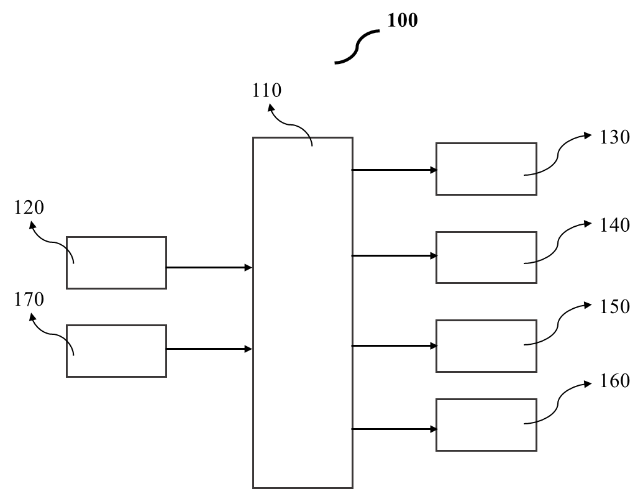

Fig. 1: Schematic of the health monitoring system.

Dated this the 24th day of September 2024

Applicants: No. of Sheets: 5
Application No.: Sheet No. 2

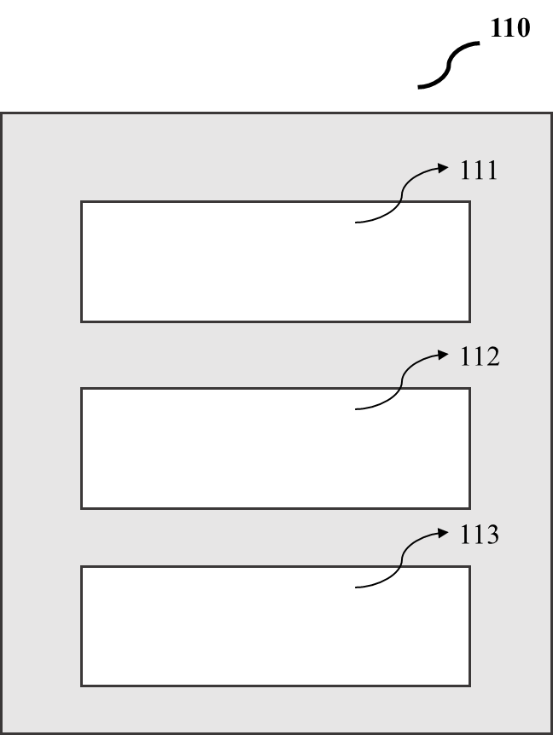
Fig. 2: The control unit with Arduino Mega, Arduino Uno and NodeMCU.

Dated this the 24th day of September 2024

Applicants: No. of Sheets: 5
Application No.: Sheet No. 3

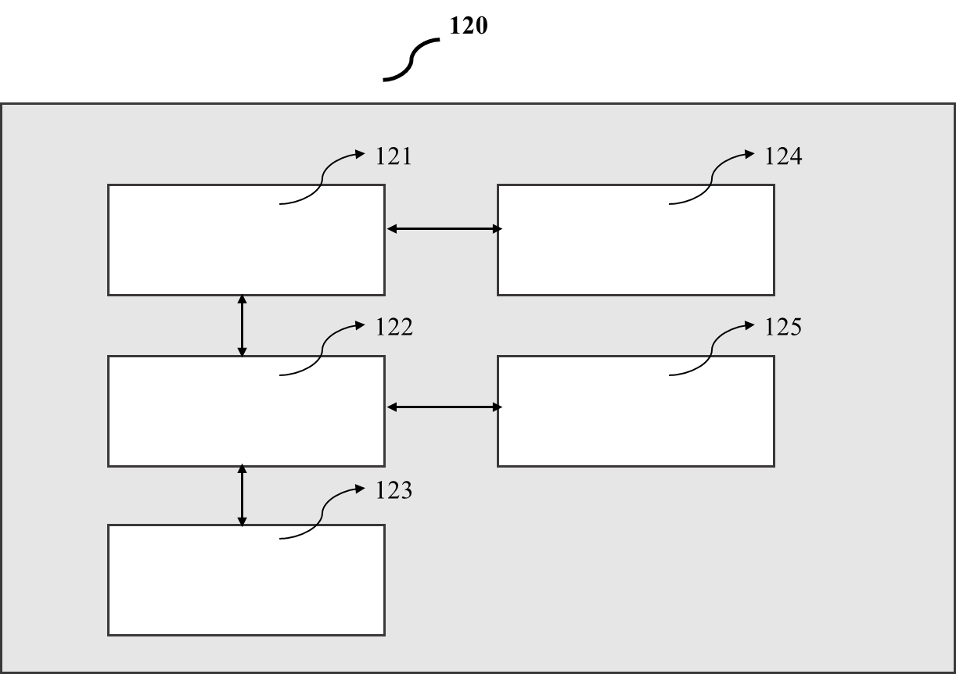
Fig. 3: The components of sensing unit (120).

Dated this the 24th day of September 2024

Applicants: No. of Sheets: 5
Application No.: Sheet No. 4

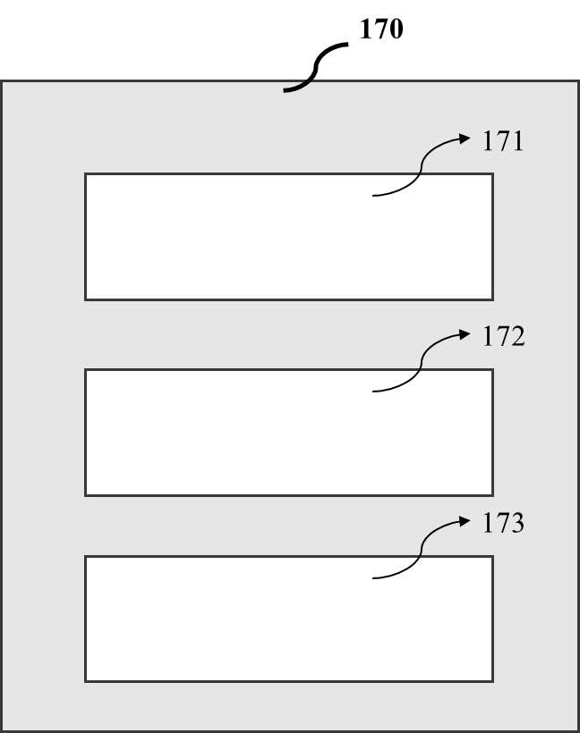

Fig. 4: Wireless communication system (170)

Dated this the 24th day of September 2024
Applicants: No. of Sheets: 5
Application No.: Sheet No. 5

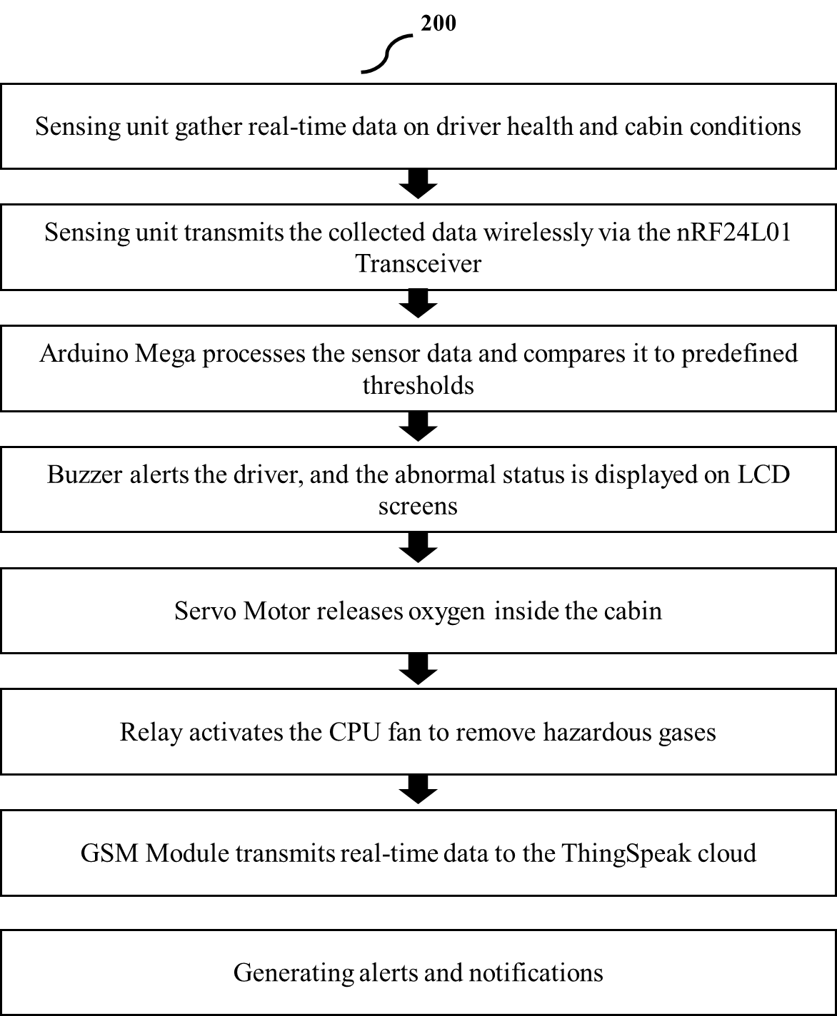
Fig. 5: The method of working of the monitoring system

Dated this the 24th day of September 2024

