**Day-1 Assignment**

1. Create a table with name depart for the following specification.

USE pl_sql_ex;

**Create table department (DEPART_ID int(4) NOT NULL PRIMARY KEY, DEPART_NAME varchar(30) NOT NULL, MANAGER_ID int(6) unique NOT NULL);**

Table structure:

* **describe department;**

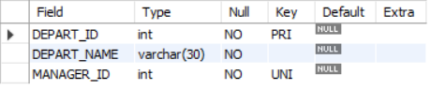

2) Create a table with name depart for the following specification.

**Create table employees(EMP_ID varchar(6) PRIMARY KEY, EMP_NAME varchar(20) NOT NULL, EMAIL character(25), PHONE_NUMBER varchar(10) NOT NULL, DEPART_ID int);**

Table structure:

* **describe employees;**

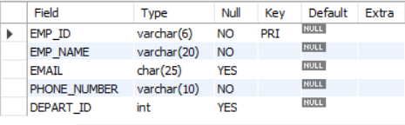

1. Using Alter command add a new column in employees table with name salary and with datatype and precision as Number(8,2)

**Alter table employees add salary numeric(8,2);**

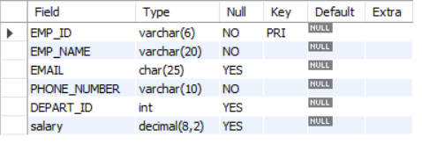

1. Using Alter command add a new table constraint in employees table with name for key for DEPT_ID column in employees table which refers the primary key of depart table (consider the usage of both foreign key and references constraints)

**ALTER TABLE employees ADD CONSTRAINT fk FOREIGN KEY (DEPART_ID) REFERENCES department(DEPART_ID);**

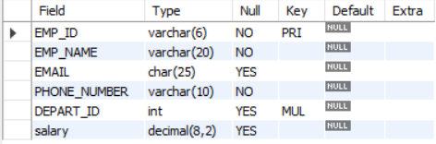

1. Using Alter command drop the constraint in employees table with name for key and modify the column DEPT_ID with column constraint references for the primary key in depart table.

**ALTER TABLE employees drop constraint fk ;**

1. Using Alter command drop the column in employees table with name EMAIL.

**Alter table employees drop column EMAIL;**

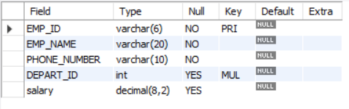

1. After adding salary column (Q.3), add a column constraint to the EMPLOYEES table which restricts the addition of those employees who have salaries less than 10000

**Alter table employees add constraint salary_check CHECK (salary>10000);**

1. Using Alter command, rename table employees as empl;

**Alter table employees rename to empl;**

**desc empl;**

1. Create a new table with name depart1 as same as depart in structure.

**Create table depart1 as select * from department;**

**(Or)**

**Create table depart1 like department;**

**desc depart1;**

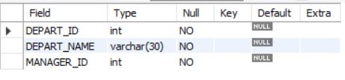

1. After creation, drop table depart1 using drop command.

**drop table depart1;**