* Kollam
* Tvm
* Pathanamthitta
* Palakkad
* Thrissur
* Malappuram
* Kottayam
* Idukki
* Alappuzha
* Kannur
* Kasargod
* Ernakulam
* Wayanad
* Kozhikode

Kannur:

1.  Muzhappilangad beach

It is considered as the longest drive-in beach in Asia.[[5]](https://en.wikipedia.org/wiki/Muzhappilangad_Beach#cite_note-5)

The beach festival is celebrated in the month of April and it is one of the important tourist attraction in the district of Kannur in Kerala.

Despite a tourist destination the beach is a bird watching hotspot too.[[6]](https://en.wikipedia.org/wiki/Muzhappilangad_Beach#cite_note-6) More than thirty species of migratory birds visit here in the [winter](https://en.wikipedia.org/wiki/Winter).

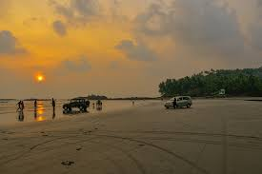

2.Palakkayam Thattu

Palakkayam Thattu is a picturesque hill station situated about 3500 ft above sea level. Many tourist-friendly activities have been organized in this secluded hill station, which was once a rather undiscovered gem. Adventure parks, viewing spots and tents have now been set up to engage visitors.

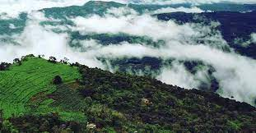

3. St Angelo's Fort

The colossal St Angelo's Fort, which stands majestically on a hill overlooking the sea, has a significant place in the historical map of Kerala. The fort, also known as the Kannur fort, lies three kilometres west of Kannur, near the Government hospital.

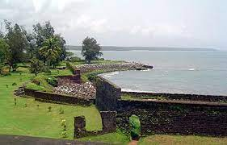

4. Kunhimangalam

Kunhimangalam, near Payyanur, is situated about 31 kms from the town, on the banks of Perumba River. The place is known for its handcrafted bronze lamps, sculptures and curios. It is a village of craftsmen, especially those who work on bronze and bell metal. These artisans are called Moosaris and are famous for making idols, lamps and sculptures with  unparalleled artistry. They are considered unique for their expertise is handed down from generation to generation.

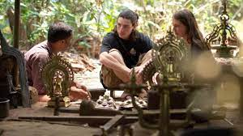

5. Aralam Wildlife Sanctuary

Aralam Wildlife Sanctuary, the only one of its kind in the district, is home to a wide array of flora and fauna. The sanctuary is located 45 kms east of Kannur and is often frequented by Nature lovers. It sprawls over an area of 55 sq. kms on the western slopes of the Western Ghats. The Sanctuary, established in 1984, is administered by the Wayanad division and headquartered at Iritty. The Sanctuary also offers exciting trekking opportunities for adventure lovers.

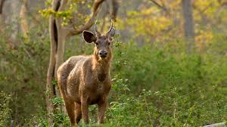

6. thalassery pier

The pier at Thalassery, known locally as Kadalpalam, is an old structure extending into the Arabian Sea.

It was built many years ago to facilitate transportation of goods to the ships. It is said that the large rocks on the shore prevented the ships from reaching the shoreline and caused shipwrecks, which made the British government construct this pier. The town soon rose to a bustling trade centre.

Today, the pier is a beautiful and serene picnic spot frequented by locals and tourists alike.

