**Computer Vision**

**Programming Assignment 1**

**Name:** Mohammad Al Fahim K **Roll No.:**EE17B021

1. **Brief Description:**

To present brief details of the datasets provided

**Table:**

|  |  |  |  |  |  |  |  |  |  |  |  |  |  |  |  |  |  |  |  |  |  |  |  |  |  |  |  |  |  |  |  |  |  |  |  |  |  |  |  |  |  |  |  |  |  |  |  |  |  |
| --- | --- | --- | --- | --- | --- | --- | --- | --- | --- | --- | --- | --- | --- | --- | --- | --- | --- | --- | --- | --- | --- | --- | --- | --- | --- | --- | --- | --- | --- | --- | --- | --- | --- | --- | --- | --- | --- | --- | --- | --- | --- | --- | --- | --- | --- | --- | --- | --- | --- |
| |  |  |  |  |  |  | | --- | --- | --- | --- | --- | --- | | **Name of Dataset** | **Feature vector dimension** | **No. of classes** | **Prior Prob. of each class** | **Mean vector dimension** | **Covariance matrix dimension** | | Image segmentation dataset1 | 19 X 1 | 7 | 1/7 for all classes | 19 X 1 | 19 X 19 | | Iris Dataset 3 | 4 X 1 | 3 | 1/3 for all classes | 4 X 1 | 4 X 4 | | Letter Recognition dataset 4 | 26 X 1 | 26 | variable | 26 X 1 | 26 X 26 | | Solar Flare dataset 6 | 10 X 1 | 3 | variable | 30 X 1 | 30 X 30 | | Wisconsin prognostic breast cancer dataset | 30 X 1 | 2 | variable | 30 X 1 | 30 X 30 | | Wisconsin diagnostic breast cancer dataset | 32 X 1 | 22 | variable | 32 X 1 | 32 X 32 | |  |  |  |  |  |  |  |

1. **Aim:**

To plot 1-D and 2-D histograms on one of the datasets provided and apply Bayesian classification

**Short Theory:**

If P(X/W1) and P(X/W2) are the likelihoods of the classes W1 and W2 respectively, the decision boundary obtained from,

*P(X/W1) = P(X/W2)*

The decision boundary is where the probability curves of two classes meet.

I have worked on the iris dataset

**Procedure:**

🡪 After importing the dataset, split the samples into each class

🡪 Define one_d and two_d functions, with parameters stating which feature to use for the plots, to plot the 1-D and 2-D histograms

🡪 Input the feature index you wish to use to plot the histograms. By default, for the one_d, 0th feature is used and for the two_d, 0th and 1st features are used.

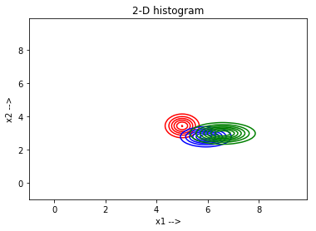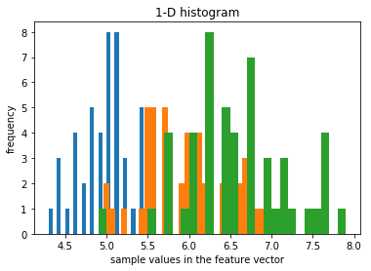**Plots:**

**Interferences:**

The edges where the plots belonging to two different classes, denoted by different colours, meet are the decision boundaries

1. **Aim:**

To perform Bayesian classification on the dataset, que3.xlxs, for the given conditions

1. Same covariance matrices for all the classes
2. Different covariance matrices
3. Diagonal covariance matrices

**Short Description:**

If we have three classes, W1, W2, and W3 respectively, a test case X will belong to that class which has the highest value among P(X/W1), P(X/W2) and P(X/W3). The Bayesian classification done here is only using the likelihood functions and I have not used the prior probabilities.

**Procedure:**

🡪 Import the dataset and split them into three classes and in each class, split it into 70% and 30% for training and test data respectively.

🡪 Define a custom function, gauss, to calculate probability and assign respective class

🡪 Calculate mean and sigma matrices for each case, calculate accuracy on test data using the cusom gauss function and plot their respective contours individually for each case

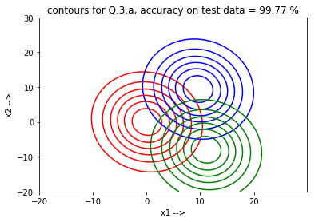**Plots:**

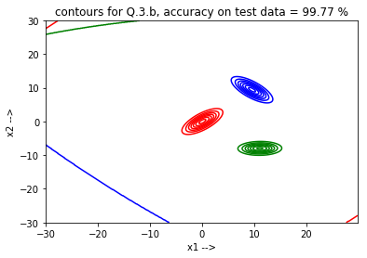

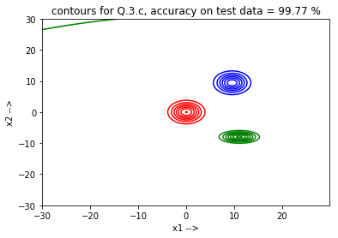

**Inferences:**

In the 1st case, when all the classes have the same sigma matrices, the decision boundary is a perpendicular bisector between the mean points of every class.