PeakMedia Data Warehouse – Data Modelling & Architecture

1. Overview
This data model integrates three primary data sources (TrackAff, AffMatrix, and Campaign data) into a unified star schema designed for analytical querying in a production-grade data warehouse. The model supports performance analysis across operators, campaigns, cards, and currencies.

2. Schema Design
The warehouse follows a star schema with two fact tables and five dimension tables:
Fact Tables:
- fact_affiliate_performance: Stores registrations, FTDs, and commission data
- fact_campaign_spend: Stores marketing spend and traffic metrics
Dimension Tables:
- dim_operator: Operator reference
- dim_campaign: Campaign reference
- dim_card: Card reference
- dim_currency: Currency reference
- dim_currency_rate: FX conversion rates
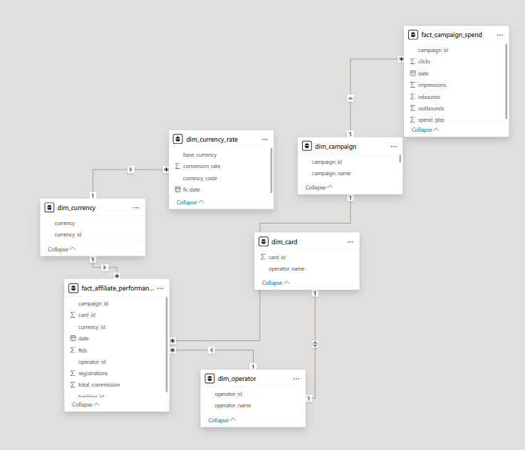

3. Data Integration Logic
Data from TrackAff and AffMatrix sources are transformed and aggregated into a unified grain:
- Daily level
- Per tracking_id, campaign_id, operator_id, and card_id
AffMatrix data is pivoted:
- registration_date → registrations
- ftd_date → ftds
- commission_earned → total_commission
Campaign data is loaded separately into fact_campaign_spend.

4. Key Transformations
- tracking_id is padded and parsed to derive card_id and campaign_id
- Dates standardized to yyyy-MM-dd format
- Currency mapped via dim_currency
- FX conversion handled via dim_currency_rate
- Operator and currency converted to surrogate keys

5. Relationships
The model enforces the following relationships:
- fact_affiliate_performance → dim_operator (operator_id)
- fact_affiliate_performance → dim_campaign (campaign_id)
- fact_affiliate_performance → dim_card (card_id)
- fact_affiliate_performance → dim_currency (currency_id)
- dim_currency → dim_currency_rate (currency_code)
- fact_campaign_spend → dim_campaign (campaign_id)
This ensures consistent filtering and enables cross-fact analysis.

6. Production Considerations
- Surrogate keys used for dimensional joins
- Data is aggregated at consistent grain
- Schema supports incremental loads
- Designed for Direct Lake / Power BI semantic models
- Currency normalization enables global reporting

