Analysis
Using SQL, produce answers to the following:

1)Which operator generated the most total commission over the quarter?

WITH commission_gbp AS (
SELECT
f.[date],
o.operator_name,
CAST(f.total_commission AS DECIMAL(18,2)) / NULLIF(fx.conversion_rate, 0) AS commission_gbp
FROM dbo.fact_affiliate_performance f
LEFT JOIN dbo.dim_operator o
ON CAST(f.operator_id AS INT) = o.operator_id
LEFT JOIN dbo.dim_currency dc
ON CAST(f.currency_id AS INT) = dc.currency_id
LEFT JOIN dbo.dim_currency_rate fx
ON fx.currency_code = dc.currency
AND fx.fx_date = f.[date]
AND fx.base_currency = 'GBP'
)
SELECT TOP 1
operator_name,
SUM(commission_gbp) AS total_commission_gbp
FROM commission_gbp
GROUP BY operator_name
ORDER BY total_commission_gbp DESC;

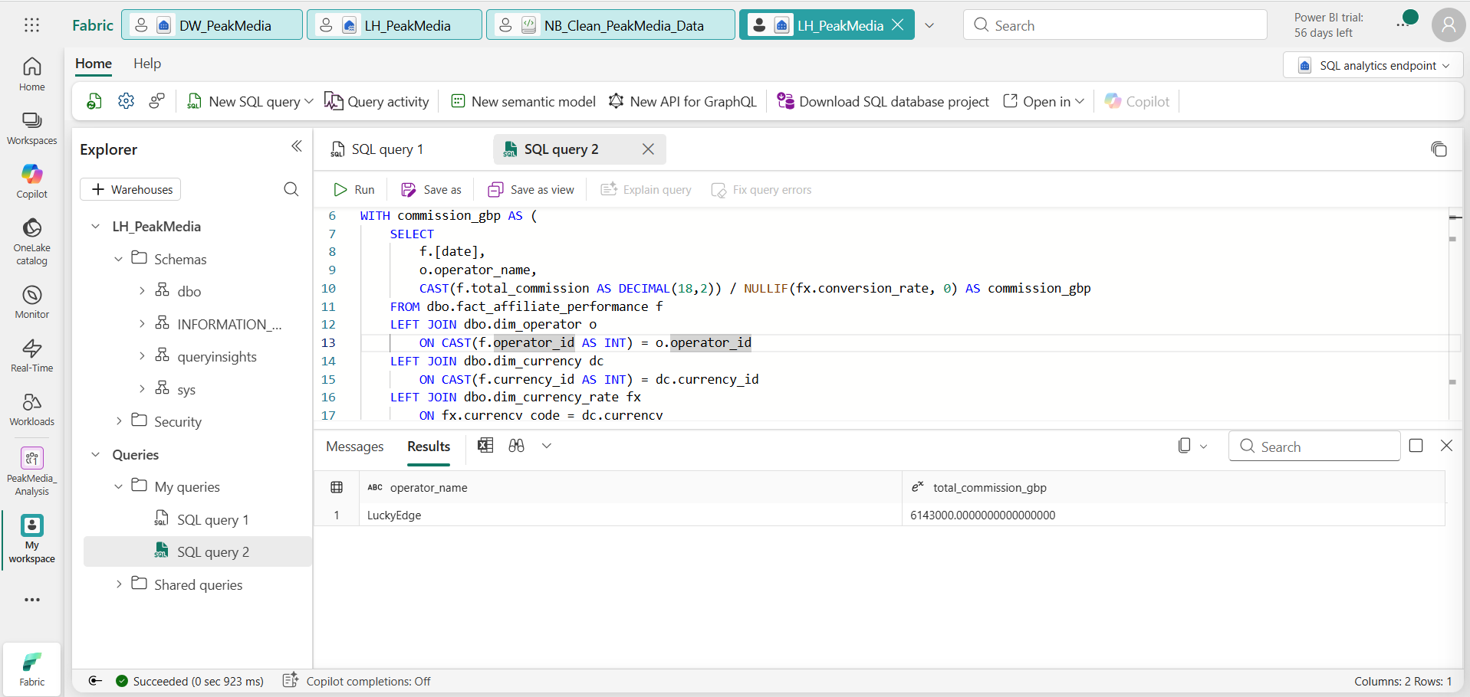

Ranking

WITH commission_gbp AS (
SELECT
f.[date],
o.operator_name,
CAST(f.total_commission AS DECIMAL(18,2)) / NULLIF(fx.conversion_rate, 0) AS commission_gbp
FROM dbo.fact_affiliate_performance f
LEFT JOIN dbo.dim_operator o
ON CAST(f.operator_id AS INT) = o.operator_id
LEFT JOIN dbo.dim_currency dc
ON CAST(f.currency_id AS INT) = dc.currency_id
LEFT JOIN dbo.dim_currency_rate fx
ON fx.currency_code = dc.currency
AND fx.fx_date = f.[date]
AND fx.base_currency = 'GBP'
)
SELECT TOP 1
operator_name,
SUM(commission_gbp) AS total_commission_gbp
FROM commission_gbp
GROUP BY operator_name
ORDER BY total_commission_gbp DESC;

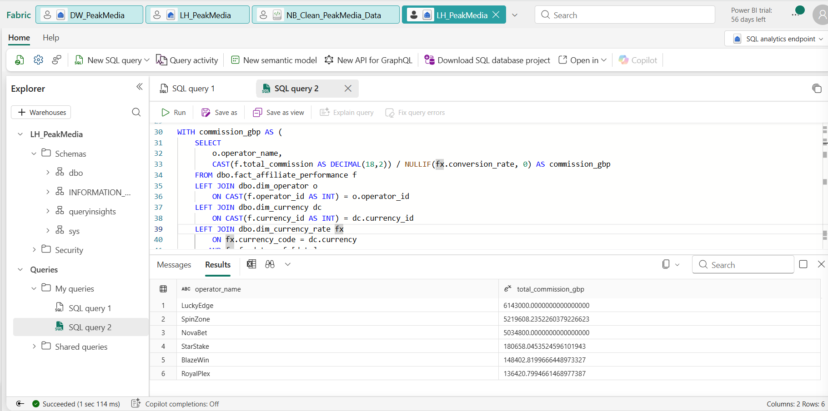

2)Which campaign delivered the best return on spend (commission earned vs spend)?

WITH affiliate_commission AS (
SELECT
f.[date],
RIGHT('000' + CAST(f.campaign_id AS VARCHAR(10)), 3) AS campaign_id,
SUM(CAST(f.total_commission AS DECIMAL(18,2)) / NULLIF(fx.conversion_rate, 0)) AS commission_gbp
FROM dbo.fact_affiliate_performance f
LEFT JOIN dbo.dim_currency dc
ON CAST(f.currency_id AS INT) = dc.currency_id
LEFT JOIN dbo.dim_currency_rate fx
ON fx.currency_code = dc.currency
AND fx.fx_date = f.[date]
AND fx.base_currency = 'GBP'
GROUP BY
f.[date],
RIGHT('000' + CAST(f.campaign_id AS VARCHAR(10)), 3)
),
campaign_spend AS (
SELECT
[date],
RIGHT('000' + CAST(campaign_id AS VARCHAR(10)), 3) AS campaign_id,
SUM(spend_gbp) AS spend_gbp
FROM dbo.fact_campaign_spend
GROUP BY
[date],
RIGHT('000' + CAST(campaign_id AS VARCHAR(10)), 3)
),
campaign_perf AS (
SELECT
ac.campaign_id,
SUM(ac.commission_gbp) AS total_commission_gbp,
SUM(cs.spend_gbp) AS total_spend_gbp
FROM affiliate_commission ac
INNER JOIN campaign_spend cs
ON ac.[date] = cs.[date]
AND ac.campaign_id = cs.campaign_id
GROUP BY ac.campaign_id
)
SELECT TOP 1
dc.campaign_name,
cp.total_commission_gbp,
cp.total_spend_gbp,
cp.total_commission_gbp / NULLIF(cp.total_spend_gbp, 0) AS return_on_spend
FROM campaign_perf cp
LEFT JOIN dbo.dim_campaign dc
ON cp.campaign_id = dc.campaign_id
ORDER BY return_on_spend DESC;

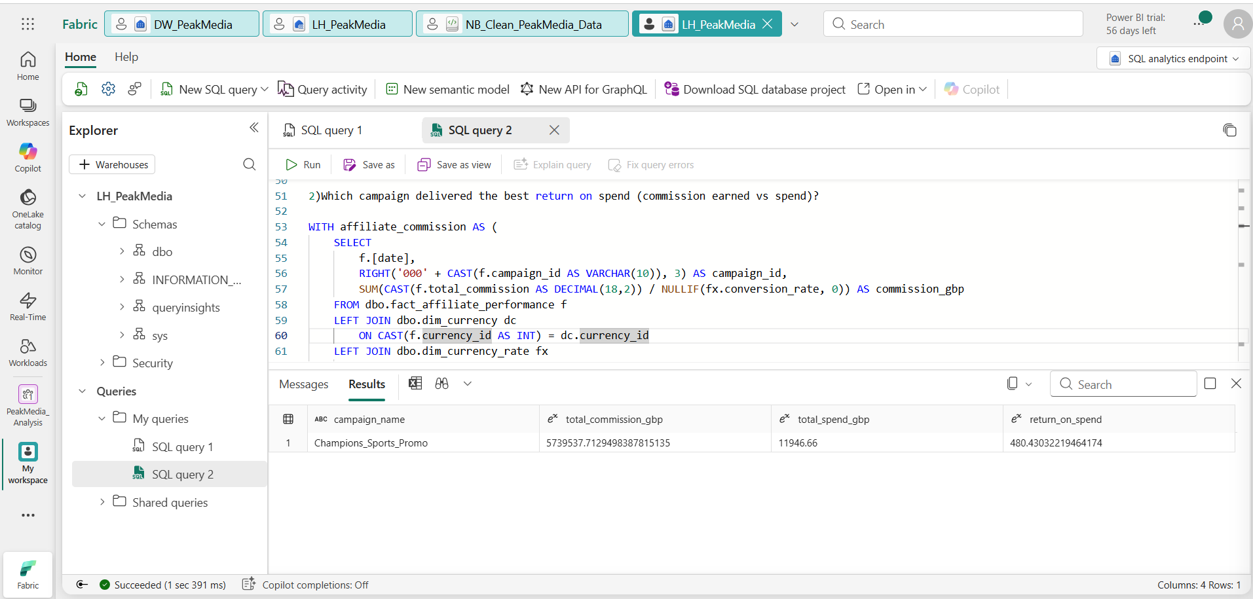

WITH affiliate_commission AS (
SELECT
f.[date],
RIGHT('000' + CAST(f.campaign_id AS VARCHAR(10)), 3) AS campaign_id,
SUM(CAST(f.total_commission AS DECIMAL(18,2)) / NULLIF(fx.conversion_rate, 0)) AS commission_gbp
FROM dbo.fact_affiliate_performance f
LEFT JOIN dbo.dim_currency dc
ON CAST(f.currency_id AS INT) = dc.currency_id
LEFT JOIN dbo.dim_currency_rate fx
ON fx.currency_code = dc.currency
AND fx.fx_date = f.[date]
AND fx.base_currency = 'GBP'
GROUP BY
f.[date],
RIGHT('000' + CAST(f.campaign_id AS VARCHAR(10)), 3)
),
campaign_spend AS (
SELECT
[date],
RIGHT('000' + CAST(campaign_id AS VARCHAR(10)), 3) AS campaign_id,
SUM(spend_gbp) AS spend_gbp
FROM dbo.fact_campaign_spend
GROUP BY
[date],
RIGHT('000' + CAST(campaign_id AS VARCHAR(10)), 3)
)
SELECT
dc.campaign_name,
SUM(ac.commission_gbp) AS total_commission_gbp,
SUM(cs.spend_gbp) AS total_spend_gbp,
SUM(ac.commission_gbp) / NULLIF(SUM(cs.spend_gbp), 0) AS return_on_spend
FROM affiliate_commission ac
INNER JOIN campaign_spend cs
ON ac.[date] = cs.[date]
AND ac.campaign_id = cs.campaign_id
LEFT JOIN dbo.dim_campaign dc
ON ac.campaign_id = dc.campaign_id
GROUP BY dc.campaign_name
ORDER BY return_on_spend DESC;

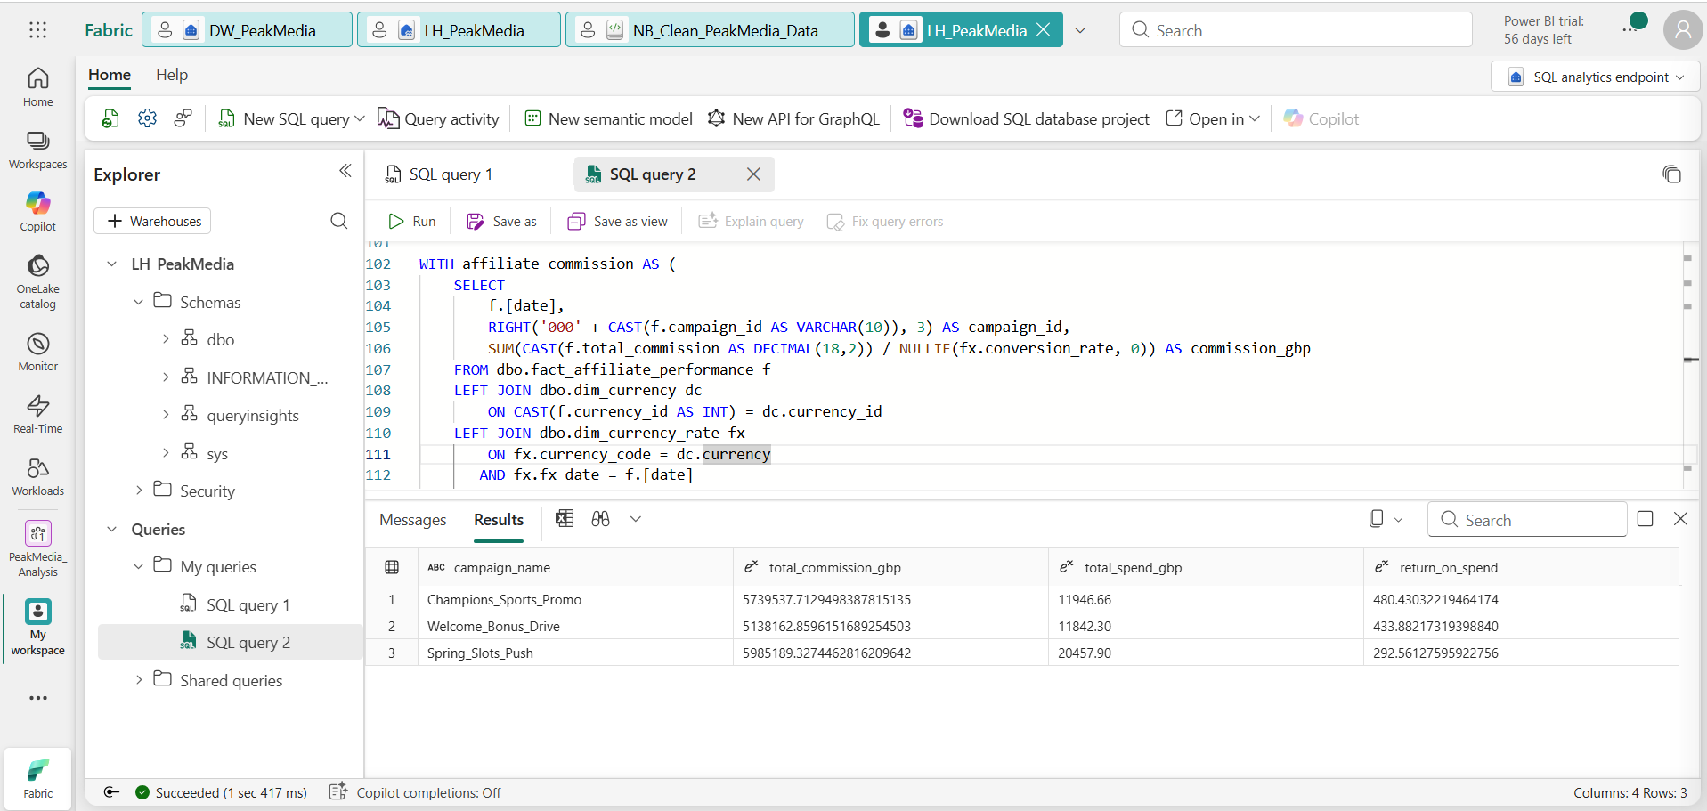

3) What is the click-to-registration ratio and registration-to-FTD ratio, by operator and by campaign?

WITH aff AS (
SELECT
[date],
RIGHT('000' + CAST(campaign_id AS VARCHAR(10)), 3) AS campaign_id,
SUM(registrations) AS registrations,
SUM(ftds) AS ftds
FROM dbo.fact_affiliate_performance
GROUP BY
[date],
RIGHT('000' + CAST(campaign_id AS VARCHAR(10)), 3)
),
spend AS (
SELECT
[date],
RIGHT('000' + CAST(campaign_id AS VARCHAR(10)), 3) AS campaign_id,
SUM(clicks) AS clicks
FROM dbo.fact_campaign_spend
GROUP BY
[date],
RIGHT('000' + CAST(campaign_id AS VARCHAR(10)), 3)
)
SELECT
dc.campaign_name,
SUM(sp.clicks) AS total_clicks,
SUM(af.registrations) AS total_registrations,
SUM(af.ftds) AS total_ftds,
CAST(SUM(af.registrations) AS DECIMAL(18,4)) / NULLIF(SUM(sp.clicks), 0) AS click_to_registration_ratio,
CAST(SUM(af.ftds) AS DECIMAL(18,4)) / NULLIF(SUM(af.registrations), 0) AS registration_to_ftd_ratio
FROM aff af
LEFT JOIN spend sp
ON af.[date] = sp.[date]
AND af.campaign_id = sp.campaign_id
LEFT JOIN dbo.dim_campaign dc
ON af.campaign_id = dc.campaign_id
GROUP BY dc.campaign_name
ORDER BY dc.campaign_name;

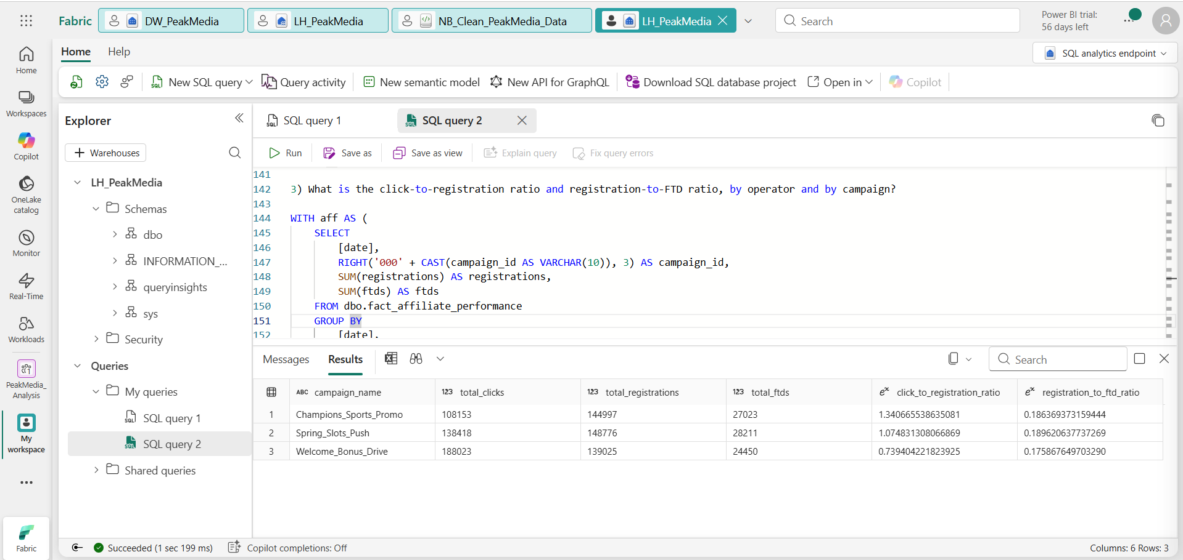

Operator

SELECT
o.operator_name,
SUM(f.registrations) AS total_registrations,
SUM(f.ftds) AS total_ftds,
CAST(SUM(f.ftds) AS DECIMAL(18,4)) / NULLIF(SUM(f.registrations), 0) AS registration_to_ftd_ratio
FROM dbo.fact_affiliate_performance f
LEFT JOIN dbo.dim_operator o
ON CAST(f.operator_id AS INT) = o.operator_id
GROUP BY o.operator_name
ORDER BY o.operator_name;
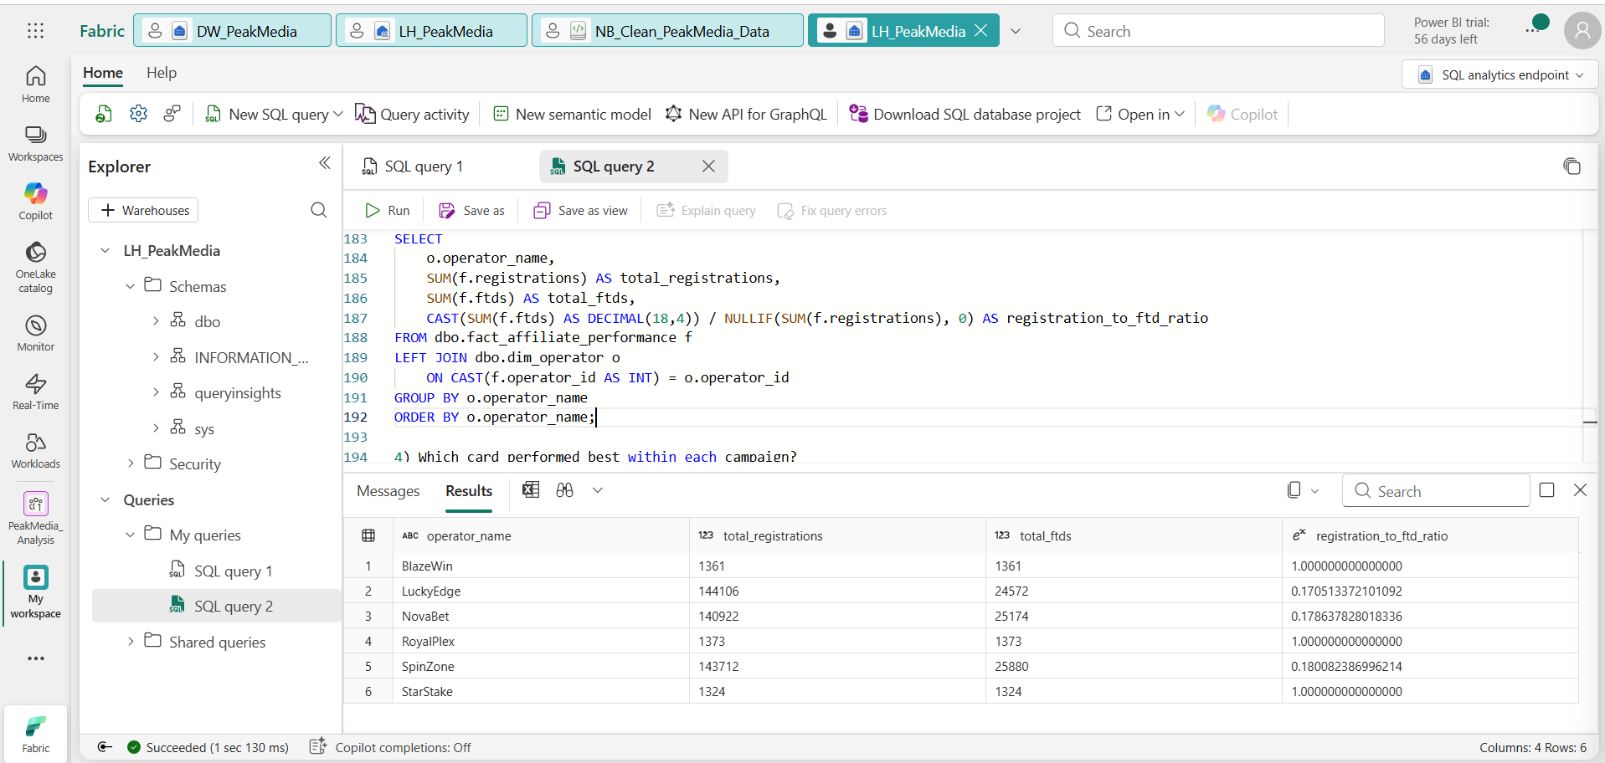

4) Which card performed best within each campaign?

WITH card_perf AS (
SELECT
RIGHT('000' + CAST(f.campaign_id AS VARCHAR(10)), 3) AS campaign_id,
f.card_id,
SUM(CAST(f.total_commission AS DECIMAL(18,2)) / NULLIF(fx.conversion_rate, 0)) AS commission_gbp,
SUM(f.registrations) AS registrations,
SUM(f.ftds) AS ftds,
ROW_NUMBER() OVER (
PARTITION BY RIGHT('000' + CAST(f.campaign_id AS VARCHAR(10)), 3)
ORDER BY SUM(CAST(f.total_commission AS DECIMAL(18,2)) / NULLIF(fx.conversion_rate, 0)) DESC
) AS rn
FROM dbo.fact_affiliate_performance f
LEFT JOIN dbo.dim_currency dc
ON CAST(f.currency_id AS INT) = dc.currency_id
LEFT JOIN dbo.dim_currency_rate fx
ON fx.currency_code = dc.currency
AND fx.fx_date = f.[date]
AND fx.base_currency = 'GBP'
GROUP BY
RIGHT('000' + CAST(f.campaign_id AS VARCHAR(10)), 3),
f.card_id
)
SELECT
dcam.campaign_name,
cp.card_id,
cp.commission_gbp,
cp.registrations,
cp.ftds
FROM card_perf cp
LEFT JOIN dbo.dim_campaign dcam
ON cp.campaign_id = dcam.campaign_id
WHERE cp.rn = 1
ORDER BY dcam.campaign_name;

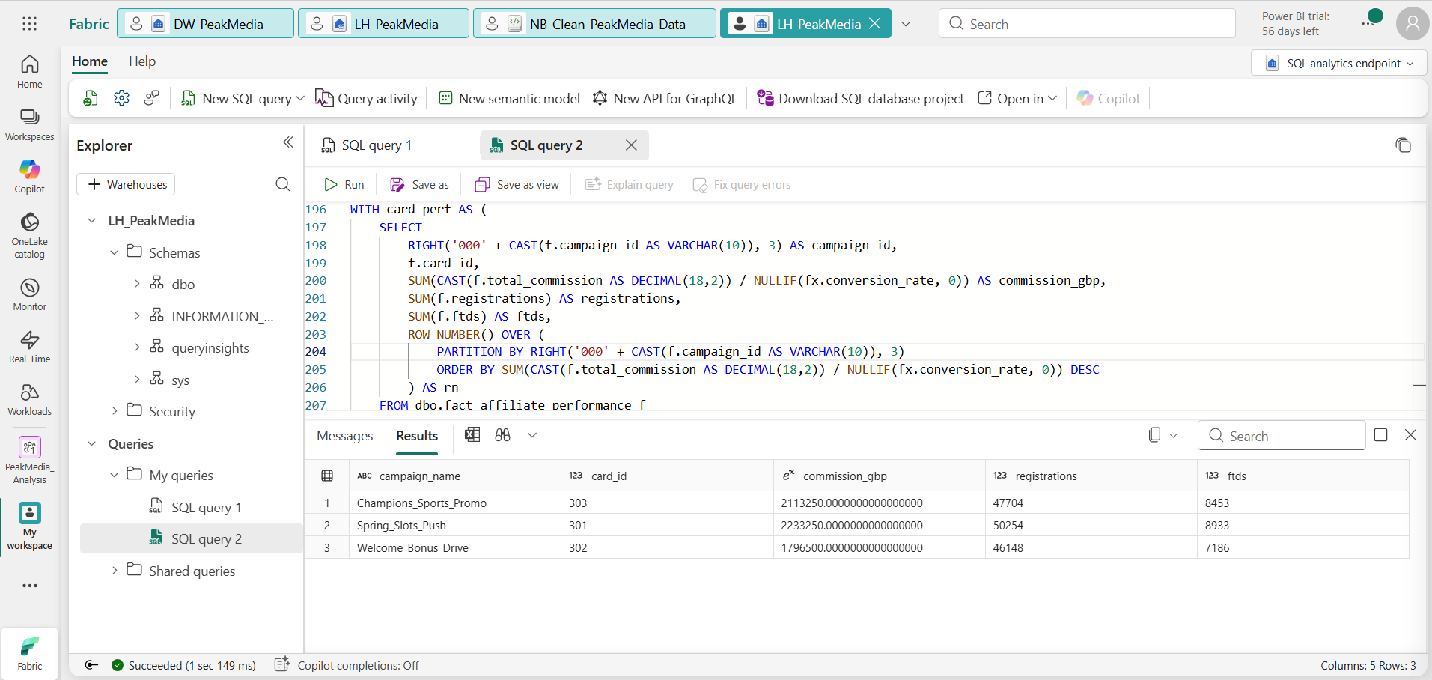

5. PeakMedia Data Quality & Anomalies Report

1. Mixed Date Formats
Example:
- 28/01/2025 (DD/MM/YYYY)
- 03/07/2025 (ambiguous: 3rd July or 7th March)
Explanation:
Different formats exist in the same column, making parsing unreliable.
Impact:
- Incorrect time-series analysis
- Wrong joins with campaign data
- Misaligned FX rates (date-dependent)

2. Missing tracking_id
Example:
10/02/2025 | NovaBet | 101 | 773 | 109 | 200 | 21800 | GBP
Explanation:
tracking_id is the primary key used to connect datasets (campaign, card, date).
Impact:
- Cannot join to campaign_data
- Data becomes unusable for attribution
- Should be quarantined

3. Malformed Rows
Example:
29/01/2025 | LuckyEdge | 250129302002 | 302 | 250 | GBP
(Missing columns like registrations, FTDs, commission)
Explanation:
Row structure does not match schema.
Impact:
- Breaks ingestion pipelines
- Causes null propagation
- Should be rejected or logged

4. Negative Registrations
Example:
registrations = -47
Explanation:
Likely adjustment or correction entries from the platform.
Impact:
- Distorts conversion rates
- Misrepresents funnel performance
- Should be handled as adjustments, not raw metrics

5. FTDs Greater Than Registrations
Example:
registrations = 8, FTDs = 312
Explanation:
Logically impossible unless definitions differ.
Impact:
- Breaks KPI trust
- Invalid conversion ratios
- Must be flagged as critical anomaly

6. Registrations = FTDs (Suspicious)
Example:
registrations = 50, FTDs = 50
Explanation:
Implies 100% conversion rate, which is extremely unlikely.
Impact:
- Indicates aggregation or reporting issue
- Could be duplicated FTD counts
- Needs validation with source system

7. Duplicate Records
Example:
Same tracking_id, operator, and metrics repeated.
Explanation:
Duplicate ingestion or upstream duplication.
Impact:
- Inflates revenue and KPIs
- Must deduplicate using business keys

8. Missing player_id (affMatrix)
Example:
BlazeWin | NULL | 250324503003 | ...
Explanation:
Player-level dataset without a player identifier.
Impact:
- Cannot track user journey
- Cannot deduplicate
- Must be removed

9. Negative Commission
Example:
commission = -300
Explanation:
Chargebacks, refunds, or clawbacks.
Impact:
- Financially valid but must be treated separately
- Should not be blindly converted to 0 (loses meaning)
⚠️ Your cleansing set this to 0 — mention this as a trade-off

10. Invalid Date Sequence
Example:
- registration_date = 2025-02-06
- ftd_date = 2025-02-01
Explanation:
FTD occurs before registration — impossible.
Impact:
- Indicates data corruption or timezone issues
- Must be excluded or corrected

11. Zero Commission & No FTD
Example:
- ftd_date = NULL
- commission = 0
Explanation:
Valid non-converting users.
Impact:
- Important for funnel metrics
- Should NOT be removed
- Must remain in registrations but excluded from FTD logic

12. Placeholder Dates (1900-01-01)
Example:
Used when ftd_date is NULL
Explanation:
Artificial default introduced during cleaning
Impact:
- Pollutes time-based analysis
- Can create fake spikes in 1900
- Should use NULL instead

13. Currency Inconsistency
Example:
- NovaBet → GBP
- BlazeWin → EUR
Explanation:
Different operators report in different currencies.
Impact:
- Cannot compare performance directly
- Requires FX normalization (as you implemented in model )

14. Granularity Mismatch
Example:
- trackAff → daily aggregated
- affMatrix → player-level
Explanation:
Two datasets at different grains.
Impact:
- Risk of double counting
- Requires aggregation of affMatrix before joining
- Critical modelling decision

15. Duplicate Player Entries
Example:
Same player_id appearing multiple times with identical data.
Explanation:
Duplicate ingestion or event duplication.
Impact:
- Inflates registrations/FTDs
- Must define deduplication rule (e.g., earliest event)

16. Campaign Data Integrity Assumptions
Example Checks Needed:
- clicks ≤ impressions
- spend ≥ 0
Explanation:
No explicit validation rules enforced.
Impact:
- Could allow impossible marketing metrics
- Weakens ROI calculations

